# COMMISSIONER'S CORNER

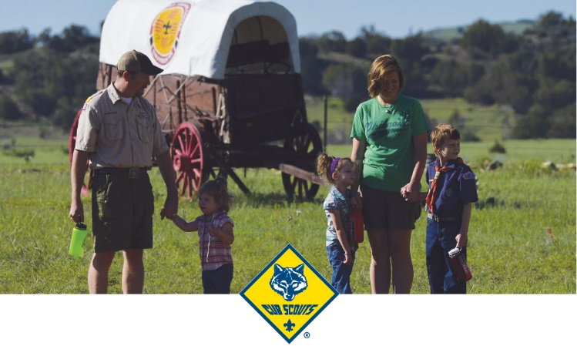

## 2017 CS EXTRAVAGANZA

**Sign Up Now!!**

Week 2: June 18–24, 2017

Week 7: July 23–29, 2017

Imagine attending the Philmont Training Center for a week and being able to interact with Cub Scout leaders from across the country, *and* being able to pick and choose which sessions to attend to improve your leadership skills! The summer of 2017 offers you that opportunity!

The 2017 Cub Scout Extravaganza at PTC! It’s your local council University of Scouting—but lasting for a week. Plan a program of your choice, designed to meet your needs by selecting from an assortment of Cub Scout leader topics ranging from outdoor skills to training administration … from den and pack management to Cub Scout fun and pizzazz. All of those, plus information on the Lion pilot program and the recently revised BALOO Cub Scout leader training experience. There is something for everyone!

Register now for an extravaganza week, and when you arrive at PTC, you’ll be able to get the most out of your time spent in Scouter’s paradise. Faculty comprises the Boy Scouts of America’s national-level volunteers and professional experts on the topics. It doesn’t get any better than this!

G to <http://www.philmontscoutranch.org/ptc.aspx>

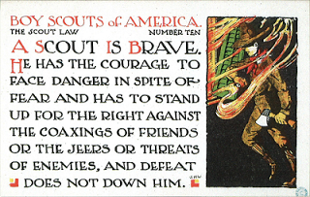

# TABLE OF CONTENTS

COMMISSIONER'S CORNER 1

2017 CS EXTRAVAGANZA 1

TABLE OF CONTENTS 2

CORE VALUES 2

BRAVE QUOTES 3

REPTILE QUOTES 4

THOUGHTFUL ITEMS 5

Prayers 5

Examples of BRAVE Cub Scouts - 5

BIOGRAPHY 7

THE BRAVEST MAN I KNOW… 7

Augusta Chiwy 8

CUB SCOUT IDEAS 10

DEN MEETING TOPICS 11

CHARACTER COMPASS 11

THEME RELATED STUFF 12

THEME RELATED ADVENTURES 12

PACK MEETING THEMES AND PLANS 12

PACK MEETING THEMES 13

UPCOMING MONTHS 14

CUBMASTER THOUGHTS 16

LEAD A SONG. 16

WEBELOS 18

Year-Round Growth Plan 19

Webelos-to-Scout Planning Calendar 19

June Crazy Holidays 22

June – A month to celebrate Bravery 24

TOP TEN MOST FAMOUS FICTIONAL REPTILES AND AMPHIBIANS 27

Things to talk about while you camp 31

Fun Facts About Reptiles 32

TRAINING TOPICS 34

Will your pack attend Camp this summer? 34

Some Tips Before Leaving for Camp 35

SPECIAL OPPORTUNITIES 36

Cub Scout Outdoor Activity Award 36

CUB GRUB 37

ONE LAST THING 41

Murphy Was A Scouter 41

Top 10 Reasons to be a Cub Scout Leader 41

**I'm not funny.  
What I am is brave.**

Lucille Ball

# CORE VALUES

**The Core Value for this month is the 10th point of the Scout Law - BRAVE**

**The core value highlighted this month is:**

**Brave -**

* A Scout can face danger although he is afraid. He has the courage to stand for what he thinks is right even if others laugh at him or threaten him.

Why **"Super Cub!"** for **Brave?**

* Superheroes are known for facing danger even when they are afraid. A Scout, like a superhero, has the courage to stand for what he thinks is right even if others laugh at him or threaten him.

**Per our Founder, Lord Baden-Powell**

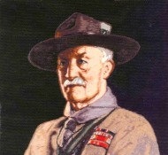

***Note –*** *The original Scout Law published in 1908 had 9 points. In 1910, the BSA added Brave, Clean, and Reverent. In 1911 B-P added* ***Clean*** *to his original list and defined it the following way: (So I do not have a B-P definition of Brave)*



*See the original Norman Rockwell painting at*[*https://encrypted-tbn2.gstatic.com/images?q=tbn:ANd9GcRq2AM3-zvDba--kUmbMnDGIuAJJ7_EXEUR_5vg5NWvVh1F8gWa*](https://encrypted-tbn2.gstatic.com/images?q=tbn:ANd9GcRq2AM3-zvDba--kUmbMnDGIuAJJ7_EXEUR_5vg5NWvVh1F8gWa)



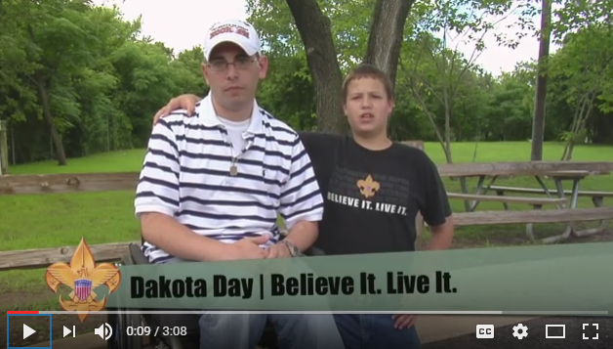

 In this video, the "Believe It Live It" team profiles Allen Babin who suffered severe injuries while a Medic in the Mideast. Go to URL:  
<https://www.youtube.com/watch?v=RCj5y-I1OL8>

**BRAVE QUOTES**

*Quotations contain the wisdom of the ages, and are a great source of inspiration for Cubmaster’s minutes, material for an advancement ceremony or an insightful addition to a Pack Meeting program cover.*

  
Superheroes are known for facing danger even when they are afraid. A Scout, like a superhero, has the courage to stand for what he thinks is right even if others laugh at him or threaten him.

Take a few minutes to talk to your scout about what it means to be brave. Encourage them to always do the right thing even though it is difficult or uncomfortable. Give them an example of how you show your bravery in your every day life despite the difficulties. Try something new this month, get out of your comfort zone. Do your best each and every day to live the scout law.

The pressure of adversity does not affect the mind of the brave man . . . It is more powerful than external circumstances. – Seneca

Don’t be afraid to challenge the pros, even in their own backyard.– General Colin Powell

Without courage, we cannot practice any other virtue with consistency. We can’t be kind, true, merciful, generous, or honest. –Dr. Maya Angelou

I learned that courage was not the absence of fear, but the triumph over it. The brave man is not he who does not feel afraid, but he who conquers that fear.  
 – Nelson Mandela

As you move outside of your comfort zone, what was once the unknown and frightening becomes your new normal.– Robin Sharma

It takes courage to grow up and become who you really are. –E.E. Cummings

Moral excellence comes about as a result of habit. We become just by doing just acts, temperate by doing temperate acts, brave by doing brave acts .– Aristotle

Take chances, make mistakes. That’s how you grow. Pain nourishes your courage. You have to fail in order to practice being brave. – Mary Tyler Moore

Don’t let the noise of others’ opinions drown out your own inner voice. – Bill George

The real man smiles in trouble, gathers strength from distress, and grows brave by reflection. –Thomas Paine

Self-reflection encourages great bravery. Rationalization is your greatest enemy. – Awa Kenzo

You cannot escape the responsibility of tomorrow by evading it today. –Abraham Lincoln

Fear has its use but cowardice has none.– GANDHI

Fortune always favors the brave, and never helps a man who does not help himself. – P.T. Barnum

Conscience is the root of all true courage; if a man would be brave let him obey his conscience. –  
James Freeman Clark

Integrate what you believe in every single area of your life. Take your heart to work and ask the most and best of everybody else, too .– Meryl Streep

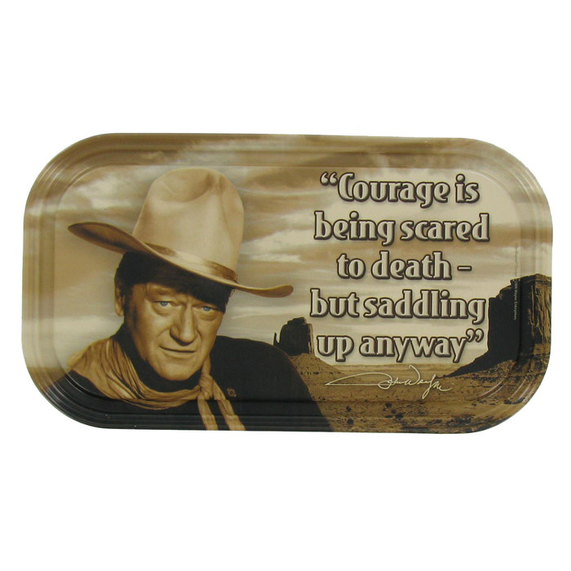

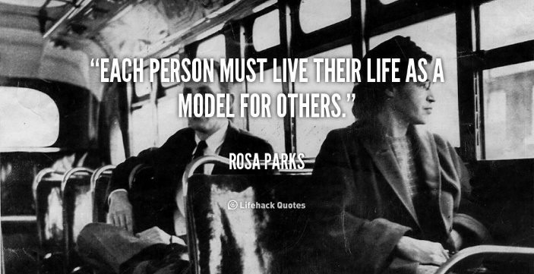

If you always put a limit on everything you do, physical or anything else, it will spread into your work and into your life. There are no limits. There are only plateaus, and you must not stay there, you must go beyond them. – Bruce Lee

I beg you take courage; the brave soul can mend even disaster. –Catherine The Great

It is courage, courage, courage, that raises the blood of life to crimson splendor. Live bravely and present a brave front to adversity.– Horace

The thing you fear most has no power. Your fear of it is what has the power. Facing the truth really will set you free. –Oprah

You must take personal responsibility. You cannot change the circumstances, the seasons, or the wind, but you can change yourself. That is something you have charge of. –Jim Rohn

It is curious that physical courage should be so common in the world and moral courage so rare. –Mark Twain

All that an obstacle does with brave men is, not to frighten them, but to challenge them .–   
Woodrow Wilson

The best protection any women can have . . . is courage. – Elizabeth Cady Stanton

Between stimulus and response, there is a space. In that space is our power to choose our response. In our response lies our growth and our freedom. –  
Viktor Frankl

The obstacle is the path .– Zen Proverb

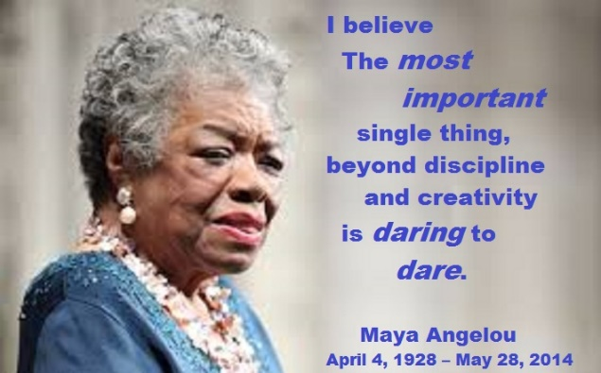

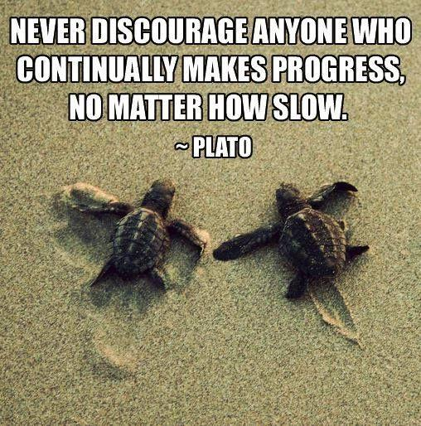

**REPTILE QUOTES**

“The very fact we use the term "cold-blooded" as a synonym for "heartless" should tell you something about the innate bias we primates hold against reptiles. Do not judge other species by your own social norms.”   
― Becky Chambers

“If you truly believe love conquers all try to give a kiss to a rattlesnake..” ― Erik Tanghe

“I feel more human when I compare the cuteness of a lizard to a newborn child's sweetness. Both are God's creations filled with precious innocence”   
― Munia Khan

The man who never alters his opinions is like standing water, and breeds reptiles of the mind.  
William Blake

I have dogs, and it's no secret that I find reptiles interesting, but the thing about reptiles is that they really just wanna be left alone, and I understand them. It's, 'Don't pick me up, stop holding me, don't look at me, just leave me alone.' I must admit, sometimes I feel like that. Nicolas Cage

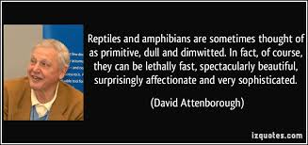

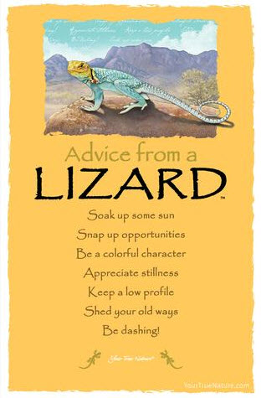

**The Lizard’s Advice is –**

**Soak up some sun Appreciate stillness**

**Snap up opportunities Keep a low profile**

**Be a colorful character Shed your old ways**

**Be dashing**

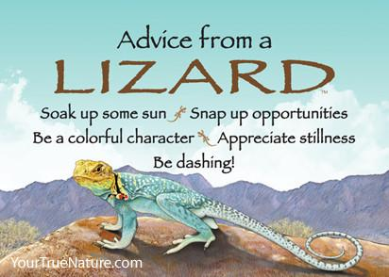

***This picture has two less thoughts***

Want the Tee shirt (or magnet or bookmark, or ???) go to <https://yourtruenature.com> and check out the 100’s of things giving advice!!

# THOUGHTFUL ITEMS

## Prayers

*2006-2007 Cub Scout Roundtable Planning Guide*

Oh, Great Spirit, we come to you with love and gratitude for all living things. We ask for a blessing on all creatures, and the human creatures who care for them in zoos, shelters and homes. Fill our hearts with respect for all living things. **Amen.**

*From Albert Schweitzer*

Dear God, protect and bless all beings that breathe, keep all evil from them, and let them sleep in peace. **Amen.**

## Examples of BRAVE Cub Scouts -

**Troop 211, Manhattan, NY**

*The Scouter’s Minute, ©1957*

“Mr. Chairman, this page of a New York newspaper that I am holding up, as you will see, contains a photograph of a 14-year-old Scout and nearly two columns describing how he saved the lives of six persons and dog in a blazing tenement and from sheer modesty kept the fact from his family for two weeks, when they accidentally learned about his feat. The Scout’s name is Frank Catalano, a member of an East Side Troop and it was chiefly his feeling of kindness toward animals that sent him in after the dog, and then just incidentally he dragged the six people one after another, through the smoke and flames to safety. That’s all, Mr. Chairman.”

**Speaking of Bravery**

*The Scouter’s Minute, ©1957*

I hardly know when a more striking example of Scout courage and scorn of obstacles has reached us than the one-armed Boy Scout, Howard Rote of ***Vineland, New Jersey***, who dove from the upper deck of a yacht and rescued a child who had fallen off a public pier. Both the Scout and the child were in danger of being crushed between the pier and the swinging yacht before the rescue could be effected. This is not the first time Rote has qualified as a lifesaver. Twice before he has saved persons from drowning, in one case rendering artificial respiration to the unconscious victim, thus doubly saving his life. Rote is an Eagle Scout. He, too, has not regarded a physical handicap as a bar to progress in Scouting. Any reason why you shouldn’t do at least as well as this scout? —Scouting Magazine.

**He Gave His All**

*The Scouter’s Minute, ©1957*

Allen Daggett, 14-year-old Boy Scout from Oakland California gave his life to save his younger brother from being killed by an electric train. He regained consciousness a few moments before he died and his first question was for his brother. Upon being assured of the younger lad’s safety he smiled content. “I couldn’t have done anything else,” he said, “I’m a Scout,” and the word “Scout” was the last on his lips.

Another Scout, Thomas B. Robinson, of Camden, New Jersey, also recently made the ultimate sacrifice giving his own life to save that of another boy from drowning. His effort was successful but in the end he was himself overcome by exhaustion and never recovered consciousness. Pathetically enough it was reported later that the boy had confided to his friends the he coveted the chance to be a hero and to win the Life Saving Medal awarded by the National Court of Honor. He died as he lived—a true Scout. — Boy’s Life.

**Cub Scout To Receive Award   
For Saving Brother's Life**

*By Rodger L. Hardy, Deseret News*

Sitting at the dinner table across from 4-year-old son Nicklaus, Jed Morley says he can't imagine what life would be like had his 10-year-old son, Ethan, not had the courage to enter their burning house in February and pull out his little brother feet first.

Next week, the Utah National Parks Council of the Boy Scouts of America plans to recognize Ethan Morley for that act of heroism with the Honor Medal, the national organization's second-highest live-saving award. Local Scout leaders don't see many Cubs earning a national award for life saving. But when Ethan receives the award at a Court of Honor on Tuesday, he will become the third Cub Scout in the council this year to receive an award for saving a life. Just 34 Scouts across the nation received the Honor Medal last year, according to the Boy Scouts of America Web site, [www.scouting.org.](http://www.scouting.org.) "It's quite an honor," said Michele Morley, Ethan's mother. "I'm not sure he really understands yet what it really means."

Jed and Michele Morley had stepped out of the house that cold February evening, leaving their 14-year-old daughter, Emily, in charge of the five children and a cousin, Michele Morley recalled.

"About 45 minutes to an hour later, I got a call from Emily (in a panic)," she said. The house caught fire when Nicklaus was apparently playing with matches. The fire alarm went off, but another daughter who was preparing food in the kitchen thought it was just her cooking that set it off, Michele Morley said. When the alarm persisted, one of the children went upstairs and saw the flames.

Emily ran a pan of water upstairs, but when she saw the size of the fire, she dropped it and hustled the children out of the house. They ran across the street where Emily counted noses. That's when she realized Nicklaus wasn't there.

Ethan, then 9, bolted back across the street and re-entered the house. Flames had already burst through the upper-story windows.

"Suddenly I felt courage," he later told his mother.

When Ethan arrived on the second floor, fire was already coming down the hall. Smoke was so thick it was difficult to see. He turned toward the boys' room but changed direction as suddenly "he just knew where to go," his mother said. Ethan went into the girls' room, where he saw Nicklaus' feet in the closet. He grabbed them and pulled him out of the room, Michele Morley said.

Together they escaped the burning house. When firefighters arrived moments later, they said the house didn't have enough oxygen left to sustain life. "The fire department told me there was only 6 inches of oxygen on the floor," Jed Morley said. "There was no way (Nicklaus) would have lived."

The second level was a total loss. The family had just finished remodeling the home and had moved in a week before the fire, Jed Morley said. After making repairs, they moved back into the home the week of the Fourth of July.

Ethan will join fellow Utah Cub Scouts Steven Ashworth, 9, of Highland, and Kade Kleven, then 9, of Orem, as recipients of awards for saving a life. Steven will be given his award for pulling a younger boy out of a family pool last June. "The boy was face down, not moving when Steven saw him," Utah National Parks Council spokesman John Gaily said. "Steven swam over, turned him over and saw that he was blue in the face. So he got him over to the side of the pool, pushed him onto the deck and called for help. Adults then started CPR and revived the young boy." Kade was honored for applying the Heimlich maneuver on his little brother, who was choking on a piece of Halloween candy in November.

Steven and Kade both earned the Medal of Merit, an award for demonstrating unusual concern for others. The Honor Medal is given to Scouts who save a life or attempt to save a live with considerable risk to themselves.

One early morning, while waiting for the bus, after not working for a while, I realized I had missed road noise. As Scout Leaders, we are all about nature and the outdoors. When we think about Scouting, most think about quiet and solitude or the wilderness, the sound of a mountain stream, the call of wild birds. We don’t often think about the places we live, in the cities and towns of America. Roads as we know them are an invention of the last century. Many if not all of us have heard the song about Route 66, the road that crossed the country from Chicago across the country to Los Angeles. There is also the Lincoln Highway, the Dixie Highway and many other named roads. There are Scenic Byways all across the country, place to visit, with a history to tell

The street where I catch the bus every workday morning has a number, but just down the street it changes to a named road. Most people don’t remember why they call it “Orchard Drive.” On the far south end many years ago there were orchards where people would come from miles around to purchase fruit. On the far north end, there used to be a church owned farm with fruit trees and a small dairy, all of which, for the most part, were operated by volunteers with all the production of the orchard and dairy being processed and given to needy families. I remember being taken there by my father with my older brothers to do volunteer work. I did what little work a young lad could do, picking up branches and hauling them out of the fields after others had pruned trees. The orchards and the farm are now gone, replaced by urban sprawl and a subdivision.

There is another road in my county that runs east to west named Antelope Drive. Should you drive the road west from I-15to the edge of the Great Salt Lake, you would come to an entrance booth to the causeway to Antelope Island State Park. After paying a Park entrance fee, you could drive the road across the Great Salt Lake to a wonderful State Park with clean sandy beaches and its own herd of Buffalo roaming the Island.

I am not trying to brag about where I live. I am merely trying to raise the competitive spirit in the reader to say, *Oh yea, well you ought to see what we have around here. There is this great place right down the road. We have some wonderful history right here in our city park.* That is the reaction that this month is all about. Discovering the treasures our country has for all of us. Teaching boys about where they live and the reasons that things are the way they are. Where did your town get its name? I bet there is a story to tell there. Beyond the boundaries of your community, to the wonders of you state, what stories are there to tell? What places are there to visit near where you live? Beyond the boundaries of your state, what places of history and beauty are there in you region? Let us teach our Cub Scouts about the America, and the States and the towns where they live.



# BIOGRAPHY

# THE BRAVEST MAN I KNOW…

Brave is our Scout Law part for this month. So I went out to pick someone to highlight who was brave. My first choice (If you know me, not a surprise) was Davy Crockett. But I have used him for other points. Then I googled the phrase I used for the title of this item. I got many pages of hits on Severus Snape, the instructor in the Harry Potter books. I did find a great article by Michael Bass of CNN about his Dad, a WWII vet, being bravest person he knew. And for many years I felt the same about my Dad, a WWII vet and a Police Officer. But his story is copyrighted and mine would take too long to write. The story of Michael Bass's Dad can be found at: <http://www.cnn.com/2014/06/09/opinion/bass-dad-hero-world-war-two/> if you wish to use it for a Cubmaster's Minute or to make point this month.

If you are looking for other examples - there is the classic, *Profiles in Courage* by John F Kennedy. *Profiles in Courage* is a 1957 Pulitzer Prize-winning volume of short biographies describing acts of bravery and integrity by eight United States Senators throughout history.

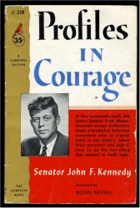 

Or Tom Brokaw's, *The Greatest Generation. The Greatest Generation* describes the bravery and other characteristics of the generation who grew up in the United States during the deprivation of the Great Depression, and then went on to fight in World War II, as well as those whose productivity within the war's home front made a decisive material contribution to the war effort.

Then I read about the this nurse during WWII -

**A BRAVE Person   
Who Faced Long Odds**

## Augusta Chiwy

*"Forgotten" African nurse of Battle of the Bulge*

This **BRAVE** lady risked her life treating soldiers during the Battle of the Bulge. She recently passed away at age 94.

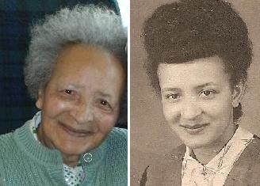

For decades, stories circulated among veterans and historians about an African nurse who tended to wounded and dying American soldiers in Belgium during the Battle of the Bulge, the bloody campaign through the Ardennes in the 1944-45 winter that became the last major German offensive of World War II

"Band of Brothers", the 2001 TV war drama based on historian Stephen E. Ambrose's best-selling book, referenced a nurse from Congo. But no such nurse was identified and celebrated until nearly seven decades after the war -when the Belgian king granted a knighthood, and the U.S. government awarded a high civilian honor, to Augusta Chiwy.

Ms. Chiwy (pronounced she-wee), 94, died Aug. 23, 2015 at a nursing home in Brussels. The cause was a heart attack, said her son, Alain Comet. She was credited with ministering to hundreds of men during the Battle of the Bulge, so named for the brief and ultimately unsuccessful German penetration of Allied lines.

As a volunteer nurse - amid unremitting shelling and in sub-zero temperatures, with inadequate food and little rest - Ms. Chiwy was said to have helped rescue the injured, dressing their wounds, bathing them and boiling snow for water. On Christmas Eve, she nearly lost her life when a bomb hit her makeshift aid station in the besieged town of Bastogne.

"'A black face in all that white snow was a pretty easy target," she once said, remarking on her survival through the battle. "Those Germans must be terrible marksmen."

Augusta Marie Chiwy was born June 3, 1921, in Mubavu, an East African village that became part of a Belgian colony and that is now located in Burundi. Her father was a white Belgian veterinarian and her mother was African.

Ms. Chiwy moved to Belgium as a girl, trained as a nurse in the city of Leuven, and arrived in Bastogne to spend the holidays with her father just as the Germans launched their attack through the Ardennes forest in eastern Belgium on Dec. 16, 1944. It would be one of the costliest engagements of World War II, with more than 80,000 American and 100,000 German casualties.

Bastogne, located at a major road junction, was surrounded during the battle. Ms. Chiwy joined the beleaguered skeletal medical operation there led by U.S. Army physician, Jack Prior. "He told me that he had no one left," Ms. Chiwy once recalled in an interview with Public Radio International, "that his ambulance driver had been killed."

For much of her life, Ms. Chiwy spoke little about the carnage that she witnessed, according to her son. Her story was in large part documented by Martin King, a Scottish historian and co-author with Michael Collins of "Voices of the Bulge: Untold Stories From Veterans of the Battle of the Bulge."

Dr. Prior recounted his wartime service in a written account that is online. He recalled the contributions of two nurses - one, a Belgian named Renee Lemaire, and another identified as "a native of the Belgian Congo."

"They played different roles among the dying," Prior wrote. "Renee shrank away from the fresh, gory trauma, while the Congo girl was always in the thick of the splinting, dressing, and hemorrhage control. Renee preferred to circulate among the litter patients, sponging, feeding them, and distributing the few medications we had (sulfa pills and plasma). The presence of these two girls was a morale factor of the highest order."

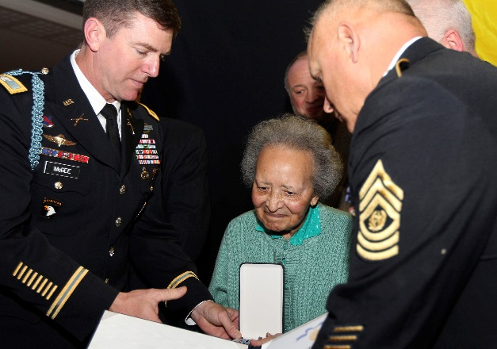

Ms. Chiwy is honored by the   
U.S. Army in Brussels in 2011.

Some white soldiers reacted negatively to the prospect of a black woman providing intimate care. One man, King said, suffered from severe frostbite and asked Prior not to allow the black nurse to touch him. "Fine," Prior replied, according to King's account. "Die, then."

On Christmas Eve, Ms. Chiwy and Prior were invited to step out of their aid station. "A bottle of champagne was opened," Ms. Chiwy recalled. "A glass was passed around. And I do not know whether he finished filling the glass, but we heard something coming screaming towards us. And then a big bang! And all of the windows were blown out."

A bomb had hit the aid station, killing 30 of the approximately 100 wounded soldiers, according to King. Lemaire perished in the blast. Years later, Prior told ABC News that he collected her remains and gathered them in a white parachute that Lemaire hoped to fashion one day into a wedding dress.

After the bombing, Ms. Chiwy followed Prior to another clinic, where she continued providing medical care until mid-January 1945, when Prior and his unit moved out of Bastogne.

Ms. Chiwy worked as a nurse for some years after the war. She was married to Jacques Cornet, who died two decades ago. Survivors include two children, five grandchildren; and six great-grandchildren.

King, the historian who publicized Ms. Chiwy's story, is a son, husband and father of nurses and told The Washington Post in an interview that he was intrigued by the reference in "Band of Brothers" to the African battlefield aide. After an 18-month search, he located Ms. Chiwy in a Belgian retirement community.

She became the subject of a biography by King- "The Forgotten Nurse" (2011) published in French and Dutch - and the documentary film "Searching for Augusta" (2014).

"What I did was very normal," Ms. Chiwy said when she was honored in 2011. "I would have done it for anyone. We are all children of God."

Prior, the Army physician, became a pathologist in Syracuse, NY. A daughter, Anne P. Stringer, said in an interview that her father told his children about an African nurse who had so valiantly assisted him during the war. "He said that he would never forget her courage," said Stringer, who recently traveled to Belgium to meet Ms. Chiwy. "She was only 23 when she helped my Dad."

Prior died in 2007. Until then, he and MS Chiwy exchanged greetings at Christmastime, a period coinciding with the anniversary of their survival at Bastogne. He kept her letters in a trunk along with a bayonet and wartime mail from his mother. Along with her letters, Ms. Chiwy sent Belgian chocolates.

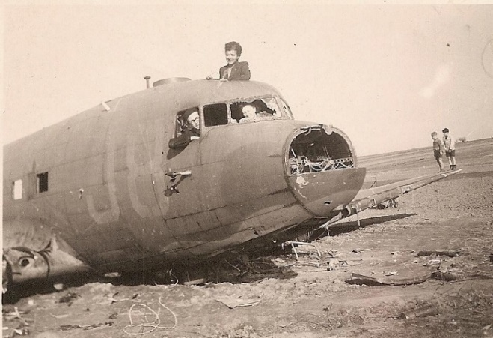

Ms. Chiwy is shown atop an airplane   
in this photograph, believed to have   
been taken in the summer of 1945.

# CUB SCOUT IDEAS

**Ten Camping Commandments to Build Excitement Outdoors**

*Sent by Alice @ Golden Empire Council*

***CDs Note - There are some great ideas here. However, this item was written for families going camping. Not for Packs going Family Camping as Cub Scouts. Some of the items listed are against BSA policy for Packs to do   
(e,g, shooting activities)***

How do you get a girl or boy excited about the outdoors? How do you compete with the television and remote control? How do you prove to a kid that success comes from persistence, spirit and logic, which the outdoors teaches, and not from pushing buttons?

The answer is in the Ten Camping Commandments for Kids. These are lessons that will get youngsters excited about the outdoors, and will make sure adults help the process along, not kill it. Some are obvious, some are not, but all are important:



1. Trips with children should be to places where there is a guarantee of action. A good example is camping in a park where large numbers of wildlife can be viewed, such as squirrels, chipmunks, deer and even bear. Other good choices are fishing at a small pond loaded with bluegill, or hunting in a spot where a kid can shoot at .22 at pine cones all day. (Cub Scouts on a Scout trip may only shoot of the veent is District or Council run) Boys and girls want action, not solitude.
2. Enthusiasm is contagious. If you aren't excited about an adventure, you can't expect a child to be. Show a genuine zest for life in the outdoors, and point out everything as if it is the first time you have ever seen it.
3. Always, always, always be seated when talking to someone small. This allows the adult and child to be on the same level. That is why fishing in a small boat is perfect for adults and kids. Nothing is worse for youngsters than having a big person look down at them and give them orders. What fun is that?
4. Always show how to do something, whether it is gathering sticks for a campfire, cleaning a trout or tying a knot. Never tell— always show. A button usually clicks to "off" when a kid is lectured. But they can learn behavior patterns and outdoor skills by watching adults, even when the adults are not aware they are being watched.
5. Let kids be kids. Let the adventure happen, rather than trying to force it within some preconceived plan. If they get sidetracked watching pollywogs, chasing butterflies or sneaking up on chipmunks, let them be. A youngster can have more fun turning over rocks and looking at different kinds of bugs then sitting in one spot, waiting for a fish to bite.
6. Expect young peoples' attention spans to be short. Instead of getting frustrated about it, use it to your advantage. How? By bringing along a bag of candy and snacks. Where there is a lull in the camp activity, out comes the bag. Don't let them know what goodies await, so each one becomes a surprise.
7. Make absolutely certain the child's sleeping bag is clean, dry and warm. Nothing is worse than discomfort when trying to sleep, but a refreshing sleep makes for a positive attitude the next day. In addition, kids can become quite scared of animals at night. The parent should not wait for any signs of this, but always play the part of the outdoor guardian, the one who will "take care of everything."
8. Kids quickly relate to outdoor ethics. They will enjoy eating everything they cook, building a safe campfire and picking up all their litter, and they will develop a sense of pride that goes with it. A good idea is to bring extra plastic garbage bags to pick up any trash you come across. Kids long remember when they do something right that somebody else has done wrong.
9. If you want youngsters hooked on the outdoors for life, take a close-up photograph of them holding up fish they have caught, blowing on the campfire or completing other camp tasks. Young children can forget how much fun they had, but they never forget if they have a picture of it
10. ***The least important word you can ever say to a kid is "I."*** Keep track of how often you are saying "Thank you" and "What do you think?" If you don't say them very often, you'll lose out. Finally, the most important words of all are: "I am proud of you."

# DEN MEETING TOPICS

Remember – Boys want to be active!!   
See, too, that they earn their awards   
***(Never say GET. You get sick, you do not get awards – You earn awards. A little CD Philosophy)***.

**Big Rock Ideas** – suggestions for Big Rocks that fit Interest Topics or seasonal activity. If years are next to an item (e.g. 13-14) that suggested Big Rock is in that Roundtable Planning guide and on-line at <http://www.scouting.org/scoutsource/Commissioners/roundtable.aspx>



# CHARACTER COMPASS

**JUNE -** ADVENTURES with a **CHARACTER COMPASS** pointing to **BRAVE:**

**TIGER –**

* Games Tigers Play (Core)
* Tigers – Safe and Smart (Elec)
* Tiger Theatre (Elec)

**WOLF –**

* Paws on the Path (Core)
* Hometown Heroes (Elec)

**BEAR –**

* Paws for Action (Core)
* Salmon Run (Elec)

**WEBELOS CORE –**

* First Responder (Core)
* Webelos Walkabout (Core)

**ARROW OF LIGHT CORE –**

* (None)

**WEBELOS & AOL ELECTIVES –**

* Build My Own Hero (Elec)



**JULY -** ADVENTURES with a **CHARACTER COMPASS** pointing to **TRUSTWORTHY:**

**TIGER –**

* Team Tiger (Core)
* Tigers – Safe & Smart (Elec)

**WOLF –**

* Howling at the Moon (Core)
* Adventures in Coins (Elec)

**BEAR –**

* Bear Claws (Core)
* Baloo the Builder (Elec)

**WEBELOS CORE –**

* Cast Iron Chef (Core)

**ARROW OF LIGHT CORE –**

* Camper (Core)

**WEBELOS & AOL ELECTIVES –**

* Game Design (Elec)

# THEME RELATED STUFF

## http://www.orgsites.com/in/pack3092/tsalute.jpgTHEME RELATED ADVENTURES

All Adventures are fun. –

**ADVENTURES THAT INVOLVE CAMPING or OUTDOORS:**

**TIGER –**

* Tigers in the Wild (Outdoor Meeting or Campfire) Core

**WOLF –**

* Call of the Wild (Family campout with Pack or other group) Core
* Howling at the Moon (Campfire) Core

**BEAR –**

* Bear Necessities (Overnight campout) Core
* Roaring Laughter (Campfire) Elec

**WEBELOS –**

* Cast Iron Chef (Outdoor Cooking) Core

**ARROW of LIGHT –**

* Outdoorsman (Camping) Core
* Scouting Adventure (Campout with a troop) Core

**WEBELOS ELECTIVES –**

* Castaway (Outdoor Survival) Elec
* Bear Necessities (Overnight campout) Core
* Sky is the Limit, Req 8 (if where you visit is a National treasure) (Elec)

**“ROAMING REPTILE ALERT” RELATED**

**TIGER –**

* Tiger Jungle (Identify animals) Core
* Tigers in the Wild, (Find animals on a hike, visit Zoo) Core

**WOLF –**

* Call of the Wild (identify animals) Core
* Paws on the Path (Name animals) Core

**BEAR –**

* Fur, Feathers and Ferns (Identify signs from reptile (or other), discuss an Extinct animal) Core
* Critter Care (Do you have a pet reptile? Tell about your pet) Elec

**WEBELOS CORE –**

* Webelos Walkabout (Dangerous animals near you) Core

**ARROW OF LIGHT CORE –**

* NONE

**WEBELOS & AOL ELECTIVES –**

* Into the Wild (Identify **a reptile** (or other animal) found only in your area, keep **reptile** (or other critter) for a while) Elec
* Into the Woods (Tell about animals that help plants) Elec



# PACK MEETING THEMES AND PLANS

[*www.scouting.org*](http://www.scouting.org)

**From National's Website for the new plans using the Core Values based on the Scout Law:**

Here are a few thoughts to consider around these new pack meeting plans. First, there is a plan for each month that corresponds with a point of the Scout Law. In addition, each plan has a theme to help make the pack meeting even more fun! The plans do not have to be used in a specific order.

**Tips for Utilizing the Plans**

* Pack meeting plans do not have to be done in any special order, but it is recommended that you include all of the points of the Scout Law each year. The pack planning meeting would be a good time to determine the order.
* There are pack meeting plans for multiple years posted on the website. It is your pack's choice of which one to select from each point of the Scout Law for each year.
* Pack meetings should not last longer than an hour. Adjust the plan to make it fit within the time. Research and experience tells us that Cub Scouts have a hard time sitting still for that long. Keep the meetings fun, active, and engaging.
* If you are comfortable with a costume to fit the theme of the meeting, go for it!
* Importantly, keep it simple and make it fun.
* The following required adventures have a requirement that suggests or requires completion at a pack meeting. Please plan accordingly as part of your annual program planning process. Work with your den leaders to plan when these activities will take place.

**Tiger**

* **Tigers in the Wild,** requirement 5. Participate in an outdoor pack meeting or pack campout campfire. Sing a song and act out a skit with your Tiger den as part of the program.
* **Games Tigers Play,** requirement 3. Make up a new game, and play it with your family or members of your den or pack.

**Wolf**

* **Council Fire,** requirement 6c. Create a den project from recyclables for a pack meeting.

**Bear**

* **Grin and Bear It**, requirement 2. Working with the members of your den, organize a Cub Scout carnival and lead it at a special event.
* **Grin and Bear It**, requirement 3. Help younger Cub Scouts take part in one of the events at the Cub Scout carnival.

**Webelos**

* **Stronger, Faster, Higher**, requirement 5. With adult guidance, lead younger Scouts in a fitness game or games as a gathering activity for a pack or den meeting.

**Arrow of Light**

* **Building a Better World (if chosen**), requirement 10b. Set up an exhibit at a pack meeting to share information about the World Friendship Fund.

**As a personal note:** *I have read most of the plans and they are excellent and just as complete as the new Den Leader Books. The games, and other stuff are right there. Including costuming ideas for that added PIZAZZ!! If you do not use themes and do not add PIZAZZ you are not doing your best for your pack.****GOOD JOB!!!*** *From CD*

Check them out at:   
<http://www.scouting.org/Home/CubScouts/Leaders/CubmasterResources/PackMeetingPlans.aspx>



# PACK MEETING THEMES

Kim, the chair of the task force, says **"I do want to stress that the focus is still the Core Value and the theme is just there as an enhancement. Pack meeting theme plans are specifically crafted to bring out the important points of the Core Value in a fun way."**

|  |  |  |
| --- | --- | --- |
| **2016–2017 Pack Meeting Plans** | | |
| May | Clean | ["A Picnic With Pizzazz"](http://www.scouting.org/filestore/cubscouts/pdf/YEAR2/310-842(15)_May%20Clean_WEB.pdf) |
| Jun | Brave | ["Roaming Reptile Alert"](http://www.scouting.org/filestore/cubscouts/pdf/YEAR2/310-842(15)_June%20Brave_WEB.pdf) |
| Jul | Trustworthy | ["Let The Games Begin"](http://www.scouting.org/filestore/cubscouts/pdf/YEAR2/310-842(15)_July%20Trustworthy_WEB.pdf) |
| Aug | Friendly | ["#CUBSCOUTS"](http://www.scouting.org/filestore/cubscouts/pdf/YEAR2/310-842(15)_August%20Friendly_WEB.pdf) |
| **2017–2018 Pack Meeting Plans** | | |
| Sep | Courteous | [How the West Was Fun](http://www.scouting.org/filestore/cubscouts/pdf/2017/310-842(17)_September_Courteous.pdf) |
| Oct | Thrifty | [A-Camping We Will Go](http://www.scouting.org/filestore/cubscouts/pdf/2017/310-842(17)_October_Thrifty.pdf) |
| Nov | Reverent | [Cubs Give Thanks](http://www.scouting.org/filestore/cubscouts/pdf/2017/310-842(17)_November_Reverent.pdf) |
| Dec | Kind | [Paying It Forward](http://www.scouting.org/filestore/cubscouts/pdf/2017/310-842(17)_December_Kind.pdf) |
| Jan | Helpful | [Jobs, Jobs, Jobs](http://www.scouting.org/filestore/cubscouts/pdf/2017/310-842(17)_January_Helpful.pdf) |
| Feb | Cheerful | [Abracadabra!](http://www.scouting.org/filestore/cubscouts/pdf/2017/310-842(17)_February_Cheerful.pdf) |
| Mar | Trustworthy | [Cub Scout Investigators](http://www.scouting.org/filestore/cubscouts/pdf/2017/310-842(17)_March_Trustworthy.pdf) |
| Apr | Loyal | [Cubs in the Future](http://www.scouting.org/filestore/cubscouts/pdf/2017/310-842(17)_April_Loyal.pdf) |
| May | Friendly | [Treasure Hunters](http://www.scouting.org/filestore/cubscouts/pdf/2017/310-842(17)_May_Friendly.pdf) |
| Jun | Obedient | [Wheel Into Summer](http://www.scouting.org/filestore/cubscouts/pdf/2017/310-842(17)_June_Obedient.pdf) |
| Jul | Brave | [Home of the Brave](http://www.scouting.org/filestore/cubscouts/pdf/2017/310-842(17)_July_Brave.pdf) |
| Aug | Clean | [Destination Parks](http://www.scouting.org/filestore/cubscouts/pdf/2017/310-842(17)_August_Clean.pdf) |

**If you are using a paper copy the link to all the   
Pack Meeting Plans is:**

<http://www.scouting.org/Home/CubScouts/Leaders/CubmasterResources/PackMeetingPlans.aspx>

# **UPCOMING MONTHS**

For June, the suggested Pack Meeting theme, **ROAMING REPTILE ALERT**, emphasizes the Tenth point of the Scout Law point, **BRAVE.**

**Previous months whose themes may have   
great material:**

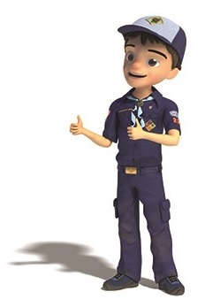

program updates banner

For April, the suggested Pack Meeting theme, **POWER UP**, emphasizes the Scout Law point, **THRIFTY.**

**The core value highlighted next month is:**

July's point of the Scout Law, **TRUSTWORTHY,** will use the theme, **LET THE GAMES BEGIN.**

**A SCOUT IS TRUSTWORTHY**A Scout tells the truth. He is honest, and he keeps his promises. People can depend on him.

**HOW DOES “LET THE GAMES BEGIN” RELATE TO THE FIRST POINT OF THE SCOUT LAW, TRUSTWORTHY??**

A Scout tells the truth. As the athletes of the world strive to do their personal best in international competition, Cub Scouts have the opportunity to “Let the Games Begin” by doing their best in feats of skill and sport. Remember that not only is it important to do your best when you play a sport, but it is also important to be trustworthy when following the rules of the game. Winning at all costs is not part of a Scout’s code of conduct.

For the July theme, LET THE GAMES BEGIN, I believe the intent is for athletic games. CS Olympics was always a popular theme when I was a Cub and when my son was a Cub in the late 80’s. Sometime after that the IOC got protective of its branding nd now we can no longer use the word Olympics. So the theme became “Let the Games Begin.” But I did provide some Game themed months for you to prep a Plan B.

**Previous months whose themes may have   
great material:**

|  |  |  |
| --- | --- | --- |
| **Month** | **Year** | **Theme** |
| **SPORTS** | | |
| **Sept** | **1939** | **Cub Olympics** (Note 1) |
| August | 1945 | Sports |
| August | 1950 | Cub Scout Olympics |
| August | 1953 | Sports Carnival |
| August | 1956 | Cub Scout Field Day |
| June | 1960 | Cub Scout Olympics |
| June | 1964 | Cub Scout Olympics |
| June | 1966 | Sports Carnival |
| July | 1968 | Cub Scout Olympics |
| June | 1970 | Olympics |
| August | 1970 | Cub Scout Field Day |
| July | 1972 | Cub Scout Olympics |
| June | 1975 | Sports Carnival |
| June | 1979 | Learn a Sport |
| June | 1990 | Sports Arena |
| August | 2002 | Sports Extravaganza |
| July | 2005 | Play Ball! |
| June | 2008 | Go For The Gold |
| July | 2009 | Cub Scout Sports |
| June | 2010 | Hoop-De-Doo |
| August | 2015 | Play Ball! |
| January | 2016 | The Great Race |
| June | 2016 | It's a Hit |

**Note 1 –** This was the very first use of themes in   
Cub Scouts – Cub Olympics in September 1939.



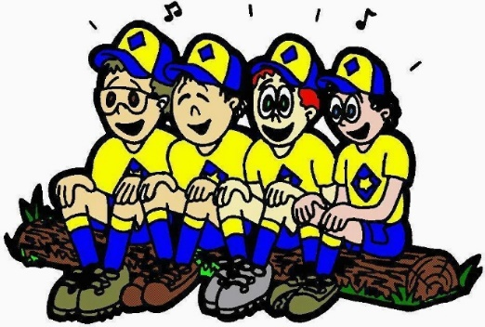

# **CUBMASTER THOUGHTS**

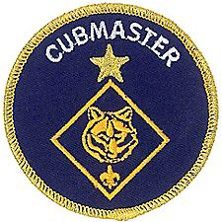

***Talk about being BRAVE -***

**LEAD A SONG.**

***Bill Smith****, the Roundtable Guy*

***I would guess that there are few things most Cubmasters fear more than having to get up at a pack meeting and……***

Unless you are an experienced choir leader or perhaps the concertmaster of your local symphony orchestra, the thought of standing in front of friends and neighbors and getting them to sing some silly song probably fills you with dread.

***Join the club.***I had watched in horror at Roundtables and such, when leaders would take us through renditions of *B-I-N-G-O* or *Cub Scout Spirit* and I realized that we were expected to do something similar. Not me! I am a cool urbane dude and this just doesn’t fit the image.

It took a trip to [***Philmont Training Center***](http://www.philmonttrainingcenter.org) to change my mind. The staff there convinced me that pack meetings should be fun – as Sean Scott often reminds us:

**WHY DO WE SING?**

Most people love to sing, and Cub Scouts are no exception. Singing builds den and pack spirit and enthusiasm. Singing gives boys a chance to let off steam.

**Singing is fun!** Use a song or two to set the mood for your meetings. Have a few songs ready to use as “fillers” during transition times of your meetings. Use songs to get the audience moving **and get rid of those wiggles.** Use songs to quiet and calm the group when it’s time to go. If you’re not using songs in your program, you’re missing out on the power of music!

**A PRODUCTION, A SHOW.**

The cool, urbane image may be OK around the water cooler at work but is not going to make it in a Cub Scout setting. Singing, they emphasized, was a great method for injecting fun and excitement into the program. So I bit the bullet and chose a song for my next pack meeting. We tried *Throw it Out the Window*. Each den chose a nursery rhyme and we all came in on the choruses. To my utter amazement it worked. The kids, Cubs and siblings, loved it and parents even commented that the pack meetings had improved.

***If I could do it, so can you!***If songs are not a regular part of every pack meeting, then you may be missing an important element that could make your meetings more enjoyable and more effective. Songs are the great mood setters. I can’t think a better way to get a bunch of Cub Scouts smiling and clapping than a few verses of *Alice the Camel* or *My Bonnie*. Is it possible to have a good campfire without songs? Not in my wildest imagination!

**HOW TO GET STARTED**

Try leading cheers and audience participation stories. A simple cheer like: I’ll throw the neckerchief up in the air and everyone yell until it comes down. These activities promote an atmosphere where the boys and even the parents become used to following your lead. It then becomes an easy step to try in a simple song like *I Like Bananas, Coconuts and Grapes.*

Pick easy songs with lots of repetition and simple tunes. Good Cub Scout songs rarely make much sense. I personally do not like those songs that attempt to introduce the theme with complicated lyrics. They are difficult to teach and they detract from the main purpose of songs in Cub Scouting. Songs should be uproarious fun. As you develop more confidence you can also try the quieter, closing or patriotic songs. These can be great mood setters but it’s usually best to start with the fun, silly songs.

Getting Cubs (or any group) to sing takes mostly enthusiasm and a dose of confidence. Choose a song that you like and feel confident about. Never apologize or dismiss the song or your leadership.

***It’s a great fun song and   
we’re going to really blast it out!***

It’s important to name the song, make sure they know the tune and the words and tell them that they should sing loud.

You might want to have the words printed out on large poster boards or butcher paper rather than on song sheets. Songs with lots of repetition or familiar words work well. If you have musical accompaniment, like a guitar or piano, that will make it so much the better. I am intrigued by some of these new electronic MP3 gadgets that allow one to download music files and play them back to teach the tunes. I can barely carry a tune so I need all the help I can get.

It helps to have everyone stand for singing. When they are ready, start them off with your version of a downbeat and keep a lively time by waving your arms. Enthusiasm beats musical ability here so have lots of fun while you’re doing it. Ed Hesser, one of my Wood Badge instructors, taught us to wear orange gloves to lead songs. It works.

***The Cub Scout Song Book*** is a great source of songs. It seems there is always a new edition is in the works but there is nothing wrong with current book. There are more and more Internet sites with good Scouting songs. Many now have music files as well as the lyrics. The Cub Scout songbook has a CD with tunes and words.

Your boys will undoubtedly come back from camp this summer with some great songs they picked up from the staff there. Use a few of these as regular fare for your pack meetings and campouts.

Here are some good internet sources:

From [www.usscouts.org](http://www.usscouts.org) –

<http://usscouts.org/songs.asp>

And –

Macscouter - Songs for Scouts and Scouters –

<http://www.macscouter.com/songs/>

Other good sites -

[Scoutsongs.com](http://scoutsongs.com)

[Boy Scout Trail - Songs](http://www.boyscouttrail.com/songs.asp)

Search youtube.com for Scout groups singing your favorites

For example – The Pizza Man (Hey Bo Diddley Bop)

<https://www.youtube.com/watch?v=XY3s3-Hphqk>

**CHOOSE THE RIGHT SONGS**

*From Cub Scout Songbook*

One of the important elements of Scouting is fun—especially when singing. When using humor and fun in Cub Scout activities, leaders should keep in mind that amusing and entertaining program elements are excellent opportunities to reinforce and teach the values of Scouting—to both youth and to adults.

Every Cub Scouting activity should be a positive experience in which young people feel emotionally secure and find support, not ridicule, from their peers and leaders. Everything we do with our Cub Scouts— including the songs we sing—should be positive and meaningful, and support rather than contradict the philosophy expressed in the Scout Oath and Law

Some guidelines for determining appropriate songs for Cub Scouting activities:

* The lyrics should be positive, build self-confidence and self-esteem, and be age-appropriate.
* Name-calling, put-downs, hazing, ridiculing, physical harm, or references to such, are not appropriate.
* References to undergarments, nudity, or bodily functions are not acceptable.
* Derogatory references to ethnic or cultural backgrounds, economic situations, and disabilities are not acceptable.
* Alcohol, drugs, gangs, guns, suicide, and other sensitive social issues are not appropriate subjects.
* Wasteful, ill-mannered, or improper use of food, water, or other resources is not appropriate.
* Refrain from “inside jokes” that are exclusionary and have meaning to only part of the audience.
* To encourage citizenship and respect for patriotic ideals, the lyrics to the following patriotic songs should not be changed: “America,” “America the Beautiful,” “God Bless America,” and “The Star-Spangled Banner.” Similar respect should be shown for hymns and other spiritual songs.
* All Cub Scouting activities should reflect the values and ideals of Scouting as outlined by the Scout Oath and Law.

As leaders of the Boy Scouts of America, it is our responsibility to model the values of the organization and set a high standard for appropriateness in all Cub Scouting activities. When making decisions, resolve to follow the high road—if in doubt, take it out.

The aims of the Boy Scouts of America are to develop character, citizenship, and personal fitness (including mental, moral, spiritual, and physical fitness) in today’s youth. All activities—including den, pack, or campfire programs—should contribute to the aims of Scouting.

**HOW TO LEAD A SONG**

*From Cub Scout Songbook*

**Choose It.** As the leader you must choose the song that the group will sing. You want to be certain that all songs chosen support the values and ideals of Cub Scouting. You will also want to choose a song that fits the program. Fast action songs get the program off to a brisk start. Patriotic songs add a note of dignity to the program. At the end of the program, slower closing songs can leave every one calm and thoughtful.

**Know It.** The song leader should know the song—both words and tune—before leading it. Learn the song, then practice before the meeting by teaching the song to your family or to the pack committee members at the monthly pack planning meeting.

**Teach It.** Start by telling your audience the name of the song. Unless you are certain that everyone in the group knows the song, you need to teach both the words and the tune. You may wish to provide copies of the words. Use songbooks, reproduced song sheets, or words on a large sheet of paper or overhead projector.

**Sing It.** Sing the song through once, either alone or with a small group who already know it. Let the singers try a verse at a time, slowly at first. When they master it, pick up speed.

**Pitch It.** Set the pitch by singing the first word of the song loudly so that everyone starts out on the same key. Musical accompaniment helps—a keyboard, piano, accordion, guitar, or harmonica are all good because they can play harmony not just single melody notes.

**Lead It.** Be active in your song leading. Use simple arm motions to lead the song so that everyone is singing together.

* • Start the singing with a slight upward motion and then a decisive downward motion (a downbeat). Begin singing yourself on the downbeat. Don’t worry if some don’t start with the first note—they’ll join in quickly.
* Beat time with a simple up-and-down motion of the arm, but make it definite and brisk. You’re in command.
* Control volume by raising your hands for loudness and lowering them for softness.
* Move around a little. Inject a little pep and personality. Keep smiling.
* Smile at your group. Relax. Radiate confidence and enthusiasm, even if you don’t feel particularly confident or enthusiastic. Morale catches.

**Stop It.** When the group has sung it a time or two, stop—don’t make it a music lesson. If the song isn’t going well, or it was pitched wrong at the beginning, stop the song and start over.

For more help be sure to check out –



# WEBELOS





**Always an S** Webelos always ends with an S whether talking about one Webelos Scout or a den of Webelos. It is an acronym – **WE**’ll **BE LO**yal **S**couts. As the CS RT Commissioner who mentored me says – "If you don’t have an S at the end – then there is nothing to which to be loyal."

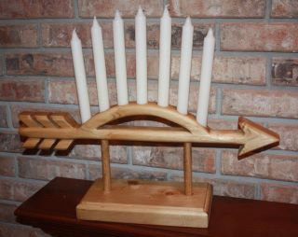

*Note: For Traditional units, Webelos Scouts / Dens means Webelos (4th grade) and Arrow of Light (5th grade) Scouts / Dens. For LDS Units where the Webelos experience is the 12 months a Scout is 10 years old, it is all inclusive.*

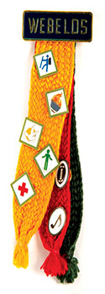

# Year-Round Growth Plan

<http://www.scouting.org/scoutsource/BoyScouts/YearRoundGuide/graduate.aspx>

The year-round growth plan is designed to facilitate Scout recruitment and pack-troop relations.

To carry out the plan, the troop membership chair will need to remember some important guidelines:

* Work closely with a nearby Cub Scout pack.
* Prepare an effective Webelos-to-Scout plan.
* Make new Scouts and their parents feel welcome.

At the beginning of the recruitment process, the troop should align with a Cub Scout pack in the community. If more than one troop draws its new Boy Scouts from this pack, contact the leadership of the other troops and design a plan to work together with the pack. Offer the use of your troop's equipment and expertise to the Cubmaster and the Webelos den leaders, and work with them to develop an effective Webelos-to-Scout plan, following the year-round calendar provided on this Web site.

Use the Second-Year Webelos Scout Tracking form to collect information on each second-year Webelos Scout. The information will be invaluable as the year-round plan is implemented. The form helps track the Webelos Scouts' progress toward becoming Boy Scouts.

Lastly, ensure that the Scouts and their parents have a smooth transition from the Webelos den to the Boy Scout troop. Make the Scouts and their parents feel welcome and at ease in the new troop environment, and recruit parents of the new Boy Scouts to become assistant Scoutmasters and troop committee members.

The activities recommended in this plan will help stimulate youth interest in the Boy Scout program. Implementing the plan involves the active involvement of adult and youth leaders of the Boy Scout troop as well as the leadership of the Cub Scout pack.

For more information on graduating Webelos Scouts into a troop, see the Webelos-to-Scout Transition DVD and brochure, No. AV-02V012.

**Webelos-to-Scout Planning Calendar**

Here is a Month by Month Plan for graduating your Webelos into Boy Scouts!

**Key Personnel:**

* CM 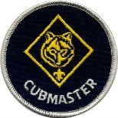-Cubmaster
* PLC  -Patrol Leaders' Council
* SM 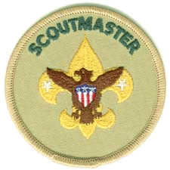 -Scoutmaster
* SPL 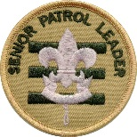 -Senior Patrol Leader
* TCC 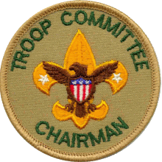 -Troop Committee Chair
* TG  -Troop Guide
* TMC 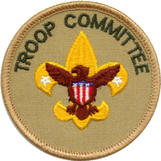 -Troop Membership Chair
* WDL  -Webelos Den Leader
* Also, the Assistants  
  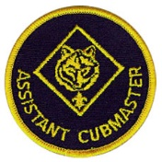  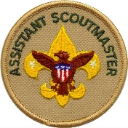

|  |  |  |  |
| --- | --- | --- | --- |
| September | **August** | | **Person Responsible** |
| 1 | Get names, addresses, and telephone numbers of second-year Webelos Scouts. Record the information on the Webelos Scout Tracking form. | **TMC, WDL, CM** |
| 2 | Plan a joint Boy Scout troop/Webelos den camping trip for October. | **SM, PLC, CM, WDL** |
| 3 | Plan a program of upcoming events to present at a Webelos den meeting visit in November. | **TMC** |
| 4 | Select a den chief for each Webelos den. | **SM, SPL, CM** |
| September | **September** | | **Person Responsible** |
| 1 | Mail a letter of introduction from the Boy Scout troop to second-year Webelos Scouts to introduce them to the troop. | **TMC, SM** |
| 2 | Put second-year Webelos Scouts on the mailing list to receive the troop newsletter. | **TMC** |
| 3 | Continue planning the joint camping trip for October. | **SM, PLC, CM, WDL** |
| September | **October** | | **Person Responsible** |
| 1 | Conduct the joint camping trip with the Webelos den. | **SM, TMC, SPL, CM** |
| September | **November** | | **Person Responsible** |
| 1 | Attend a Webelos den meeting to teach the Webelos Scouts how the Boy Scout troop works. | **SM, TMC, SPL** |
| 2 | Have den chiefs attend a local council or district training course. | **SM** |
| September | **December** | | **Person Responsible** |
| 1 | Set a date for Webelos Scouts and their parents to visit a Boy Scout troop meeting in January. | **SM, WDL** |
| 2 | If desired, send a small holiday gift to each Webelos Scout. | **SM, TMC** |
| September | **January** | | **Person Responsible** |
| 1 | Host Webelos Scouts and their parents at a Boy Scout troop meeting. | **SM, SPL** |
| 2 | Plan a bridging ceremony for the blue and gold banquet in February to welcome graduating Webelos Scouts to their new troop. | **SM, CM, TMC, SPL** |
| 3 | Attend a meeting of first-year Webelos Scouts to introduce them to Boy Scouting. | **SM, TMC, CM** |

|  |  |  |  |
| --- | --- | --- | --- |
| September | **February** | | **Person Responsible** |
| 1 | Hold the bridging ceremony at the blue and gold banquet. | **SM, CM, SPL, TMC** |
| 2 | Get new Scouts actively involved with the troop through troop activities. | **TMC, SM, CM** |
| 3 | Recruit parents of new Scouts to become assistant Scoutmasters or troop committee members. | **TCC, SM** |
| September | **March** | | **Person Responsible** |
| 1 | Plan a troop activity for new Scouts to get them involved with their new troop. | **PLC, SM, TMC, TG** |
| September | **April** | | **Person Responsible** |
| 1 | Conduct summer camp orientation to encourage troop involvement. | **SM** |
| 2 | Attend a meeting of Bear Cub Scouts to introduce them to Boy Scouting. | **SM, TMC, CM** |
| 3 | Sponsor a troop activity for the new Scouts. | **SM, TMC, TG, PLC** |
| September | **May** | | **Person Responsible** |
| 1 | Work closely with new Scouts and parents during their transition to the Boy Scout troop, ensuring their needs are met and that their move has been natural and fun. | **TMC** |
| 2 | Work on rank advancement with new Scouts. | **SM, SPL, TG** |
| September | **June** | | **Person Responsible** |
| 1 | Ensure that all new Scouts attend summer camp. | **TMC, SM** |
| September | **July** | | **Person Responsible** |
| 1 | Work closely with new Scouts and parents during their transition to the Boy Scout troop, ensuring their needs are met and that their move has been natural and fun. | **TMC** |
| 2 | Work on rank advancement with new Scouts. | **SM, SPL, TG** |

# June Crazy Holidays

*Claralyn in Golden Empire Council Adapted from* <http://holidayinsights.com/moreholidays/index.htm>  
[http://www.brownielocks.com/april.htm](http://www.brownielocks.com/april.html)l

**June is:**



* **Aquarium Month**
* **African-American Music Appreciation Month**
* **Candy Month**
* **Caribbean-American Heritage Month**
* **Child Vision Awareness Month**
* **Children's Awareness Month**
* **Country Cooking Month**
* **Dairy Month**



* **Fight the Filthy Fly Month**
* **Great Outdoors Month**
* **International Childhood Cancer Awareness Month**

[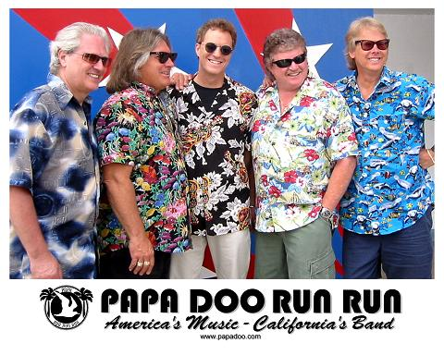](http://www.papadoo.com/)  
Check them out at - <http://www.papadoo.com/>  
My friend Bo is the drummer. He is the one in the blue shirt on the right side. He was a Life Scout in Troop 227 with me in Bergen County, NJ!!!

* [**International Surf Music Month**](http://www.nesmasurf.org/featurearchive/june%202009%20surf%20music%20month.htm)
* **National Accordion Awareness Month**
* **National Adopt a Cat Month**
* **National Fruit and Veggies Month**



* **National Ice Tea Month**



*The shape reminds us to be Cheerful and smile!!*

* [**National Smile Month**](http://www.nationalsmilemonth.org/)
* **National Soul Food Month**
* [**National Camping Month**](http://www.treehugger.com/culture/get-outdoors-itatms-national-camping-month-says-the-north-face.html)
* **Rose Month**
* **Turkey Lovers Month**

**Weekly Celebrations:**

* International Clothesline Week: 3-10
* [National Lemonade Days: 3-11](https://www.alexslemonade.org/campaign/alexs-lemonade-days)
* [National Sun Safety Week: 4-10](http://www.sunsafetyalliance.org/)

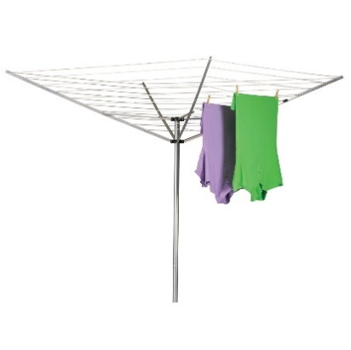

* [Pet Appreciation Week, 4-10](https://www.zazzle.com/brownielocks/gifts?cg=196935689316602907)
* [End Mountain Top Removal Week: 4-10](http://ilovemountains.org/)



* [**Superman Days: 8-11**](http://www.supermancelebration.net/schedule/)
* National Flag Week: 11-17
* [Men's Health Week, 12-18](http://www.menshealthmonth.org/week.html)
* Nursing Assistants Week: 15-22

`

* [Duct Tape Days: 16-18](http://www.ducktapefestival.com/)
* [Lightning Safety Awareness Week, 18-24](http://lightningsafetycouncil.org/)
* Old Time Fiddlers Week: 19-24
* Watermelon Seed Spitting Week: 22-25
* Water Ski Days: 23-25

**June Daily Holidays, Special   
and Wacky Days:**

1 [Dare Day](http://holidayinsights.com/moreholidays/June/dareday.htm)

1 [Flip a Coin Day](http://holidayinsights.com/moreholidays/June/flipacoinday.htm)

2 [National Bubba Day](http://holidayinsights.com/moreholidays/June/bubbaday.htm)

2 [National Rocky Road Day](http://holidayinsights.com/moreholidays/June/rockyroadday.htm)



2 [National Doughnut Day](http://holidayinsights.com/moreholidays/June/doughnutday.htm)

3 [Repeat Day (I said "Repeat Day")](http://holidayinsights.com/other/repeatday.htm)

3 [National Trails Day](http://holidayinsights.com/moreholidays/June/national-trails-day.htm)

4 [Applesauce Cake Day](http://holidayinsights.com/moreholidays/June/applecakeday.htm)

4 [Hug Your Cat Day](http://holidayinsights.com/moreholidays/June/hugyourcatday.htm)

4 [Old Maid's Day](http://holidayinsights.com/other/oldmaidday.htm)

5 [World Environment Day](http://holidayinsights.com/moreholidays/June/worldenvironmentday.htm)

6 [National Gardening Exercise Day](http://holidayinsights.com/other/gardeningexercise.htm)- Get out and exercise with your plants.

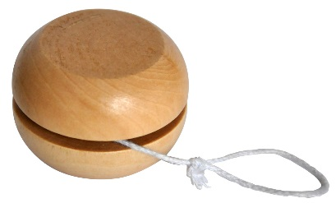

6 [National Yo-Yo Day](http://holidayinsights.com/other/yoyoday.htm)

7 [National Chocolate Ice Cream Day](http://holidayinsights.com/moreholidays/June/chocolateicecream.htm)

8 [Best Friends Day](http://holidayinsights.com/moreholidays/June/bestfriendday.htm)

8 [Name Your Poison Day](http://holidayinsights.com/moreholidays/June/nameyourpoison.htm)



**Donald turns 82 on June 9th this year!!!**

9 [Donald Duck Day](http://holidayinsights.com/moreholidays/June/donaldduckday.htm)

9 [National Strawberry Rhubarb Pie Day](http://holidayinsights.com/moreholidays/June/national-strawberry-rhubarb-pie-day.htm)

10 [Iced Tea Day](http://holidayinsights.com/moreholidays/June/icedteaday.htm)

11 [National Corn on the Cob Day](http://holidayinsights.com/moreholidays/June/national-corn-cob-day.htm)

12 [Red Rose Day](http://holidayinsights.com/moreholidays/June/redroseday.htm)

13 [Sewing Machine Day](http://holidayinsights.com/moreholidays/June/sewingmachineday.htm)

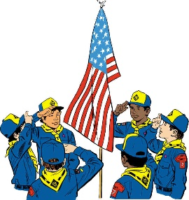

**14** [**Flag Day**](http://holidayinsights.com/other/flagday.htm)

14 [Monkey Around Day](http://holidayinsights.com/moreholidays/June/monkey-around-day.htm)



15 [Smile Power Day](http://holidayinsights.com/moreholidays/June/smilepowerday.htm)

15 [Global Wind Day](http://holidayinsights.com/moreholidays/June/global-wind-day.htm)

16 [Fresh Veggies Day](http://holidayinsights.com/moreholidays/June/freshveggiesday.htm)

17 [Eat Your Vegetables Day](http://holidayinsights.com/other/eatyourvegetablesday.htm)

17 [World Juggler's Day](http://holidayinsights.com/moreholidays/April/jugglersday.htm)

17 [National Hollerin' Contest Day](http://holidayinsights.com/moreholidays/June/hollerincontest.htm)

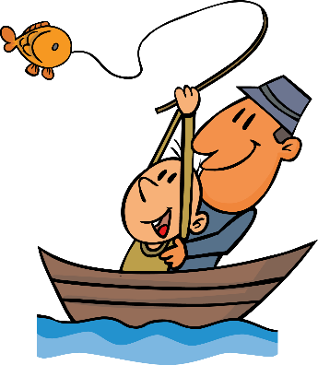

18 [Go Fishing Day](http://holidayinsights.com/moreholidays/June/gofishingday.htm)

18 [International Picnic Day](http://holidayinsights.com/moreholidays/June/international-picnic-day.htm)

18 [National Splurge Day](http://holidayinsights.com/moreholidays/June/splurgeday.htm) - Oh yeah!!



18 [Father's Day](http://holidayinsights.com/other/father.htm)

19 [National Kissing Day](http://holidayinsights.com/moreholidays/July/international-kissing-day.htm)

19 [World Sauntering Day](http://holidayinsights.com/moreholidays/June/saunteringday.htm)



20 [Ice Cream Soda Day](http://holidayinsights.com/moreholidays/June/icecreamsodaday.htm)

21 [National Selfie Day](http://holidayinsights.com/moreholidays/June/national-selfie-day.htm)

21 [Finally Summer Day](http://holidayinsights.com/other/summer.htm)- Summer Solstice



21 [International Yoga Day](http://holidayinsights.com/moreholidays/June/international-yoga-day.htm)

21 [Go Skate Day](http://holidayinsights.com/other/goskateday.htm)

22 [National Chocolate Éclair Day](http://holidayinsights.com/moreholidays/June/chocolateeclair.htm)

23 [National Columnists Day](http://holidayinsights.com/moreholidays/June/columnistsday.htm)

23 [National Pink Day](http://holidayinsights.com/moreholidays/June/pinkday.htm)

23 [Take Your Dog to Work Day](http://holidayinsights.com/moreholidays/June/dogtoworkday.htm)

24 [Swim a Lap Day](http://holidayinsights.com/moreholidays/June/swimalapday.htm)

25 [Log Cabin Day](http://holidayinsights.com/moreholidays/June/logcabinday.htm)

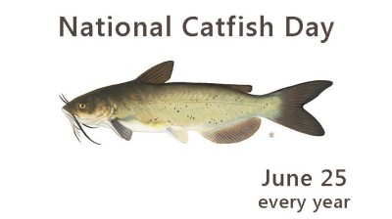

25 [National Catfish Day](http://holidayinsights.com/moreholidays/June/catfishday.htm)

26 [Beautician's Day](http://holidayinsights.com/moreholidays/June/beauticianday.htm)

26 [Forgiveness Day](http://holidayinsights.com/moreholidays/June/forgivenessday.htm)

27 [Sun Glasses Day](http://holidayinsights.com/moreholidays/June/sunglassesday.htm)

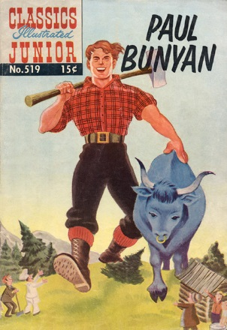

28 [Paul Bunyan Day](http://holidayinsights.com/moreholidays/June/paulbunyanday.htm)

29 [Camera Day](http://holidayinsights.com/moreholidays/June/cameraday.htm)

29 [International Mud Day](http://holidayinsights.com/moreholidays/June/international-mud-day.htm)

29 [Hug Holiday](http://holidayinsights.com/moreholidays/June/hugholiday.htm)



29 [Waffle Iron Day](http://holidayinsights.com/moreholidays/June/waffleironday.htm)

30 [Meteor Day](http://holidayinsights.com/moreholidays/June/meteorday.htm)

30 Superman’s Birthday



# June – A month to celebrate Bravery

*(Alice – Golden Empire Council)*

***NOTE: Many of these activities may also fulfill Adventure Loop and Pin requirements. – check in your books – Alice***

**1 – Flip a Coin Day -** Caesar would take a coin and flip it to make decisions where the right choice was unclear. The correct answer was "heads", which of course carried HIS head on the coin! But here are some FUN reasons to Flip a Coin:

* **Flip a Coin Hike -** Go for a hike or walk around the neighborhood – but every time you come to a crossroads of any kind you take turns flipping a coin to decide your route – OR
* **Flip a Coin – Make a Choice -** Set out different activities and then boys take turns flipping – heads (yes), tails (no) – to decide what activities you are going to do.
* **Flip for a Treat** - have two different treats – and flip a coin to decide which one to eat!



**2 – National Doughnut Day** – National Doughnut Day honors the **bravery** and perseverance of Salvation Army "Lassies" of WWI - volunteers who made home cooked foods to boost troop morale – and they still provide support today to troops and victims of natural disasters.

In the beginning, they used a bottle to roll out the dough – and because they didn’t have a doughnut cutter, they cut their doughnuts into strips.

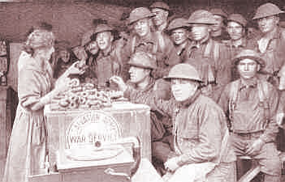

Eventually, a retired French blacksmith fastened the top of a condensed milk can and camphor-ice tube to a wooden block so a doughnut with a hole could be made. Later, all sorts of other inventions were employed, such as the lid from a baking powder can or a lamp chimney to cut the doughnut, with the top of a coffee percolator to make the hole. Sometimes doughnuts were cooked inside the metal helmet of an American soldier – which may be one reason for the infantry being called “Doughboys.”

But even in the Civil War, the name was used - as a kind of “put-down” of the ordinary foot soldier – Both General Custer and his wife referred to the name in letters, and some soldiers mentioned that they, ordinary foot soldiers, had to wait for “the artillery to cross the bridge in their carriages.” And in the 19th Century, baker apprentices in England were called doughboys, and soldiers and sailors were used to a fried flour dumpling called “doughboys.”

But remember that all of those “doughboys” kept going – and because they did, that name became a badge of honor and affection. So… Celebrate by making some easy doughnuts for a treat – see Cub Grub. Cook the holes, too – then let boys choose which sprinkles to roll their holes or doughnuts in.

**Make some doughnuts to share with the local military.** Check with Pack families or a VFW post, military base or Salvation Army. In Sacramento, we have several choices, including Reserve units and a Coast Guard Station in addition to regular military bases.

**3 - Repeat Day –** And repeating is something you NEED to do in order to get good at a new skill or to improve your performance – So be BRAVE – Repeat till you are Doing Your Best! But a fun way to celebrate Repeat Day would be to do one of the “Repeat After Me” songs– or try the Repeat After Me Story – “I’m going to Keep Going.”



**6** – **National Yo-Yo Day –** Learn a new trick **-** Great way to practice being BRAVE by persevering and having some FUN! Go to: [**http://entertainment.howstuffworks.com/easy-yo-yo-tricks.htm**](http://entertainment.howstuffworks.com/easy-yo-yo-tricks.htm)

Here are some fun facts about the Yo-Yo:

* It may have originated in China as early as 500-1000 B.C.
* Greeks were probably using a Yo-Yo even earlier than that!
* National Yo-Yo Day on June 6 honors the birthday of Donald F. Duncan Sr. – who manufactured the Duncan Yo-Yo.
* In 1992, Jeffrey Hoffman took a Yo-Yo into space aboard the shuttle Atlantis
* Presidents Kennedy, Johnson and Nixon showed off their Yo-Yo expertise while in office!
* The world’s largest Yo-Yo weighs 256 pounds - It’s on display at the National Yo-Yo museum.
* "Walking the Dog" or "Shooting the Moon" are the most popular Yo-Yo tricks.

**8 – Best Friends Day –** Best Friends are dependable– they work together and never give up! And being with a good friend can help keep you safe, too. Make sure the boys practice the Buddy System – especially if they are going swimming!

**Or celebrate Best Friends Day in the den:**

* **Have treats that must be shared** – one long length of licorice for example. The boys must agree how the treat will be divided, then come to Akela and explain BEFORE they can eat the treat!
* Another great food to share – **make a giant sandwich** that everyone contributes to, a fruit salad, a soup that everyone brings a veggie for, or, most fun of all, a giant ice cream sundae.
* **Make cookies**, then divide them into small baggies – give two to each person, but each boy shares one with a buddy.
* **Prepare a “community” trail mix** – have each person bring an item to add, then mix them all together while you talk about why that item is good to have. Then everyone gets to fill a snack bag with some trail mix and the den can go on a hike. OR Have everyone bring a snack to share on a den hike – two cookies, two boxes of raisins. Let the boys share or mix and match.



**14 – Flag Day –** Many BRAVE people persevered in serving our country – and Cub Scouts can honor their BRAVERY, service and sacrifice by learning how to display the flag with respect. It also takes BRAVERY to participate in a flag ceremony, raising, lowering, and folding the flag properly!

**15 – Fly a Kite Day -**  This holiday commemorates that famous experiment of Benjamin Franklin, which took place on this day in 1752. But be sure to emphasize that scouts aren’t trying to attract lightning! In fact, make sure you don’t fly a kite with a storm approaching. And look for a safe place with lots of space, away from power lines. Check with a local kite shop or club for some ideas.

**17 – Eat Your Vegetables Day –** Now here’s something that your Mother probably perseveres at – trying to get you to eat your veggies. But you should listen to her and be BRAVE by trying at least a couple of bites of every new vegetable – you might even learn to like it!

**Here are two different third Saturday in June Celebrations** - Flip a coin and decide how to spend that third Saturday – or let every den or boy try a different one and report on what they did –

**17 - World Juggler’s Day** – always held on the Saturday closest to June 17th – and it certainly takes BRAVERY to persevere to get good at juggling. So give it a try! Here are some good tips:

* Start with scarves if you are brand new.
* Then throw and catch a ball from one hand to the other.
* Now add a second ball – use medium sized soft balls to practice.
* Once you have practiced and can do two balls really well, add a third ball.
* With the hand you write with, hold two balls in that hand and one in the other.
* Throw one of the two balls toward the other hand, and just before you catch it, throw the ball in the other hand.
* Practice over and over till you get really good! In other words, Be BRAVE!

**18 - Go Fishing Day –** Fishing is a lot of fun – but it also takes perseverance! Sometimes it takes quite a while to learn how to bait a hook, cast a line without snagging it, or pick a good place and time to catch some fish. And you often have to wait a while for those fish to take the hook! But persevere – fishing can be a great hobby.

This year, Go Fishing Day is the same day as Father’s Day – so you could celebrate both holidays at once!

**18 – Father’s Day** – Make sure to do something special for and with your Dad – today is also Go Fishing Day. And the day after tomorrow is Ice Cream Soda Day – You could do all THREE for a wonderful celebration!

**20 – Ice Cream Soda Day –** I’m sure you can find the perfect thing to do to celebrate – even though I don’t think it takes BRAVERY!

**21 – Go Skate Day –** And whether it’s ice skating, roller skating, inline skating or skateboarding – it requires perseverance to get really good! But be sure to WEAR A HELMET, and pads or guards that will keep you safe! And if you want to hear the Paul Bunyan version of how inline skating was invented, check out Paul Bunyan Day!

**24 – Swim a Lap Day –** Like all sports, swimming requires lots of practice, especially if you are afraid of the water. But persevere, and you can always improve your swimming skills! Don’t forget Safe Swim Rules – and never swim alone!

**28 – Paul Bunyan Day -** Some Cub Scouts will recognize Paul Bunyan as an American folklore character – but we think the story originated among French Canadians. Paul was a giant of man, with a gigantic blue ox called Babe – the story goes that he was a logger who used his enormous size and strength to perform amazing feats – and he didn’t give up – he knew how to Persevere! When the Axmen got into a fight and ruined all the flapjacks, Paul had to mine the ore to make the pan to cook a giant flapjack; he had to figure out a way to get lots of eggs and milk. He even had to figure out how to make a giant eggbeater and get enough wood to make a fire to cook his giant pancake – and he invented online skating to solve the problem – and that’s just one of his stories!

Go to: [**www.first-school.ws/activities/onlinestory/books/pbunyan.htm**](http://www.first-school.ws/activities/onlinestory/books/pbunyan.htm) to watch and hear the whole story!

Here are some of his other legendary deeds:

* He created logging in the U.S.
* He scooped out the Great Lakes to water Babe, his ox.
* He cleared the entire states of North and South Dakota for farming.
* He trained ants to do logging work - Carpenter Ants.
* Babe's large footprints created Minnesota's 10,000 lakes.

Celebrate Paul Bunyan Day in a giant way. Learn more of his tales and tell them around a campfire!

**29 – Camera Day –** Celebrate Camera Day by taking pictures – with any kind of camera. But a digital camera is really easy to use, and you can print out the results very quickly.

The camera can capture moments and keep them forever. But it can take perseverance to learn how to use a camera – how to focus, use different angles and lighting, choose the right moment and position to take your photo, even what kind of film to use. It can also take lots of practice to learn how to show your photographs so they tell the story you want to show – how the picture is cropped, the kind of matting, even the kind of frame – or no frame at all.

And here’s a fun way to help the boys see how important it is to choose the right way to show your photos

* If boys have a photo they like, print out several copies of the same photo – they could be from online images
* Gather several different frames and mats that would fit the photo, OR
* You could even print out “matting” and “frames” from online images and cut out the center so you can “insert” the photo
* Let each boy try different matting and frames and decide which he likes best
* You could even display their favorites at the Pack meeting, with an explanation of why each boy made his choice

This is a good exercise in how to make choices, and the need to be open to try different things and persevere till you find the right solution

**30 – Meteor or Comet Day – AND Superman’s Birthday!** Check out the great ideas at NASA’s “The Space Place” – Scouts are listed as “Friends” – and they have all kinds of great ideas that are keyed to Advancement. They actually list the ideas by rank.

**For Superman’s Birthday on the 30th, encourage pack and den families to watch the Chris Reeve’s – Superman, the Movie -** and challenge the boys to find ways that the Superhero follows the Scout Law.

(Families might point out that he is BRAVE, he does Good Deeds all the time, and CHEERFULLY!) He saves Lois from a helicopter accident, rescues a cat from a tree, and replaces an engine on Air Force One – all of it cheerfully, like a scout! In real life, Christopher Reeve also displayed perseverance after being thrown by a horse and suffering a devastating spinal injury that left him paralyzed. (Be sure to talk about what Perseverance means – that in spite of problems, obstacles and challenges, a boy can keep trying to Do Your Best – even without “Super powers!”)

**Note on Superman’s Birthday -** There are actually several dates given as his birthday. Superman premiered in Action Comics Volume 1, Number 1 which has June on the cover. That led to people saying he was born June 30.

# TOP TEN MOST FAMOUS FICTIONAL REPTILES AND AMPHIBIANS

[www.backwaterreptilesblog.com](http://www.backwaterreptilesblog.com)

Because we’re obsessed with all things inspired by herpetology at Backwater Reptiles, we’re devoting this blog article to the topic of the top ten most famous fictional reptiles and amphibians in pop culture.

Reptiles and amphibians have become a part of pop culture appearing in everything from music videos to television commercials. The funny thing is that until you really sit down and think about it, you probably wouldn’t even notice.

So, in no particular order, here are our picks for the top ten most famous fictional herps in recent memory.

**About Backwater Reptiles**

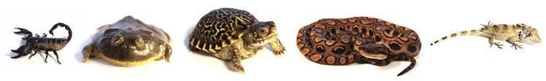

[www.backwaterreptiles.com](http://www.backwaterreptiles.com)

Backwater Reptiles specializes in captive breeding and select importation of a multitude of species, including snakes, lizards, turtles, tortoises, frogs, toads, newts, salamanders, scorpions, tarantulas, and more!

We offer the healthiest reptiles, amphibians, and invertebrates at rock-bottom prices for individuals interested in keeping these fascinating critters as pets or even beginning their own breeding projects.

We are reptile enthusiasts who believe that captive breeding is a personally rewarding experience that helps protect the wild populations by promoting knowledge, awareness, and passion for these incredible creatures.

Staffed by reptile enthusiasts who are passionate about herps, Backwater Reptiles not only provides the highest quality live reptiles for sale, we also offer an ironclad live arrival guarantee PLUS a seven-day extended guarantee on all animals purchased from us.

We’re all about hardy, happy reptiles and truly satisfied customers. Included in our clientele are individuals, zoos, museums, and countless prestigious colleges and universities from coast to coast.

**A small portion of all our sales goes towards protecting the remaining Madagascan forests** which house many indigenous and rare reptile species. We are also a proud contributing member of the International Reptile Conservation Foundation as well as a USARK (United States Association of Reptile Keepers) gold member and Policy Advisory Panel member.

We encourage all reptile hobbyists to donate to these organizations working to preserve and enrich our wonderful hobby.

**Backwater Reptiles Blog**

[www.backwaterreptilesblog.com](http://www.backwaterreptilesblog.com)

Besides the sales services offered above, Backwater Reptiles runs a great Blog with lots of information on the care and feeding of your pet reptiles and related animals. There are over 160 entries in their Blog. Most deal with an issue related to care and feeding of your pet. Some give advice, such as, what species of Anole Lizard makes the best pet. The following article is from their Blog. Please go visit their blog at the URL above to learn more about reptiles.

**So here are the Top Ten Most Famous Fictional Reptiles and Amphibians:**

**Kermit the Frog**

Young children to grown adults are probably familiar with the very famous Muppet frog named Kermit created by the late Jim Henson.

First appearing in the year 1955, Kermit rose to fame as the leader of the Muppets and became famous for his love affair with an equally famous Muppet by the name of Miss Piggy.



Kermit the Frog is a lovable, green, Muppet frog. He is often the sensible leader of the Muppets and is in love with Miss Piggy. Definitely one of the most famous fictional amphibians.

Kermit has appeared in many TV shows including *The Muppet Show, Muppet Babies,* and Sesame*Street.*He also stars in *The Muppet Movie*and each subsequent movie incarnation featuring Muppets.

Kermit is perhaps most famous and well-known (at least by the older generation) for his chart-topping singles “The Rainbow Connection” and “Bein’ Green.”

Originally performed by the legendary Jim Henson himself, Kermit is now performed by Steve Whitmire since Henson’s passing in 1990.

In addition to appearances on all of his own shows and films, Kermit has been a guest star and made cameos in countless other productions. He has been interviewed on *The Tonight Show Starring Johnny Carson*and also played on *Hollywood Squares.*

And if fifty plus years of pop culture involvement doesn’t make Kermit famous enough for you, he’s even met Michelle Obama in 2014! Not too many frogs can say they’ve had the opportunity to shake the hand of the First Lady!

Kermit the frog also has a star on the Hollywood Walk of Fame and had his own set of collector postage stamps issued on his 50th birthday in 2005.

**The Geico Gecko**

Although we might not know his name, it’s fair to say that anyone who has a TV or watched an online video has likely seen the Geico Gecko in a commercial. You know him – he’s that little green day gecko who tries to persuade you to purchase car insurance in a very sensible manner.



The Geico Gecko is at heart a salesman, so don’t be surprised when his tagline of “Fifteen minutes could save you fifteen percent on car insurance” gets stuck in your head.

Making his first appearance in 1999, the Geico Gecko has evolved and changed into an anthropomorphic, computer animated cartoon with a cute British accent.

Although Geico has featured other personalities and characters in its ad campaigns, we think it’s safe to say that the Geico Gecko is not only the cutest and most memorable, but the one with the most staying power as well.

**Rango**

Rango is the lead character from the animated feature film of the same name. Rango is voiced by Johnny Depp and his tale is that of a misplaced pet chameleon who ends up in the wild west trying to help the locals recover their water supply. Along the way, he encounters many other animated animals including a female desert iguana named Beans and a gunslinging rattlesnake named Rattlesnake Jake.

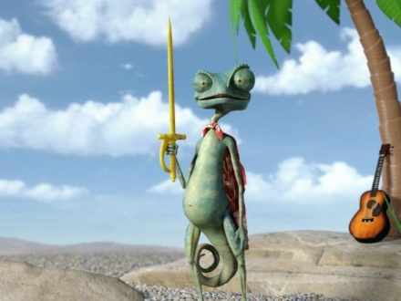

Johnny Depp voices the chameleon Rango. The film is a western in which the title character, Rango, gets stranded in the desert and comes into contact with some interesting animals.

While Rango might not be as popular a character as other animated animals such as Mickey Mouse or Dory from *Finding Nemo*, Rango certainly holds his own in the world of animated, anthropomorphic animals.

Rango is such a quirky character with a unique story that the film even won best animated feature in 2011. And we’re all for any movie starring a chameleon – animated or not!

**Godzilla**

Okay, we’ll admit Godzilla might better be classified as a monster instead of a reptile, but we think he bears enough resemblance to our herp friends that he qualifies for this list.

Godzilla originated in a Japanese film of the same name in the year 1954 and has since become a cultural icon. He has made appearances in many movies (American and Japanese), comics, and even TV shows.



This is the modern iteration of Godzilla from the American 2014 film. We think he’s much more menacing here than when he’s portrayed by an actor in a costume.

When Godzilla was first conceived, he was mainly meant to serve as a metaphor and commentary on the threat of nuclear weapons. However, with time, the reptilian monster took on many more nuanced aspects including playing an antihero, a purely destructive villain, and even a defender of humanity.

Godzilla has evolved over time from being played by a man in a suit to his latest American incarnation where he is an elaborate computer simulated masterpiece. No matter how technologically advanced Godzilla might become, he’s still one very famous reptile and we are excited to see the next movie he stars in.

**Tick Tock, the Crocodile**

There are many iterations of the classic story of Peter Pan in the film and TV world. And many of the stories have some version of a crocodile that ate Captain Hook’s hand leaving him with his famous hook.

For the purposes of this article, we’re going to discuss the 1953 Disney animated version of Peter Pan and the crocodile Tick Tock.



Here we see Tick Tock the Croc eagerly awaiting a chance to take another bite out of Captain Hook.

At some point, Tick Tock the croc managed to eat an alarm clock. This has left him with a permanent “tick” and a delightfully catchy tune that accompanies him whenever he appears on screen.

Tick Tock might not get much screen time in the movie, but when he does appear, he definitely steals the scene!

**Wally Gator**

Wally Gator is an old school Hanna-Barbera cartoon that first appeared on TV in the 1960s. Wally lives in the city zoo and is watched over by the zookeeper Mr. Twiddle who has to make sure Wally doesn’t get into too much trouble when he leaves the zoo.



Wally Gator is a famous Hanna-Barbera cartoon that aired in the 1960s.

Nowadays, Wally isn’t really seen too much on TV, mainly due to issues with remastering the series. Fans of this anthropomorphic Cajun alligator still hope that a complete DVD set of the series featuring all fifty-two episodes will be released at a future date.

**Mr. Toad**

The character of Mr. Toad originates in literature. He is one of the main characters in the book *The Wind in the Willows*by Kenneth Grahame and he is also the title character in the A.A. Milne play *Toad of Toad Hall*which is based upon the book.

Although he is a famous literary character, Mr. Toad has also made his way into many hearts by being animated into a Disney film entitled *The Adventures of Ichabod and Mr. Toad.*The film depicts Mr. Toad as an egocentric chaser of fads who is accused of car theft and ultimately winds up being acquitted. If you’ve ever been to Disneyland, there is an entire ride in Fantasyland based around the crazy antics that Mr. Toad gets himself into. This is Disney’s version of Mr. Toad.



Ultimately, Mr. Toad is portrayed as a lovable but selfish rogue. He gets himself into trouble, but not *too much*trouble. The people who live with him put up with him and have come to accept his behavior as normal although he is constantly obsessed with something or other.

**Kaa the Snake**

Kaa is another famous fictional reptile born out of literature. He makes his debut in Rudyard Kipling’s *The Jungle Book*, a tale many of us have come to know through countless adaptations on the big screen.

Probably the most famous incarnation of Kipling’s Kaa is in the 1967 Disney animated feature film *The Jungle Book.*Not only is this movie filled with memorable songs, but Kaa is portrayed as less of a menacing character and more of a bumbling failure. Each time he tries to eat Mowgli, he is unsuccessful and flounders comically when his attempts are thwarted by Bagheera the panther.



In Disney’s version, Kaa the snake is not as menacing as he is in Kipling’s depiction. The Disney animated version of Kaa even gets his very own song in the movie titled, “Trust in Me.”

Kaa’s lisping voice coupled with his hypnotic powers make him quite a memorable reptile, even if he is only a cartoon.

**The Teenage Mutant Ninja Turtles**

The popular eighties cartoon featuring the four teenage mutant ninja turtles – Michelangelo, Donatello, Leonardo, and Raphael – has since been adapted to big budget feature films directed by established action-flick director Michael Bay.

The older generation will fondly remember the popular Ninja Turtles animated cartoon TV series that aired in the 1980s until 1996 and lasted a full ten seasons! This was a light-hearted cartoon where the turtles ate pizza and fought crime. The cartoon was accompanied by a series of toys that became extremely popular. While the cartoon was on the air, the Ninja Turtles could be seen on everything from lunch boxes to T-shirts.

Aside from being television stars, the four Ninja Turtles have also starred in several movies. In the early nineties, they starred in three live-action films with partially animatronic likenesses portraying the iconic turtles. Jim Henson’s Creature Shop developed animatronic heads that were placed atop real actors and the result, while considered somewhat “cheesy” by today’s special effects standards, was quite cutting edge at the time.

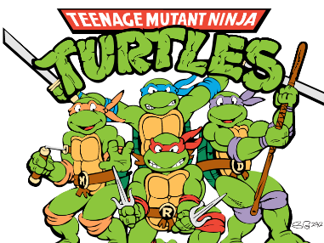

The Ninja Turtles got a reboot in 2014. There appearance was modified for the three Michael Bay movies. Since the three films in the nineties, director Michael Bay has resurrected the legacy of the Ninja Turtles within the last few years, giving Michelangelo, Donatello, Leonardo, and Raphael new life thanks to the magic of computer special effects and digital animation. The Ninja Turtles have become super heroes and action heroes.

Not only do the Ninja Turtles have quite a presence in TV and movies, they even starred in a series of video games. The Ninja Turtles were first seen in game form on the NES system and have since been found in arcade systems as well as more modern consoles like the Playstation and XBOX systems.

**Yoshi**

We’re pretty sure Yoshi isn’t a typical reptile. In fact, to be fair, he’s essentially a dinosaur, but we’re still including him on this list because he very closely resembles some of our lizard friends and we think he deserves recognition.

Yoshi is a creation of Nintendo. He’s a cute little green dinosaur who originally started out as Mario and Luigi’s side kick. He has since grown into a character with his own game series and personality to match.



One of Yoshi’s talents within the video game world is grabbing enemies with his long tongue.

Yoshi is known in the gaming world for his ability to eat virtually any enemy and produce a spotted egg which can then be used as a weapon. Like a chameleon, he has a sticky tongue that extends very far out of his mouth and allows him to grab food and enemies from very far away. He is also capable of behaving like a horse and Mario and Luigi can ride on his back if both characters are appearing in the same game.

Aside from appearing in the various *Super Mario Brothers*games, Yoshi has starred in his own Nintendo games such as “Yoshi’s Story” and “Yoshi’s Island.” He is also always a playable character in the *Super Smash Brothers*games as well as the *Mario Kart*series, both of which are games that feature a collection of Nintendo characters pitted against one another.

**Conclusion**

Even though all the fictional reptiles on this list might not technically be considered true reptiles and/or amphibians, we think it’s great that herps have gotten recognition throughout the years and carved out such notable niches for themselves in pop culture.

So, whether your favorite herp appears on TV, in movies, in a video game, or even in a classic work of literature, be sure to note what a feat it is that they became so recognizable in the first place. The more reptiles and amphibians we see daily, whether fictional or real, the happier we are!

So, what did you think of our list of the top ten most famous reptiles and amphibians in pop culture? Was your favorite included? Any noteworthy or honorable mentions you think we should have included? Let us know, please.

## Things to talk about while you camp

*Catalina Council*

* An earthworm doesn’t breathe through a mouth or nose like you; he breathes through his skin.
* A deer gets a new set of antlers every year. During the winter his old set begins to get itchy, and he rubs them against trees until they come off. If you see him early in the spring, he won’t have any antlers at all!
* Birds have a calendar too. Birds have a special way to telling how long the days are. When the days get shorter in the fall, they know it is time to go south. And when the days get longer in the spring, it is time to come back. It took scientists a long time to learn this secret, and they still do not know everything about it.
* Although some dinosaurs were large, the blue whale is bigger and heavier than all of them were.
* A hummingbird’s wings buzz because he beats them more than five thousand times each minute. If you flap your arms that fast, you would buzz too!
* A beaver sharpens his own teeth. The outside of each tooth s softer than the center of it, so the softer part wears off first, leaving the harder part always sharp.
* A fish can’t see as far as you can. But he can point his eyes in two directions at once!
* If a bird doesn’t have any teeth, how can he chew? He swallows his food whole, and his gizzard grinds it.
* A catfish has fingers. Well, not really, but he uses his whiskers to touch and feel the bottom of a murky lake just as we use our hands.
* A bird stays on a perch when asleep because of an automatic locking mechanism in his feet.
* The eggs of hummingbirds are about the size of peas. Those of the ostrich are about seven inches long.
* A porcupine has about 30,000 quills in his arsenal, and, if he loses any, they will grow back in a few months.
* A litter of baby armadillos is born usually four at a time and will be all brothers or all sisters, never both in the same litter.
* The opossum is the only marsupial in North America. Marsupials have pouches in which to carry their young. New-born opossums are smaller than bees - a whole litter would fit into a teaspoon.

## Fun Facts About Reptiles

*Alice, Golden Empire Council &*<http://www.sciencekids.co.nz> *&*[www.weirdfacts.co](http://www.weirdfacts.co)

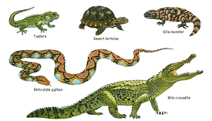

* Nearly all reptiles lay shelled eggs.
* Reptiles breathe air.
* Reptiles are covered in scales or have a bony external plate such as a shell.
* The first reptiles are believed to have evolved around 320 million years ago.
* The size of reptile’s brains relative to their body is much smaller than that of mammals. The brain of a reptile is not more than 1% of its body mass. This means that the brain of a 70-pound python is no larger than a lima bean.
* Reptiles use a variety of methods to defend themselves from dangerous situations, such as avoidance, camouflage, hissing and biting.
* Crocodiles and alligators are reptiles.  
  Turtles and tortoises are reptiles.  
  Lizards and snakes are reptiles.  
  Lizard and snake species make up the largest number of different reptiles.
* Tuataras found in New Zealand are reptiles.
* Reptiles can be found on all continents except for Antarctica.
* The science of reptiles is called herpetology. The most common reptiles include alligators, crocodiles, lizards, snakes, tortoises and turtles.
* Reptiles are among the longest-lived species on the planet. For example, large tortoises such as the Aldabra tortoise can live for more than 150 years. Alligators can live nearly 70 years. Ball pythons, a popular type of pet snake, can live up to 40 years
* ***It is a fact that more Americans die each year from bee stings than from snake bites.***
* The skulls of snakes are made up of many small bones that are interconnected in a flexible fashion. This is entirely different from a human skull, which is one solid piece. Most snake species can dislocate their jaw, allowing them to swallow prey much larger than themselves.. A common garter snake, for example, could swallow a frog more than twice the size of its head.
* Reptiles, like birds, have voluntary control over the muscles in their eyes, which determine their pupil size. This means that they can constrict or dilate their pupils at will, not just in response to light. It is believed that when a snake grows old, it sheds its skin. On the contrary, it is the younger ones who shed their skin since they grow faster.
* The world’s fastest reptile (measured on land) is the spiny-tailed iguana of Costa Rica. It has been clocked at 21.7 mph!
* Reptiles do not have sweat or sebaceous glands; therefore, they are not slimy. So their skin is usually cool and dry. They are waterproof, and this, in addition to lacking a metamorphic stage is one of the distinctions between amphibians and reptiles (tadpoles metamorphose, or change, into frogs). Snakes have scales made up of keratin, which is the same material that constitutes our fingernails and hair. It makes their skin dry, cold and non-slimy.
* The heaviest snake on record is an Anaconda (Eunectes murinus) that was shot in Brazil in 1960. She was never officially weighed but scientist estimate that her 27 feet 9 inch length and her 44 inch girth must have put her over 500lbs!
* The king cobra is the longest venomous snake in the world. The longest specimen ever was kept at the London Zoo and measured 18 feet and 9 inches. Zookeepers killed it in 1939 due to the outbreak of war. They feared it would escape the zoo and pose a threat to the citizens of London.
* Most of the world's snakes (nearly two-thirds) are non-venomous. Only about 500 snake species are venomous, out of which only 30 to 40 harm humans. In other words, less than 2 percent of all snakes are considered harmful to humans. The opposite is true in Australia. There are more venomous snakes in Australia than non-venomous snakes. Australia is the only continent where venomous snakes outnumber non-venomous snakes.
* Some types of snakes can go months without eating. This is especially true of the big constrictors, such as the Anaconda and the reticulated python. Snakes eat large meals (relative to their body size), and they have much slower metabolisms and it takes time to digest it.
* Snakes and lizards flick their tongues in the air to capture scent particles. They don't smell through noses, instead the use their tongues to collect scent particles and then pass the particles over something called a Jacobson's organ to decipher the air around them. This is partly how reptiles hunt for food.
* The world’s largest lizard is the adult male Komodo Dragon found on the islands of Indonesia. The largest ever recorded was 10 feet 2 inches long and weighed 365 pounds! These lizards can eat animals as large as goats. They cannot chew so they must rip chunks of flesh off their prey and swallow it whole.
* The largest reptile is the Saltwater Crocodile, which grows up to 7 meters (23 feet) in length.
* The smallest lizard in the world is the rare, tiny gecko of the Virgin Islands. Only 15 specimens have ever been found. They measure 0.70 inches from snout to vent (nose to butt).
* Certain Chinese and American alligators can survive the winter by freezing their heads in ice, leaving their nose out to breath for months on end.
* The tuatara lizard's metabolism is so slow they only breathe once an hour.
* An iguana can stay under water for 28 minutes.
* A crocodile has an ability to grow new teeth to replace the old teeth.
* The basilisk lizard can run across water without sinking earning the nickname of Jesus Christ lizard
* Most reptiles are carnivorous and eat insects, other reptiles and small animals.
* A reptile will eat 30 - 50 times less food than do birds and mammals (warm-blooded animals) of a similar size.
* Although reptiles cannot bear very cold climate, the Blanding’s turtle (Emydoidea Blandingii) can swim in ice lakes.

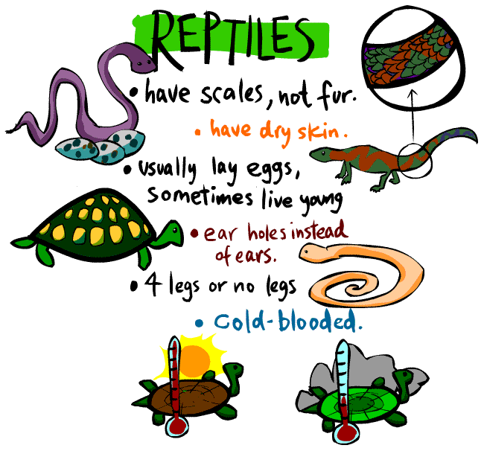

# TRAINING TOPICS

## Will your pack attend Camp this summer?

***Bill Smith****, the Roundtable Guy*

There are varieties of Cub Scouting Camps: camps for Cubs and camps for Webelos, day camps and resident camps. Some are in a local park and others are at a Scout camp some distance away. Some leaders and their families may even be camping at Philmont Training Center! Facilities, like shelters, lodges, storage huts and waterfront, differ greatly from camp to camp. No matter what your camp is like, the camps and the staff that run them must conform to BSA standards. I fervently hope that you and the boys in your pack will be attending one of them.

I’m sure that your council has provided you a list of what to expect and especially what to bring with you to camp.

It’s important to have the right number of adult help with you and wear suitable clothing and be equipped with enough rain gear, sun block, med forms, and drinking water.

**What will you bring back from camp?**

Besides almost finished craft projects, dirty clothes, and a few insect bites, I hope that you return home with a bunch of special memories and great plans for what your pack or den will do next year.

Think of your time at camp as a relaxed leader training experience. A lot goes on there that can help and inspire you in the years to come. If you are observant and know what to look for you can learn a lot that will help your den, your pack and your boys. The staff that runs your camp are experienced well trained Scouters and can serve as valuable role models for you and the other leaders.

**Let’s start with Memories.**

As a help, you might take along a note book and a camera. Make notes, keep a journal, and have boys give their input and observations. Take lots of photos. They could make a great display that will help at fall recruiting.

You should get many opportunities to stand back and observe rather than be the instigator and leader. What did the boys enjoy? Did they participate and have fun? Did they cooperate and do their best or merely go through the motions? Would the good activities you see at camp work at your meetings?

What did the boys learn? What made a particular activity a good learning experience? You will probably notice that your boys respond differently to each activity and you may learn some new things about them.

**New Activities.**

The boys will engage in some new activities that will probably become favorites of theirs for a while. Make notes about them so you can always pop the good ones into your program when things get dull. (I know, you never have dull programs.)

Games are always popular activities and boys enjoy playing their favorites again and again. Keep those in mind – and in your notes - for later. When things get routine next winter, it may be fun to bring out a game they played at camp. Make sure you have the all rules before you leave and note any equipment you may have to add to your game chest.

**The training provided by at National Camping Schools to the Camp Leaders was revised this year to include sessions on using the new Cub Adventure Program. When your Cubs go to camp, they will be getting a jump start on the new Adventure program for Advancement!!**

Camps usually have regular assemblies for openings, closings or camp fires. These can be a treasure of songs, skits and stunts that may become part of your group’s repertoire. If you have trouble leading songs at your pack meetings, try using one of the fun songs the boys know and loved to sing at camp. Learn the tune and get a copy of the words. It might be a good idea to take a portable recorder along so you can bring back a copy. Ask the person who leads the good ones for help.

**Watch the camp staff.**

How do they manage discipline and control? Try to detect how they use each of these control methods:

* Getting and holding the boys’ attention,
* Explaining the rules,
* Well-planned activities,
* Giving individual attention.

You will see a variety of methods. Which ones worked and which ones could you use?

Many camps employ youth leaders: Boy Scouts or Venturers to lead activities. If you camp does, watch how the Cub Scouts respond to them. Would Den Chiefs work out OK in your program? Sometimes the timing is difficult for a Den Chief to make den meetings, but how about for pack camp outs and other special activities?

**How does the camp run?**

Camp is a good source of ideas for your pack’s camping program. You should get some insight into topics like:

* **Food and food storage** – How do they manage it? Will their methods work for your pack?
* **Safety and medical** – Check with the camp nurse or medical staff for how they prepare and get set up.
* **Sanitation** – How are toilets, hand washing and showers set up and organized?
* **Campfire activities** – Most camp staffs are good at this. Pick their brains for ideas.
* **Emergency Preparedness** – how is the staff prepared for dangerous weather, medical assistance, etc? What are their communication methods?

**Your gang of adults.**

You will spend considerable time in the company of the adults from your pack. Get to know them, their attitudes, knowledge and skills. You should learn a lot about their appreciation of Scouting and how it helps boys grow.

Look for potential leaders, committee members and special helpers amongst this group. You will rarely get a better chance to get to know some of these people and discover how they might help their sons and their sons’ Cub Pack.

**Make it work for Your Pack.**

Camp is great for boys and mostly they love it but the important value is: how can it help your pack and you as a leader? You are paying your money and your time to attend, so make it worthwhile. Get the best for your pack.

**What are YOU going to do now?**

***The best gift for a Cub Scout.......  
 ......get his parents involved!***

***The greatest gift you can give your child   
 ..... good self esteem!***

## Some Tips Before Leaving for Camp

*(Alice – Golden Empire)*

**After seeing boys, parents and leaders who returned frustrated from Camp, I wanted to share some tips for getting a good start on that Camp experience – especially for new scouts and parents:**

1. Remember that pack families may have different levels of EXPERIENCE with camping – make sure “first-timers” have necessary equipment, resources.
2. Share photos and information about the camp – if others have been there, ask them to share some tips.
3. At least a month before, introduce information that will help everyone prepare – for example, give everyone a list of required and suggested equipment and items to bring. Even better, have a display for people to check out.
4. Have a “trial” event – maybe an overnighter in a nearby park so everyone can check out those tents, stoves, and other equipment.
5. Encourage dens and families to take short hikes to get in shape. Teach hiking skills, such as the “resting” step – on an uphill, put your next foot down, but don’t put your full weight on it immediately – just that short hesitation will help you persevere!
6. Team camping experienced families with “first-timers” – a little mentoring can really help!
7. Teach skills that can be life-saving: Make a game of learning the Hug A Tree program skills. For example, have a team relay to make shoe prints, turn a garbage bag into a shelter, practicing how to Look Big and blow a whistle if you are lost. Go to: [**http://www.nasar.org/nasar/hug_a_tree_program.php**](http://www.nasar.org/nasar/hug_a_tree_program.php) or [**http://www.theozarks.com/HugATree.htm**](http://www.theozarks.com/HugATree.htm) for information about the Program.
8. Have a Workshop to do some outdoor and Dutch Oven cooking. Kids could also make Trail Mix and learn why we include the various kinds of food.
9. Make sure everyone has the essentials: a good water container, sunscreen, hats, extra socks, WHISTLE, layers of clothes, some easy to carry food.
10. At least two weeks before the Camp, make sure everyone has a good pair of shoes – NOT NEW, but ones they have “broken in.” This is a classic ‘first time” mistake, and it can make for a miserable hike or camp experience.
11. Make sure your adults all have Youth Protection training, as well as having other required training representatives such as Hazardous Weather and BALOO, if needed.
12. COMMUNICATE – Make certain everyone knows about the programs available and if they need to pre-register, or bring special equipment. Make sure everyone knows when and where to meet.
13. Have an Emergency Contact who is not going on the trip, in case a phone tree change of plans is needed.
14. Prepare for FUN – bring along guitars, telescopes, magnifying glasses, nature guides, song books, binoculars, campfire stories and treats.
15. Consider having everyone bring their gear the night before leaving for camp – just as many Scoutmasters do. That way, everyone can check their items against the list and make sure they’re ready.
16. Assign someone to bring a camera and record the FUN for everyone to look back on fondly!
17. Do an Evaluation – things you want to do again, do a different way, or eliminate – Believe me, you will NOT remember everything you want to by next year!

# **SPECIAL OPPORTUNITIES**

With the start of the Cub Scout Adventure Program, in June 2015 the requirements for awards that say things like, "Complete Wolf Achievement 7," needed to be revised to send you to the new Adventures. I will periodically give you an update on an award’s changes

To get a complete list now, you can go to http://www.scouting.org/scoutsource/programupdates.aspx and download the .PDF of all the changes. Or you could go to [www.usscouts.org](http://www.usscouts.org) and get the changes for a specific award.

## Cub Scout Outdoor Activity Award

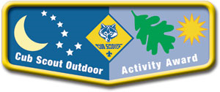

*from* [*www.scouting.org/programupdates*](http://www.scouting.org/programupdates)[*http://usscouts.org/advancementTOC.asp*](http://usscouts.org/advancementTOC.asp)

Tiger Cubs, Wolf and Bear Cub Scouts, and Webelos Scouts have the opportunity to earn the Cub Scout Outdoor Activity Award. Boys may earn the award in each of the program years as long as the requirements are completed each year. The first time the award is earned, the boy will receive the pocket flap award, which is to be worn on the right pocket flap of the uniform shirt. Each successive time the award is earned, a wolf track pin may be added to the flap. Leaders should encourage boys to build on skills and experiences from previous years when working on the award for a successive year.

**Cub Scout Outdoor Activity Award**

What it is: Cub Scouts can earn the Cub Scout Outdoor Activity Award in each of the program years as long as the requirements are completed each year. The first time the award is earned, the boy will receive the pocket flap award, which is to be worn on the right pocket flap of the uniform shirt. Each successive time the award is earned, a Wolf Track pin may be added to the flap. Leaders should encourage boys to build on skills and experiences from previous years when working on the award for a successive year.

**Requirements**

**All Ranks**

Attend Cub Scout day camp or Cub Scout/Webelos Scout resident camp. Additionally, complete the rank-specific requirements as follows:

**Tiger Scouts**

Complete the Backyard Jungle adventure, and complete four of the outdoor activities listed below.

**Wolf Scouts**

Complete the Paws on the Path adventure, and complete five of the outdoor activities listed below.

**Bear Scouts**

Complete the “Bear Necessities” adventure, and complete six of the outdoor activities listed below.

**Webelos Scouts**

Complete the Webelos Walkabout adventure, and complete seven of the outdoor activities listed below.

**Outdoor Activities**

These activities must be in addition to any similar activities counted toward rank advancement and can be accomplished as a family, a den, or a pack.

* Participate in a nature hike in your local area. This can be on an organized, marked trail, or just a hike to observe nature in your area.
* Participate in an outdoor activity such as a picnic or a fun day in a park.
* Eplain the buddy system, and tell what to do if lost. Explain the importance of cooperation.
* Attend a pack overnighter. Be responsible by being prepared for the event.
* Complete an outdoor service project in your community.
* Complete a nature/conservation project in your area. This project should involve improving, beautifying, or supporting natural habitats. Discuss how this project helped you to respect nature.
* Participate in your pack’s earning the Summertime Pack Award.
* Participate in a nature observation activity. Describe or illustrate and display your observations at a den or pack meeting.
* Participate in an outdoor aquatics activity. This can be an organized swim meet or just a den, pack, or family swim.
* Participate in an outdoor campfire program. Perform in a skit, sing a song, or take part in a ceremony.
* Participate in an outdoor sporting event.
* Participate in an outdoor Scouts Own or other worship service.
* Explore a local city, county, state, or national park. Discuss with your den how a good citizen obeys park rules.
* Invent an outside game, and play it outside with friends for 30 minutes.

# CUB GRUB

**Cub Grub Cookbook**

This is a really great cookbook for Cubs -

<http://balboaoaks.bsa-la.org/download/blog/Cub%20Grub%20Cookbook.pdf>

You can save a copy on your PC by selecting   
**File, Save As...** in your web browser's menu bar.

**What else for Roaming Reptiles?**

**TURTLES**

*Baloo’s Files*

**Pretzel Turtles**



**Ingredients**

* 24 pecan halves
* 24 mini pretzel twists
* 24 individually wrapped soft caramel squares, unwrapped
* 8 ounces good­quality milk chocolate, melted,

**Directions:**

* Preheat the oven to 325 degrees F.
* Put the pecan halves on a baking sheet in a single layer and bake, shaking the sheet once halfway through, until lightly toasted, 5-6 minutes.
* Transfer the nuts to a plate to cool.
* Line the baking sheet with parchment paper or a silicone baking mat. Arrange the pretzels neatly on the baking sheet, then top each pretzel with an unwrapped caramel. Bake until the caramels soften (but are definitely not melting), 4 to 5 minutes.
* Remove the baking sheet from the oven and gently press a pecan half onto each caramel, just enough for the caramel to fill the pretzel.
* Set aside to cool completely.
* Remove the cooled pretzel/caramels from the baking sheet. Spoon 24 small dollops (1 1/2­teaspoon helpings) of the melted chocolate all over the baking sheet, then lightly drop a pretzel onto the middle of each dollop, making sure the pretzel is centered.
* Allow them to cool completely before serving (you can hasten this along in the fridge).
* Cook on ungreased cooking sheet, cheese side up for 10-15 minutes or until brown.

**Chocolate Caramel Pecan Turtles**

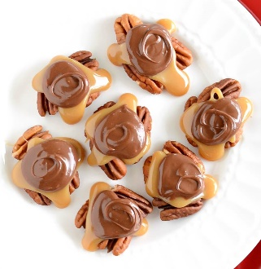

**Ingredients**

* 3 cups whole pecans
* 1/2 cup butter
* 1 cup brown sugar
* 1/2 cup corn syrup
* Dash of salt
* 1/2 cup + 2 Tbsp sweetened condensed milk (half of a 14oz can)
* 1/2 tsp vanilla
* 1 1/2 cups chocolate chips (I used milk chocolate chips)
* 1/2 tsp vegetable oil or shortening

**Directions:**

* Place pecans in a single layer on a baking sheet. Bake at 350° for about 10 minutes or till lightly browned and fragrant. Let cool. Arrange in clusters of 3-4 on silicone liners or parchment paper.
* Combine butter, brown sugar, corn syrup, and salt in a 6-quart pot. Bring to a boil over medium heat. Add the sweetened condensed milk.
* Continue cooking and stirring till mixture reaches 235-240 degrees. I like to use the ice water test, it's more accurate. Drop a small spoonful of the hot caramel into a bowl of ice water. When you take it out, you should be able to roll it into a ball. Then it's done.
* Quickly spoon the caramel over the pecan clusters, making sure caramel is touching each of the pecans. Let sit to harden.
* Melt the chocolate chips and oil in the microwave at half power, stirring often till smooth. Spoon chocolate on top of each layer of caramel. Let sit for 1-2 hours, or till hardened.

**Turtle Candy**

**Ingredients**

* 12 ounces of unwrapped soft caramels, homemade or store-bought
* 6 oz (about 1.5 cups) toasted pecan halves
* 8 ounces semi-sweet or milk chocolate chips

**Directions:**

* Prepare a cookie sheet by covering it with aluminum foil or parchment, and spraying the foil or parchment with nonstick cooking spray.
* Arrange the pecans in clusters of 4 with each pecan pointing in a different direction (like turtle legs). Alternately, you can just drop them in small clusters on the baking sheet.
* Unwrap the caramels and place them in a microwave-safe bowl. If they are very stiff, add a spoonful of water so the final product will be softer.
* Microwave them until melted, stirring after every 30 seconds.
* Allow the caramel to cool slightly, so it's not piping-hot, then use a spoon or a small candy scoop to drop a spoonful of caramel each pecan cluster. They are meant to be a rustic candy, so don't worry about keeping the turtles round or about having some of the pecans poking through.
* Melt chocolate chips in the microwave or over a double boiler. Spoon the melted chocolate over the caramel layer, letting some drip down the sides, and nudging it around so it covers the top of the caramel completely.
* Place the baking sheet of candies in the refrigerator to fully set the chocolate and caramel, for at least 30 minutes. For the best taste and texture, serve the turtles at room temperature. Extras can be stored in an airtight container in the refrigerator or at cool room temperature for up to two weeks. Toast bread in toaster.



**WANT MORE RECIPES??**

**Go to Pinterest Link below**

<https://www.pinterest.com/explore/turtle-recipe/?lp=true>

**COPYCAT TEXAS ROADHOUSE RATTLESNAKE BITES**

*Baltimore Area Council*

**

**Ingredients**

* 2 (8 oz) blocks Pepper Jack cheese, shredded
* 2-3 jalapenos, diced (depending on how hot you like them)
* 1/2 cup flour
* 1 egg
* 1 cup milk
* 1 1/2 cup bread crumbs
* 1 tsp cayenne pepper
* 1 tsp paprika
* 1 tsp garlic powder
* Oil for frying

**Directions:**

* In bowl combine your shredded cheese and jalapenos.
* Shape cheese mixture into about 1 1/2" balls, squeezing tightly to compress.
* Place on cookie sheet and freeze for about 30 minutes.
* Meanwhile preheat your deep fryer to 350.
* Once chilled, in bowl add your flour.
* In another bowl mix together your egg and milk.
* Lastly in bowl stir together your bread crumbs and seasonings.
* Start by rolling your balls into the flour mixture, then dipping into milk and lastly coating with bread crumbs.
* Fry in batches for about 3-4 minutes or until golden brown.
* Drain on paper towel.
* Serve with your favorite dipping sauces.

**Sherbet the Frog**

*Alice, Golden Empire Council*

**Ingredients:**

* Lime Sherbet
* 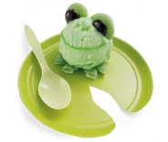Green decorating gel (or a strip of green fruit leather or even lime peel)
* Junior mints
* Green Gummy Ring Candy
* Small green plate

**Instructions:**

1. Set a scoop of sherbet (or any green ice cream) on a small green paper plate trimmed to resemble a lily pad.
2. Cut one green gummy ring candy into quarters and place under the sherbet to make frog feet.
3. Set a Junior Mint and half a gummy ring in place for each eye at the top and back of the sherbet scoop.
4. Finally, add a mouth and nostrils with decorator gel or one of the options.
5. This would be a great treat after spending time looking for frogs and pond creatures!

**ROLL AROUND ICE CREAM**

*Utah National Parks*

**Ingredients:**

* 1 cup milk
* 1 cup heavy cream
* 1/3 cup sugar
* 1 tsp. vanilla
* 1 clean empty 1 lb. coffee can with lid
* 1 clean empty 3 lb. coffee can with lid
* Ice cubes
* Rock or table salt

**Directions:**

* Mix the milk, cream, sugar and vanilla.
* Pour into the 1 lb. coffee can and put the lid on.
* Seal with duct tape.
* Place the small can inside the 3 lb. can
* Fill the large can with ice and salt.
* Duct tape the lid.
* Wrap a towel around the can because it will get very cold.
* Give the can to two Scouts and have them roll it back and forth on the floor for at least 20 minutes.
* If the ice melts, unseal the large can and add ice and salt.
* After 20 minutes have passed unseal the small can.
* Inside will be delicious vanilla ice cream!

**Animal Crackers**

*San Gabriel Valley Council*

Yields 2 dozen cookies

**Ingredients:**

* 1/2 cup rolled oats
* 1/4 cup all-purpose flour
* 1/4 teaspoon baking soda
* 1/4 teaspoon salt
* 1/4 cup butter
* 2 teaspoons honey
* 1/4 buttermilk

**Directions:** Preheat the oven to 400 degrees F (200 degrees C). Grind oats until fine using a blender of food processor. In medium bowl, stir together the blended oats, flour, baking soda and salt. Cut in the butter using a pastry blender or your fingers until the butter lumps are smaller than peas. Stir in the buttermilk and honey to form a stiff dough, On a lightly floured surface, roll the dough out to 1/8 inch I thickness. Cut into desired shapes with cookie cutters. Place cookies 1 inch apart onto cookie sheets. Bake for 5 to 7 minutes in the preheated oven until edges are lightly browned. Remove from cookie sheets to cool on wire racks.

**Cub Cakes**

*Great Salt Lake Council*

**You will need**

* Chocolate cake mix
* Cup cake liners
* Muffin tin
* Frosting
* Small mint patties
* Junior mints

**Directions:** Mix and cook cup cakes following directions on the cake mix. Allow cooling down, then frost with store bought frosting or use the frosting recipe we used for the birds nest cupcakes. Once they are done frosting them have the boys place one small mint patty and three small chocolate mints to make the paw prints.

**Chocolate Covered Animal Crackers**

*Great Salt Lake Council*

You will need Animal crackers Chocolate and White dipping chocolate Sprinkles Colored sugar Chopped nuts Crock-pot Parchment paper Cookie sheet Put the parchment paper on the cookie sheet and set aside. Melt the dipping chocolate in the crock-pot on low heat. Once melted put in about 6 to 8 animal crackers at a time. Use a wooden spoon to remove them and place them in your desired topping. Turn the cracker until evenly coated and then place on the cookie sheet and allow cooling down.

**Dump Cake**

*Baltimore Area Council*

**Ingredients**

* l/2 cup brown sugar
* 1 egg
* 1 can cherries
* 1 cake mix
* 1 stick margarine

**Directions:**

* Spray pan with non stick cooking aerosol.
* Spread brown sugar evenly on bottom of pan.
* Cut margarine into thin pats, distribute evenly in pan.
* Add cherries in juice.
* Mix beaten egg with cake mix and spread over cherries.
* Bake at 400 degrees for 25 minutes or until brown.

**BBQ Wieners**

*Baltimore Area Council*

**Ingredients**

* 1 package of wieners

**Directions:**

* Cut wieners into bite size pieces.
* Place in pan on the stove and let brown, but not dark.
* Add 1½ cups of your favorite BBQ Sauce.
* Let simmer for 15 minutes.

***(We used to do this in camp with a #10 can on a fire CD)***

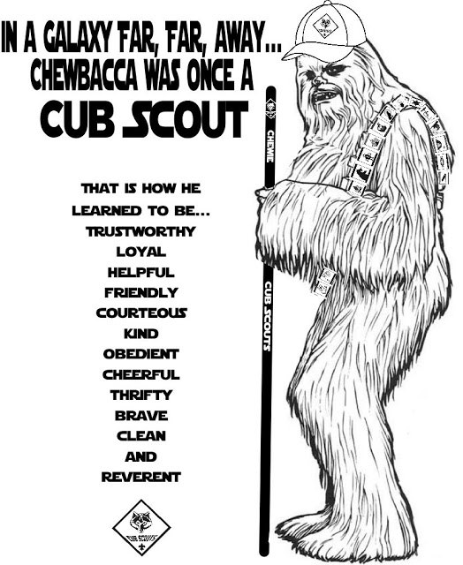

# ONE LAST THING

## Murphy Was A Scouter

*Baltimore Area Council*

Everyone knows Murphy’s Law. Well, it is a little-known fact the Murphy was actually a Scout Leader. In my continuing quest to learn more about Scouting, I have begun to locate a number of his quotations, which I now offer to share with everyone. Murphy traveled throughout Canada, the USA, England and Australia, so some of the terms listed here may have a regional flavor.

* Scout Leaders who fail to show up at Leader’s planning meetings are automatically volunteered for the next least favored instruction or activity.
* The last Scouter who quit will be held responsible for everything that goes wrong - at least until the next Scouter quits.
* No matter how long or hard you shop for a piece of camping gear, immediately after you’ve bought it, it will be on sale somewhere cheaper.
* Under the most rigorously controlled conditions of time, planning, material acquisition, skill testing and training, Cub Scouts will invariably do as they dang well please.
* The time spent on consuming a camp meal is in inverse proportion to the time spent preparing it.
* Any tent peg, when dropped, will fall immediately where the tent will be placed and directly underneath where you will place your sleeping bag.
* Interchangeable parts - aren’t.
* The chance of a piece of bread falling with the buttered side down, is directly proportional to the amount of mud in which you are standing.
* Leakproof seals - will.
* Never eat prunes when you’re famished.
* Matches are always at the bottom of the rucksack (backpack) when you need them.
* Matchboxes always open upside down, spilling the contents.
* The size of the fire is inversely proportional to the need, (for example - a glimmer for cooking and a roaring inferno for the campfire singing).
* The Map you bring is the wrong one, someone has just used the correct one to light the fire.
* The number of tent pegs is always equal to the number of guy-ropes, less one.
* There is always a rock buried where you want to drive in the tent peg.
* The strength of the wind (and rain) is inversely proportional to the number of people putting up the tent.
* Meals are always eaten before the Leader has time to eat.
* The Leaders sausages (hot-dogs) are always the ones that fall into the fire.
* Lights out, for Scouts, is defined as the time to start having fun.
* The weight of rucksacks increases with the distance traveled.
* Contents of a rucksack always increase in size when you try to repack them.
* Contents of the rucksack reverse position after packing, in proportion to their urgency of need (most needed items at the bottom).
* The carrier of the First Aid kit is always the furthest person away from the emergency.
* The size of a cut is always greater than the biggest Band-Aid available.

## Top 10 Reasons to be a Cub Scout Leader

*Baltimore Area Council*

#10 To help your community and to wear fancy duds.

#9 To witness stupid comic skits for free.

#8 To do stupid comic skits for free

#7 To conduct a one-hour meeting that took three anguish-filled hours to prepare for Cub Scouts who only want to know, “What’s the snack?”

#6 To sew hundreds of little patches on a uniform only to have your son outgrow it.

#5 To go out and enjoy nature with a bunch of nine-year-olds instead of watching the University of (Your home State) play football.

#4 To provide the perfect excuse to your friends so you don ‘t have to golf, go to dinner, or play tennis with them.

#3 To get rid of ail those worthless pieces of string, yam, fabric, wire, and plastic milk bottles.

#2 To collect and store forever priceless crafts made from useless pieces of string, yam, wire, and plastic milk bottles.

and the number one reason why someone   
would be an adult Scout volunteer. . . .

#1 To clear your wallet or purse of those filthy, germ-laden $10 or $20 bills!