TABLE OF CONTENTS
TABLE OF CONTENTS 1
PACK ADMIN HELPS 2
WHAT DO CEREMONIES DO?? 2
ROUNDTABLE HINTS 5
ROADBLOCKS AND PLAN B 5
GO AHEAD – ASK!! 5
2016 – 2017 CS RT PLANNING GUIDE IS ISSUED!!! Error! Bookmark not defined.
CUB SCOUT RT SCHEDULE OF SESSIONS 6
LIONS 9
LION GUIDE AND PARENT ORIENTATION VIDEO 9
ORGANIZING FOR LIONS 9
NEW LION HUB 9
THE CHIEF SCOUT EXECUTIVE ON LIONS 10
MORE LION INFORMATION 10
CUB SCOUT LEARNING LIBRARY 11
The NEW https://cubscouts.org/ !!! 11
ADVENTURE PLAN TRACKERS 16
CUB SCOUT LEADER TRAINING 16
IN-PERSON TRAINING 16
ON-LINE TRAINING 16
BE UP TO DATE 17

PACK ADMIN HELPS

WHAT DO
CEREMONIES DO??
Bill Smith, the Roundtable Guy
Celebrate the Occasion
Our ceremonies often observe the importance of an event. We need to stop what we are doing and reflect on the moment. Ask: Why is this time important? What really happened? What does it mean to us?
The range of events we celebrate this way is expansive from simple, personal to profound and universal. A ceremony can mark the opening of a den meeting: The fun is about to start! A Blue and Gold banquet acclaims: Scouting is one hundred and X years old! Special times like Memorial Day and the Fourth of July extol our heritage and history.
We stop doing our usual routines and honor something of value in our lives. We gather together, we hold a ceremony for the occasion. These moments are special and contribute to the meaning and spirit of our lives.
Ritual replaces our normal-day discourse and activities in these ceremonies. Reciting the Scout Oath at a den meeting, singing the Star Spangled Banner or Take Me Out To The Ball Game at MLB games and throwing the bouquet at a wedding are just some of the rituals we use at these special times. They are important and we should do our best to punctuate our ceremonies with rituals that instruct and inspire.
Each pack and each den will have its own set of rituals that make Cub Scouting and its character connections part of a boy’s life. Families too have their own rituals, like those described by Michael Gurian in Scouting Magazine.
Protect your family rituals
like they are gold.
We Recognize the Person
Our ceremonies acknowledge the importance and value of the individual. Ceremonies are formal opportunities to present awards and honors to Cub Scouts who have worked hard for them. Ceremonies are your chance to praise a boy's work in front of his parents, his friends and even in front of strangers, thus making him the focus of attention for a short, but significant period of time. At the same time ceremonies encourage other Cub Scouts to complete their own programs. The key to any and all Cub Scout ceremonies is the boy.
How often do parents get to thank
and praise their sons in public?
We respect the boy’s accomplishments when we present him with rank badges and special awards. We use ceremonies to show how much we appreciate the fact that he is here with us. We call out his name and repeat it more than once during those few second he is in the spotlight. It’s the boy we applaud, not the badge.
I am a big fan of dramatic lighting at ceremonies. A Scout trainer once pointed out to me that a single candle in a darkened room is effective because there is nothing else to look at except what the candle illuminates. So when you use candle-lit ceremonies, make sure that the boy faces the audience and the light shines on his face so that everyone in the room can see just him. Don’t block the view. This is his moment!
We Commemorate the Importance
Our ceremonies fix the events in our memory. One of the most important aftermaths of a good ceremony is that we remember it. Years later we can recall what was done, what was said and what effect it all had on our lives. Make your ceremonies occasions to remember and treasure.
Surprising, dramatic effects help to make the ceremony memorable. Vary your methods enough each time so that you catch and hold everyone’s attention. Change the sight, sound, and atmosphere to catch your audience a bit off-guard. Both participants and the audience will pay closer attention and remember it longer.
The glow of a campfire or other lighting effects can emphasize the action and effects. Recorded sounds of nature or music add to the experience. The smell of pine boughs or wood smoke evokes strong feelings that many hold dear. Your ceremonies should trigger as many senses and communication channels as possible.
Symbols representing Scouting’s ideals are essential to make a ceremony meaningful and to perpetuate the experience. Typical are candle (fake or real) representing the spirit of Scouting and three lights standing for the critical Character Connection areas. Neckerchiefs are invitations to the outdoors and adventure. Use lots of symbols to emphasize your message.
Participation intensifies the experience. Remember that boys are happiest when they are doing things so give them something to do in their ceremonies. Using simple props like the Ceremony Ladder or the Pack Advancement Board {How-To Book} where the boy moves his token to the next rank work well.
Packs that tie their ceremonies to the monthly themes have lots of opportunities to surprise their members with unique and unforgettable times. Getting your badge as pirate booty or an astronaut discovering a new planet is a lot more vivid and easier to relive than just having it handed to you. Adventure Belt Loops or cards have more impact when your ceremony ties them to Geology, Travel etc. You may recall those spectacular Run-On awards of Kriste Ryan we related in the October 2007 Bugle. It’s worth the time to go back and read it again.
The Tiger Cub Scout who pops a balloon to discover that it contains his Bobcat Badge will remember that night. So will the graduating Webelos who is greeted at the far end of the bridge by Boy Scouts holding a flaming troop neckerchief.
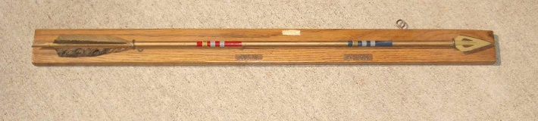
Career Arrow -1967

There was a great Scouting Ceremony several years ago that lasted several months and that involved thousands of people:
Scout and Guide Spirit Flame
February 22, 2007 marked the 150th anniversary of the birth of Scouting’s founder: Robert Baden-Powell (Easy to remember for us Americans - the same date (not year) as George Washington). On that day, several thousand Scouts and Guides from around the world assembled at his gravesite in
Nyeri, Kenya where a torch was lit.
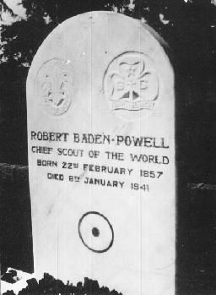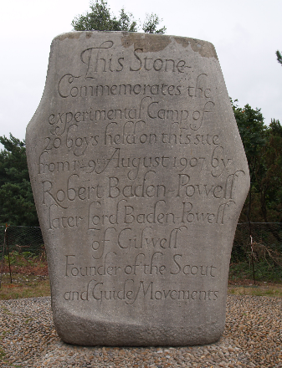
The flame was carried by Scouts and Guides through Ethiopia, Sudan, Egypt, Greece, Italy, France, Belgium and finally the UK to arrive on Brownsea Island, UK on the eve of Scouting's Sunrise. After the Sunrise celebrations on 1 August 2007, the flame continued onwards to the 21st World Scout Jamboree.

The flame that traveled from Africa was used to light a campfire that burned through the night, marking the passing of the first 100 years of the Scout movement.
I would imagine that most of those who walked from BP’s home to his grave site, or lit the Spirit Flame, or carried the torch or who tended the campfire were moved by the experience and will remember it for years to come.
What are YOU going to do now?
The best gift for a Cub Scout.......
......get his parents involved!
The greatest gift you can give your child
..... good self respect!

Kriste’s Awards from the
October 2007 Baloo’s Bugle–
Note this article was written before the current advancement plan, so the awards are not current but the thought is what counts –
DO SOMETHING!! HAVE FUN!!
Kriste Ryan had a wonderful description of what she calls quick, simple, easy Run-on Awards for Webelos Activity Badges on Cub-Scout-Talks on Yahoo Groups. She relates what Jo did for some of the Webelos Activity Badges:
Aquanaut: I had on a swim vest, mask, and flippers and carried a big swim noodle. I had a whistle around my neck and I interrupted the meeting by coming in with the flippers on and whistling and yelling Everyone out of the pool!" and the Cubmaster, asked "What is going on here?". Then I said, "Well, there are some boys here tonight that have worked very hard on their Aquanaut badge, and I have them here in my pail. I pulled them out of a sand bucket and the Cubmaster announced their names, gave them the awards and a handshake while I told a 30-second commercial of what kinds of things go into an aquanaut badge. Then I pulled a water spray bottle out of my bucket and sprayed the boys hair. And then the entire pack gave them a cheer.
The meeting went on and soon I interrupted again. This time I was a newspaper boy and I came in with a newspaper bag yelling "Extra! Extra! Read all about it! and I was throwing newspapers towards the various dens as I went. The Cubmaster demanded to know what I was doing again, and then we did the same sort of thing for the boys who earned their communicator badges. I had the badges inside the newspaper bag.
The meeting went on and for my final interruption; I was dressed as a tourist with a camera, a map, a visor and a roll-behind suitcase. As the Cubmaster was talking about popcorn sales, I was visiting a Wolf, Tiger or two with my map asking "Do you know how to get to Baltimore?" and things like that. By this time the kids were kind of yelling out to the Cubmaster "She's here again!” So finally, I award the Traveler badge from the suitcase.
What Kriste describes also shows preparation. A lot of the fun came when the Cubmaster, playing the straight man role, pretended to be irritated by the interruptions.

Look for more CEREMONY Information is other parts of Baloo’s Bugle this month!!!

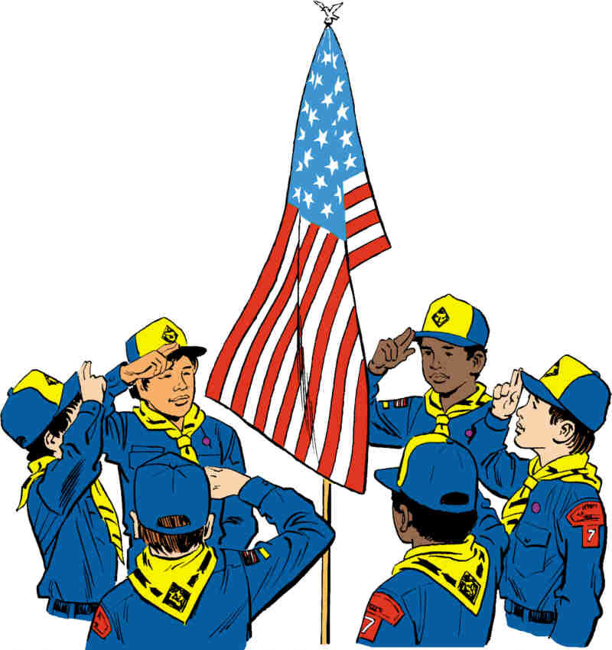

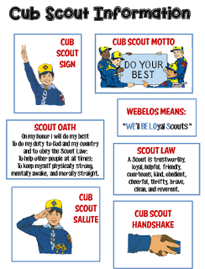
Go to http://strongarmor.blogspot.com/2015/06/cub-scouts-scout-oath-and-law-helps-and.html to get full size, full color (or black and white) printable versions
ROUNDTABLE HINTS

GREAT NEWS!!! – Jeff McHoul, ACC – RTs at Cradle of Liberty Council, has returned from his third (and final, he says) deployment in Afghanistan and will resume writing the Roundtable column next month!!
Thank you Jeff both for your service to our country and to the BSA!!

ROADBLOCKS AND PLAN B
Beverly, Capital Area Council
Ever had the rug pulled out from under you in the middle of Roundtable?? It is not any fun. That happened to my RTC awhile back. We were about half way through the best roundtable of the year – more participants than we had had in months, everyone having a really fun time and the District Commissioner pulls my RTC aside to tell him roundtables for the next month will be cancelled in order to hold the district re-charter party. We have learned through past experiences that you do not cancel roundtable unless it is unavoidable (ice on the roads will do it!). My RTC argued that next month is our derby workshop and always a big gathering, and was told the school will not let us bring in a derby track (no reason given). So we told him we would hold RT outside in the parking lot and he was opposed to having us in a separate spot from the other roundtables and the re-charter party. The last half of the roundtable was a struggle for staff to keep the smiles on and keep the group energy level high. We did – largely in part to a Jeopardy-like game show dealing with flag facts and some fun action songs. And after the meeting we grabbed the DE, District Chairman and District Vice Chair (the District Commissioner had left right after he told Chris of the cancellation) and made a plea to hold roundtable as usual. And we won – but still had the problem of no tracks allowed and the folks in charge not wanting to separate the groups.
At our staff planning meeting a couple of days later, we started out trying to plan the derby workshop by setting up in the parking lot, weather permitting and the heck with the District Commissioner. And then, we decided that not knowing if the track ban included the parking lot, we would plan a “track-free” workshop and save ourselves a lot of grief. It may be “death by power point”, but we have built lots of fun in – songs, run-ons, costumes, etc. I’ll let you know how it works.
If something like this happens to you in the middle of your RT program, take a deep breath and think before you speak. There is almost always a “Plan B” (or C or D…) and a way to work it out. And try to work it out as soon as possible – don’t go home with hurt feelings that will fester over time. And try not to get confrontational – remember we are in this for the leaders and ultimately the boys.

GO AHEAD – ASK!!
There is no such thing as a stupid question! How many times have you heard this? Or…the only stupid questions are the ones not asked. This year, the Round Table Planning Guide instructs us to have a “Parking Lot”, a poster on which the participants could post questions that the roundtable staff would address before closing.
Well…how many questions has your “Parking Lot” collected?
We dutifully set up the poster, had sticky notes and pens close by and pointed it out after the opening. For 2 months, the thing was empty. So…we decided to “salt the claim” – the staff posted a couple of questions last month and suddenly, there were several more from the participants. We had a really good Q & A session before we broke for refreshments and breakout sessions. We hope this will continue in the months to come and we plan to advertise “bring your questions to Roundtable” when we send out the email invites.
This year, with the leaders doing most, if not all training online, there is little opportunity for them to ask questions except at roundtable. The roundtable staff should welcome the opportunity to share their scouting knowledge and experiences. You might want to invite your professional to sit in on the session to answer any district or council-related questions.
If the poster does not work, try a question can or basket with 3x5 cards. The more the leaders know, the less likely they will be to quit out of frustration. And if the leaders stay, the boys will too.

CUB SCOUT RT SCHEDULE OF SESSIONS
Per 2016-2017 Roundtable Planning Guide
RT  Month | Program  Month | Pack Meeting Theme and Scout Law Point |  | Roundtable Interest Topic and Scout Law Point
 |  | Pack Meeting  Scout Law  Point | Pack Meeting  Theme | Roundtable  Scout Law  Point | Roundtable  Interest Topic
Nov  2015 | Dec  2015 | Cheerful | Celebrate | Friendly | Working as a Team
Dec  2015 | Jan  2016 | Obedient | Cub Scout City Council | Brave | Recognition
Jan  2016 | Feb  2016 | Reverent | Passport to Other Lands | Reverent | Duty to God
Feb  2016 | Mar  2016 | Loyal | Our National Treasures | Cheerful | STEM Activities
Mar  2016 | Apr  2016 | Thrifty | Power Up | Obedient | Aqua Cubs
Apr  2016 | May  2016 | Clean | A Picnic with Pizzazz | Clean | Cub Scout Hiking
May  2016 | Jun  2016 | Brave | Roaming Reptile Alert | Helpful | Cub Scout Camping
Jun  2016 | Jul  2016 | Trustworthy | Let the Games Begin | Kind | Campfire Etiquette
Jul  2016 | Aug  2016 | Friendly | #CUBSCOUTS | Courteous | Enjoying Nature

RT  Month | DL Breakout Topics | WL Breakout Topics | CM Breakout Topic | Comm Breakout | CS Leader
Nov  2015 | Teams in your dens | Den Teams, Less parents,  Prep for teams in Boy Scouts | The CM and the Pack Team | The Pack Committee team
Dec  2015 | Recognition in Dens | Recognition in Dens, Recognize leadership | How to recognize youth & adults | Recognizing Pack Adults | Why, how, & when we recognize youth  & adults
Jan  2016 | Combined Session - Duty to God  Duty to God Adventures & religious emblems
Feb  2016 | STEM Adventure Rqmnts (Hands On)  Discussion of STEM Nova & Supernova Awards | STEM Adventure Rqmnts (Hands On)  Discussion of STEM Nova & Supernova Awards | Combined Session - STEM -  Review STEM Nova and Supernova Awards on line. Then discuss |  | Overview of CS STEM Nova and Supernova
Mar  2016 | Review Reqmnts for water realated Adventures | Review Reqmnts for water realated Adventures | Adv Rqmnts, BSA Swim policies and local swim areas | Water Safety | Aquatic Adevntures, Areas, Safety
Apr  2016 | Preparing for a hike | Review Webelos Walkabout | The CM and Den & Pack Hikes | Hike Planning | Various Hiking Topics for all levels
May  2016 | Combined Session - CS Camping  BALOO Training, BSA Camping Rules, Types of Camps, Camp Logistics, Resources
Jun  2016 | Combined Session - Campfire Etiquette  Part 1 - Etquette, Safety, LNT  Part 2 - Program Material, Positive Emphasis, Resources
Jul  2016 | Nature is NATURE-al in Scouting | Nature is NATURE-al in Scouting | Combined Session - Nature  Nature is NATURE-al in Scouting  Safety, 2 Deep, Buddy System |  | Overview of Nature is NATURE-al

Cub Scout Adventures To Highlight at RT
RT  Month | Tiger Adventure | Wolf Adventure | Bear Adventure | Webelos Adventure | Arrow of Light
Nov  2015 | Team Tiger | Council Fire | Paws for Action | Project Family
Dec
2015
Jan  2016 | My Family’s Duty to God | Duty to God Footsteps | Fellowship and Duty to God | Duty to God and You | Duty to God in Action
Feb  2016 | Backyard Jungle; Curiosity, Intrigue, and Magical Mysteries; Sky Is the Limit | Adventures in Coins; Air of the Wolf; Code of the Wolf; Council Fire; Digging in the Past; Germs Alive!; Grow Something; Motor Away | Baloo the Builder; Forensics; Fur, Feathers, and Ferns; Make It Move; Robotics; Super Science; A World of Sound | Adventures in Science; Build It; Earth Rocks!; Engineer; Into the Wild; Into the Woods
Mar  2016 | Floats and Boats | Spirit of the Water | Salmon Run | Aquanaut
Apr  2016 | Backyard Jungle | Paws on the Path | Fur, Feathers, and Ferns | Webelos Walkabout
May  2016 |  | Call of the Wild | Bear Necessities | Camper, Castaway
Jun  2016 | Tiger Theatre | Call of the Wild | Bear Necessities, Grin & Bear It, Roaring Laughter
Jul  2016 | Backyard Jungle, Tigers in the Wild | Call of the Wild, Grow Something, Paws on the Path | Fur, Feathers, and Ferns, Bear Goes Fishing | Webelos Walkabout, Into the Wild, Into the Woods

LIONS

LION GUIDE AND PARENT ORIENTATION VIDEO
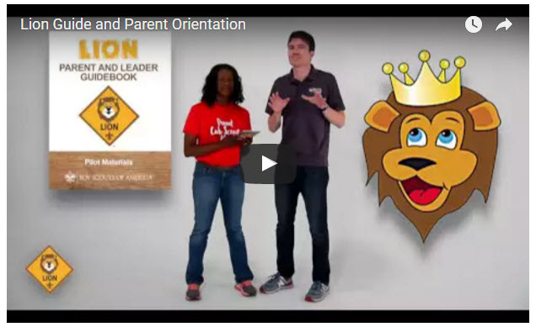
Video URL - https://youtu.be/YaIBTUO70JA

ORGANIZING FOR LIONS
From – New Birth of Freedom Council
For those packs that are thinking ahead about participating in the Lion Scouts program, having the right volunteers involved in delivering the Lion Scouts program will be important. Research shows that the most important person for a successful Scouting experience is a good leader. There are two new adult leader positions within the pack that are directly engaged in the delivery of the Lion Scouts program – a Lion Coordinator and a Lion Guide. Where do these positions fit into the current pack structure? What is the Lion Coordinator’s job description?
- Is an experienced and successful den leader
- Understands den and pack operations within the overall structure of Cub Scouting
- Demonstrates excellent communication and organization skills (and will remain in at least monthly contact with the Lion dens)
- Participates as needed in the unit’s School Night with all new Lions and their parents
- Assists the Lion guide in hosting the first orientation meeting for all the individual Lion dens in their pack
- Serves as a coach and mentor for Lion Guide

NEW LION HUB
Big Smiles
Build Bigger Futures
BSA has launched a new Lion Hub at:
http://scoutingwire.org/lion/

Available Lion Resources include:
PARTICIPATING COUNCILS
PROGRAM OVERVIEW
FAQS
The FAQ PDF is 13 pages long!!
Lots of great information!!
LION GUIDE AND PARENT ORIENTATION VIDEO
LION GUIDE AND PARENT ORIENTATION POWERPOINT
CONTACT US
LION PROMOTIONAL MATERIALS
(HELP SPREAD THE WORD!)
LION PROMOTIONAL VIDEO

THE CHIEF SCOUT EXECUTIVE ON LIONS
What We Know According to a 2014 U.S. Census Bureau report, 57 percent of kids ages 6–17 participate in at least one after-school extracurricular activity. This means that by the time they are eligible for Tigers, more than half of them already are engaged in some type of athletic, artistic or other program.
Often, children become attached to lifelong activities at an early age — that is certainly a goal we would have, as we know the long-term benefits of Scouting involvement include strong asset development in the areas of character and leadership. However, we also know that when youth participate in numerous activities at an early age, and miss joining Scouting, they are unlikely to do so at adolescence.
What will be important to learn in the next few years, if the initial entry point works at the kindergarten-age level, is will this cause losses at a different age, or will the program keep the same retention all the way through to Boy Scouting?
What we learn from the pilot Lion format could also help us assess and create a smoother transition from Webelos into Boy Scouting. Too many parents now see a barrier or obstacle, rather than a smoother transition. You will often hear parents say, “We did Cub Scouting, now we’re not sure if we are going to do Boy Scouts.” We do not have a seamless transition into Boy Scouts for a number of reasons. This pilot test will help us think through some of these issues.
We want to be sure that our Lion program delivers the right mix of character and leadership values and that we set the bar high. The program must be sustainable, we must have the right infrastructure to support it, and it needs to address in a meaningful way the needs of parents who want their kids to join Scouting at an earlier age.
You can rest assured that we will carefully evaluate our progress and keep you apprised of the results. Stay tuned for more.
Reprinted from "The Chief's Corner" on Scoutingwire.org

MORE LION INFORMATION
Bryan's Blog has written about Lions –
Go to http://blog.scoutingmagazine.org/2016/ and you can look them up. Here are a few -
Lion pilot program brings Scouting to kindergartners in nearly 200 councils
September 27, 2016
Answering the call of families who want a Scouting program for kindergarten-age boys, the BSA has expanded its Lion pilot program to nearly 200 councils.
In full gear: Here’s your first look at Lion Scouts T-shirts and hats
April 28, 2016
This week we get our first look at new T-shirts and caps to be worn by Lions — members of the pilot program for kindergarten boys set to roll out this fall.
Will Lions be part of the pack? (And answers to your other Lion questions)
April 15, 2016
Will Lions be part of the Cub Scout pack? By adding another year to the program, is the BSA concerned about "burnout"? And why was the Lions name chosen?
New details released about Lions, the pilot program for kindergarten boys
March 10, 2016
In Lions, the new pilot program for kindergartners, boys wear T-shirts instead of uniforms and earn adventure stickers instead of adventure loops.

Cub Hub Lion Posts
Go to the Cub Scout Learning Library item in this issue of Baloo's Bugle to see the Cub Hub Blog entries on The Lion Program. Or go to www.cubscouts.org and click on the Cub Hub Blog.
There are slideshows on the web put up
by local councils. Some examples are:
WD Boyce Council has "Lion Cub Pilot Program" at: http://www.wdboyce.org/document/lion-cub-pilot-program/161325
Northern Star Council has a training slide show for District Coordinators and others at: https://www.signup4.net/UPLOAD/NORT26A/LION12E/District%20Lion%20Cub%20Coordinator%20Training.pdf
Councils have put up webpages about what their packs need to know to begin a Lions Program. Examples are:
New Birth of Freedom: http://seb.newbirthoffreedom.org/2016/03/22/were-approved-for-the-lion-scouts-pilot/
WD Boyce:http://www.wdboyce.org/cub-scouts/lion-cub-pilot-program/63360
Garden State (My Council): http://www.gardenstatescouting.org/lion-program-0
Garden State, also, has an FAQ PDF - http://www.gardenstatescouting.org/sites/default/files/Lion%20Program%20FAQ.pdf
And we have created a Facebook page for our units with Lions - https://www.facebook.com/GSCLion/
Selected FAQ's
National has posted a PDF file of FAQs about the LION program at http://www.scouting.org/filestore/pdf/Lion_FAQs.pdf

CUB SCOUT LEARNING LIBRARY

The NEW https://cubscouts.org/ !!!
This is the Cub Scout Learning Library –
Everything you could want to know for Cub Scouts is or will be here. And all within a click or 3 of the home page. National heard the message that although things were at www.scouting.org they were often buried too deep to be found.
This site has admin stuff and practical stuff. The new Den Leader Resource Books are here. You can download some of the pages for FREE
This website is a great resource. There are still parts under construction but what is there is GREAT!!
Yes,
https://cubscouts.org
runs on a phone, too!!!

There are 3 tabs on top of the home page –
- Learning Library
- Cub Hub Blog
- Join Scouting
Plus – a magnifying Glass to start a search and Icons for various Social Media –
- Learning Library takes you where you can learn about your position and pick up hints. Besides specifics for dens of each rank, other clickable links include –
KEY
- All or most of material was placed on site this past month
- All or most of material was in place and listed as such in last month's Baloo's Bugle.
- Site / pages under construction
Den Leader
Den Meeting Basics
- Your First Den Meeting
- Planning Den Outings
- The Parts of a Den Meeting
- Getting Started
Three of the Core Adventures for the selected rank are listed here. Click on them and you will see / can download all the Leader's Guide pages for these three Adventures.
- Additional Required Adventures
The remaining Core Adventures for the selected rank are listed here. When you click them you get an intro to the Adventure but do not get the Meeting Plans and Resources. You see this note:
To get you started in delivering fun and engaging meetings, complete Den Meeting Plans are available here on the Learning Library for the Backyard Jungle and Games Tigers Play adventures. To obtain Den Meeting Plans for all other adventures, Den Leader Guides are available at your local Scout Shop, online at scoutstuff.org, or as an eBook through Amazon.
- Elective Adventures
All the Elective Adventures for the selected rank are listed here. When you click them you get an intro to the Adventure but do not get the Meeting Plans and Resources. You see the same note (above).
- Building Strong Dens
The Basics of Cub Scouts
- Advancement
- BSA Mission and Vision Statements
- Cub Scout Ages and Ranks
- Cub Scout Uniforming
- Den Flags
- Den Yells
- Leader Survival Kit
- Methods of Cub Scouting
- Purpose of Cub Scouting
- Roles and Responsibilities
- Scout Oath and Law
- What Is Cub Scouting?
- Training
- The Role of Training
- Youth Protection
- Den Planning And Administration
- Advancement Basics
- Advancement Requirements
- Annual Planning For Your Den
- Coordinating Your Den Plan with Pack
- Tracking and Recognizing Advancement
- Youth Protection Training
- Positive Youth Development and Working with Boys
- Developmental Differences Boys 7-11
- Behavior and Discipline
- Positive Youth Development
- Working With Special Needs Cub Scouts (Advice is specific to each Special Need. Lots of research was done to prep these pages.)
- Parents’ Prejoining Conference
- Leadership Techniques
- Working With Specific Disabilities and Needs
- The other positions are still under development:
- Cubmaster
- Committee Chair/Member
- Chartered Org Rep
- Parent / Adult Partner
- Cub Hub Blog takes you to a Cub Scout specific Blog similar to Bryan's Blog. The most recent topics discussed are listed here. There are more at www.cubscouts.org:
There were 16 new posts in November and late October 2016.
November 23, 2016
Cyber Monday Sale – Save On Boys’ Life Subscriptions A Special Cyber Monday Sale! Wondering what your Scout wants this holiday season? Could you be a pack…
November 22, 2016
Larger than Life Movies to Look Forward to Movies are often a big part of how we celebrate holiday time off with our families. Settling…
November 22, 2016
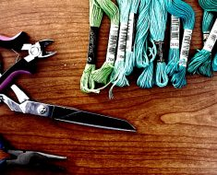Thanksgiving Crafts For Cub Scouts Thanksgiving crafts to bring the family together Thanksgiving is a busy time of year, but that doesn’t mean…
November 22, 2016
A Very Dutch Oven Thanksgiving If you’re looking for a way to change up the ol’ kitchen mess this year for Thanksgiving…take…
November 22, 2016
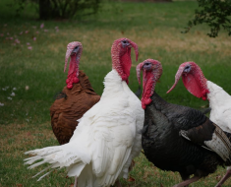Thanksgiving Trivia and Fun Facts As you start the final countdown for warm pumpkin pie and a long Thanksgiving weekend, we wanted to…
November 21, 2016
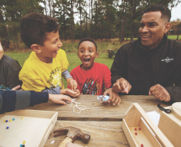Duct Tape: A Scouting Tradition Scouts and duct tape go together like campfires and marshmallows. From craft projects to field repairs, there’s virtually…
November 18, 2016
What to Read During Holiday Weekends What to Read Finding out what to read or recommend to our Cub Scouts to read, can…
November 18, 2016
How to Have a Great Thanksgiving A Very Scouting Thanksgiving It’s that grand American tradition where we fill a table full of foods…
November 17, 2016
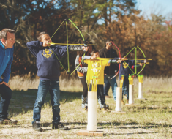5 Character Traits You Can Learn in Cub ScoutsThere are surely many more than five things boys can learn in Cub Scouts. But these five qualities…
November 15, 2016
Cub Scouts and Kendama: Why Skill Toys Are Perfect for Cub Scouts
So much of what makes Scouting fun is the hands-on experiences your Cub Scouts get to have…
October 21, 2016
November 10, 2016
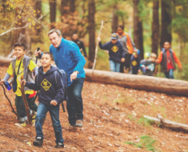The Wonders of a Trusty Walking Stick One of the most cherished trophies of any Scouting or outdoor enthusiast is the glorious walking stick. Indeed…
November 9, 2016
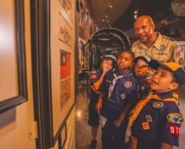4 Awesome Go-See-It Ideas For Any Den A good go-see-it is a great learning opportunity for any den Learning skills that can be helpful later…
November 4, 2016
How Do I Get Help as A Den Leader? Just Ask! Getting help as a den leader is important – just ask Danny Heitman. As a Scout parent who…
October 31, 2016
These Scary Stories are Sure to Please Halloween Gems from the Pages of Boys’ Life (Part 3 – Scary Stories and Chilling Reads) Spooky Books…
October 31, 2016
Pumpkins Galore and All Their Gore Halloween Gems from the Pages of Boys’ Life (Part 2 – The Pumpkin Kings!) We’re corralling all…
October 31, 2016
3 Things to Boost Your Halloween Spirit Halloween Gems from the Pages of Boys’ Life – Part 1 From trick shots to side-splitting jokes,…
October 31, 2016
4 Awesome Ways to Use Leftover Halloween Candy Help sugared-up Scouts stay productive with these simple science experiments that make use of excess Halloween loot. Reducing…

Cub Hub Blog Lion Posts
A Look at the Lion Uniform and Gear Lion uniform, shirts and hats! In case you’ve missed the Lion uniform images floating around the Digital Pack…
Will Lions Join Tigers and Bears? Oh My! — A Lions FAQ Lions: Answers to your top questions. We have seen a lot of great feedback, comments and questions from…
5 Questions (and Answers) for the New Lion ProgramMore Information on the New Lion Program As we mentioned earlier on the Cub Hub, Select councils will…
Lion Program will bring Scouting to Kindergarten BoysSomething Roaring in the Jungle There is an exciting new Scouting program called “Lion” for Kindergarten-aged boys…

- Join Scouting takes you to
www.beascout.org
This picture on https://beascout.scouting.org/ home page. Check it out!!
Also, on the home page –
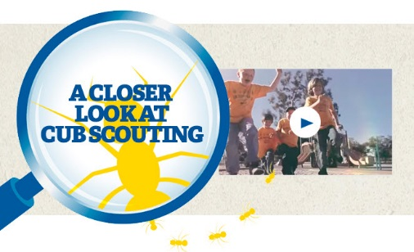
Click for a YouTube Video on Cub Scouting.
https://www.youtube.com/watch?feature=player_embedded&v=dqKFgk8SJlE
And 6 picture links -
These Six Links take you to:
www.scoutstuff.org –The Supply Division site where you can locate your nearest National Scout Shop or buy your Scout supplies
http://scoutingwire.org/ - Where you can get the latest Scouting News from around the country. You can sign up to get notifications when things are posted here...
https://cubscouts.org/pinewood-derby-2016-photo-contest Takes you to a page that says promotion has ended. Pictures of entries that were received have been removed.
https://www.scoutbook.com/Where you can get the Scoutbook APP to track your son's Scouting Experience from Tiger to Eagle Scout.
www.boyslife.org– Go directly to the on-line edition of Boys 'Life
http://scoutingwire.org/marketing-membership/ Get resources and materials to strengthen your unit at BSA's marketing and membership site. Learn the best practices and tips employed by the most successful units.

ADVENTURE PLAN TRACKERS
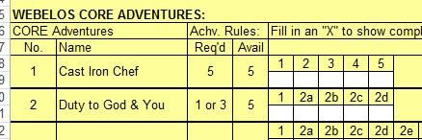
- Tracking Spreadsheets are posted on the USScouts Advancement webpage (http://usscouts.org/advance/cubscout/intro.asp). The spreadsheets were tested by a software developer who said they are so good he sees no reason to develop his own!!
- Utah National Parks Council, also, has Excel spreadsheets posted for all the new Adventure Plan requirements on their Akela's Council BlogSpot.
http://akelascouncil.blogspot.com/search/label/Tracking%20Sheet (The page starts with Arrow of Light scroll down for other ranks)
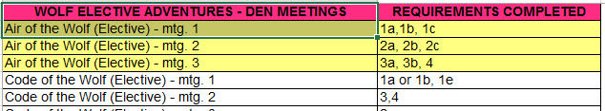
- A spreadsheet that correlates Meetings to Adventure requirements is available on the Utah National Parks' Akela's Council Blogspot at https://www.dropbox.com/s/yb8fweg7etnhqrt/WOLF%20BEAR%20WEBELOS%20REQUIREMENTS%20-%20MTGS.xlsx?dl=0 . It has all the Wolf, Bear, Webelos and AOL Adventure requirements.
These Advancement Spreadsheet workbooks are FREE for Scouters. But be COURTEOUS and observe the following -
PLEASE do not download the files from either site to email or send them digitally to others.
They are for your personal / pack use only. If you would like to share these files with others, please copy / send the link to them and send them to the site so they can print off their own. They would love everyone that wants a copy to get their own copy absolutely free. Both USScouts and Utah National Parks receive Ad money based on the number of people visiting the site. That ad money helps keep their websites open. Please help them (us) by encouraging others to visit to obtain files.

CUB SCOUT
LEADER TRAINING

IN-PERSON TRAINING
Position-Specific In-Person Training Guides Available Now! The training guides for
- Den Leader (http://www.scouting.org/filestore/training/pdf/515-215.pdf ),
- Cubmaster/Assistant Cubmaster (http://www.scouting.org/filestore/training/pdf/511-503_WB.pdf ), and
- Pack Committee (http://www.scouting.org/filestore/training/pdf/511-504_WB.pdf )

Are available on Scouting University. You can access them at http://www.scouting.org/training/adult.aspx .
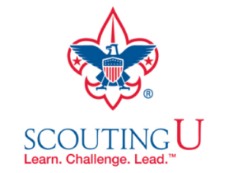

ON-LINE TRAINING
On-Line Training for all Cub Scout positions has been available since October 25, 2015
The online training for Den Leaders, Cubmasters, Committee Chairs and members, and Chartered Organization Representatives is totally updated with help from volunteers from around the country. The new training is divided into shorter, more targeted modules so leaders can get the training they need, in the order they want, any time they need it. It is organized around the learning needed prior to the first meeting, in the first 30 days, and to be position-specific trained. This training was developed to be implemented in conjunction with the BSA’s new learning management system. Keep an eye on
my. Scouting Tools (log in at https://My.Scouting.org) for more information.
Go to the BSA Volunteer Training Team Facebook page (Link above) and.
Then you automatically receive the latest news!!
If you are having difficulties with
the training or system call
BSA Member Care at 972-580-2489,
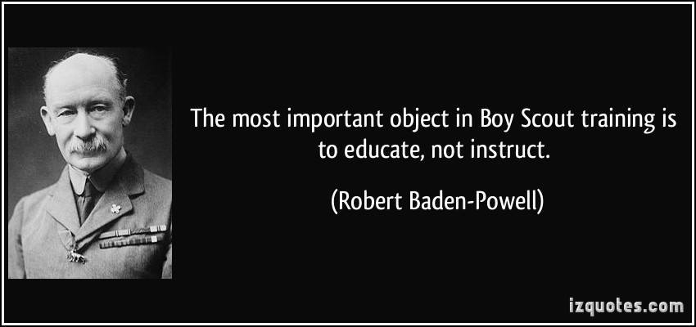
A Typical Learning Plan has several parts –
There is no need to complete more than one section at a time. Do what you have time to do.
Here you can see the three parts of the CM Course -
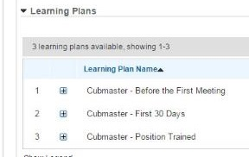

Each of these three parts is broken down into "bite sized" chunks:
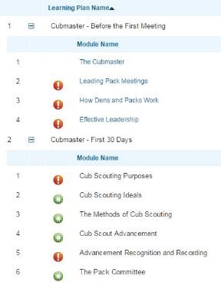
Go check it out and get your
people trained!!!

BE UP TO DATE
www.scouting.org/programupdates
The Program Updates page has been regrouped. Since the CS Adventure is in full swing, the emphasis on getting ready for it has been reduced. The downloads are still all there. And great information about three new Cub Leader courses at Philmont Training Center next summer.
There is a lot of information now on etting ready and implementing the changes to the Boy Scout program.
Check it all out – stay current!!

Same is true for Boy Scout Leaders!!

