# COMMISSIONER'S CORNER

It is sports time – time to show that Cubs can play sports, too. Time to have fun in the sun!! Time to look at athletes doing their best and showing your Cubs what can happen when they do their best, too!!!

**“Play the game – don’t look on.” –   
Lord Robert Baden-Powell**

Get involved, Life is not a spectator sport. Don’t let your Cubs sit down and rest, keep them going!! They want to go!! (Except for one Cub who told me that he would not go to my Webelos Resident Camp because there is no air conditioning. He only camps in a trailer where he can play video games)

Oh Well. Be sure your Cubs know they can do sports and do Cubs, too. ***The Cub Scout Adventure program has lots of games and outdoor activities!! Use them!!***

The Cub Scout Roundtable Planning Guide is not issued yet. I have seen drafts of the 12 sessions and the material has promise. The Task Force is not assigning months to the sessions, they are allowing each CS RTC to decide which session works best each month. Baloo’s Bugle will continue to use the Pack meeting Themes and Core Values found at <http://www.scouting.org/Home/CubScouts/Leaders/CubmasterResources/PackMeetingPlans.aspx> . Judy and Dave will put out a schedule of which sessions we will support each month once the CS RT PG is issued.

## TEN COMMANDMENTS OF SPORTSMANSHIP

*Jim Jones, Great Salt Lake Council*

1. Thou shalt not quit.
2. Thou shalt not alibi.
3. Thou shalt not gloat over winning.
4. Thou shalt not be a rotten loser.
5. Thou shalt not take unfair advantage.
6. Thou shalt not ask odds thou art unwilling to give.
7. Thou shouldst always be ready to give thine opponents the shake.
8. Thou shouldst not under-estimate an opponent, or over-estimate thyself.
9. Remember that the game is the thing, and that he who thinks otherwise is a mucker and not a true sportsman.
10. Honor the game thou playest, for he who playeth the game straight and hard wins even when he loses.

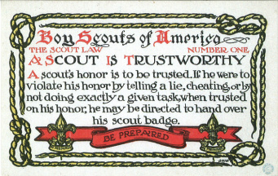

# TABLE OF CONTENTS

COMMISSIONER'S CORNER 1

TEN COMMANDMENTS OF SPORTSMANSHIP 1

TABLE OF CONTENTS 2

CORE VALUES 2

**TRUSTWORTHY QUOTES** 3

THOUGHTFUL ITEMS 4

Prayers 4

BIOGRAPHY 5

**DAVY CROCKETT** 5

DAVY CROCKETT QUOTES 6

THE BALLAD OF DAVY CROCKETT 7

CUB SCOUT TIPS 8

CAMPFIRE PLANNING 8

POSITIVE VALUES 11

THE GREY AREAS 11

TEACHING THE SCOUT LAW 12

DEN MEETING TOPICS 13

CHARACTER COMPASS 13

THEME RELATED STUFF 14

THEME RELATED ADVENTURES 14

PACK MEETING THEMES AND PLANS 14

PACK MEETING THEMES 15

UPCOMING MONTHS 16

CUBMASTER THOUGHTS 18

**AFTER THE AOL CROSSOVER** 18

WEBELOS 20

WEBELOS TRIVIA 20

July Crazy Holidays 22

**July – A Trustworthy Month** 26

TRAINING TOPICS 29

Planning Campfires 29

SPECIAL OPPORTUNITIES 31

National Summertime Pack Award 31

CUB GRUB 32

ONE LAST THING 35

TO BUILD A CAMPFIRE 35

MURPHY WAS A SCOUTER 35

**Trust men and they will be true to you; treat them greatly and they will show themselves great.**--Ralph Waldo Emerson

# CORE VALUES

**The Core Value for this month is the 1st point of the Scout Law - TRUSTWORTHY**

**The core value highlighted this month is:**

July's point of the Scout Law, **TRUSTWORTHY,** will use the theme, **LET THE GAMES BEGIN.**

**A SCOUT IS TRUSTWORTHY**A Scout tells the truth. He is honest, and he keeps his promises. People can depend on him.

**HOW DOES “LET THE GAMES BEGIN” RELATE TO THE FIRST POINT OF THE SCOUT LAW, TRUSTWORTHY??**

A Scout tells the truth. As the athletes of the world strive to do their personal best in international competition, Cub Scouts have the opportunity to “Let the Games Begin” by doing their best in feats of skill and sport. Remember that not only is it important to do your best when you play a sport, but it is also important to be trustworthy when following the rules of the game. Winning at all costs is not part of a Scout’s code of conduct.

**Per our Founder, Lord Baden-Powell**<https://en.wikipedia.org/wiki/Scout_Law>

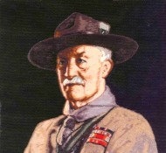

***Note –*** *The original Scout Law published in 1908 had 9 points. In 1910, the BSA added Brave, Clean, and Reverent. In 1911 B-P added* ***Clean*** *to his original list.*

**A SCOUT'S HOUOUR IS TO BE TRUSTED.**   
If a scout says "On my honour it is so," that means that it is so, just as if he had taken a most solemn oath. Similarly, if a scout officer says to a scout, "I trust you on your honour to do this," the scout is bound to carry out the order to the very best of his ability, and to let nothing interfere with his doing so. If a scout were to break his honour by telling a lie, or by not carrying out an order exactly when trusted on his honour to do so, he would cease to be a scout, and must hand over his scout badge."

[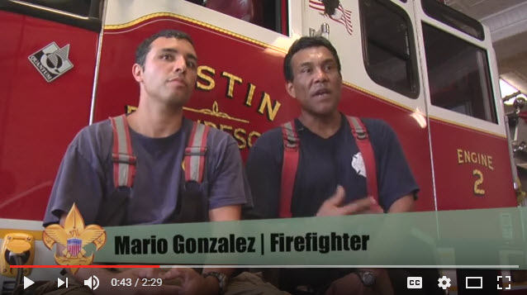](https://www.youtube.com/watch?v=ssIC6YrlWOY)

 In this video, the "Believe It Live It" team speaks with Austin, Texas, Fipe Fighters. Fire Fighters truly exemplify Trustworthy, as they are trusted to respond at any time. And they must trust each other to leave the equipment in operable condisytion. Go to URL: <https://www.youtube.com/watch?v=ssIC6YrlWOY>

**TRUSTWORTHY QUOTES**

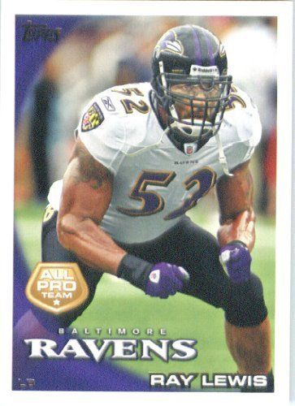*Quotations contain the wisdom of the ages, and are a great source of inspiration for Cubmaster’s minutes, material for an advancement ceremony or an insightful addition to a Pack Meeting program cover.*

**I like to see honesty out of people.   
People who are trustworthy.   
I like to see people who are involved with The Lord.   
Ray Lewis,**

Just trust yourself, then you will know how to live.   
--Johann Wolfgang von Goethe

Leadership requires five ingredients--brains, energy, determination, trust, and ethics. The key challenges today are in terms of the last two--trust and ethics.   
--Fred Hilmer

The best way to find out if you can trust somebody is to trust them. --Ernest Hemingway

The only way to make a man trustworthy is to trust him. Henry L. Stimson

You further develop trust by consistently delivering on your promise ― Sharon Macaluso

Trust, but verify. --Ronald Reagan

The United States established itself as a trustworthy new nation in its first two decades after the Revolutionary War by paying its debts, even when many in the country believed it had no obligation to do so. Alexander Hamilton, the founder of this newspaper, insisted on it. John Podhoretz

If the Lord says to give more than you think you are able to give, know that He will provide for you. Whether things are sailing smoothly or the bottom has dropped out, He is always trustworthy. You can count on Almighty God to keep His everlasting Word.   
Charles Stanley

God has never made a mistake. Ever. Ray Lewis

Depend upon yourself. Make your judgement trustworthy by trusting it. You can develop good judgement as you do the muscles of your body - by judicious, daily exercise. To be known as a man of sound judgement will be much in your favor.   
Grantland Rice

It gives me immense pleasure to be trustworthy, faithful, and true - to have the kind of romantic bond that inspires this. Kate Christensen

The Bible gives a true and trustworthy account of creation, and that account in no way conflicts with or contradicts an old-Earth view, and vice versa.   
Hugh Ross

The glue that holds all relationships together -- including the relationship between the leader and the led is trust, and trust is based on integrity.   
--Brian Tracy

Better to trust the man who is frequently in error than the one who is never in doubt. --Eric Sevareid

The greatness of a man is not in how much wealth he acquires, but in his integrity and his ability to affect those around him positively. -Bob Marley

When people honor each other, there is a trust established that leads to synergy, interdependence, and deep respect. Both parties make decisions and choices based on what is right, what is best, what is valued most highly. --Blaine Lee

We need people in our lives with whom we can be as open as possible. To have real conversation with people may seem like such a simple, obvious suggestion, but it involves courage and risk. --  
Thomas Moore

We're never so vulnerable than when we trust someone--but paradoxically, if we cannot trust, neither can we find love or joy. --Walter Anderson

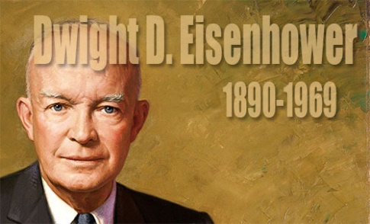

The supreme quality for leadership is unquestionably integrity. Without it, no real success is possible, no matter whether it is on a section gang, a football field, in an army, or in an office. --Dwight D. Eisenhower

If we aren't trustworthy to our own words and values, why should we expect others to trust us with their resources, let alone with their lives?  
― Assegid Habtewold

The leaders who work most effectively, it seems to me, never say I. And that's not because they have trained themselves not to say I. They don't think I. They think we; they think team. They understand their job to be to make the team function. They accept responsibility and don't sidestep it, but we get the credit…. This is what creates trust, what enables you to get the task done.   
--Peter Drucker

Let me define a leader. He must have vision and passion and not be afraid of any problem. Instead, he should know how to defeat it. Most importantly, he must work with integrity.-A. P. J. Abdul Kalam

As soon as you trust yourself, you will know how to live. --Johann Wolfgang von Goethe

Self-trust is the first secret of success.   
--Ralph Waldo Emerson

The chief lesson I have learned in a long life is that the only way to make a man trustworthy is to trust him; and the surest way to make him untrustworthy is to distrust him and show your distrust.   
--Henry L. Stimson

Trust each other again and again. When the trust level gets high enough, people transcend apparent limits, discovering new and awesome abilities for which they were previously unaware. --David Armistead

Achievement of your happiness is the only moral purpose of your life, and that happiness, not pain or mindless self-indulgence, is the proof of your moral integrity, since it is the proof and the result of your loyalty to the achievement of your values. --Ayn Rand

Building trust takes long- years, sometimes decades.   
It only takes a second, a word, or a misstep to lose it.   
Regaining trust takes even longer.”   
― Assegid Habtewold

# THOUGHTFUL ITEMS

## Prayers

**Let The Games Begin Theme Prayer**

*An Old CS Roundtable Leaders’ Guide*

As we learn to play together, let us remember that we need to respect others and to do our best. **AMEN**

**PRAYER OF THE SPORTSMAN**

Dear Lord, in the battle that goes on through life,

I ask but a field that is fair:

A chance that is equal with all in the strife,

If I should win, let it be by the code

With my faith and my honor held high,

If I should lose, let me stand by the road

And cheer as the winners go by.

—Brayley.

**A SPORTSMAN’S PRAYER**

**Dear God:**   
Help me to be a sport in this little game of life. I don’t ask for any easy place in the lineup, play me anywhere you need me. I only ask for the stuff to give you 100 per cent of what I’ve got. If all the hard drives seem to come my way, I thank you for the compliment. Help me to remember that you won’t ever let anything come my way that you and I can’t handle. And help me take the bad breaks as part of the game. Help me to understand that the game is full of knocks and knots and trouble, and make me thankful for them. Help me to get so that the harder they come, the better I like it.

“And, O God, help me always to play on the square. No matter what the others do, help me to come clean. Help me to study the Book so that I will know the rules and to study and think a lot about the greatest player that ever lived and the other great players that are told about in the Book. If they found that the best part of the game was helping other guys who were out of luck, help me to find it too. Help me to be a reg’lar feller with the other players.

“Finally, O God, if fate seems to upper-cut me with both hands and I’m laid on the shelf in sickness of old age or something, help me to take that as part of the game too. Help me not to whimper or squeal that the game was a frame-up or that I had a raw deal.

“When in the falling dusk I get the final bell, I ask for no lying complimentary stones, I’d only like to know you feel that I’ve been a good, game guy.

—By George H. Brimhall.

Children have never been very good at listening to their elders, **but** they have never failed to imitate them"   
James Baldwin

"We cannot hold a torch to light another's path without brightening our own."  Ben Sweetmand

**What I learned from Officiating Youth Sports**

*Scouter Jim, Great Salt Lake Council*

***It is just a game and it is personal.*** For every little boy and girl playing sports, it is personal. They may look tough on the outside, but they are still tender on the inside. Be positive with the boys you work with, never berate of criticize them. I would always rather hear, “You’ll do better next time,” rather than, “That’s not the way I taught you.” The fragile spirits of the children are crushed by the latter while they are encouraged to try to do better by the earlier.

***Winning isn’t everything, sportsmanship is****.* I once officiated a Pop Warner football game where one team had a special needs player. They asked if they could put him in as a deep safety on defense. While they were playing defense, they played with twelve players against eleven. The opposing coach was thrilled to be playing against “such a worthy opponent.” He received the “Good Turn” coin I tried to give away each week to the best sport of the day.

***Opponent and enemy isn’t the same thing.*** Too many times rivalries form and players playing against each other forget that a game is not a war. I once did a softball game where one team did not have a pitcher for a second game. The other team lent them a couple of theirs. The first pitcher hit three of her own players in the first inning with pitched balls. Both coaches keep encouraging her to do her best, even against her own teammates. After the first inning, the opposing team lent them one of their best pitchers to finish the game. At the end of the game, both coaches parted friends.

***Character Counts!*** The most important thing I have learned in my years of officiating youth sports it that character counts. The most important thing coaches, and Scout leaders either for that fact, can teach, is that it is more important to be try your best; be courteous to other players, coaches and officials; and to be a good sport. Sometimes the biggest winners are the ones on the teams with the fewest points when the game is over.

**A Cub Scout Prayer**

*Circle Ten Council*

Oh Lord that I will do my best, in prayer, I come to thee.

Help me to help others every day and always lead me.

To honor my parents and obey the Scout Oath and Law, too.

This I ask that I may be a loyal Cub Scout true. Amen.

# BIOGRAPHY

DAVY CROCKETT

**Proving He Was Trustworthy**

**"Make sure you are right –   
then go ahead"**

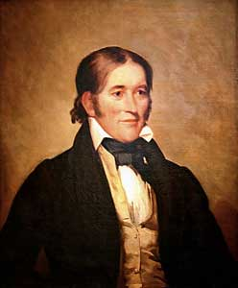

Davy Crockett was born to a large family that lived in the American wilderness where there were no stores, schools, or churches. The family finally settled on the Holston River and opened a tavern where travelers stopped on their way from Virginia to the West. Davy was only 8 when he started working in the tavern – he was excited by the stories visitors told, and wanted to see the world.

When Davy was only 12 years old, his father agreed to let him work for a Dutchman driving a herd of cattle over the mountains to Virginia – he offered to let Davy stay, but homesickness brought him home. He was excited to learn that a new school had opened, but on his fourth day, Davy was bullied by another boy, and finally fought the boy and won – but he was afraid the boy and his friends would be waiting for him the next day, so he stayed in the woods till school would have been out and then went home. The schoolmaster sent a note to Davy’s father after a few days, and the angry father headed off with a hickory stick to find Davy. When Davy saw his father coming, he ran away and joined a drover taking cattle hundreds of miles away.

For two years, Davy worked at odd jobs, earning about 25 cents a day, but finally his fear of his father faded, and he headed home. There was a great celebration. Davy was bound by customs of the time to stay with his father till he reached 21 – but his father offered to give Davy his freedom early if he would work for six months to earn off a debt his father owed. Davy developed a sense of what it meant to be honest as he worked, and discovered he could earn another $40 if he worked an extra six months. So six months later, he returned home and presented his father with a cancelled note for two debts – a total of almost $80.

Davy was now 16, and knew he should learn how to read and write. He took a job working two days a week for board, and went to school the other four days. He married, built a log cabin, and became an outstanding shot with his musket. He moved several times, settling in Tennessee, and was one of the best riflemen in Andrew Jackson’s army. His skill in hunting kept the troops from starving. He learned to write in order to serve as a magistrate, and became very popular, being a great storyteller. He was asked to run for the legislature, and his jokes and stories, and his wonderful memory helped him get elected.

There was nothing he liked more than a good bear hunt, and his skill was legendary – twice he brought down a bear weighing more than 600 pounds, and he once killed 105 bears in one year. The meat was considered a delicacy, their fur was used for coats, and their skins were used for beds and bedding.

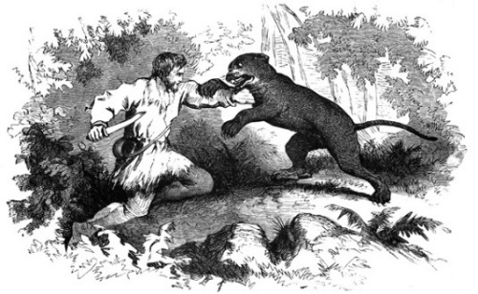

In 1827 he was elected to Congress, and introduced himself by saying, “I am …fresh from the backwoods, half horse, half alligator, a little touched with snapping turtle…I can ship my weight in wildcats.” He made quite a stir in Washington, but was always well liked. As a Congressman, Crockett’s service was outstanding – he was honest and conscientious, never took a bribe or voted for something he didn’t believe in – he was called the “Honest Congressman.” He also wrote an autobiography which he called “a plain, honest, homespun account of my life.”

In 1846, Crockett and his “Tennessee boys” went to the Alamo to help the Texans in their battle against a far larger Mexican force of 5,000 men. The Texans and Crockett’s men numbered only about 108. But the determined defenders inside the Alamo forced the Mexicans back twice. Out of ammunition, Crockett and the Texans were finally killed as the Mexicans stormed a short wall. On the day he died, Crockett wrote a letter to his daughter telling her not to worry, that he was among friends. His youngest daughter later wrote she remembered him leaving for Texas, “dressed in his hunting suit, wearing a coonskin cap, and carrying a fine rifle presented to him by friends in Philadelphia.”

He was a real-life hero, an honest man, and became a legend while he was still alive.

## DAVY CROCKETT QUOTES

**"Let your tongue speak what your heart thinks"**[Davy Crockett](http://www.goodreads.com/author/show/219075.Franklin_D_Roosevelt)

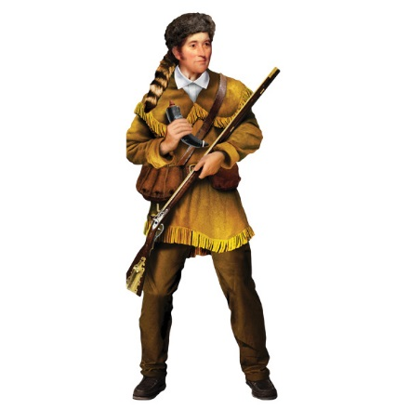

* I am at liberty to vote as my conscience and judgment dictates to be right, without the yoke of any party on me... Look at my arms, you will find no party hand-cuff on them.
* We have the right as individuals to give away as much of our own money as we please in charity; but as members of Congress we have no right to appropriate a dollar of the public money.
* It is [better to keep a good conscience with an empty purse, than to get a bad opinion of myself, with a full one.](http://www.quotationspage.com/quote/3254.html)
* Although our great man at the head of the nation (Andrew Jackson), has changed his course, I will not change mine.
* It was expected of me that I was to bow to the name of Andrew Jackson... even at the expense of my conscience and judgement. such a thing was new to me, and a total stranger to my principles.
* Pop, pop, pop! Boom, boom, boom!   
  Throughout the day  
  No time for memorandums now.  
  Go ahead! Liberty and independence forever.
* [I have suffered myself to be politically sacrificed to save my country from ruin and disgrace and if I am never again elected I will have the gratification to know that I have done my duty.](http://www.quotationspage.com/quote/2545.html)
* I would rather be politically dead than hypocritically immortalized.
* I have always supported measures and principles and not men.
* I would rather be beaten and be a man than to be elected and be a little puppy dog.

**"Fame is like a shaved pig with a greased tail, and it is only after it has slipped through the hands of some thousands, that some fellow, by mere chance, holds on to it!"** [Davy Crockett](http://www.goodreads.com/author/show/219075.Franklin_D_Roosevelt)

## THE BALLAD OF DAVY CROCKETT

Music by George Bruns and   
Lyrics by Thomas W. Blackburn.

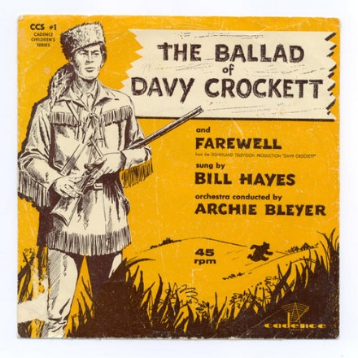

Born on a mountain top in Tennessee  
Greenest state in the Land of the Free  
Raised in the woods so's he knew every tree  
Kilt him a b'ar when he was only three.  
Davy, Davy Crockett, King of the wild frontier!

In eighteen thirteen the Creeks uprose  
Addin' redskin arrows to the country's woes  
Now, Injun fightin' is somethin' he knows  
So he shoulders his rifle an' off he goes.  
Davy, Davy Crockett, The man who don't know fear!

Off through the woods he's a marchin' along  
Makin' up yarns an' a singin' a song  
Itchin' for fightin' and rightin' a wrong  
He's ringy as a b'ar and twice as strong.  
Davy, Davy Crockett, The buckskin buccaneer!

Andy Jackson is our general's name  
His reg'lar soldiers we'll put to shame  
Them redskin varmints us volunteers'll tame  
'Cause we got the guns with the sure-fire aim.  
Davy, Davy Crockett, The champion of us all!

Headed back to war from the ol' home place  
But Red Stick was leadin' a merry chase  
Fightin' and burnin' at a devil's pace  
South to the swamps on the Florida Trace.  
Davy, Davy Crockett, Trackin' the redskins down!

Fought single-handed through the Injun War  
Till the Creeks was whipped an' peace was in store  
And while he was handlin' this risky chore  
Made hisself a legend for evermore.  
Davy, Davy Crockett, King of the wild frontier!

He give his word and he give his hand  
That his Injun friends could keep their land  
And the rest of his life he took the stand  
That justice was due every redskin band.  
Davy, Davy Crockett, Holdin' his promise dear!

Home fer the winter with his family,  
Happy as squirrels in the ol' gum tree,  
Bein' the father he wanted to be,  
Close to his boys as the pod and the pea.  
Davy, Davy Crockett, Holdin' his young 'uns dear!

But the ice went out and the warm winds came  
And the meltin' snow showed tracks of game  
And the flowers of Spring filled the woods with flame  
And all of a sudden life got too tame.  
Davy, Davy Crockett, Headin' on West again!

Off through the woods we're ridin' along  
Makin' up yarns and singin' a song  
He's ringy as a b'ar and twice as strong  
And knows he's right 'cause he ain't often wrong.  
Davy, Davy Crockett, The man who don't know fear!

Lookin' fer a place where the air smells clean  
Where the trees is tall and the grass is green  
Where the fish is fat in an untouched stream  
And the teamin' woods is a hunter's dream.  
Davy, Davy Crockett, Lookin' fer Paradise!

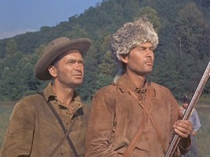

*Fess Parker as Davy, and   
Buddy Ebsen as Georgie*

*in Walt Disney's Production*

Now he'd lost his love an his grief was gall  
In his heart he wanted to leave it all  
And lose himself in the forests tall  
But he answered instead his country's call.  
Davy, Davy Crockett, Beginnin' his campaign!

Needin' his help they didn't vote blind  
They put in Davy 'cause he was their kind  
Sent up to Nashville the best they could find  
A fightin' Spirit and a thinkin' mind.  
Davy, Davy Crockett, The man who don't know fear!

The votes were counted and he won hands down  
So they sent him off to Washin'ton town  
With his best dress suit still his buckskins brown  
A livin' legend of growin' reknown.  
Davy, Davy Crockett, The Canebrake Congressman!

He went off to Congress and served a spell  
Fixin' up the Gover'ment and laws as well  
Took over Washin'ton so we heared tell  
And patched up the crack in the Liberty Bell.  
Davy, Davy Crockett, Seein' his duty clear!

Him and his jokes travelled all through the land  
And his speeches made him friends to beat the band  
His politickin' was their favorite brand  
And everyone wanted to shake his hand.  
Davy, Davy Crockett, Helpin' his legend grow!

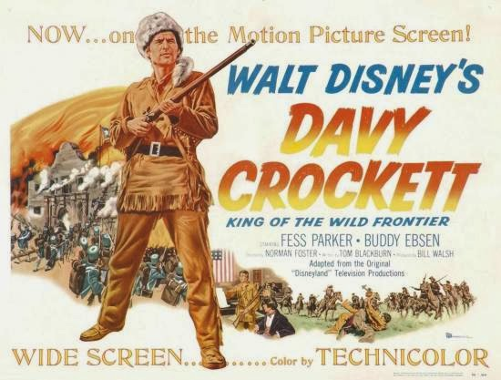

He knew when he spoke he sounded the knell  
Of his hopes for White House and fame as well  
But he spoke out strong so hist'ry books tell  
And patched up the crack In the liberty Bell.  
Davy, Davy Crockett, Seein' his duty clear!

When he come home his politickin' done  
The western march had just begun  
So he packed his gear and his trusty gun  
And lit out grinnin' to follow the sun.  
Davy, Davy Crockett, Leadin' the pioneer!

He heard of Houston and Austin and so  
To the Texas plains he jest had to go  
Where freedom was fightin' another foe  
And they needed him at the Alamo.  
Davy, Davy Crockett, The man who don't know fear!

His land is biggest and his land is best  
From grassy plains to the mountain crest  
He's ahead of us all meetin' the test  
Followin' his legend into the West.  
Davy Davy Crockett, King of the wild frontier!

Hear Fess Parker sing it at - <https://www.youtube.com/watch?v=txcRQedoEyY>

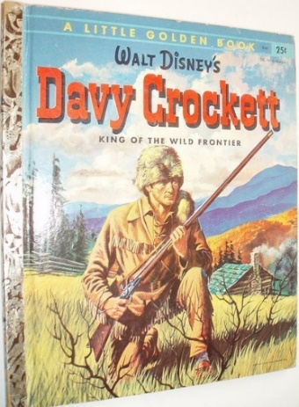

# CUB SCOUT TIPS

## CAMPFIRE PLANNING

*Baloo’s Bugle files and various BSA Syllabi*

**Why should we do a campfire?**

A great campfire makes a wonderful conclusion to a fun day of activities. It can serve to wrap up the day with a feeling of fellowship and good Cub Scout fun. It should wind the boys down and prepare them to get ready for a good night's rest. Campfires can create magic in a boy's mind that will last long past the memories of the events of the day. Ask an adult who was a Scout as a youth what they remember from those days and they can probably relate a campfire story or two.

Campfires can be an exciting and inspirational part of the Cub Scout outdoor program. Ask any Cub Scout why he likes going to campfires. His answer will be one of the following:

* **Fun!** It's hard not to have fun at campfires! There is enjoyment for all concerned.
* **Entertainment!** Our families, friends, neighbors, and guests get pleasure from attending a pack campfire.
* **Fellowship!** We can bring a den or pack closer together-a deeper feeling than just "fun."
* **Action!** Cub Scout-age boys always have extra energy. Let's use it singing songs, doing cheers, and performing skits!
* **Adventure!** A campfire is a great place to share someone else's adventure or start one of your own!
* **Training!** Baden-Powell said it: "Scouting is a game ... with a purpose." Our Cub Scouts can learn new things in an informal setting.
* **Inspiration!** Campfires will inspire everyone to leave with a greater commitment to Scouting's ideals.

Many packs use indoor campfires as part of their Pack Meetings. Let's make it even better by taking our Cub Scouts out for a real campfire, if possible. Don't let them miss this great experience.

**Campfire Leadership**

Most leaders will take a lot of time physically building a campfire. The location and construction are important, but above all, it's the program that counts. Campfires can be big, little, formal, informal, and can feature storytelling, dramatics, mystery, guest night, stunts, or a songfest.

The Leader should make sure that everything presented meets the criteria of **Good, Clean Cub Scout Fun.**

To do that, everything that occurs at a campfire **must** be approved in advance. Do not allow jokes or stunts that are in poor taste. Do not make anyone the brunt of a joke, stunt, or skit. There simply is too much good material available. Keep the program on a higher plane. ***See Gray Area article after this one.***

**When in doubt, leave it out!**

Encourage participants to "raise the bar" in the material that will be presented at a campfire for which they are responsible. There is no place for off-color or questionable jokes, stories, or songs. Do not hesitate to have groups walk you through the skit or song if you are not familiar with it. ***You should not be surprised by anything at your campfire!***

**A good rule of thumb is   
"Would you do this if your saintly grandmother was in the audience?"**

There is a lot of great material available; let's use it and be proud of the finished product.

As you review all the material, write down who is doing what on the BSA Campfire Program Planner (<http://www.scouting.org/filestore/pdf/33696.pdf> ).

**Follow the Flames**

Once you know who is doing what, organize it into a flow that will **“Follow the Flames.”** Early in the program, when the flames are high, the energy level should be also. Now is the time to bum off any leftover energy from the day. Songs and activities fit well here. Use action songs, loud cheers, and noisy stunts to get everyone involved. As the fire dies down, the songs and stories get quieter, more reflective, and more inspirational. Use a respectful tone. This will lead to a natural quiet that should build the mood. Do not have anyone constantly adding wood to the fire. The goal is to have low coals after 45 minutes to an hour. Start fast, reach a peak, slow down, and give an inspiring close.

**Start FAST,   
Reach a PEAK,   
Slow DOWN,   
Have an inspiring CLOSE!**

The sequence of events you choose will affect the success of your program. Make sure you let people know who they follow and where they are in the program, to keep everything running smoothly. If someone gets "lost," be prepared with a run-on or joke to fill the time.

**Location Considerations**

* A scenic spot
* Good drainage
* Protection from wind
* Freedom from insects
* Fire safety
* Firewood supply

**Layout Considerations**

* A stage area
* Lighting
* The fireplace
* Types of fires
* Sound-will it carry or will it get lost?

**The Four S’s**

What is needed for a successful campfire?   
**Just the Four S's!**

**Songs –** Use Scouting songs

* Can be peppy, quiet, action, special occasion, or novelty songs.
* Singing at a campfire should be a fun, natural thing. "Old favorites" work great for this.
* Know the songs you are singing!
* Start with a song everybody knows, just to get the whole group singing

**Stunts** Will add life to your campfire

* **Fire-lighting** - Adult supervision is required. Make it safe!
* **Stunts –** Theycan be action, contests (physical or mental), humorous, mixers, "magic," or educational.
* **Opening ceremony** - sets the tone for your program.
* **Closing ceremony** - should be quiet and inspirational, can be the "main event."

**Be sure to have an impressive opening and closing so everyone knows the campfire has begun and that it is over.**

**Stories -** Adventure, humorous, heroic, biographical, nature, scientific

* Watch "scary" stories. You don’t want a bunch of scared boys banging on your tent because they cannot sleep and their parents send them to you.
* Cubmaster's Minute at closing -   
  "Big idea" talk.

**Showmanship-** Adds sparkle and life!

* Peppy when the fire is high.
* Vary the pace and timing of stunts.
* "Dress up" the setting.
* •Encourage enthusiasm, but control discipline always.
* Quiet down as the embers die.

**Campfire Etiquette.**

Some rules are:

* Enter and leave in silence.
* Be courteous (quiet, No Booing) when it's not your turn on stage.
* Cheer everyone for their contributions (one Scouter tells the Cub Scouts to cheer even louder if they didn't like a skit or a joke-and no one knows that way!).
* Keep your flashlights off during the program.

**Storytelling and Yarns**

Baden-Powell once said "The Cubmaster can command rapt attention at any time by telling his Cubs a story and through it can convey the lessons he wants. It is the gilding of the pill which never fails if the teller is any good at all."

Stories are a favorite part of any campfire. A good storyteller can take over a whole pack with just a few key thoughts in mind! There are four types of stories:

* **Adventure!** These have a fast-moving plot, a romantic background, and unexpected events! We all are natural "hero worshipers."
* **Instructive!** These teach important things about nature, skills, safety, or others.
* **Good fun!** These call for laughter and jokes. They share happiness, good fortune, and fun. Telling a funny story about a mistake can teach an easy lesson.
* **Inspirational!** These are serious, with a moral, such as the Scout Oath or Law, or even religious themes.

**How Do I Tell a Story?**

Here are a few simple things to remember to help you tell a great story.

* Believe in your story. Make it your own. Use names, places that are familiar to you, and it will come across in your story. You are "selling" this story by the way you tell it.
* Paint your picture with words. Remember, your audience is used to “seeing" the story on a TV. Use your talents to help them see the picture in their imaginations.
* Don't hurry, except at appropriate spots to help create excitement. Let the story move at its own pace-slow to get their attention, faster when the action gets exciting. Pace your telling speed to the action in the story.
* Vary the tone of your voice to fit the points of the story. When the action is exciting your voice should be louder; when it's suspenseful, lower it. Volume can be adjusted either way to get and hold attention. Use your voice as an instrument.
* See the action in your mind's eye. If you live the story while you're telling it, your audience will join you in the adventure.
* Be sure everyone is comfortable before you begin. Nothing kills a mood faster than someone getting up to go to the bathroom.

**Stories and Songs -   
Keep them simple.**

**Songs**

I sing like a frog. How can I lead a song? So, sing a frog song! ***Enthusiasm will cover for a lack of skill.*** Here's what an audience needs from a song leader.

* The name of the song. Give the name of the song, and if it's an unfamiliar song, give the tune. Sing a line or so to get them going.
* The pitch or key. Sing that first note; make sure they can sing it with you. Adjust, if necessary.
* The tempo-marking time. Keep the rhythm by clapping hands or waving arms to the beat.
* Info about the song. Make sure everyone knows it. If not, teach them.

**Scouters tell stories of a famous campfire leader who had a tradition of yelling "That's my favorite song!" when a song was announced, no matter what song was being sung. What a great way to sell enthusiasm and get everyone right into it!**

* Pep-enthusiasm! If it doesn't go well, say that was a good practice, now let's do it for real. Show them you really like this song.
* Leadership-control. Plan your selections carefully. Using songs that fit the crowd and the event. ***Always tell them what the next song is, don't ask for ideas.***

And don't forget ... singing builds a group!

**Campfires create memories, and with proper planning it's simple to be successful.**

Need More Help??

Go to the   
**MacScouter’s Campfire Planning Book**   
at <http://macscouter.com/Campfire/>

## POSITIVE VALUES

Fun is an important element of Scouting. But we must remember that everything we do with our Scouts should be positive and meaningful. Activities should build self-esteem, be age-appropriate, and should not offend participants or the audience. As leaders of the Boy Scouts of America, it is our responsibility to model the values of the organizations and set a high standard for appropriateness in all Scouting activities. When making decisions, **“If in doubt, take it out.”**

These are some of the things that can make activities inappropriate and unacceptable:

* Name-calling, put-downs, or hazing
* References to undergarments, nudity, or bodily functions
* Cross-gender impersonation
* Derogatory references to or stereotyping of ethnic or cultural backgrounds, economic situations, or disabilities
* Sensitive social issues such as al cohol, drugs, gangs, guns, suicide, etc.
* Wasteful, ill-mannered, or improper use of food or water
* “Inside jokes” that exclude some of those present
* Cultural exclusion—emphasis on the culture or faith of part of the group while ignoring that of the rest of the group
* Changing lyrics to patriotic songs (“America,” “America the Beautiful,” “God Bless America,” or “The Star-Spangled Banner”) or to hymns and other spiritual songs

**IF IN DOUBT, TAKE IT OUT!**

## THE GREY AREAS

*Northeast Region, BSA*

Scouting's program is designed to develop boys in character, citizenship, and fitness) including mental, moral, spiritual, and physical fitness). Activities, meetings, camp programs, and campfires all contribute to Scouting's aims. Therefore, some items that may be acceptable in other segments of society are not part of the Scouting program.

One of the important elements of Scouting is FUN. In our attempt to use humor and fun activities. We must continually remind ourselves that these amusing and entertaining programs are excellent opportunities to teach the values of Scouting, and must not detract from nor contradict the philosophy expressed in the Scout Oath and Law.

Although many leaders are able to determine the appropriateness of most program choices, there are certainly numerous songs. stories, skits, and stunts that force the leader to make decisions. To add to the complexity of the decision is that in many cases it is not so much what is done, but how it is done. The areas that fall between the inappropriate and the absolutely acceptable, we call the grey area.

Just because a skit, song, or story falls in one of the grey area categories does not, in itself, establish that it may not be done. At the same time, if an item is in the grey area, then a leader must exercise his judgment concerning not only the subject matter. but also the performers and their sensitivity to the values and ideals of Scouting. The final decision must be the impact the item has on developing character, fitness, and citizenship or setting the wrong example of what Scouting is all about.

The following "Grey Areas" should alert leaders to exercise their best judgment:

1. **Underwear**

**Concerns:** Nudity. natural modesty of Scouts, mental fitness, and cleanliness.

**Judgment** Note: The J. C. Penney Skit can be done in Swim Suits as an example.

1. **Water Concerns: Victims (self-worth and self-esteem)**

**Victims** - Persons may be hurt physically and emotionally. Equipment/clothing damaged.

**Bodily Functions** - Skits, etc., portraying urination, sexual acts, or defecation do not help develop Scouting's Ideals and Values.

1. **Toilet Paper**

**Concerns:** Bodily Functions (see above) and Toilet Humor.

**Judgment Note:** "The Viper Is Coming" can have a person with Paper Towels and Windex to clean someone else's eyeglasses.

1. **Inside Jokes**

**Concerns:** Only the participants or those in the "KNOW" can appreciate the humor, etc. Don't bore, or even worse, ignore the rest of us in the audience.

**Judgment Note:** Staff Banquets, and Last Wills, and Testaments, are great uses of inside jokes and most, if not all, of the participants are in on the joke.

1. **Alcohol/Drunkenness**

**Concerns:** BSA's Unacceptable - Alcohol is the most abused drug especially within the age group Scouting is trying to serve.

**Drunkenness -** Making fun of people. Courtesy. Self-esteem and self-worth.

1. **Cross Gender impersonation**

**Concerns:** Bodily Functions and excessive exaggeration of body parts.

**Embarrassments**. May become a form of sexual harassment.

*The Northeast Region prepared this Grey Areas guidance with the sincere desire for wholesome fun, recreation, and enjoyment for all at Scouting activities, - especially campfires. Hopefully, these guidelines are helpful as you thoughtfully approve these activities, guide boys in making the right decisions, and personally set the example for Scouting at Its best.*

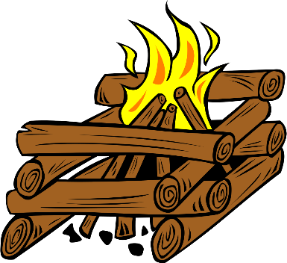

Who hath smelt wood smoke at twilight?

Who hath heard the birch log burning?

Who is quick to read the noises of the night?

Let him follow with the others.

For the young men's feet are turning,

To the camps of proved desire and known delight.

Rudyard Kipling

# TEACHING THE SCOUT LAW

**TO CUB SCOUTS**

I received a nice note from Jennifer, a Webelos leader suggesting singing the Scout Law to the tune of "Ten Little Indians."

A Scout is  
Trustworthy, Loyal,  
Helpful, Friendly,  
Courteous, Kind,  
Obedient, Cheerful,  
Thrifty, Brave,  
Clean and Reverent  
This is the Scout Law.

It took me a few tries but I got it down, and so can you!! Try it.

***And a Big Heap How to Jennifer!!***

Here is a Karaoke version that show the original words but plays only music   
<https://www.youtube.com/watch?v=mbVUayytvMY>

And a sung version -   
<https://www.youtube.com/watch?v=k0SkWCCWrF8>

I would not try and fit it to this version:  
<https://www.youtube.com/watch?v=r9-OrJnt1O4>   
*(It is the Beach Boys version!!!!)*

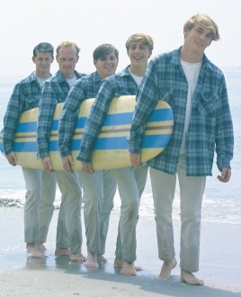

***Other new ideas welcome – Just write Judy and I the address shown on Baloo's Bugle's Home Page!!! CD***

# DEN MEETING TOPICS

Remember – Boys want to be active!!   
See, too, that they earn their awards   
***(Never say GET. You get sick, you do not get awards – You earn awards. A little CD Philosophy)***.

**Big Rock Ideas** – suggestions for Big Rocks that fit Interest Topics or seasonal activity. If years are next to an item (e.g. 13-14) that suggested Big Rock is in that Roundtable Planning guide and on-line at <http://www.scouting.org/scoutsource/Commissioners/roundtable.aspx>



# CHARACTER COMPASS

**JUNE -** ADVENTURES with a **CHARACTER COMPASS** pointing to **TRUSTWORTHY:**

**TIGER –**

* Team Tiger (Core)
* Tigers – Safe & Smart (Elec)

**WOLF –**

* Howling at the Moon (Core)
* Adventures in Coins (Elec)

**BEAR –**

* Bear Claws (Core)
* Baloo the Builder (Elec)

**WEBELOS CORE –**

* Cast Iron Chef (Core)

**ARROW OF LIGHT CORE –**

* Camper (Core)

**WEBELOS & AOL ELECTIVES –**

* Game Design (Elec)



**JULY -** ADVENTURES with a **CHARACTER COMPASS** pointing to **FRIENDLY:**

**TIGER –**

* Games Tigers Play (Core)
* Curiosity, Intrigue, & Magical Mysteries (Elec)

**WOLF –**

* Running with the Pack (Core)
* Digging in the Past (Elec)

**BEAR –**

* Grin & Bear It (Core)
* Marble Madness (Elec)

**WEBELOS CORE –**

* Stronger, Faster, Higher (Core)

**ARROW OF LIGHT CORE –**

* Building a Better World (Core)

**WEBELOS & AOL ELECTIVES –**

* Aware & Care (Elec)

# http://www.orgsites.com/in/pack3092/tsalute.jpgTHEME RELATED STUFF

## THEME RELATED ADVENTURES

All Adventures are fun. –

**ADVENTURES INVOLVING GAMES:**

**TIGER –**

* Games Tigers Play (Entire badge devoted to games and sports) Core
* Rolling Tigers – Adapt Bicycle stuff to games – Elec
* Tiger-iffic! – Lots of indoor games – Elec
* Tiger tag – Active & Relay games – Elec

**WOLF –**

* Running with the Pack (Games, Exercise) Core
* Adventures with Coins – Money game – Core
* Code of the Wolf - Math games – Elec
* Digging in the past – dinosaur game – Elec

**BEAR –**

* Grin and Bear It – Challenge or Initiative Game - Elec
* Roaring Laughter (Campfire) Elec
* Marble Madness – Play marbles - Elec

**WEBELOS –**

* Stronger, faster, Higher (Fitness Plan and Activities – make is a game) Core

**ARROW of LIGHT –**

* NONE

**WEBELOS ELECTIVES –**

* Castaway (Invent a game and play it) Elec
* Sportsman (Playing various sports) Elec

**CAMPFIRE RELATED**

**TIGER –**

* Tigers in the Wild, (#5 – Participate in a campfire) Core

**WOLF –**

* Call of the Wild (#6 - Participate in a campfire) Core
* Howling at the Moon (#3 - plan, prepare, and rehearse a campfire program, #4 – Practice and perform your role at campfire) Core

**BEAR –**

* **Bear Necessities (#2 – Attend and participate** in a campfire) Core
* Roaring Laughter –(#6 – Do two run-ons at a campfire) Elec

**WEBELOS CORE –**

* Outdoorsman (#4 – Plan a campfire program) Core

**ARROW OF LIGHT CORE –**

* NONE

**WEBELOS & AOL ELECTIVES –**

* NONE

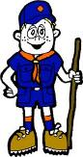

# PACK MEETING THEMES AND PLANS

[*www.scouting.org*](http://www.scouting.org)

**From National's Website for the new plans using the Core Values based on the Scout Law:**

Here are a few thoughts to consider around these new pack meeting plans. First, there is a plan for each month that corresponds with a point of the Scout Law. In addition, each plan has a theme to help make the pack meeting even more fun! The plans do not have to be used in a specific order.

**Tips for Utilizing the Plans**

* Pack meeting plans do not have to be done in any special order, but it is recommended that you include all of the points of the Scout Law each year. The pack planning meeting would be a good time to determine the order.
* There are pack meeting plans for multiple years posted on the website. It is your pack's choice of which one to select from each point of the Scout Law for each year.
* Pack meetings should not last longer than an hour. Adjust the plan to make it fit within the time. Research and experience tells us that Cub Scouts have a hard time sitting still for that long. Keep the meetings fun, active, and engaging.
* If you are comfortable with a costume to fit the theme of the meeting, go for it!
* Importantly, keep it simple and make it fun.
* The following required adventures have a requirement that suggests or requires completion at a pack meeting. Please plan accordingly as part of your annual program planning process. Work with your den leaders to plan when these activities will take place.

**Tiger**

* **Tigers in the Wild,** requirement 5. Participate in an outdoor pack meeting or pack campout campfire. Sing a song and act out a skit with your Tiger den as part of the program.
* **Games Tigers Play,** requirement 3. Make up a new game, and play it with your family or members of your den or pack.

**Wolf**

* **Council Fire,** requirement 6c. Create a den project from recyclables for a pack meeting.

**Bear**

* **Grin and Bear It**, requirement 2. Working with the members of your den, organize a Cub Scout carnival and lead it at a special event.
* **Grin and Bear It**, requirement 3. Help younger Cub Scouts take part in one of the events at the Cub Scout carnival.

**Webelos**

* **Stronger, Faster, Higher**, requirement 5. With adult guidance, lead younger Scouts in a fitness game or games as a gathering activity for a pack or den meeting.

**Arrow of Light**

* **Building a Better World (if chosen**), requirement 10b. Set up an exhibit at a pack meeting to share information about the World Friendship Fund.

Check them out at:   
<http://www.scouting.org/Home/CubScouts/Leaders/CubmasterResources/PackMeetingPlans.aspx>



# PACK MEETING THEMES

Kim, the chair of the task force, says **"I do want to stress that the focus is still the Core Value and the theme is just there as an enhancement. Pack meeting theme plans are specifically crafted to bring out the important points of the Core Value in a fun way."**

|  |  |  |
| --- | --- | --- |
| **2016–2017 Pack Meeting Plans** | | |
| Jun | Brave | ["Roaming Reptile Alert"](http://www.scouting.org/filestore/cubscouts/pdf/YEAR2/310-842(15)_June%20Brave_WEB.pdf) |
| Jul | Trustworthy | ["Let The Games Begin"](http://www.scouting.org/filestore/cubscouts/pdf/YEAR2/310-842(15)_July%20Trustworthy_WEB.pdf) |
| Aug | Friendly | ["#CUBSCOUTS"](http://www.scouting.org/filestore/cubscouts/pdf/YEAR2/310-842(15)_August%20Friendly_WEB.pdf) |
| **2017–2018 Pack Meeting Plans** | | |
| Sep | Courteous | [How the West Was Fun](http://www.scouting.org/filestore/cubscouts/pdf/2017/310-842(17)_September_Courteous.pdf) |
| Oct | Thrifty | [A-Camping We Will Go](http://www.scouting.org/filestore/cubscouts/pdf/2017/310-842(17)_October_Thrifty.pdf) |
| Nov | Reverent | [Cubs Give Thanks](http://www.scouting.org/filestore/cubscouts/pdf/2017/310-842(17)_November_Reverent.pdf) |
| Dec | Kind | [Paying It Forward](http://www.scouting.org/filestore/cubscouts/pdf/2017/310-842(17)_December_Kind.pdf) |
| Jan | Helpful | [Jobs, Jobs, Jobs](http://www.scouting.org/filestore/cubscouts/pdf/2017/310-842(17)_January_Helpful.pdf) |
| Feb | Cheerful | [Abracadabra!](http://www.scouting.org/filestore/cubscouts/pdf/2017/310-842(17)_February_Cheerful.pdf) |
| Mar | Trustworthy | [Cub Scout Investigators](http://www.scouting.org/filestore/cubscouts/pdf/2017/310-842(17)_March_Trustworthy.pdf) |
| Apr | Loyal | [Cubs in the Future](http://www.scouting.org/filestore/cubscouts/pdf/2017/310-842(17)_April_Loyal.pdf) |
| May | Friendly | [Treasure Hunters](http://www.scouting.org/filestore/cubscouts/pdf/2017/310-842(17)_May_Friendly.pdf) |
| Jun | Obedient | [Wheel Into Summer](http://www.scouting.org/filestore/cubscouts/pdf/2017/310-842(17)_June_Obedient.pdf) |
| Jul | Brave | [Home of the Brave](http://www.scouting.org/filestore/cubscouts/pdf/2017/310-842(17)_July_Brave.pdf) |
| Aug | Clean | [Destination Parks](http://www.scouting.org/filestore/cubscouts/pdf/2017/310-842(17)_August_Clean.pdf) |

**If you are using a paper copy the link to all the   
Pack Meeting Plans is:**

<http://www.scouting.org/Home/CubScouts/Leaders/CubmasterResources/PackMeetingPlans.aspx>

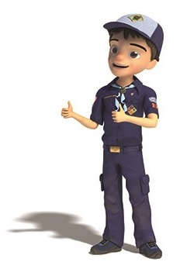

program updates banner

# **UPCOMING MONTHS**

For July, the suggested Pack Meeting theme, **LET THE GAMES BEGIN**, emphasizes the Scout Law point, **TRUSTWORTHY.**

**The core value highlighted next month is:**

July's point of the Scout Law, **TRUSTWORTHY,** will use the theme, **LET THE GAMES BEGIN.**

**A SCOUT IS TRUSTWORTHY**A Scout tells the truth. He is honest, and he keeps his promises. People can depend on him.

**HOW DOES “LET THE GAMES BEGIN” RELATE TO THE FIRST POINT OF THE SCOUT LAW, TRUSTWORTHY??**

A Scout tells the truth. As the athletes of the world strive to do their personal best in international competition, Cub Scouts have the opportunity to “Let the Games Begin” by doing their best in feats of skill and sport. Remember that not only is it important to do your best when you play a sport, but it is also important to be trustworthy when following the rules of the game. Winning at all costs is not part of a Scout’s code of conduct.

For the July theme, **LET THE GAMES BEGIN**, I believe the intent is for athletic games. CS Olympics was always a popular theme when I was a Cub and when my son was a Cub in the late 80’s. Sometime after that the IOC got protective of its branding and now we can no longer use the word Olympics. So, the theme became “Let the Games Begin.” But I did provide some Game themed months for you to prep a Plan B.

**Previous months whose themes may have   
great material:**

|  |  |  |
| --- | --- | --- |
| **Month** | **Year** | **Theme** |
| **SPORTS** | | |
| **Sept** | **1939** | **Cub Olympics** (Note 1) |
| August | 1945 | Sports |
| August | 1950 | Cub Scout Olympics |
| August | 1953 | Sports Carnival |
| August | 1956 | Cub Scout Field Day |
| June | 1960 | Cub Scout Olympics |
| June | 1964 | Cub Scout Olympics |
| June | 1966 | Sports Carnival |
| July | 1968 | Cub Scout Olympics |
| June | 1970 | Olympics |
| August | 1970 | Cub Scout Field Day |
| July | 1972 | Cub Scout Olympics |
| June | 1975 | Sports Carnival |
| June | 1979 | Learn a Sport |
| June | 1990 | Sports Arena |
| August | 2002 | Sports Extravaganza |
| July | 2005 | Play Ball! |
| June | 2008 | Go For The Gold |
| July | 2009 | Cub Scout Sports |
| June | 2010 | Hoop-De-Doo |
| August | 2015 | Play Ball! |
| January | 2016 | The Great Race |
| June | 2016 | It's a Hit |

**Note 1 –** This was the very first use of themes in   
Cub Scouts – Cub Olympics in September 1939.



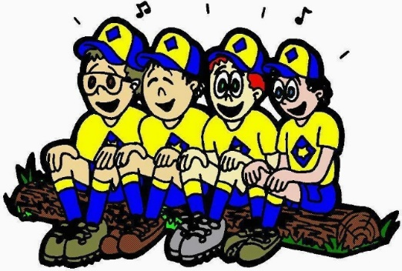

For August, the suggested Pack Meeting theme, **#CUBSCOUTS**, emphasizes the Scout Law point, **FRIENDLY.**

**The core value highlighted next month is:**

August's point of the Scout Law, **FRIENDLY,** will use the theme, **#CUBSCOUTS.**

**A SCOUT IS FRIENDLY**A Scout is a friend to everyone, even people who are very different from him.

**HOW DOES “LET THE GAMES BEGIN” RELATE TO THE FIRST POINT OF THE SCOUT LAW, TRUSTWORTHY??**

A Scout is a friend to all. #CubScouts is trending! Communicate in new ways with computers and more to spread the word on how much fun Scouting can be. Let the boys friendstorm who they would like to invite to join Cub Scouting..

|  |  |  |
| --- | --- | --- |
| **COMPUTERS** | | |
| Sept | 1996 | World of Computers |
| January | 2000 | Does not Compute |
| August | 2017 | #CUBSCOUTS |
| **COMMUNICATIONS** | | |
| October | 1945 | Communications |
| November | 1950 | Radio Stuff |
| January | 1959 | Cub Scout Newsmen |
| January | 1968 | Communications |
| March | 1974 | Communications |
| Sept | 1980 | Communications |
| October | 1982 | Communications |
| November | 1987 | Communications |
| Sept | 1991 | Communications |
| November | 1998 | Stop the Presses |
| January | 2002 | Did You Get My Message |
| January | 2005 | Cub Scouts Spread  the News |

|  |  |  |
| --- | --- | --- |
| **FRIENDLY** | | |
| December | 1944 | The Other Fellow |
| December | 1949 | The Other Fellow |
| December | 1951 | F-H-G (good followers,  helpers, & givers) |
|
| Sept | 1965 | Barn Raising |
| December | 1984 | Do a Good Turn |
| December | 1986 | The Golden Rule |
| December | 1992 | To Help Other People |
| December | 1995 | Do a Good Turn |
| December | 1996 | Helping Others |
| December | 1997 | The Golden Rule |
| July | 2002 | Inside Out and Backwards |
| March | 2004 | Walk In My Shoes |
| January | 2009 | A-MAZE-ing Games |

August may be a great month to earn the [www.USScouts.org](http://www.USScouts.org) “Internet Scout” patch. Go to - <http://usscouts.org/InternetScoutPatch.asp> to see the requirements while planning your August activities.

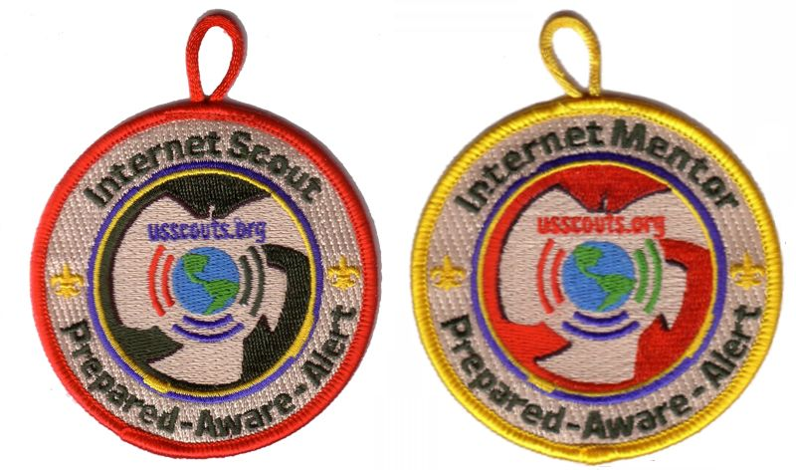

**REMEMBER –**

You must earn the CYBER Chip first -

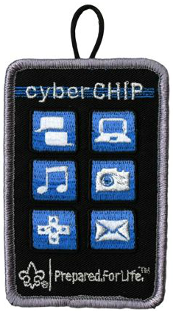

# **CUBMASTER THOUGHTS**

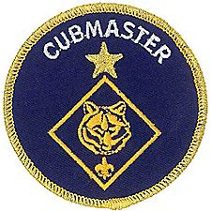

**AFTER THE AOL CROSSOVER**

*Mark Diienno, Cubmaster, Garden State Council,  
a wise old OWL   
who has earned the Unit Leader Award of Merit*

By now, all of us Cubmasters have experienced it. So much time, work, and preparation in presenting an awesome Blue and Gold. So much coordination between Scouts, parents, leaders, Committee Members, and Cubmaster to insure success.

And if all things have come together, we witness boys transition from the Arrow of Light (AOL) den to Boy Scouts.

**Job well done.**

**And then the next Pack Meeting.**   
The first thing you notice is the pack is considerably smaller. Actually, it's pretty startling. Up to 30% of your unit has vanished. And everyone knows it. There is a feeling on the room. A lack of energy. As Cubmaster, I realized immediately that this meeting will require real effort to overcome the hole left by the dens who are now forming new patrols in Boy Scout units across town. The Gathering activity I had prepared which had worked so well in the past is not energizing the boys as they come in. They almost seem passive. I'm in trouble. Before it even begins, the meeting is showing signs of faltering.

**Mayday. Mayday.**

Ok. After the opening, I will hit them with my fastball. We will sing their favorite songs. The “Alligator” and “Penguin” songs. And as the words are leaving my lips the unthinkable is happening.

**I am singing by myself.**

Oh, there is faint mumbling that kind of resembles singing accompanying me. But nothing like my pack is accustomed to performing. ***“Come on, Everybody! You can't let The Cubmaster do it alone!!! Let's start over and let me hear your outdoor voice!!”***

And you begin again. And the harsh reality begins to set in. This is going to be one of THOSE meetings. No one is really participating. And your game plan changes. Because change is good. RETREAT. Get through this one with as much dignity as you can and spare the Pack the slow death. Pick up the pace, give out the recognitions and insure that this meeting ends well within the hour it is supposed to end but never does cause everyone on a normal night is having too much fun to keep it on time.

And when you close the meeting, give your minute which by now seems more like a eulogy than it does a teaching moment you realize what you just experienced -

**Post Crossover Traumatic Syndrome.**

What an awful feeling and it makes for a long drive home. Even if you live around the corner from your meeting location. We have all been there and now comes the harder part -

**Planning the next meeting.**

It cannot be flat. The badge of office we Cubmasters wear is one of the heaviest in Scouting. And now it weighs a ton. But we must not fail.

So, as I planned the next meeting I remembered something a friend had told me. It's an old adage, that is so wise, so awesome and yet we forget it in our quest to have spectacular meetings.

**KEEP IT SIMPLE,   
MAKE IT FUN.**

I called a leader and asked her for her help in planning. And the simple hit us. Out of the blue.

Balloons. Lots of them. We will play games with balloons. Line up trash cans, put point totals on them, and will have competitions with these simple pieces of rubber floating in the air.

The big night came. And again, the pack rolled on and boy it looked a lot like the last meeting did. Small.

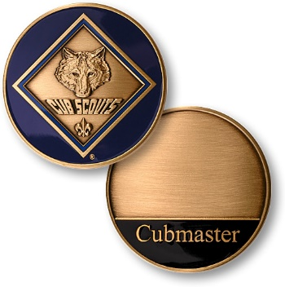

We did a simple opening. Yes. Simple. We needed simple. And unlike other meetings where I thought let's sing a song, I went right to the balloons. And the magic started happening. And as Cubmaster you can feel it when it starts. The eyes of the scouts lighten up. There's energy in the room. Big time energy. And it begins to build. All of a sudden the pack doesn't seem so small anymore. In fact, it doesn't look any different than it was before. We had one of our best meetings ever. All of us had a blast. The Badge of Office no longer had weight on my shoulder. IT HAD WINGS. And it lifted me through the room. And it was a magical evening.

I learned a valuable lesson about my unit. And my job in the unit. And sometimes we overlook the easy to get the job done.

But it's the easy that insures success. So, next year after crossover, the most complicated time of year, I will remember the secret weapon that sometimes I forget. And I will turn to the easy to lift my pack over the hurdle of Post Crossover Traumatic Syndrome.

And I will remember to keep it simple.

For more help be sure to check out –

[](http://www.cubmaster.org)

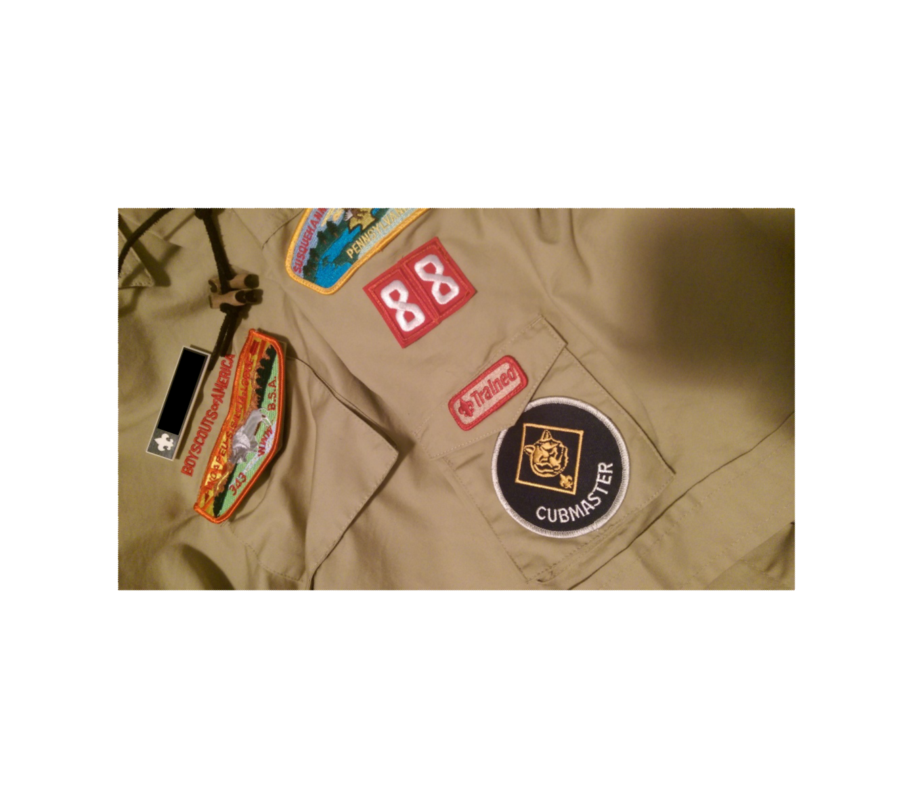

# WEBELOS

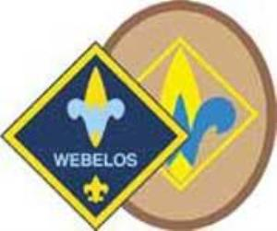

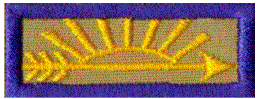

**Always an S -** Webelos always ends with an S whether talking about one Webelos Scout or a den of Webelos. It is an acronym – **WE**’ll **BE** **LO**yal **S**couts. As the CS RT Commissioner who mentored me says – "If you don’t have an S at the end – then there is nothing to which to be loyal." **(She was the N5-690-17 Wood Badge Scoutmaster!!)**

## WEBELOS TRIVIA

*I thought this might be a good time to reflect on some of the items the new Webelos Scouts and their parents will encounter and give a little background.* ***CD***

**Meaning of Webelos**

Webelos is an invented term originated by the Boy Scouts of America circa 1954. The Bear Cub Scout Book of 1954 claims that "Webelos" is an American Indian tribe of which Akela is chief, and that the name comes from "Wolf, Bear, Lion, Scout." At that time 10-year-old boys spent their first 6 months in a Lion Den to earn their Lion Badge and second 6 months in a Webelos Den to earn the "Webelos Award" (1941-1967), later renamed "Arrow of Light" before graduating to Boy Scouts at age 11.

The program was modified in the early 1960's and Webelos became a 1 year program and the rank of Lion Scout was eliminated. The Webelos acronym was kept. It was redefined to be **WE**’ll **BE** **LO**yal **S**couts

**Webelos Emblem**

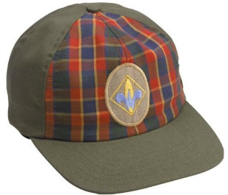

The emblem is made up of a gold Scout badge with a blue 'W,' for Webelos, on it. It shows that you are moving from Cub Scouting to Boy Scouting.

This ceremony combines “Top of the Mountain,” based on a story by Ernest Thompson Seton and “The Seven Virtues” graduation ceremony. Either one alone also makes an impressive Arrow of Light Ceremony

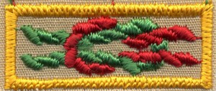 **Oval Webelos Coin**

**Arrow of Light Square Knot**

**See above.**  The Arrow of Light Square Knot is an adult only item. This knot is given in recognition of attaining Cub Scouting's highest rank, the Arrow of Light. If you earned the Arrow of light when you were a Cub Scout, you are entitled to wear this knot. It has a red rope forming the standing loop and green rope ends to the left.

Note: prior to 1967, the rank following Bear was Lion, and the Webelos Award was the "getting ready for Boy Scouts" award. Like those Adults who earned the Arrow of Light in Cub Scouts (1967 to present), if you earned your Webelos Award / Getting Ready for Boy Scouts award prior to 1967, you are entitled to wear this knot.

For guidance on wearing of BSA Square Knots, see <http://blog.scoutingmagazine.org/2012/11/20/in-the-loop-a-guide-to-square-knots-and-how-to-wear-them/>

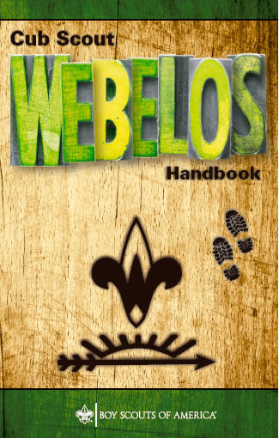

**Webelos Scout Uniform**

<http://www.scouting.org/scoutsource/CubScouts/Uniform/webelos.aspx>

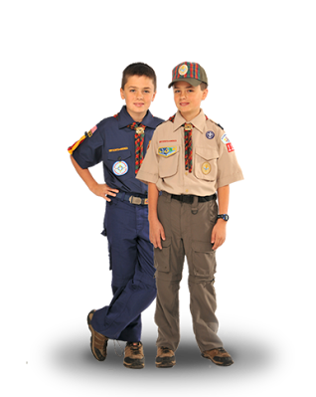

Webelos Scouts may choose to wear either the blue Webelos uniform based on the Cub Scout uniform or the tan/olive uniform like the one that Boy Scouts wear. ***The decision belongs with the Webelos Scout and his family.***

For the tan/olive uniform, boys wear the official Boy Scout olive trousers or shorts and official Boy Scout tan long- or short-sleeved shirt with blue shoulder loops. Official blue socks (with gold tops) are worn with the blue uniform, and official olive socks are worn with the tan/olive uniform.

With either uniform, all Webelos Scouts should wear the Webelos neckerchief (plaid with the Webelos emblem), Webelos neckerchief slide **(handmade slides are also acceptable)**, Webelos cap, and Webelos belt buckle.

The Webelos Scout has the option of displaying the pins he receives for completing Adventures either on a set of Webelos Colors or on his hat*. (See the January 2017 issue of Baloo’s Bugle (Our National Treasures) for a complete discussion of WEBELOS Colors.)*

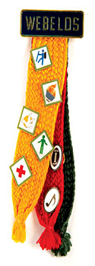

**When to switch from blue to khaki?**

***The following are personal opinions of Commissioner Dave that are allowed by BSA policy above.***

In our pack, we always encouraged the parents to wait until the blue shirt no longer fit their Webelos Scout. The sooner you buy your first khaki shirt, the sooner you will have to buy your second khaki shirt. ***Because boys do grow!!*** We graduated many a Webelos in a blue shirt.

Another good time to switch is when the Webelos Badge is presented if the pack is using the oval Webelos Badge and removal of the Cub Scout Bobcat-Tiger-Wolf-Bear diamond would be required. That is one of the reasons the oval badge was created – to save sewing all the square patches on the khaki shirt. If the pack is using the diamond patch, removal of the Tiger Rank badge would be required.

**Webelos Plaid (or Tartan)**

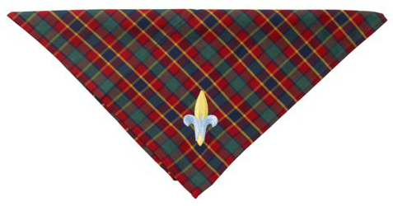

In the January 2017 issue of Baloo's Bugle, the Webelos colors were discussed. The Webelos Plaid contains the same colors for the same reason - The three badge colors represent the three programs in the BSA:

* Yellow - Cub Scouting
* Red - Boy/Varsity Scouting
* Green - "Senior Scouting" (used to be Exploring and now Venturing).

The plaid is registered and recognized as an official tartan in Scotland. The family name is Cub Scouts of America. Go to [The Scottish Register of Tartans](https://www.tartanregister.gov.uk/tartanDetails?ref=819)<https://www.tartanregister.gov.uk/tartanDetails.aspx?ref=819> and you can see it.



# July Crazy Holidays

*Claralyn, Golden Empire Council,   
Adapted from* <http://holidayinsights.com/moreholidays/index.htm>  
[http://www.brownielocks.com/month2.html](http://www.brownielocks.com/month2.html%20)

**July is:**

* **AC Appreciation Days (7/3-8/15)**
* **Dog Days (7/3 to 8/11)**



* [Family Golf Month](http://www.pga.com/pga-america/play-golf-america/FGM)
* [Independent Retailer Month](http://indieretailermonth.com/)
* [Juvenile Arthritis Awareness Month](http://www.curearthritis.org/juvenile-arthritis-awareness-month/)
* **National Anti-Boredom Month**
* **National Black Family Month**

[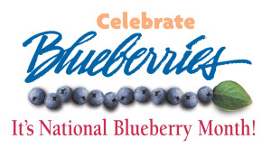](http://www.nabcblues.org/?page_id=23)

* [National Blueberries Month](http://www.nabcblues.org/?page_id=23)
* [National Cell Phone Courtesy Month](http://jacquelinewhitmore.com/july-is-national-cell-phone-courtesy-month-5/)
* [National Cord Blood Awareness Month](https://www.nhlbi.nih.gov/about/directorscorner/messages/national-cord-blood-awareness-month)
* **National "Doghouse Repairs" Month**
* National Grilling Month

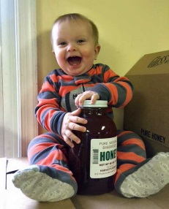

* [National Honey Month](https://wedderspoon.wordpress.com/2015/07/06/july-is-national-honey-month-beeaware-of-the-change/)
* [National Child Centered Divorce Month](http://www.childcentereddivorce.com/?pg=home)



* [Women's Motorcycle Month](http://www.youmustbetrippin.com/travel-tips/celebrating-womens-motorcycle-month/)

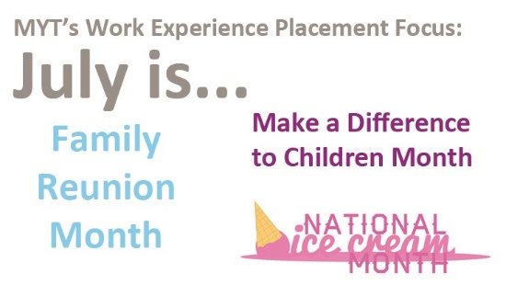

* [National Family Reunion Month](https://patch.com/connecticut/northhaven/july-is-national-family-reunion-month-3)
* [National Make A Difference to Children Month](http://www.universalgiving.org/in_the_news/in_the_news/itemDetail.do?id=603)
* [National Ice Cream Month](http://www.idfa.org/news-views/media-kits/ice-cream/july-is-national-ice-cream-month)

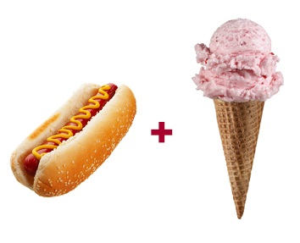

* **National Hot Dog Month**

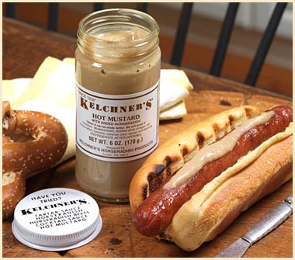

* [National Horseradish Month](http://www.foodchannel.com/articles/article/go-for-the-gusto-during-national-horseradish-mont/)
* **National Picnic Month**
* National Parks and Recreation Month
* National Wheelchair Beautification Month
* Sandwich Generation Month
* Smart Irrigation Month

**Weekly Celebrations:**

* [Beans and Bacon Week, 1-5](http://beanandbacondays.info/)
* National Tom Sawyer Days, Week 7-9
* Freedom Week: 4-10

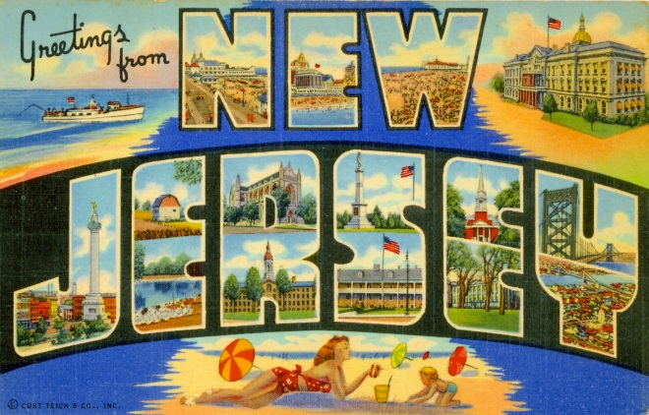

* **Be Nice To New Jersey Week: 2-8**
* National Farriers Week: 9-15
* Sports Cliché Week: 9-15 (Always Week of Maj. League Baseball All Star Game)
* Rabbit Week: 15-21  
  (Re: Magician Rabbits The sponsor is Melvin Rabbit up in Canada.)
* National Baby Food Week: 19-22

[](http://venthaven.org/)

* [National Ventriloquism Week: 12-15](http://venthaven.org/)
* Comic Con International: 20-23
* Restless Leg Syndrome (RLS) Education & Awareness Week: 18-25 (Note: Different sponsor than the September 23 observance has.)
* [National Parenting Gifted Children Week: 16-22](http://sengifted.org/programs/national-parenting-gifted-children-week/)
* Captive Nations Week: 16-22
* [National Independent Retailers Week: 16-22](http://independentretailer.com/2010/07/19/celebrate-national-independent-retailers-week/)

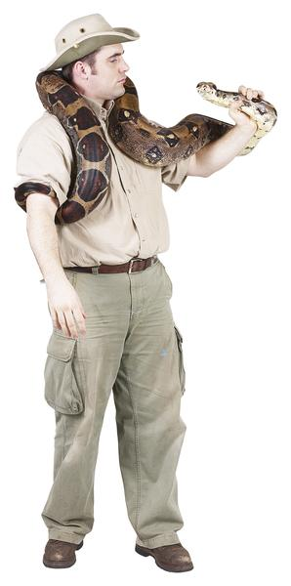

* [National Zoo Keeper Week: 16-22](https://www.aazk.org/committee/national-zoo-keeper-week/)

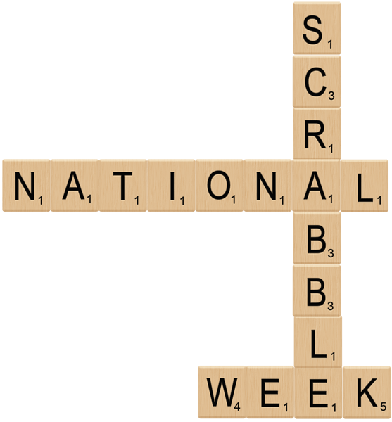

* [National Scrabble Week 22-27](http://www.scrabbleplayers.org/w/2017_North_American_SCRABBLE_C)
* World Lumberjack Championships: 27-29
* Garlic Days: 28-30 (Last Weekend)

**July Daily Holidays, Special   
and Wacky Days:**

1 [Canada Day](http://holidayinsights.com/other/dominion.htm)

1 [Creative Ice Cream Flavors Day](http://holidayinsights.com/moreholidays/July/icecreamflavors.htm)

1 [International Joke Day](http://holidayinsights.com/moreholidays/July/intljokeday.htm)

[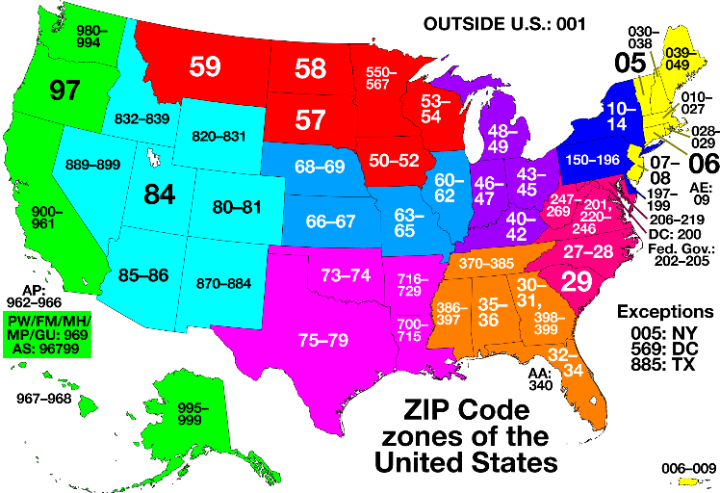](http://www.pbandjallday.com/2014/07/13/us-zip-code/)

1 ZIP Code Day

2 [Build A Scarecrow Day](http://holidayinsights.com/moreholidays/July/buildascarecrow.htm) - first Sunday in month

2 [I Forgot Day](http://holidayinsights.com/moreholidays/July/iforgotday.htm)

[](https://upto.com/upto-everything/made-in-the-usa-day-2016-07-02-14-00)

**2** [**Made In The USA Day**](https://upto.com/upto-everything/made-in-the-usa-day-2016-07-02-14-00)

2 [World UFO Day](http://holidayinsights.com/moreholidays/July/worldufoday.htm)

3 **Roswell UFO Days (July 3-6)**

3 [Compliment Your Mirror Day](http://holidayinsights.com/moreholidays/July/complimentmirror.htm)

3 [Stay out of the Sun Day](http://holidayinsights.com/moreholidays/July/stayoutofsun.htm)



**4** [**Independence Day (U.S.)**](http://holidayinsights.com/july4/index.htm)

4 [National Country Music Day](http://holidayinsights.com/moreholidays/July/countrymusicday.htm)

4 [Sidewalk Egg Frying Day](http://holidayinsights.com/moreholidays/July/sidewalkeggfrying.htm)-   
Hmmmm, I wonder why!?!

5 [Work-a-holics Day](http://holidayinsights.com/moreholidays/July/workaholicday.htm) -   
even though everyone is on holiday

6 [National Fried Chicken Day](http://holidayinsights.com/moreholidays/July/friedchickenday.htm)

6 [International Kissing Day](http://holidayinsights.com/moreholidays/July/international-kissing-day.htm)

7 [Chocolate Day](http://holidayinsights.com/other/chocolateday.htm)

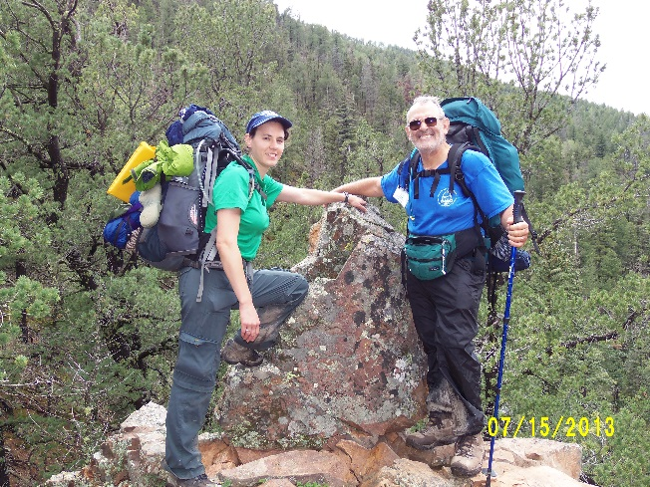

7 [Father-Daughter Take A Walk Together Day](https://www.facebook.com/events/584015955051303/)



7 [National Strawberry Sundae Day](http://holidayinsights.com/moreholidays/July/strawberrysundae.htm)

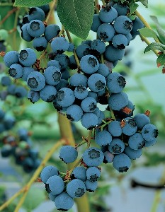

8 [National Blueberry Day](http://holidayinsights.com/moreholidays/July/national-blueberry-day.htm)

8 [Video Games Day](http://holidayinsights.com/moreholidays/July/videogamesday.htm)

9 [National Sugar Cookie Day](http://holidayinsights.com/moreholidays/July/sugarcookieday.htm)

10 [Teddy Bear Picnic Day](http://holidayinsights.com/moreholidays/July/teddybearpicnic.htm)

11 [Cheer up the Lonely Day](http://holidayinsights.com/moreholidays/July/cheeruplonely.htm)

11 [World Population Day](http://holidayinsights.com/moreholidays/July/worldpopulationday.htm)



11 [Slurpee Day or 7-11's Birthday:](http://freebies.about.com/od/freefood/p/free-slurpee-day.htm)

12 [Different Colored Eyes Day](http://holidayinsights.com/moreholidays/July/coloredeyesday.htm)

12 [Pecan Pie Day](http://holidayinsights.com/moreholidays/July/pecanpieday.htm)

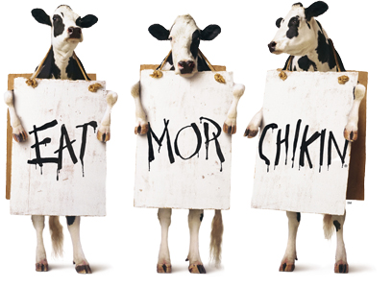

12 [Cow Appreciation Day](http://holidayinsights.com/moreholidays/July/cowappreciationday.htm)  
[Get a free Chicken Sandwich at Chik-fil-A](http://www.chick-fil-a.com/Cows/Appreciation-Day)

13 [Barbershop Music Appreciation Day](http://holidayinsights.com/moreholidays/July/barbershopmusic.htm)

13 [Embrace Your Geekness Day](http://holidayinsights.com/moreholidays/July/geeknessday.htm)

13 [Fool's Paradise Day](http://holidayinsights.com/moreholidays/July/foolsparadiseday.htm)

14 [Bastille Day](http://holidayinsights.com/moreholidays/July/bastilleday.htm)

14 [Pandemonium Day](http://holidayinsights.com/moreholidays/July/pandemoniumday.htm)

15 [Tapioca Pudding Day](http://holidayinsights.com/moreholidays/July/tapiocapuddingday.htm)

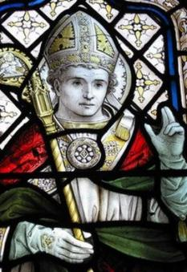

15 [Saint Swithins Day](https://www.theguardian.com/notesandqueries/query/0,5753,-19341,00.html)

16 [National Ice Cream Day](http://holidayinsights.com/other/icecreamday.htm) (3rd Sunday of July)

16 [Fresh Spinach Day](http://holidayinsights.com/moreholidays/July/fresh-spinach-day.htm)

17 [Peach Ice Cream Day](http://holidayinsights.com/moreholidays/July/peachicecream.htm)

17 [Yellow Pig Day](http://holidayinsights.com/other/pigday.htm)

17 [Global Hug Your Kid Day](http://www.mindfullivingnetwork.com/global-hug-your-kid-day/)

18 [National Caviar Day](http://holidayinsights.com/moreholidays/July/caviarday.htm)- something's fishy here

[](http://www.un.org/en/events/mandeladay/)

18 [Nelson Mandela day](http://www.un.org/en/events/mandeladay/)

19 [National Raspberry Cake Day](http://holidayinsights.com/moreholidays/July/raspberrycakeday.htm)

20 [Moon Day](http://holidayinsights.com/moreholidays/July/moonday.htm)

20 [Ugly Truck Day- it's a "guy" thing](http://holidayinsights.com/other/uglytruckday.htm)



20 [National Lollipop Day](http://www.aol.com/article/2015/07/19/10-facts-national-lollipop-day/21210691/)

21 [National Junk Food Day](http://holidayinsights.com/other/junkfoodday.htm)

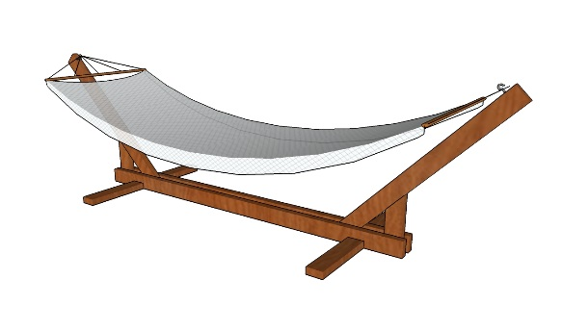

22 [Hammock Day](http://holidayinsights.com/other/hammock.htm)

22 Casual Pi Day: 22 (22/7)

22 [Ratcatcher's Day](http://holidayinsights.com/moreholidays/July/ratcatchersday.htm)

23 [Parent's Day](http://holidayinsights.com/moreholidays/July/parentsday.htm)  - fourth Sunday in July

23 [National Hot Dog Day](http://holidayinsights.com/moreholidays/July/hotdogday.htm)



23 [Vanilla Ice Cream Day](http://holidayinsights.com/moreholidays/July/vanillaicecream.htm)

23 [National Day of the Cowboy](http://nationaldayofthecowboy.com/wordpress/)

24 [Church of Latter Day Saints Pioneer Day](https://en.wikipedia.org/wiki/Pioneer_Day_(Utah))

24 [Amelia Earhart Day](http://holidayinsights.com/moreholidays/July/ameliaearhart.htm)

24 [Cousins Day](http://holidayinsights.com/moreholidays/July/cousinsday.htm)

25 [Threading the Needle Day](http://holidayinsights.com/moreholidays/July/threadtheneedle.htm)



25 [Carousel (Merry Go Round) Day](http://carousels.org/index.html)

26 [All or Nothing Day](http://holidayinsights.com/moreholidays/July/allornothingday.htm)

26 [Aunt and Uncle Day](http://holidayinsights.com/moreholidays/July/auntandunclesday.htm)

27 [Take Your Pants for a Walk Day](http://holidayinsights.com/moreholidays/July/takepantswalk.htm)

28 [Buffalo Soldiers Day](https://en.wikipedia.org/wiki/Buffalo_Soldier)

28 [National Milk Chocolate Day](http://holidayinsights.com/moreholidays/July/milkchocolateday.htm)



29 [National Lasagna Day](http://holidayinsights.com/moreholidays/July/lasagnaday.htm)

30 [National Cheesecake Day](http://holidayinsights.com/moreholidays/July/cheesecakeday.htm)

30 [Father-in-Law Day](http://holidayinsights.com/other/fatherinlawday.htm)

30 [International Day of Friendship](http://holidayinsights.com/moreholidays/July/international-day-of-friendship.htm)

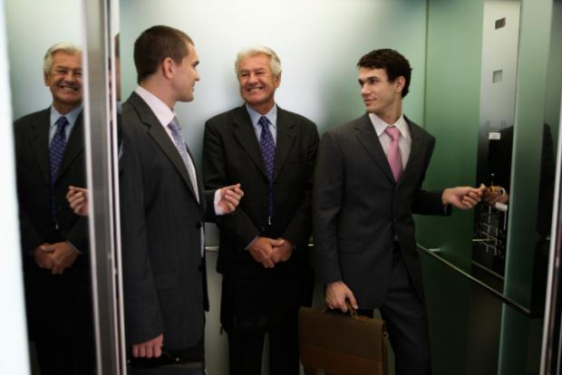

31 [National Talk in an Elevator Day](http://www.otisworldwide.com/)

31 [Mutt's Day](http://holidayinsights.com/moreholidays/July/muttsday.htm)

**July – A Trustworthy Month**

*Alice, Golden Empire Council*

**July 1st – Build a Scarecrow Day –**

This may just the right time to build a scarecrow to protect your family garden. But also think about his buddy, the “Cowardly Lion”, who lacked Courage, or thought he did. Check out the movie and have a fun evening watching it. Be sure and notice the song he sang when he met Dorothy:

“It’s sad believe me, missy,  
When you’re born to be a sissy  
Without the vim and verve….”

Some people will tell you it takes courage to be a sissy – to say no to a risky dare or let others call you “chicken” because you won’t do something wrong.  Sometimes courage is backing down and refusing to go along with the crowd. Talk about it with your den or family.

**July 4th – Independence Day –** As you celebrate this holiday with picnics, parades and fireworks, remember the real reason behind the day – Learn something about the Founding Fathers and their trust for each other. In the den, you could focus on a different Founding Father each week, or ask each boy or family to choose one to learn about. Look for examples of their trust. Go to: <http://en.wikipedia.org/wiki/Founding_Fathers_of_the_United_States>

**July 11th – Cheer up the Lonely Day -** Frances Pesek from Detroit, Michigan started this to spend his birthday bringing happiness to elderly or lonely people. For a Cub Scout, it can take trust and courage to visit people you don’t know, especially if they are in a rest home or might even look a little scary. Trust you’re your Leaders and Parents have not sent you into trouble and that they trust you to be able to do what you were asked. This would be a great day to take some pictures and ice cream or simple treat to share with them. But the real gift is the time you spend – a lonely person really needs is a visit from someone!

**July 13th – Go West Day**

Two famous explorers showed great Trust and Courage in traveling across America all the way to the Pacific Coast at a time when very little was known of the region. You can find examples of great leadership if you learn about Lewis and Clark and their famous journey – you might also think about the trust that the members of their crew had in Lewis and Clark!

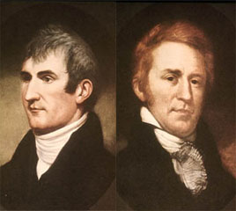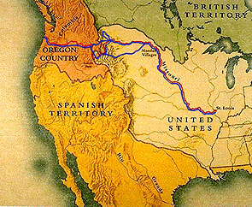

Lewis and Clark's Outbound Route Shown in Red, Inbound in Blue

In 1803, the size of the United States was doubled when President Thomas Jefferson negotiated the Louisiana Purchase. A few weeks later, he asked Congress for $2500 to send “intelligent officers with ten or twelve men to explore… to the Western ocean.” They were called the Corp of Discovery, and Captain Meriwether Lewis was chosen to lead the expedition. He in turn chose William Clark as his partner – and he showed his leadership skills when he always referred to Lewis as Captain and treated him as an equal, even though his commission had not been granted.

The expedition was to explore the plants, animals, geography and Indian populations of the entire area, along with making accurate maps. Jefferson hoped that they might discover a water route to completely cross the continent. The courage and leadership of the Corp of Discovery resulted in the loss of only one man, Sergeant Charles Floyd, who died of acute appendicitis.

They had to deal with hostile Indians, difficult water crossings and rapids, and extreme weather. They also met friendly tribes, and in the winter of 1804, they were joined by a French-Canadian trapper and his Shoshone/Hidatsa wife, Sacagawea and her young baby.

The Corp of Discovery brought back many examples of plants and animals, including a live prairie dog, and made a major contribution to mapping the North American continent and learning about the western regions – because of their work, the great western areas were much more accessible to the American people.

Check out the National Geographic web site for actual journal entries, a timeline of the expedition, photos and online games. A great way to learn about Trust and Courage! Go to: [www.nationalgeographic.com/lewisandclark/](http://www.nationalgeographic.com/lewisandclark/)

**July 17th – Disneyland opens in 1955**

You might be surprised at how much trust it took for Walt Disney to imagine and then make his dream real! Check out these quotes to get an idea of the challenges he faced:

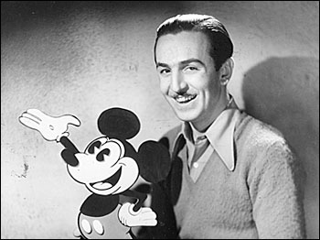

* - "When you're curious, you find lots of interesting things to do. And one thing it takes to accomplish something is courage."
* "Somehow I can't believe there are any heights that can't be scaled by a man who knows the secret of making dreams come true. This special secret, it seems to me, can be summarized in four C's. They are Curiosity, Confidence, Courage, and Constancy and the greatest of these is Confidence. When you believe a thing, believe it all the way, implicitly and unquestionably."
* "I have been up against tough competition all my life. I wouldn't know how to get along without it."
* "It's no secret that we were sticking just about every nickel we had on the chance that people would really be interested in something totally new and unique in the field of entertainment."
* "We did it (Disneyland), in the knowledge that most of the people I talked to thought it would be a financial disaster - closed and forgotten within the first year."
* "I first saw the site for Disneyland back in 1953, In those days it was all flat land - no rivers, no mountains, no castles or rocket ships - just orange groves, and a few acres of walnut trees."

And by the way, next time you get to Disneyland, notice how many characters, real and imagined, show courage in what they believe in and how they act!

**July 19th – Stick Your Tongue Out Day**

Trust sometimes requires you to take a new look at things – so check out the Fun Facts About the Tongue – and challenge yourself by trying the Tongue Twisters under Run-Ons!

**June 24th – Amelia Earhart Day –**

Amelia Earhart is recognized as a courageous person around the world – she disappeared on her last great adventure, trying to fly solo around the world – Check out the Fun Facts About Amelia Earhart!

**July 25th – Threading the Needle Day –**

So be trusting and try something new your leaders or parents asked you try / do. Learn to thread a needle and try sewing on a button or patching a hole!

**Courageous Tom Whittaker**

On May 27, 1998, Tom Whittaker made history as the leader of his own expedition to climb Mount Everest, the tallest mountain on earth.

He lost his right leg below the knee in an auto accident in 1979. Tom climbs using a prosthetic leg. After battling a viral infection even before beginning, then a problem with a bone spur that had grown on his leg stump, a two week storm that kept everyone off the summit, and finally having to go all the way to base camp because of a respiratory infection, he made the almost unbelievable climb all the way from base camp to the top in the final hours of their expedition permit to be on the mountain.

He has received lots of awards, including the MBE from Queen Elizabeth, for service to people with disabilities. One way serves is as the Executive Director of the Call to Duty Foundation, which helps service men and women returning from Iraq and Afghanistan back into regular lives.

He also came up with an interactive curriculum for 5th through 12th graders to help kids learn about diversity, and had a web site for them to follow during the Everest expedition.

One thing he showed the students was the effect of garbage and trash that has been left on Everest by expeditions. His group retrieved more than 1000 pounds of garbage from the high camps and recycled it properly. They also retrieved 89 oxygen cylinders that were shipped back to the United States and sold to cover the cost of his environmental initiative.

A prime time CBS documentary film, "A Footprint on Everest" about the climb won the 1998 Teddy award for best adventure documentary.

**Fun Facts about Amelia Earhart**

* Amelia’s nickname was “Meelie” because her younger sister Muriel couldn’t pronounce Amelia.
* She helped buy a date farm for her former mechanic who had contracted Tuberculosis, so he could benefit from the warm Arizona climate.
* She was the first female, and one of only a few females to ever receive the Air Force Distinguished Flying Cross.
* The U. S. Post Office issued an 8 cent commemorative airmail stamp in her honor on July 24, 2963.
* She sold her first plane and bought a 1922 Kissel Goldbug automobile, which she called “Yellow Peril.”
* She was the first woman to cross the Atlantic as a passenger on an airplane.
* She and her sister weren’t much for dolls – but they have two jointed wooden animals they took everywhere. Donk, the donkey was Amelia’s, and Ellie the elephant was Muriel’s.
* The two sisters, with the help of their uncle, once made a roller coaster in their backyard, after a vacation trip to the St. Louis World’s Fair.
* Her childhood pet was a large black dog named James Ferocious, because of the way he acted around strangers.
* Amelia and Muriel also had two imaginary playmates, Laura and Ringa.
* Amelia also invented a tribe of small black creatures (all imaginary) that she called Dee-Jays. She often blamed them when she had done something wrong, like talking out of turn, eating the last piece of candy, or losing something
* Amelia and Muriel also had some imaginary horses – Amelia’s was a beautiful Arab palomino named Saladin. Muriel’s was a horse named Beezle.

**Fun Facts About the Tongue**

* The tongue is made up of many groups of muscles that run in all different directions.
* The front part of the tongue is very flexible and works with the teeth to create different sounds and words.
* The tongue also pushes your food to the teeth so it can be ground up and swallowed.
* You need the back of your tongue to make some sounds: “k” and “g” – Want some proof – say the letters slowly and you can feel your tongue move against the top of your mouth.
* If you didn’t have that little membrane under your tongue, you would swallow your tongue!
* Take another look at your tongue to see how rough and bumpy the top side is – that’s where your taste buds are!
* You have about 10,000 taste buds when you are born, but as you get older about half of them die.
* Your taste buds send messages to your brain to protect you from eating or drinking something dangerous or spoiled.
* If you suck on an ice cube, you won’t be able to taste your next bite.
* Without saliva, your tongue wouldn’t work – it needs moisture to taste something.
* Your tongue even helps keep you from getting sick, by filtering out harmful germs.
* Your tongue never sleeps – it’s always working!
* You should brush your tongue, along with your teeth, to keep it working well!

Now exercise that tongue with some Tongue Twisters!

**Tongue Twisters for   
Stick Out Your Tongue Day**

*Alice, Golden Empire Council*

* Peter Piper picked a peck of pickled peppers.  
  Did Peter Piper pick a peck of pickled peppers?  
  If Peter Piper Picked a peck of pickled peppers,  
  Where's the peck of pickled peppers Peter Piper picked?
* She sells seashells by the seashore.  
  The shells she sells are surely seashells.  
  So if she sells shells on the seashore,  
  I'm sure she sells seashore shells.
* Which wristwatches are Swiss wristwatches?
* How much wood would a woodchuck chuck  
  If a woodchuck could chuck wood?  
  He would chuck, he would, as much as he could,  
  And chuck as much as a woodchuck would  
  If a woodchuck could chuck wood.
* A skunk sat on a stump and thunk the stump stunk, but the stump thunk the skunk stunk.
* Does this shop stock short socks with spots?
* A big black bug bit a big black bear.
* A cup of proper coffee in a copper coffee pot.
* Some say sweet scented shaving soap soothes sore skin.
* Many an anemone sees an enemy anemone.
* Imagine an imaginary menagerie manager  
  imagining managing an imaginary menagerie.

**Olympic Cities**

*Scouter Jim, Bountiful Utah*

**Olympic Summer Games**

Athens 1896 London 1948 Seoul 1988

Paris 1900 Helsinki 1952 Barcelona 1992

St. Louis 1904 Melbourne 1956 Atlanta 1996

London 1908 Rome 1960 Sydney 2000

Stockholm 1912 Tokyo 1964 Athens 2004

Antwerp 1920 Mexico City 1968 Beijing 2008

Paris 1924 Munich 1972 London 2012

Amsterdam 1928 Montreal 1976 Rio 2016

Los Angeles 1932 Moscow 1980 Tokyo 2020

Berlin 1936 Los Angeles '84

**Olympic Winter Games:**

Chamonix 1924 Innsbruck 1976

St. Moritz 1928 Lake Placid 1980

Lake Placid 1932 Sarajevo 1984

Garmisch- Calgary 1988

Partenkirchen 1936 Albertville 1992

St. Moritz 1948 Lillehammer 1994

Oslo 1952 Nagano 1998

Cortina d'Ampezzo 1956 Salt Lake City 2002

Squaw Valley 1960 Torino 2006

Innsbruck 1964 Vancouver 2010

Grenoble 1968 Sochi 2014

Sapporo 1972 Pyeongchang, South Korea 2018

**Fun Facts About the Olympics**

*Alice, Golden Empire Council*

* Because of World War I and World War II, there were no Olympic Games in 1916, 1940, or 1944.
* In 490 BCE, Pheidippides, a Greek soldier, ran from Marathon to Athens (about 25 miles) over terrible terrain to let the people know their soldiers were victorious over the Persians, then fell to the ground dead.
* The distance of a marathon was decided to be 26 miles and 385 yards because the British Royal Family requested the 1908 marathon to begin at Windsor Castle so their children could watch. That distance became the standard marathon length in 1924.
* Motor boating was an official sport at the 1908 Olympics.
* The original Greek athletes played in the nude. The Greek root "gymnos" means nude and the word "gymnasium" literally means "school for naked exercise."
* The Olympic flag was first flown during the 1920 Olympic Games.
* Modern Olympic Gold Medals were originally made entirely out of real gold, until after 1912.
* Ancient Greek Olympic athletes won a wreath of olive leaves – the first winner was a cook.
* James B. Connolly (United States), winner of the hop, step, and jump (the first final event in the 1896 Olympics), was the first Olympic champion of the modern Olympic Games.
* The original Olympic flame of ancient Greece was ignited by the sun and then kept burning until the closing of the Olympic Games.
* The modern Olympic flame is lit at the ancient site of Olympia by women wearing ancient-style robes and using a curved mirror and the sun. The Olympic Torch is then passed from runner to runner from the ancient site of Olympia to the Olympic stadium in the hosting city, and kept lighted till the games end.
* The Beijing Olympic motto of “One World, One Dream” was chose from over 210,000 entries submitted from around the world.
* Pierre de Frédy, a French educator and sportsman, revived the Olympic Games in 1896 and designed the Olympic Flag in 1913-1914.
* The Olympic Flag has five interlocking rings (blue, yellow, black, green and red) to represent Africa, the Americas, Asia, Australia and Europe, the five parts of the world involved when the modern Olympics began.

**PHYSICAL FITNESS TIPS**

*Sam Houston Area Council*

Exercises alone won’t keep you physically fit.   
Good personal health care should be practiced daily.

* Bathe every day, especially after exercising.
* Wash your hair at least twice a week.
* Brush your teeth at least twice a day.
* Visit your dentist regularly.
* Wear clean socks and clean underwear daily.
* Avoid eyestrain. Use good light.
* Use only your own washcloth and towel.
* Stand up straight, don’t slouch.
* Get plenty of sleep –   
   about 10 hours per night for Cub Scouts.
* Trim your fingernails and toenails.
* Wash your hands before eating.
* Wash your hands after using the bathroom.
* Protect your eyes! Don’t put anything in your ears!
* Don’t drink or eat from someone else’s cup, plate or utensils. That’s an easy way to catch their germs and get sick.
* Eat right! A balanced diet will make you feel good!
* Get plenty of exercise to make you feel great!

# TRAINING TOPICS

## Planning Campfires

*Baloo’s Archives*

There are lots of great books out there for planning campfire. Just check out the books for sale from vendors that support [www.usscouts.org](http://www.usscouts.org/) or Google the topic.

My favorite is -

**CREATIVE CAMPFIRES**

By Douglas R Bowen

*It has all the bases covered with many songs, skits, stories, yells, run-ons, cheers and more*

Also, the Canyon Campfire Companion   
(Volumes 1 & 2).

**PLANNING A PACK CAMPFIRE**

*Catalina Council*

If the fire regulations at your outdoor activity prohibits live fire, or if you’re holding your meeting at an indoor location, use an artificial campfire. See the directions later in this section.

* This would be a good time to have the parents form groups and put on presentations at the campfire.
* After the main campfire program, the cooling embers will be an enticement for special food treats – see the recipes for s’mores in the Cub Scout Program Helps for this month’s theme.
* Print a copy of the BSA’s Campfire Planner to plan your campfire program. The Campfire Planner is available on line from many, many sites. Here is one link: <http://macscouter.com/Campfire/Planning.asp>

The form has two sides. On one side you list all the skits, songs, cheers, stories, gags and other stuff you plan to do. On the other side you put them in the order you plan to do them. Start fast, build up the pace and enthusiasm as the fire builds, then slow things down as the fire wanes.

**Artificial Campfires**

Don’t let bad weather or lack of a location keep you from having a pack campfire. A little

imagination can bring the atmosphere of a real campfire indoors. Here are some methods you can use to create an artificial campfire.

* Place a candle in a large glass bowl lined with red foil. Make a rock ring around the bowl.
* Place a candle in a large can with holes punched in the sides.
* The two below are a little more elaborate, but well worth the effort



**Outdoor Ceremonies**

*Catalina Council*

Ceremonies are important, even in the outdoors. Outdoor pack activities usually call for an opening and closing ceremony (or closing campfire). Any outdoor pack activity which takes the place of a regular pack meeting should also include advancement ceremonies so awards can be presented promptly.

Remember these things when planning outdoor ceremonies:

* Weather – it is difficult to keep candles lit in winds or light rain. Have a backup plan with some type of protection.
* Acoustics – the wind sometimes carries voices in the wrong direction. Make sure the speaker can be heard.
* Natural surroundings – make the most of surroundings to furnish background. Lakefront or open areas in the woods make good ceremony sites.
* Length – make ceremonies short, especially if the audience is standing.
* Flag – be certain the U.S. flag is secure. A normal flag holder will not be adequate in winds. Insist on respect for the flag, indoors or outdoors.
* If you’re having a real fire, make sure you have complied with local fire ordinances and have provided a safety area so people are not too close to the fire. ♦ Do not use the fire as a backdrop for speakers, skits, etc, for it is very hard for the audience to see sometimes. Stand slightly to one side for best effects. (Good idea is to have portable lights shining low on speakers)

**Campfires: “Outing in Scouting”**

Cub Scout *Program Helps* 2008-2009, 2 JUN 09

Creating a memorable campfire takes planning. Here are a few hints to ensure that your campfire is a pleasant experience for all:

* Approve all elements of the campfire that the dens will do (skits, songs, stunts, run-ons, applauses, and cheers) to make sure they follow the positive values of Scouting.
* Follow the flames: Start the campfire with an exciting song/skit that gets everyone involved. As the fire diminishes, the activities become calmer.
* Use the Campfire Planner that is in the *Cub Scout Leader Book* appendix. Vary active and quieter contributions to ensure a fast-moving campfire.

There are varieties of Cub Scouting Camps: camps for Cubs and camps for Webelos, day camps and resident camps. Some are in a local park and others are at a Scout camp some distance away. Some leaders and their families may even be camping at Philmont Training Center! Facilities, like shelters, lodges, storage huts and waterfront, differ greatly from camp to camp. No matter what your camp is like, the camps and the staff that run them must conform to BSA standards. I fervently hope that you and the boys in your pack will be attending one of them.

I’m sure that your council has provided you a list of what to expect and especially what to bring with you to camp.

It’s important to have the right number of adult help with you and wear suitable clothing and be equipped with enough rain gear, sun block, med forms, and drinking water.

**What will you bring back from camp?**

Besides almost finished craft projects, dirty clothes, and a few insect bites, I hope that you return home with a bunch of special memories and great plans for what your pack or den will do next year.

Think of your time at camp as a relaxed leader training experience. A lot goes on there that can help and inspire you in the years to come. If you are observant and know what to look for you can learn a lot that will help your den, your pack and your boys. The staff that runs your camp are experienced well trained Scouters and can serve as valuable role models for you and the other leaders.

**Let’s start with Memories.**

As a help, you might take along a note book and a camera. Make notes, keep a journal, and have boys give their input and observations. Take lots of photos. They could make a great display that will help at fall recruiting.

You should get many opportunities to stand back and observe rather than be the instigator and leader. What did the boys enjoy? Did they participate and have fun? Did they cooperate and do their best or merely go through the motions? Would the good activities you see at camp work at your meetings?

What did the boys learn? What made a particular activity a good learning experience? You will probably notice that your boys respond differently to each activity and you may learn some new things about them.

**New Activities.**

The boys will engage in some new activities that will probably become favorites of theirs for a while. Make notes about them so you can always pop the good ones into your program when things get dull. (I know, you never have dull programs.)

Games are always popular activities and boys enjoy playing their favorites again and again. Keep those in mind – and in your notes - for later. When things get routine next winter, it may be fun to bring out a game they played at camp. Make sure you have the all rules before you leave and note any equipment you may have to add to your game chest.

**The training provided by at National Camping Schools to the Camp Leaders was revised this year to include sessions on using the new Cub Adventure Program. When your Cubs go to camp, they will be getting a jump start on the new Adventure program for Advancement!!**

Camps usually have regular assemblies for openings, closings or camp fires. These can be a treasure of songs, skits and stunts that may become part of your group’s repertoire. If you have trouble leading songs at your pack meetings, try using one of the fun songs the boys know and loved to sing at camp. Learn the tune and get a copy of the words. It might be a good idea to take a portable recorder along so you can bring back a copy. Ask the person who leads the good ones for help.

**Watch the camp staff.**

How do they manage discipline and control? Try to detect how they use each of these control methods:

* Getting and holding the boys’ attention,
* Explaining the rules,
* Well-planned activities,
* Giving individual attention.

You will see a variety of methods. Which ones worked and which ones could you use?

Many camps employ youth leaders: Boy Scouts or Venturers to lead activities. If you camp does, watch how the Cub Scouts respond to them. Would Den Chiefs work out OK in your program? Sometimes the timing is difficult for a Den Chief to make den meetings, but how about for pack camp outs and other special activities?

**How does the camp run?**

Camp is a good source of ideas for your pack’s camping program. You should get some insight into topics like:

* **Food and food storage** – How do they manage it? Will their methods work for your pack?
* **Safety and medical** – Check with the camp nurse or medical staff for how they prepare and get set up.
* **Sanitation** – How are toilets, hand washing and showers set up and organized?
* **Campfire activities** – Most camp staffs are good at this. Pick their brains for ideas.
* **Emergency Preparedness** – how is the staff prepared for dangerous weather, medical assistance, etc? What are their communication methods?

**Your gang of adults.**

You will spend considerable time in the company of the adults from your pack. Get to know them, their attitudes, knowledge and skills. You should learn a lot about their appreciation of Scouting and how it helps boys grow.

Look for potential leaders, committee members and special helpers amongst this group. You will rarely get a better chance to get to know some of these people and discover how they might help their sons and their sons’ Cub Pack.

**Make it work for Your Pack.**

Camp is great for boys and mostly they love it but the important value is: how can it help your pack and you as a leader? You are paying your money and your time to attend, so make it worthwhile. Get the best for your pack.

**What are YOU going to do now?**

***The best gift for a Cub Scout.......  
 ......get his parents involved!***

***The greatest gift you can give your child   
 ..... good self esteem!***

## **SPECIAL OPPORTUNITIES**

With the start of the Cub Scout Adventure Program, the requirements for awards that say things like, "Complete Wolf Achievement 7," needed to be revised to send you to the new Adventures. We have highlighted these changes here several times over the last two years.

To get a complete list, you can go to <http://www.scouting.org/scoutsource/programupdates.aspx> and download the .PDF of all the changes. Or you could go to [www.usscouts.org](http://www.usscouts.org) and get the changes for a specific award.

## National Summertime Pack Award

**for Cub Scouts, Dens, and Packs**

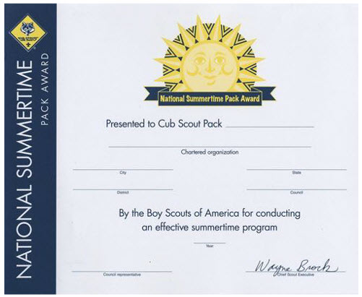  
PACK CERTIFICATE

From[*http://usscouts.org/advancementTOC.asp*](http://usscouts.org/advancementTOC.asp) and[*www.scouting.org/programupdates*](http://www.scouting.org/programupdates)

**Individual Cub Scout Summertime Award**



Boys who participate in three pack events, one each month for June, July, and August, are eligible to receive the National Summertime Pack Award pin, which they can wear on the right pocket flap of their uniform. This is an individual recognition for boys, not adults.

**Den Summertime Award**

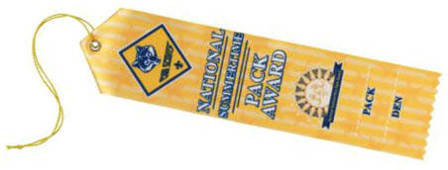

Dens with an average attendance of at least half their members at the three summer pack events are eligible for a colorful den participation ribbon.

**Pack Summertime Award**

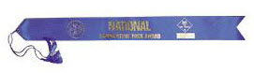

The pack can qualify for the National Summertime Pack Award certificate and streamer by planning and conducting three pack activities—one each in June, July, and August (or during other school vacations if your pack is in a year-round school).

**Application for ALL (Cub Scout, Den, and Pack) Summertime Awards**

The award application may be found at <http://www.scouting.org/filestore/pdf/33748.pdf>

# CUB GRUB

**Cub Grub Cookbook**

This is a really great cookbook for Cubs -

<http://balboaoaks.bsa-la.org/download/blog/Cub%20Grub%20Cookbook.pdf>

You can save a copy on your PC by selecting   
**File, Save As...** in your web browser's menu bar.

**Skateboard Sandwiches**

*Sam Houston Area Council*

**Ingredients –**

Your Favorite sandwich

Milk

Carrot sticks

Black olives

Food coloring

Water

Ice cube tray

**Directions –**

1. Remove the crust from the edges of the sandwich and trim the edges so that they are rounded like a skateboard.
2. Mix 3 Tbsp of milk with food coloring and place separate colors in the individual ice cube tray sections.
3. Using a new, clean water color brush, dip the brush into the colored milk and decorate the skateboard. Use the water to rinse the brush between colors.
4. To add wheels and axles, place an olive on the ends of two carrot sticks and lay the sandwich on top of both carrots.

**Mini Football Subs**

*Great Salt Lake Council*

**Ingredients**

Meat balls

Spaghetti sauce

Shredded cheese

Individual-size rolls

**Directions**

* Combine meatballs and spaghetti sauce in a skillet and warm them through.
* For each sub, cut a V-shaped notch from the top of an individual-size roll,
* Place meatball in the roll, and top with cheese shred laces.
* Finally, get the sandwiches in a huddle on a cookie sheet and
* Place them in a warm oven for a few minutes to melt the cheese.

**Yellow Howler**

*Great Salt Lake Council*

**Ingredients**

8 lemon-lime Gatorade ice cubes

¼ -1/2 c lemon-lime Gatorade or water

**Directions**

* Drop the Gatorade cubes into a blender or food processor.
* Pour in the Gatorade or water;
* Blend until slushy, adding more liquid if necessary.
* Serves 1

**Football Pudding**

*Great Salt Lake Council*

**Ingredients**

1 package instant pudding mix

Milk called for in directions on package

2 re-sealable bags

**Directions**

* Pour both milk and pudding mix into a plastic bag.
* Squeeze all the air out and seal.
* Place first bag in second bag and squeeze all the air out, seal.
* Stand in a circle and toss the “football” around for about five minutes.
* When pudding is done snip the corner of the bags and squeeze into cups for serving.

**Peanuts**

*York Adams Area Council*

Just get a bag of fresh roasted peanuts in their shells.

**Lemon Peppermint Sticks**

*York Adams Area Council*

Cut lemons into halves (two of them!) and in the center of each stick a 6-inch peppermint stick.

**Popcorn Sport Balls**

*Great Salt Lake Council*

**Ingredients**

¼ c chunky peanut butter

1 (10 oz) package large marshmallows

1 (12 oz) bag chocolate chips

7 cups popped popcorn

Black string licorice

2 tbsp soft butter

**Directions**

* Warm peanut butter on low in microwave for 1 minute.
* In another bowl, melt marshmallows and chocolate chips in microwave on low for 1 minute.
* Stir chocolate and soft peanut butter together.
* Pour over popcorn; stir to coat.
* Rub hands with butter; shape into a sport ball and
* Decorate with licorice.

**Smoothies**

*Chris Reisel, the creator of Baloo's Bugle*

Recently I have become a huge smoothie fan. I have at least one a night, sometimes two. I thought I would share some recipes I have. They are like milkshakes.

**Banana Orange Smoothie**

* Place in blender

1/2 cup orange juice,

1/2-cup milk, and

2 scoops of orange sherbet

* Slice 1 banana and add to blender with liquids
* Blend for about 10 seconds or until smooth.
* Yummy!

**Lemonade Sweet-Tart Smoothie**

* Place in blender

1 (6-ounce) can frozen lemonade concentrate

1 cup milk

1 cup water

1/4 cup sugar - or to taste

1 teaspoon vanilla extract

10 to 12 ice cubes

* Place all ingredients into container of electric blender.
* Blend on high until smooth, about 30 seconds.
* Serve immediately.
* Makes 3 to 4 servings.

*This one reminds me of a lemon sweet tart!*

**Watermelon Smoothie**

* Place in blender

2 cups seeded watermelon chunks,

1 cup crushed ice,

1/2 cup plain yogurt

1 Tbsp sugar .

* Combine all ingredients in blender container,
* Blend until smooth.

**Chocolate Graham Whipped Creme sandwiches**

*Chris Reisel, the creator of Baloo's Bugle*

***These are so good!***

**Ingredients:**

Chocolate graham crackers (not chocolate covered)

No Fat Cool Whip

**Directions**

* Break Graham Cracker in half.
* Put 2 TBS of Cool whip on one half.
* Top with other half.
* Put in freezer
* Eat frozen

**Ice Cream in a Bag**

*Oregon Trail Council*

**Ingredients:**

½ cup milk or cream

3 tablespoons sugar

1 teaspoon vanilla

**Materials:**

Quart-sized resealable freezer bag,

Gallon-sized resealable freezer bags,

Crushed ice,

Rock salt

**Directions**

* Mix the milk, sugar and vanilla in the quart-sized bag.
* Carefully push the air out of the bag and seal.
* Place this bag into the gallon-sized bag.
* Add crushed ice and several spoons of rock salt to the gallon-sized freezer bag.
* Remove any excess air and seal.
* While holding the sealed edge, shake and roll the bag for 10 or 15 minutes.
* Once the ice cream freezes, open the large bag and remove the ice cream bag.
* Enjoy your treat right from the bag.

**For flavored ice cream:**

* Add 1 tablespoon of instant pudding of your choice with the milk and freeze as in the recipe.

**Alternative for milk-sensitive Cub Scouts:**

* Use fruit juice in place of milk to make a nice cold sorbet.

**Lewis & Clark Treats**

*Alice, Golden Empire Council*

Want to experience some of the food that Lewis & Clark, John Muir and other courageous explorers have eaten? Prepare or purchase jerky, dried fruit, hardtack or make trail mix. Enjoy your treat on a den or pack hike. If you want to do as John Muir did, take white bread and squish it into little balls – Muir often lived on dried bread, tea and fruits and nuts that he gathered on the trail.

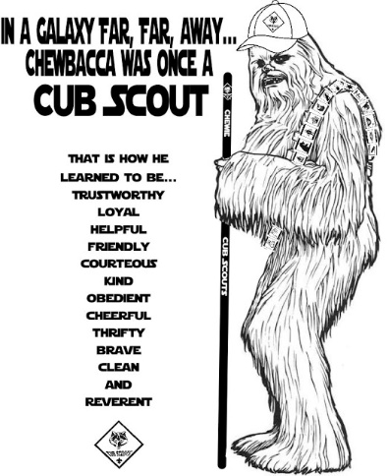**Red, White & Blue for Courage**

*Alice, Golden Empire Council*

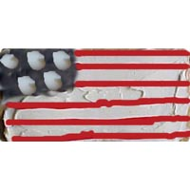

Let each boy make an individual “Salute” snack to enjoy – (this is an easier variation of the Program Helps idea) You will need: Graham Crackers, White icing, Blue sprinkles, Red rope licorice, White chocolate chips.

Each boy gets a graham cracker and craft stick or small knife to spread white icing on the cracker.

Have each boy mark off the square for the blue using the edge of a craft stick or knife. Now he can carefully drop blue sprinkles on the square.

Cut red licorice into thin strips and short pieces, and let each boy add the “stripes” to his flag.

If you have them, white chocolate chips can be used to make some stars.

While the boys enjoy eating their treat, remind them of the symbolism of the flag: 50 stars = 50 states; white = purity; blue = justice and fairness; and red = courage. Remind them that these are some of the same qualities that help make a hero.

***A larger version, I’m sure you’ve seen before, uses a sheet cake, rows of banana slices and strawberries, and blueberries. Just be sure to dip the banana in citric acid or pineapple juice so it doesn’t turn brown!***

**Pretzel Sparklers for July 4th**

*Alice, Golden Empire Council*

Give children long pretzel sticks. Have them dip the top part of the stick into melted white chocolate. Then, let them add red and blue sprinkles or other miniature candies on top of the melted chocolate.

**Fruit Sparklers for July 4th**

*Alice, Golden Empire Council*

Alternate blueberries, strawberries, bananas, cherries, and large marshmallows to make a red, white, and blue pattern onto wooden skewers. Note: When finished skewering fruit, break off sharp tips to prevent injury.

**Transformer Fruit Snacks**

*Alice, Golden Empire Council*

**Easiest of all –** just pass out Transformer fruit snacks - but be sure you have talked about what is required to “transform” yourself into a hero –someone who shows is Trustworthy and has the courage to stand up for what is right!

# ONE LAST THING

## TO BUILD A CAMPFIRE

*Alice, Golden Empire Council*

After many years of study and research, the following is a definitive step-by-step method of building a campfire

1. Split dead limbs into fragments and shave one fragment into slivers
2. Bandage left thumb.
3. Chop other fragments into smaller fragments
4. Bandage left foot
5. Make a structure of the slivers (including those imbedded in your hand)
6. Light the match
7. Light the match
8. Repeat “A Scout is Cheerful” and light a match
9. Apply match to slivers, add wood fragments and blow gently to base of flames
10. Apply burn ointment to nose
11. When wood is burning, collect more wood
12. Upon discovering that fire has gone out while out searching for more wood, soak wood from can labeled “kerosene.”
13. Treat face and arms for second-degree burns.
14. Relabel can to read “gasoline.”
15. When fire is burning well, add remaining firewood.
16. After thunderstorm has passed, repeat the above steps – in particular, continue to repeat “A Scout is Cheerful”

## MURPHY WAS A SCOUTER

*Baltimore Area Council*

Everyone knows Murphy’s Law. Well, it is a little known fact the Murphy was actually a Scout Leader. In my continuing quest to learn more about Scouting, I have begun to locate a number of his quotations, which I now offer to share with everyone. Murphy traveled throughout Canada, the USA, England and Australia, so some of the terms listed here may have a regional flavor.

* Scout Leaders who fail to show up at Leader’s planning meetings are automatically volunteered for the next least favored instruction or activity.
* The last Scouter who quit will be held responsible for everything that goes wrong - at least until the next Scouter quits.
* No matter how long or hard you shop for a particular piece of camping gear, immediately after you’ve bought it, it will go on sale cheaper.
* Under the most rigorously controlled conditions of time, planning, material acquisition, skill testing and training, Cub Scouts will invariably do as they dang well please.
* The time spent on consuming a camp meal is in inverse proportion to the time spent preparing it.
* Any tent peg, when dropped, will fall immediately where the tent will be placed and directly underneath where you place your sleeping bag.
* Interchangeable parts - aren’t.
* The chance of a piece of bread falling with the buttered side down, is directly proportional to the amount of mud in which you are standing.
* Leak proof seals - will.
* Never eat prunes when you’re famished.
* Matches are always at the bottom of the rucksack (backpack) when you need them.
* Matchboxes always open upside down, spilling the contents.
* The size of the fire is inversely proportional to the need, (for example - a glimmer for cooking and a roaring inferno for the campfire singing).
* The Map you bring is the wrong one, someone has just used the correct one to light the fire.
* The number of available tent pegs is always equal to the number of guy-ropes, less one.
* There is always a rock buried where you want to drive in the tent peg.
* The force of wind and rain is inversely proportional to the number of people putting up the tent.
* Meals are always eaten before the Leader has time to eat.
* The Leaders' sausages (hot-dogs) are always the ones that fall into the fire.
* Lights out, for Scouts, is defined as the time to start having fun.
* The weight of rucksacks increases with the distance traveled.
* Contents of a rucksack always increase in size when you try to repack them.
* Contents of the rucksack reverse position after packing, in proportion to their urgency of need (most needed items at the bottom).
* The carrier of the First Aid kit is always the furthest person away from the emergency.
* The size of a cut is always greater than the biggest Band-Aid available.