# PACK MEETING THOUGHTS

The Point of the Scout Law being highlighted for Cub Scouts in April is: **A Scout is Thrifty.** A Scout works to pay his way and to help others. He saves for the future. He protects and conserves natural resources. He carefully uses time and property.

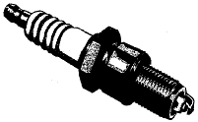

**HOW DOES “POWER UP!” RELATE TO THIS POINT OF THE SCOUT LAW?** A Scout protects and conserves natural resources. Scouts can explore the science of energy by looking at many different sources of power: solar, wind, hydroelectric, nuclear, gas, oil, coal, wood and even “Cub Scout Power!” They will discover how this energy is used in everyday life. They will explore different ways to conserve energy and protect the world in which we live.

# TABLE OF CONTENTS

PACK MEETING THOUGHTS 1

TABLE OF CONTENTS 1

GATHERING ACTIVITIES 2

OPENING CEREMONIES 5

AUDIENCE PARTICIPATIONS 6

ADVANCEMENT CEREMONIES 7

LEADER RECOGNITION 9

101 WAYS TO RECOGNIZE LEADERS 9

SONGS 11

STUNTS AND APPLAUSES 13

APPLAUSES & CHEERS 13

RUN-ONS 14

JOKES & RIDDLES 14

SKITS 15

CLOSING CEREMONIES 17

CUBMASTER’S MINUTES 18

PACK ACTIVITIES 23

Be sure to check the other parts of Baloo’s Bugle   
to see other ways you can   


***Months with Themes like***



|  |  |  |
| --- | --- | --- |
| **Month** | **Year** | **Theme** |
| **Energy** | | |
| October | 1943 | Cubs as Scientists |
| September | 1946 | Cub Scout Engineers |
| April | 1954 | The Story of Oil |
| January | 1960 | Cub Scout Scientist |
| September | 1963 | Science Fair |
| October | 1975 | The World of Sound |
| March | 1983 | Energy |
| September | 1985 | Science Fair |
| April | 2002 | Forces of Nature |
| March | 2003 | Why Does it Do That? |
| March | 2007 | Baloo Skies |
| March | 2009 | When I Grow Up |
| January | 2010 | Power Up |
| **Energy Conservation** | | |
| May | 1976 | SOAR |
| April | 1999 | Pollution Solution |
| April | 2001 | Save It For Us |

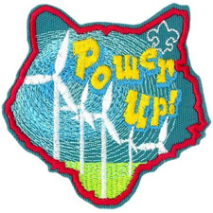

# GATHERING ACTIVITIES

***Note on Word Searches, Word Games, Mazes and such –*** *In order to make these items fit in the two column format of Baloo’s Bugle they are shrunk to a width of about 3 inches. Your Cubs probably need bigger pictures. You can get these by copying and pasting the picture from the Word version or clipping the picture in the Adobe (.pdf) version and then enlarging to page width.* ***CD***

***Three ways to make a pinwheel -  
do your best!! CD***

**PENCIL PINWHEELS**

*Mary Ruth & her RT Team, Patriots Path Council*

**Materials:** Paper (copy, origami, or light cardstock) cut into 4”x4” (or larger) squares, scissors, pencils, push pins, stickers, crayons, decorations (optional)

1. Draw diagonals on squares, with a line across each diagonal ½ inch from the center.
2. Write one of the following along each of the four dotted lines. Write it on the side of the dotted line without the big dot. The four words are WATER, SOLAR, WIND, CUB SCOUT.
3. Cut from each corner to the 1/2” mark.
4. To form the pinwheel, start with a corner point and gently pull it down to the center point of the pinwheel, be careful not to crease the paper. While holding a finger on the center to keep each piece in place, do the same with alternating corners until all four tips have been pulled to the center of the pinwheel.
5. Insert a push pin at the center. The push pin should hold all four ends together, about ¼” from each tip. Wiggle the push pin around to make the center hole a bit larger.
6. Holding the pencil on a flat surface with one hand, push the push pin into the side of the eraser. Don’t push on too tightly, to allow the pinwheel to spin more freely.
7. Finally, try blowing at the edges of the pinwheel to make it spin. Loosen the pin a bit if the blades do not rotate well.

**Tip:** If your pinwheel doesn't rotate freely, it’s probably rubbing against the pencil. You can fix this problem by inserting the pin into the eraser at a slight upward angle, or by slipping a small bead onto the pin before inserting it into the eraser.

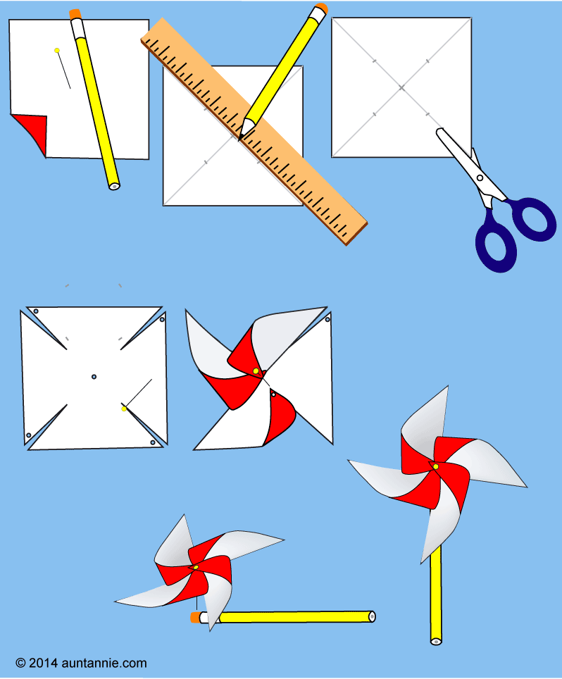

**ROCKET PINWHEEL**

*Las Vegas Area Council*

**Need:** wooden pencil with eraser, straight pin, round party balloon, flexible soda straw, scotch tape

**Directions:**

1. Stretch and inflate the balloon to stretch it.
2. Slip the end of the balloon over the end of the straw furthest away from the bend.
3. Use a piece of tape to seal it to the balloon to the straw. The balloon should inflate when you blow in the straw.
4. Bend the opposite end of the straw at a right angle.
5. Lay the balloon and straw on an outstretched finger so it balances and mark the balance point.
6. Push the straight pin through the straw at the balance point and into the eraser of the pencil, then into the wood itself.
7. Spin the straw a few times to loosen the hole the pin has made.
8. Blow in the straw to inflate the balloon and then let go of the straw.



**PINWHEEL**

*Baltimore Area Council*

*Materials*: Construction paper, brad, penny, straw, hole punch, scissors, pencil

*Directions*:

* Cut paper into a 6" x 6" square.
* Draw diagonal lines from corner to corner.
* Using the penny, trace a circle in the center.
* Cut the diagonal lines to the edge of the circle in the center.
* Close to the outer edge of the paper and just barely to the right of each cut, punch a hole in the pinwheel. Also, punch one hole in the center.
* Punch a hole through the top of the straw using a hole punch.
* Fold each corner, without creasing, to the center and fasten together with the brad.
* Push the brad through the hole in the top of the straw and loosely fasten the brad.
* Hold it in the wind. Your very own pinwheel!

**ENERGY WORD SCRAMBLE**

*Mary Ruth, Patriots Path Council*

Unscramble the jumbled letters   
to make energy-related words.

|  |  |  |
| --- | --- | --- |
| 1 | DIWN |  |
| 2 | NSU |  |
| 3 | LOI |  |
| 4 | TERCIELYITC |  |
| 5 | GEYRNE |  |
| 6 | LOSRA LAPEN |  |
| 7 | TNARLAU SGA |  |
| 8 | OEPWR LTANP |  |
| 9 | MATHGELROE |  |
| 10 | CIRTCELEORDYH |  |
| 11 | SAVERNOTCONI |  |
| 12 | GEAVTOL |  |
| 13 | WILKOATT |  |
| 14 | SLATINNUIO |  |
| 15 | SMARTTOTHE |  |

Energy Word Scramble Answers: 1 Wind, 2 Sun, 3 Oil, 4 Electricity, 5 Energy, 6 Solar Panel, 7 Natural Gas, 8 Power Plant, 9 Geothermal, 10 Hydroelectric, 11 Conservation, 12 Voltage, 13 Kilowatt , 14 Insulation, 15 Thermostat

**TYPES OF FUEL WORDSEARCH**

*Utah National Parks Council*

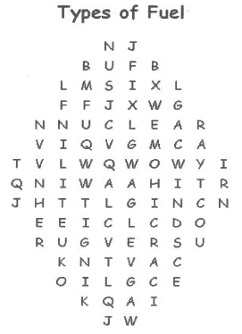

Find these words in the words search above

Coal Gas Nuclear

Oil Sun Water

Wind

**ENERGY WORD PUZZLE**

*Utah National Parks Council*

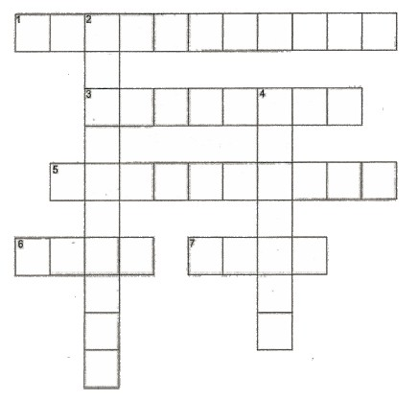

**Across**

1 - This is the power for our light bulbs

3 - A form of transportation that burns fuel to move   
(Hint - It flies)

5 - Propane turns into a liquid after this has been done to it

6 - A black rock full of energy

7 - In the US, ethanol is made from this plant

**Down**

2 - When a drop of water becomes invisible it does this

4 - The color black does this to solar energy

**SIMPLE SCIENCE EXPERIMENTS**

*Great Salt Lake Council*

Have your den chief help the boys with some of the science experiments.

**DANCING RAISINS**: Pour a can of sprite into a jar and then drop raisins in. The carbonation picks the raisins up and gravity pulls them down.

**PLEASE SQUEEZE:** Make sure your hand does not have any rings or hard objects in it. Then hold a raw egg in your hand over the sink. Squeeze as hard as you can. The egg does not break!

**BALLOON HOVERCRAFT**: You will need a large balloon. Cut off top from a plastic soft drink bottle with a 1/8-inch hole in the cap. (Make sure the rim is perfectly flat). Blow up the balloon then pinching the neck to keep the air in, stretch the mouth over the bottle top. Once the balloon is secure, let go of the neck, and watch it go!

**FLOATING METAL**: You will need a glass of water, and a paperclip. Fill a glass with water and rest a paperclip on the surface.

**BREAKING THE TENSION:**  You will need 4 toothpicks, shallow dish of water, dish soap, dropper. Fill the dish with water and allow it to settle so that the surface is completely smooth. Carefully float the toothpicks on the surface of the water, arrange into a star shape. Using the dropper add a drop of dish soap to the water in the center of the dish. This breaks the tension and the toothpicks are instantly drawn outward by the stronger surface tension around the edge of the dish.

**SNAKE CHARMING**: You will need tissue paper, silk handkerchief, plastic pen, metal plate or tray. Cut a spiral from a circle of tissue paper, lay the tissue paper spiral on the metal plate, and use the charged pen to draw the center of the spiral gently into the air. How to charge the pen: rub the plastic pen vigorously on the silk.

**REFLECTING POWER:** You will need a flashlight, small flat mirror, white cardboard, and matte black cardboard. Prop up the mirror and white cardboard at an angle to each other. In a dark room, shine the light onto the mirror. Replace the mirror with a white card. Then replace that with black cardboard. See what reflects light the most.

**COKE BOTTLE BALLOON FILLER**: You will need a coke bottle, balloon, ¼ cup vinegar, and ¼ cup baking soda. Place baking soda in the coke bottle. Pour vinegar into the balloon. Fit the top of the balloon over the top of the bottle and flip the balloon so that the vinegar goes into the bottle. The gas formed from the mixture will blow the balloon up so that it will stand upright on the bottle and begin to expand.

# OPENING CEREMONIES

**ENERGY POWERS OUR LIVES**

*Mary Ruth, Patriots Path Council*

**Materials:** Scripts with letters and pictures on back as indicated. Tell Scouts to hold up their scripts while speaking, and continue to hold them up so everyone can see the word ENERGY that is formed.

1. In our lives today, we use many forms of energy
2. *(Letter* ***E*** *and picture of electrical outlet)* **E**lectricity is used to power the lights, computers, and appliances in our homes and schools.

 

1. (*Letter* ***N*** *and picture of a flame)* **N**atural Gas, like oil, produces heat to keep us warm during those cold winter days and nights.
2. *(letter* ***E*** *and picture of ear of corn)* **E**thanol, from ears of corn, can be blended with gasoline to power our automobiles.

 

1. *(letter* ***R*** *and picture of a raindrop)* **R**ain that falls from the sky fills the lakes and rivers that we use to produce hydroelectric power.
2. *(Letter* ***G*** *and picture of geyser)* **G**eothermal energy is produced from the internal heat of the earth.

 

1. *(letter* ***Y*** *and picture of a Cub Scout)* BUT the most important form of energy comes from each of **Y**OU. It’s fueled by the enthusiasm you bring to Scouting!
2. We use energy in nearly everything we do. Let’s all work together to POWER UP!

**Cub Power Opening Ceremony**

*Utah National Parks Council*

Have the Cubs make up 8 1/2 X 11 sheets with the letters spelling out “CUB POWER” using really “electrifying” colors. Put their parts on the back in **LARGE** type.

1. C — Cub Scouts are the brightest.
2. U — You will see tonight.
3. B — Because we really can,
4. P — Power up the night.
5. O — Our leaders always tell us
6. W — We will have great fun.
7. E — Everyone will know
8. R — Really! Cub Scouts are Number One!

**Leader:** Let’s start our fun off tonight with the Pledge of Allegiance.

*(All stand, salute, and say the Pledge.)*

**ALL:** At the very end of the Pledge, the Den can shout out “Cub Power” in a manner similar to people shouting. **“PLAY BALL”** at baseball games.

**Power Up Opening**

*Las Vegas Area Council*

**Personnel -** Den of Cub Scouts with props named in ceremony, Cubmaster (CM)

**CM:** Our theme for the month is Power Up! There are different types of power we use every day of our lives.

There is solar power (have a Cub Scout walk on with exaggerated sunglasses, shining a flashlight in his own face)

Electrical power (have Cub Scout walk on with extension cord)

There is even wind power (have a Cub Scout walk on blowing a pinwheel).

But there is one source of power that is untapped - CUB SCOUT POWER! (Whole den runs in)

Please rise and join us in the Pledge of Allegiance.

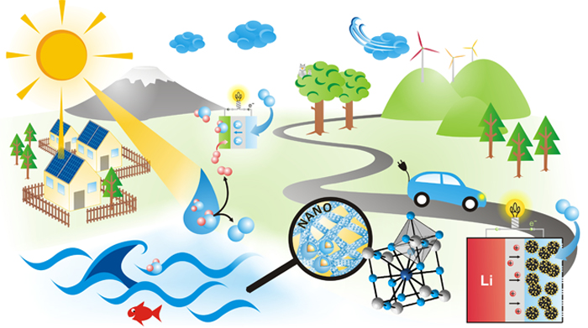

**Power Opening**

*Utah National Parks Council*

Have the Cubs make up small posters with the letters spelling out “POWER” and maybe an appropriate picture, too. on front. Write their parts on the back in **LARGE** type.

1. P - Perseverance to keep trying until we succeed.
2. O - Open to new ideas and ways to develop new skills.
3. W - Willing to test our limits and beyond.
4. E - Eager to help others whenever we can.
5. R - Ready to have fun and adventure.

**ALL** The POWER is within each of us. It is in each of us whether or not we decide to turn it on.

**OOoooops – It is Time for Opening**

*Utah National Parks Council*

* The room is darkened (dimmed lights). A den of boys comes out playing with pinwheels, hand-held electronic games, solar- powered calculators, etc.
* The Cubmaster, using a flashlight, walks over to turn on/up the lights in the room.
* One boy looks at his watch and says, “Wow, it’s time to go, so they can get on with the show!” The boys hurry to their seats.
* **Cubmaster:** I’m sure you know by now that this month’s theme is “Power Up!”, one of the most powerful things here tonight is the Power of Scouting. Will the boys of den ______ please present the Colors.



# AUDIENCE PARTICIPATIONS

**Franklin Discovers Electricity**

*Utah National Parks Council*

Divide audience into four parts. Assign each part a word and a response. Instruct them they are to say the response whenever they hear the word. Practice as you make assignments.

Franklin: “A Penny Saved!”

Lightning: “Zap-Zap-Zap”

Experiment: “Try it! Try it! Try it!”

Electricity: “Shocking!”

It was the 1740’s when Ben **FRANKLIN** started working with **ELECTRICITY**. He conducted many different **EXPERIMENTS** to try to understand more about it. His most famous **EXPERIMENT** being his kite flying one in Jun of 1752. **FRANKLIN** believed that **LIGHTNING** was a flow of **ELECTRICITY** taking place in nature. To test his hypothesis, he tied a metal key to a child’s kite and flew the kite during a thunderstorm. The key became charged with **ELECTRICITY**, and Ben had proof that **LIGHTNING** is really a string of **ELECTRICITY**. His kite **EXPERIMENT** and his others helped him develop many of the words and terms that we still use today when dealing with **ELECTRICITY**: charge, discharge, conductor, minus, plus, electrician, electric shock, and others.

**FRANKLIN'S** numerous experiments with **LIGHTNING** led to his invention of the **LIGHTNING** rod. The **LIGHTNING** rod is used to protect buildings and ships from getting struck by **LIGHTNING**. Benjamin **FRANKLIN** was a huge contributor to the field of **ELECTRICITY**. He is said to be the first man to discover anything spectacular about **ELECTRICITY**, and he is well known by people everywhere for that.

Unlike some other inventors in **ELECTRICITY, FRANKLIN** did not spend his entire life working with it. He invented many other things that had nothing to do with **ELECTRICITY**, such as bifocals, the **FRANKLIN** Stove, and the odometer. In 1831, he founded what is considered as the first public library. He wrote Poor Richard’s Almanac, which was published from 1732 to 1757. He also established the first fire department, and a police force. **FRANKLIN** was also a huge political power in colonial America. Benjamin **FRANKLIN** died at age 84 on April 17, 1790. He will forever be remembered for his contributions to **ELECTRICITY** and the rest of the world.

# ADVANCEMENT CEREMONIES

**Energy Advancement Ceremony**

*Utah National Parks Council*

For this ceremony, you will need large cardboard cutouts or drawings of sources of energy/power against back wall. If desired, the cutouts could be supported on a stand and have the awards attached to them. If this method is used, have the leader walk to each picture to get the awards as he/she speaks. One person can do all the parts or you can use the den leaders to tell about each rank. (Cubmaster (CM), Assistant CM (CA), Tiger Leader (TL) Den Leader (DL), Webelos leader (WL))

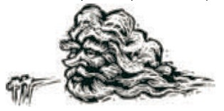

**CA** (Points to picture of wind) Just as the wind blows and creates energy, our Scouts have created energy in working on their advancements. Our Bobcats have worked hard, and deserve our recognition. Would the following Bobcats and their parents please come forward. Present awards to parents to present to sons. Lead Cheer.

**j0241091**

**TL** (Points to picture of atom) Each atom has lots of energy. By controlling the reaction, we harness this power for good. Our Tigers, too, have lots of energy and can get out of control. But when helped by their Adult Partners, their energy is used for good. Would the following Tigers and their parents please come forward? Present awards to parents to present to sons. Lead Cheer.



**DL** (Points to picture of sun) The sun heats our earth, and provides solar energy for generators. Our Wolves are also full of energy. They have accomplished many feats to earn their awards. Please help me recognize them for their accomplishments. Would the following Wolves and their parents please come forward? Present awards to parents to present to sons. Lead Cheer.



**DL** (Points to picture of liquid fuel) Liquid fuel provides the energy to heat our homes, and power our cars and airplanes. This energy has allowed us to Travel far, and discover new things we never thought possible. Our Bears are also discovering new things. They have worked to learn new ideas, and deserve our acclaim. Would the following Bears and their parents please come forward? Present awards to parents to present to sons. Lead Cheer.

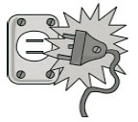

**DL** (Point to picture of electricity) Electricity has changed the way humans live. It provides energy to provide light, cook our food, run our computers and control temperature. Just as electricity changed the way we live, so have Webelos changed. They have worked on discovering new things while earning their Adventures, and learned about working on their own. They are becoming young men, and growing every day. We are proud of their accomplishments, and wish to honor them with their awards. Would the following Webelos and their parents please come forward. Present awards to parents to present to sons. Lead Cheer.

**CM** Sometimes our boys seem full of energy. Just as man learned to control energy and create useful power, these boys can use their energy for positive things. Let us commit to helping these boys continue along their Scouting path and become a source of power for others. Lead a final cheer.

**Power-ful Advancement Ceremony**

*Baltimore Area Council*

**Props:** paper pinwheels; tub with boat, pitcher with water to pour into tub; lamp and power source.

CM: This Pack Meeting is all about power. Our boys have really turned on the power as they used their energy and completed lots of Adventures.

CA: First our Tigers. Would the following Tigers and their Adult Partners come forward? (Boys and Partners come forward each carrying a picture of the sun) The sun was the first source of power for humans and the Tiger Den is the first step for many Cub Scouts. The sun kept them warm by day just as it warms our hearts to see our Tigers advancing and learning about Scouting. (Present awards - call each Scout up individually to give him recognition. Hand awards to parents with a hearty Thank You so they can present the awards to their sons) Lead a cheer.

CM: Would the following boys and their parents from our Wolf Den(s) come forward? (Boys and parents come, each blowing on their pinwheels) Just as the wind was one of the earliest known power sources, so these young scouts have achieved great and powerful goals as they have earned the Wolf Rank. (Present awards - call each Scout up individually to give him recognition. Hand awards to parents with a hearty Thank You so they can present the awards to their sons) Lead a cheer.

CA: Would the following boys and their parents from our Bear Den(s) come forward? (Boys and parents come forward each carrying a bottle of water) Let’s see you work together to make our boat float. (They pour the water into the tub, boat floats) The power of water has long been recognized Floods can quickly wash away homes and other structures and cause great destruction; but water is also a power for good-the electricity it generates provides power for many other activities. These boys can choose to channel their energy to destructive or helpful uses. It is their choice. Tonight, we have some bears who have showed us the power to do good works. (Present awards - call each Scout up individually to give him recognition. Hand awards to parents with a hearty Thank You so they can present the awards to their sons) Lead a cheer.

CM: Would the following boys and their parents from our Webelos Den(s) come forward? (Webelos and parents come forward each carrying a battery.) Webelos and parents, please put your batteries into a flashlight and turn it on. Electricity is an amazing source of power that has changed our lives forever. A lightning-quick energy is also found in these Webelos Scouts who continue to energetically get more and more Adventure pins. We commend this highest source of power. (Present awards - call each Scout up individually to give him recognition. Hand awards to parents with a hearty Thank You so they can present the awards to their sons) Lead a cheer.

CA: Just as power is all around us, so is there power within us to do great good. If we seek to do our best, to reach out and help others, that power will grow until we can accomplish whatever we want. Let's give these young men some POWERFUL applause!

**Energy Advancement**

*Las Vegas Area Council*

Have a group of designated persons - not boys - or   
pre-position flashlights to light up the awards table.)

At the designated time, turn off the room lights and turn on the flashlights.

**CM:** It took a lot of energy to achieve this award. Energy of fathers and mothers to supply materials and support, energy of the leaders to guide and lead the cub scouts and the energy of the boys devoted to completing everything required to ear this award. Everything worthwhile takes energy. Use your energy wisely.

Call up the boys and their parents. Present awards to parents to present to their sons. Lead a cheer for each group.





# LEADER RECOGNITION

## 101 WAYS TO RECOGNIZE LEADERS

*Southern NJ Council*

Recognition is a means of encouraging Scouting volunteers and sustaining their morale. It is one way of having them want to remain with the Scouting program. Recognition, in general, can take three forms:

**Embroidered knots –** Awards earned by Leaders who complete specific trainings, certain tenure, and performance requirements. The council awards the knots; the forms can be obtained at Council headquarters, filled out and returned to the council service center. Awards are usually presented at Roundtables, however, the unit will want to present it again or recognize those Leaders earning awards at the pack meeting.

**Official BSA Awards –** BSA has an extensive number of official awards and jewelry available at Council headquarters and through the BSA catalogue.

**Awards from the heart –** These are usually **pun and fun awards.** They are normally found or concocted and are often the most common and the most fun to present.

***Remember – these should be fun – not hurtful.***

Adult recognition may not be your first priority when dealing with Scouts, however, you better make it a priority or you may find yourself Scouting all alone.

**PUN AND FUN AWARDS**

The following are some “awards” that you can make and present to your adult leaders for all of the help that they give. Most of these awards could be mounted on a wooden base, or hung on yarn, string, or leather to be worn around the neck. They should also be personalized with the recipient’s name and date painted on them.

1. Super Cleaner Award – for the person who always sticks around to clean up (a tattered washcloth or bar of soap with a Scout decal painted on with acrylic or a monogrammed broom painted in Scout colors with the appropriate Scout decal attached).
2. Sticky Award – for the person that always gets you out of sticky situations (a cactus plant in a Scout decorated pot, glue with Scout decal on it, or a package of bubble gum).
3. Timer Award – for the referees or timers of races (egg timer, magnifying glass, or a pair of neckties – for those “neck-in-neck ties”).
4. Pear Award – for a great “pair” (a plastic pear) a present to a “great team”.
5. Cubby Award – for outstanding performance (like an Emmy, cut out a profile of a scout’s head, mount on wood).
6. Top Award – for the person who is “TOPS” (a small toy top).
7. First Aid Award – for the person giving you aid when you needed it (mounted band aid, or box of band aids with Scout decal on it).
8. Crutch Award – for the person on whom you can always lean (mount small crutch, or branch shaped like a crutch on a base).
9. Key To Successful Scouting – for the people who are the keys to the success of the program (cut out a giant key, paint recipient’s name on key, hang with string for necklace or mount).
10. Good Egg Award – for a person who comes through or doesn’t crack under pressure (spray a plastic Easter egg in Scout colors, or white and yellow fun foam cut in shape of a fried egg).
11. Measure Up – for the person whose performance set the standard (a ruler with recipient’s name painted on it).
12. Order of the Bear – for the person who did a “beary” good job, made things “bearable”, or did their “beary best” (any type of bear with recipient’s name on medallion hung from neck of bear).
13. Helpful Paw – for those who lent a “paw” (use ink pad, mark paw prints on a leather round and hang it on a long piece of leather s a necklace).
14. Whale Award – for the person who does a whale of a good job (can be a toy or cut out of a whale).
15. Puzzle Award – for the person who makes the pieces fall into place (small child’s puzzle minus 1 piece, put together and mounted on a piece of wood).
16. Footballer Award – for the person who isn’t afraid to tackle any job (small plastic football helmet, or a small football).
17. Hop to it Award – for a “hopping good job” or someone who “hopped to it and got it done” (mount a plastic frog or frog sticker).
18. Telephone Award – for the person who reaches out to help (small telephone on base).
19. Firecracker Award or Dynamite Award – for the person who did a “bang up” job (small firecracker made of chenille sticks in red, white and blue with ribbon or mount a firecracker).
20. Shovel Award – for the person who really digs in to help (spray paint a plastic shovel in Scout colors, write recipients name across blade).
21. Whisk Award – for the person who is un “beat” able at “whisking” our troubles away (small whisk broom or kitchen whisk).
22. Order of the Level – for the person who is one bubble sort of plumb. Mount a small level.
23. Rite on Award – for the person who is on the “right trail” (pencil with ribbon pennant put on top).
24. Apple Award – for the person with great “appeal” (real or plastic apple).
25. Cone Award – for the person who can lick any job (mount ice cream cone on base).
26. Top Banana Award – for the person who is in charge (plastic, real, or banana sticker).
27. Fire Hat Award – for the person who came to the rescue (child’s play fire hat).
28. Heart and Soul Award – for the person who put their heart and “sole” into their work (mount a small wooden heart on leather and place a cut out of the sole on a shoe on top).
29. Big Idea Award – for a person with big ideas (spray light bulbs in Scout colors and put on a plaque, two Christmas tree bulbs work well, each in Scout colors).
30. Lifesaver Award – for the person who saved the day (mount a lifesaver on a plaque, or a package of Lifesavers).
31. Pat on the Back – for a job well done (cut out a wooden or fun foam hand, place a hole in the bottom and tie a ribbon on that will fit over someone’s head, place it on backwards so that hand is on their back).
32. Spark Plug Award – for the person who “sparks” up your meetings (attach a spark plug to a plaque, make a tie slide from a spark plug, or attach plug to ribbon for a necklace).
33. Go For Awards – for the person who always runs errands or provides transportation (a toy car).
34. “YDG” Award – for the person who deserves “Ya Done Good” (cut out letters from fun foam).
35. B.S.A. 13 Hour Clock – for the leader who is very busy and still finds an extra hour to get the job done (make a clock face with “13” hours).
36. Hula Hoop – for the Scout leader to “jump through” those trying situations.
37. Loose End-er Award – for den leaders “tying up” all those loose ends (a piece of rope with lots of knots tied in it).
38. Bull Horn Award – for a leader who gets others attention (toy megaphone with recipient’s name painted on it).
39. Water Can Award – for the leader who helps the unit grow (a toy water can with their name painted on it).
40. Tulip Award – for the leader who doesn’t hesitate to spring into action (wooden, plastic, or real tulips painted in Scout colors).
41. Links to Scouting – for a Webelos leader who has prepared the boys for Boy Scouting (attach links of chain to a plaque).
42. Raise in Pay – for the leader who deserves a “raisin” pay (small box of raisins).
43. Exploding into Scouting – for the new den leader or patrol that took off into Scouting (a box of Atomic Fire Balls).
44. A Big Kiss Award – a bag of Hershey Kisses
45. The Big Headache Award – for the den leader who gave me the biggest pain (a bottle of aspirin, be careful with this one).
46. Old Fossil Award – for the person who’s been in Scouting the longest (a rock with a fossil in it).
47. Gift of Time – for the person who needs just a little more (a small bottle (baby food jar), spread glue on the inside; shake the spice thyme on the inside. Repeat until the inside of the glass is covered. Put top on jar when dry).
48. Right Direction Award – for the person who keeps the unit headed in the right direction (a small play compass).
49. Always a Winner Award – for the person who is always a winner (the ace, king, queen, jack, and ten of the same suit).
50. Good Cheer Award – for the person who is always cheerful (a box of Cheer laundry detergent).
51. Bounce Award - for the person who is enthusiastic (a box of Bounce laundry softener).
52. Flex Award – for the most flexible person I know (a bunch of rubber bands).
53. Light Award – for the person who is always there to lead us out of the darkness of confusion (candles in Scout colors).
54. Gift for the Treasurer – a small bag of gold foil covered chocolate coins.
55. A Real Peach Award – for the person who is a real peach (a can, real, or plastic peach).
56. Joy Award – for the person whom is always a joy to be around (a bottle of Joy detergent).
57. Zest Award – for the person who is always full of “zest” (a bar of Zest soap).
58. Honey Award – for the person who is a real “honey” (a jar of honey, or a Bit-o-Honey candy bar).
59. 1 Hour a Week Award – for any leader (a cardboard clock with only 1 hour on it).
60. Look Up To You – for the leader who sets the example (large wiggle eyes of a large fun foam or felt U).
61. Tea-riffic Scout/Scouter Award – tea bag mounted on wood or cardboard
62. Order of the Spare Marble – for the person who’s lost ‘em (a marble glued to a small piece of wood or to a string).
63. Berry Good Job – for the person who did a “Berry Good Job” (a wax or plastic berry mounted to a piece of wood).
64. Heads Up Award – for the person who is heads above the rest (a plastic head mounted above a piece of wood. Use a piece of wire to keep the head above the wood).
65. Hats Off Award – for someone we take our hats off to (an old hat mounted on a piece of wood).
66. Right Foot Award – for those who got us off on the right foot (trace a RIGHT foot on a piece of stiff cardboard, fun foam, or felt).
67. Big Heart Award – for those who always seem to have one (trace a very large heart shape on a piece of stiff cardboard and embellish with glitter or sequins).
68. Egg-cellent Job/Idea/Etc. Award – for those who did an excellent job (plastic Easter egg, painted in scout colors, mounted on a piece of wood).
69. “Udderly” Ridiculous Award – blown up latex glove
70. Well Done – a piece of very dark toast
71. Nuttiest – a bag of nuts
72. Corniest – an ear of corn or can of corn
73. Expanded Our Knowledge – elastic band or large rubber band
74. You Stuck To It Award – roll of tape or bottle of glue
75. Record Breaker (of any kind) – a mounted broken record. (May have to explain this to Scouts!)
76. Fantastic Award – a large paper hand fan, old decrepit electric fan
77. Thanks A Million – clip art of a million-dollar bill or fake million-dollar check (sign the check “N. O. Good”). Blow it up really big.
78. Covered the Topic – a plastic lid
79. Windbag Award – a blown up bag
80. Right-On Target – a target pasted to cardboard or fun foam
81. Kept Up In stitches – a needle and thread
82. Really Tacky Award – lots of thumb tacks mounted on scrap wood
83. Hung In There – anything hanging from something (try to get a picture of the recipient)
84. Worked Like a Dog – a mounted dog biscuit, bone, or small plastic dog
85. Tee-rific – a mounted golf tee
86. The Covered “Dime-An’-Pin” Award – glue a pin to a dime
87. Plunged Right In Award – a small plumber’s plunger
88. Rose To The Occasion – an artificial rose
89. N’ice Job – a box of N’ice cough drops
90. Had A Ball – mount a ball any size, any kind
91. Its “Bean” Wonderful- mount a lima bean or other large dried bean, or can of beans.
92. Bag of Trix Award – Trix cereal
93. Knocked Yourself Out Award – mount a small hammer or mini bat
94. A Real Card – mount a playing card
95. Shining Example – a small flashlight or small mirror.
96. Hornblower – for those who never blow their own horn. Mount a plastic bicycle horn.
97. The Rock Award – for those who are the “rock” of the unit. A small mounted rock.
98. Fizzy Award – an individually wrapped Alka Seltzer.
99. I Can Award – for the Scout/Scouter with the ‘I can do it’ attitude – a large can with a capital “I” drawn on it.
100. For You There Is No Equal – a mounted packet of Equal.
101. You’re Matchless! – an empty book of matches mounted.

# SONGS

**Let’s Go**

*Utah National Parks Council*

Tune: Row, Row, Row Your Boat

Ride, ride, ride your bike,

Pedal for goodness sake.

Up and down, up and down

How the legs do ache.

Ride, ride, ride your horse,

Following the trail.

On, no, I fell off

I’m glad the horse can’t tell.

Ride, ride, ride the bus,

Ride it here and there.

Seeing all the pretty sights

Without a driving care.

Fly, fly, fly a plane,

It’s really lots of fun.

Gliding high up in the sky

Just to see the sun.

**We’ve Got That Power**

*Mary Ruth’s RT Team, Patriots Path*

Tune: “I’ve Got That Cub Scout Spirit”

We’ve got that solar power, giving us heat,  
Growing the plants, so we can eat.  
We’ve got that solar power giving us heat,  
giving us heat today.

We’ve got that wind power, blowing on in,  
Flying our kites, high in the wind.  
We’ve got that wind power, blowing on in,  
Blowing on in today.

We’ve got that water power,   
rushing right through,  
Turning the wheels, making power for you.  
We’ve got that water power,   
rushing right through,  
rushing right through today.

We’ve got that Cub Scout power,   
deep in our hearts,  
We never rest, doing our best.  
We’ve got that Cub Scout power   
deep in our hearts,  
Deep in our hearts to stay

**Train Song**

*Mary Ruth’s RT Team, Patriots Path*

(Tune: Yankee Doodle)

I met an engine on a hill,  
All hot and broken-hearted.  
And this is what he said to me,  
As up the hill he started.

(S lowly) I think I can, I think I can,  
At any rate, I'll try.  
I think I can, I think I can,  
At any rate, I'll Try.

A-choo choo choo, A-choo choo choo,  
A-choo choo choo choo choo.  
A-choo choo choo, a-choo choo choo,  
A-choo choo choo choo choo.

He reached the top, and looking back,  
To where he stood and doubted.  
He started on the downward track,  
And this is what he shouted.

(Quickly) I knew I could, I knew I could,  
I never should have doubted.  
I knew I could, I knew I could,  
I never should have doubted.

**Energy**

*Mary Ruth’s RT Team, Patriots Path*

Tune: Jingle Bells

Energy is found in many different forms.  
Solar, wind, and coal make our electric power.  
Natural gas is burned to keep our houses warm.  
Petroleum is used to make our cars and trucks go vroom!

Oh … energy, energy, it’s what heats our homes.  
It powers our lights and fuels our cars;  
It makes the world go round.

Oh … energy, energy, it’s what heats our homes.  
It powers our lights and fuels our cars;  
It makes the world go round.

**The Runaway Train,**

*Mary Ruth’s RT Team, Patriots Path*

(Tune: When Johnny Comes Marching Home)

The runaway train came down the track  
She blew (whew), She blew(whew)  
The runaway train came down the track  
She blew (whew), She blew(whew)

The runaway train came down the track  
She ran into the tunnel and never came back  
And she blew (whew), blew (whew), blew (whew), blew (whew)  
Jiminy, how she blew (whew)!

1. Normal tempo
2. Slow and soulful
3. Elmer Fudd Style   
   (pronounce “r’s” as “w”

**Designate a group for the “whew”**

**This Light Of Mine**

*Baltimore Area Council*

Tune: This Little Cub Scout Light of Mine

**1st verse:** This solar powered light of mine,  
I'm going to let it shine.  
This solar powered light of mine,  
I'm going to let it shine.  
This solar powered light of mine,  
I'm going to let it shine, let it shine,  
Let it shine all the time.

**2nd verse:** - This hydro-powered light of mine

**3rd verse:** - This wind-powered light of mine

**4th verse:** Solar, wind and hydro-power,  
We're going to turn it on.  
Cook our food and run tile dryer  
We're going to turn it on.  
Watch TV and surf the net.  
We're going to turn it on,  
Turn it on, turn it on you bet.

**This Little Cub Scout Light**

*Mary Ruth’s RT Team, Patriots Path*

Tune - This Little Light of Mine,

This little Cub Scout light of mine,   
I'm gonna let it shine.   
This little Cub Scout light of mine,   
I'm gonna let it shine.  
This little Cub Scout light of mine,   
I'm gonna let it shine.   
Let it shine all the time, let it shine.

1. All around the neighborhood,   
   I'm gonna let it shine. ...
2. Hide it under a bushel--  
   NO!-- I'm gonna let it shine. ...
3. Don't you try to blow it out,   
   I'm gonna let it shine. ...
4. All around this world of ours,   
   I'm gonna let it shine. …

**Solar, Wind, Hydro-power**

*Baltimore Area Council*

Tune: The Worms Crawl in, The Worms Crawl Out

The world is full of such wonderful stuff

To give us power, there'll be enough

The sun, the wind and the water too

Can generate- power for me and you.

**Chorus:**Day in and out, the sun will shine,

The wind will blow another time.

The water runs down hill into dell

The generator to run as well.

The future's ours to invent and create

A clean-powered world, it's not too late.

We'll run our cars and lawnmowers too

And have clean air and water blue.

**Chorus**

**Mr. Solar Sun**

*Great Salt Lake Council*Tune – Mr. Sun, Sun, Mister Golden Sun  
<http://littlebabybum.com/mr-sun-sun-mister-golden-sun-nursery-rhyme-by-littlebabybum-hd-version/>

Oh, Mr. Sun, sun, Mr. Solar Sun  
Please give me energy  
We use solar power for many things   
To light our homes and heat it too   
These little Cubs are asking you  
To please come out so we can cook some food,  
So Mr. Sun, sun, Mr. Solar Sun,   
Please give me energy.

So come on and do the things you do.  
Oh, Mr. Sun, sun, Mr. Solar Sun  
Please give me energy,   
Oh won’t you give me,   
Please give me energy.  
Please give me energy!

# STUNTS AND APPLAUSES

## APPLAUSES & CHEERS

**Lightning Bolt Cheer**

*Mary Riuth & Her RT Team, Patriot’s Path*

* Divide the audience into 2 groups. The first group yells, “ZIP” when the leader points to them; the second group yells, “ZAP” when pointed to. Then the leader points to both and all yell, “BOOM.” (do quickly…repeat if desired)

*Utah National Parks Council*

**Locomotive Applause:** Begin by slapping your left arm slowly with your right hand. Gradually increase the speed, working down over the left palm to the end of the fingers. Then place your right hand over your eyes as if peering into the distance. Imitate a train whistle, “Whoo, whoo.”

**Electricity Applause:** Place both index fingers together and say “Zip, zap, zop!”

**Oil Well Applause:** Stand up, place both hands overhead and hook thumbs together, Wiggle fingers and say “Gush, gush, gush!”

**Fire Applause 1:**

* Pretend to gather wood, lay it down in front of you,
* Take a match from your pocket ,
* Strike it and light the fire.
* Blow lightly on the fire,
* Hold out your hands and
* Say “Ooh, ahh, that feels soooo good!”

**Fire Applause 2:** Hold hands out in front of you as if in front of a campfire, sigh and say, “I feel warm all over.”

**Fire Applause 3:** Shout “Call 911! Call Smokey Bear! The fire’s out of control!”

**Solar Power Applause:** Pretend to slather on suntan lotion, put on sunglasses and sunbathe. Say “The sun—It’s a gas!”

**Mad Scientist Applause:** Pretend to hold up a test tube in one hand. Pour something into it, then add something else, then yell, “BOOM!”

*Great Salt Lake Council*

**Great Job Applause:**  Group stands and says   
“GREAT JOB GREAT JOB GREAT JOB,   
getting louder each time.

**Electricity:** “It’s electric!”

*Baltimore Area Council*

**Lightning -** Shake your finger like jagged lightning and go "Shh Shah" on each jagged movement.   
To add thunder - add a **"BOOM"** after every 4 +/- lightning jags or so.

**Livewire -** Pretend to Grab onto a live electrical wire and shake the whole body, while saying "ZZZZZZZ".

**Two-handed Saw -** Everyone pairs off into two’s. Each pair sticks their hands out with their thumbs up. Alternately grab each other’s thumbs until all four hands are each holding a thumb. Move arms and hands back and forth as if using a hand sawing.

**Carpenter Yell -** Pretend to be holding a hammer in one hand and a nail in the other. Start pounding the nail with the hammer while saying, “Where is the electrical hammer? It takes energy but goes faster”.

**Extension Cord Yell -**Plug it in! Plug it in! Plug it in!   
Where is the electric? Where is the electric? Where is the electric?   
Use your muscles! Use your muscles! Use your muscles!

## RUN-ONS

**THREE RUN ONS -**

*Mary Ruth and her RT team*

**Run-On #1**

1. What did the Northwind say to the Southwind to start the race?
2. I didn’t know they even had a race.   
   What *DID* the Northwind say?
3. CS#1: Ready…..Set……BLOW!

**Run-On #2**

1. Why did the lights go out?
2. Hmmm…I don’t know, did a tree fall on a wire or something?
3. No. The lights went out because they liked each other!

**Run-On #3:**

1. Everyone knows we should conserve energy. Can you name one way to do that?
2. I would love to conserve energy by staying in bed all day!
3. It is announced that a member of the pack has memorized Washington’s Farewell Address and is about to do a dramatic portrayal of it. A boy emerges dressed as Washington and delivers his farewell address:

**Cheerleader**

*Great Salt Lake Council*

Leader: Give me a “B” Cubs: “B”

Leader: Give me a “L” Cubs: “L”

Leader: Give me a “B” Cubs: “B”

Leader: Give me a “L” Cubs: “L”

Leader: Give me a “B” Cubs: “B”

Leader: Give me a “L” Cubs: “L”

Leader: Give me a “B” Cubs: “B”

Leader: Give me a “L” Cubs: “L”

Leader: Put ‘em together and what do you have?

Cubs: (Put index finger between lips and say,  
”Bl-bl-bl-bl!”)

## JOKES & RIDDLES

**Jest for Fun**

*Utah National Parks Council*

Q: What did the baby light bulb say to the mommy light bulb?

A: I love you watts and watts!

Q: Why do transformers hum?

A: They don’t know the words.

Q: Why was the free electron so sad?

A: It had nothing to be positive about!

Q: Why did the lights go out?

A: Because they liked each other!

Q: Why did the foolish gardener plant a light bulb?

A: He wanted to grow a power plant.

Q: How do energy-conscious people feel about wind power?

A: They’re blown away.

Q: And how do we know that wind power is popular?

A: Because it has so many fans.

Q: How did Benjamin Franklin feel when he discovered electricity?

A: He was shocked.

Q: What does the nuclear scientist do in his spare time?

A: Goes fission.

Q: In which part of the jail are energy criminals kept?

A: The fuel cells.

Q: What is burned by cars driven late at night?

A: Midnight oil.

# SKITS

**Rockets Away!**

*Utah National Parks Council*

**Scene 1:**

***Boys are out in front of audience talking.***

Cub 1**:** I have some boards in my back yard.   
Let’s make something.

Cub 2**:** I can get some nails.

Cub 3**:** My Dad said I can use his hammer and tools if I’m careful.

Cub 4**:** My brother has an old steering wheel in the garage. I’ll get that.

Cub 5**:** How would you like a compass and some other good stuff?

Cub 6**:** I can get some tail pipes for the exhaust.

Cub 1**:** What can we use for fuel?

Cub 2**:** How about Gasoline, kerosene or sterno?

Cub 6**:** I’m not allowed to use any of that stuff.

Cub 3**:** I have an inner tube.

Cub 4**:** OK guys, let’s all meet at Jack’s in half an hour.

Cub 5**:** I’ll bring some food.

**Scene 2:**

***Boys out of site, lots of background noise— hammering, sawing, etc. Two Moms out in front. Use real Moms - cross dressing is a gray area in Scouting.***

Mom 1**:** I wonder how the boys are doing. Imagine!   
A rocket ship.

Mom 2**:** Ha, ha. Well, it kept them busy for a long time.

*(In background all boys yell “Bye Mom”   
or “Tell my mother good-bye.”)*

Moms**:** Oh, sure! Bye boys, have a nice trip. Ha, ha.

*(Loud noise in background like a rocket taking off.   
Curtains begin to blow.)*

Mom 1**:** Look! They’re leaving!

Mom 2**:** Oh, no! Come back boys, come back!

*(Mothers run offstage after Cubs looking up   
and raising hands to the sky.)*

**A Powerful Encounter**

*Utah National Parks Council*

**Scene:** Benjamin Franklin is standing center stage. He is holding on to a kite string with a large key hanging from it as he stares up into the sky. Optional costume for Ben Franklin: shoulder length wig and round rim spectacles, knickers, large coat and vest. Each boy approaches Ben Franklin one at a time.

Cub 1: What are you doing, Ben?

Ben: Flying my kite. I am trying to harness the lightning from that storm cloud. When I do, I think I will call it electricity.

Cub 1: What can you do with that electricity, Ben?

Ben: Why, you can use it to make artificial light and do away with those awful headaches from breathing lantern oil fumes.

Cub 1: That sounds real swell, Ben.

*(Cub 1 Exits.)*

Cub 2: What are you doing, Ben?

Ben: Flying my kite. I am trying to harness the lightning from that storm cloud. When I do, I think I will call it electricity.

Cub 2: What can you do with electricity, Ben?

Ben: It will provide the power to grind all of our grain, turn large machinery and even modernize my printing press.

Cub 2: That sounds real swell, Ben.

*(Cub 2 Exits.)*

***Write more little vignettes about Ben so that there will be one for each member of your Den.   
Or pair the boys up sending two at a time to meet Ben***

Cub 3: What are you doing, Ben?

Ben: Flying my kite. I am trying to harness the lightning from that storm cloud. When I do, I think I will call it electricity.

Cub 3: What can you do with electricity?

Ben: As I see it, the possibilities are endless. The only limitation will be the human imagination.

Cub 3: (Hands Ben two ‘D’ cell batteries) When you catch the electricity, will you put some back into these batteries? Our portable radio quit working about an hour ago.

*(Ben stares at the batteries in disbelief   
and drops the kite string.)*

**Saved By The Light?**

*Utah National Parks Council*

Characters: Six Cub Scouts in uniform, a Martian

Props: lights, sound effects of a crash

Scene: Wooded area, where several Cubs are sitting around.

Cub 1: Gee, I’m tired. I really think we’re lost.

Cub 2: Yeah, I wish we had stayed with (den leader).

Cub 3: She was going too slow, looking at all those boring leaves.

Cub 4: Do you think we'll ever get out of these woods? We could be here forever.

Cub 5: Don’t be silly. They’ll organize a search party for us soon.

Cub 6: I sure hope so. I’m getting hungry and it’s getting dark.

*(Stage lights begin to dim and   
a light appears from offstage.)*

Cub 1: Hey look! See the lights!

Cub 2: Yeah, I see it. Looks like they’ve got a helicopter out looking for us. That’s neat. Just like on TV.

All: (Jumping up an down, yelling And waving their arms.) Over here! Over here! Come help us! We’re lost! Over here! (More lights appear from offstage. A loud crash is heard.)

Cub 3: They’ve landed! Someone is coming through the trees over there. (Points offstage.)

*(Martian enters.)*

Martian *(In Martian accent):* Could you tell me how to get back to Mars? I was out exploring with my Den Leader, and I got lost!

**Energy Skit**

*Baltimore Area Council*

**Supplies:** pictures/drawings of energy and power sources.

**Actors:** 6 Cub Scouts each holding a picture with his part on the back in LARGE Type.

1. (Holding a picture of the wind)  
   The wind blows and creates energy we can use for many things.
2. (Holding a picture of the sun)  
   The sun heats our earth and provides energy to warm our homes.
3. (Holding a picture of a gas station pump)  
   Fossil fuels provide the energy to power our cars and airplanes, making it possible for us to go far.
4. (Holding a picture of a bolt of electricity)  
   Electricity has changed the way we live, providing energy to light up our lives.
5. (Holding a picture of an atom)  
   Fission and fusion unlock power untold.
6. (Holding a picture of a Cub Scout)  
   We’re full of energy, being a Cub Scout helps us use our power as a positive force for good things.

**Light Bulb**

*Great Salt Lake Council*

**Equipment:** one shovel for each Cub Scout

* Most of the cast has their shovels and are pretending to work hard digging.
* One Cub just stands still with his arm raised.
* A boss comes, and says to the idle man, “Why aren’t you working?”
* The man says, “I’m a light bulb!”
* The boss leaves and returns later, only to see the man still standing still.
* The boss again asks, “Why aren’t you working?”
* “I’m a light bulb!” he says.
* The boss replies, “If you don’t start working I’ll fire you!”
* The boss comes back later to see the same thing.
* “You’re fired!” he yells.
* The man walks away.
* Everyone else drops their shovels and follows him.
* The boss asks why they are leaving,
* They say, “We can’t work in the dark!”

**Lost Quarter**

*Great Salt Lake Council*

**Equipment:**  Flashlight

**Set Up:** Cub #1 and #2 are searching an area; Cub #1 has the flashlight. Cub #2 is searching on the ground in the light from the flashlight. Cub #1 and Cub #2 keep doing this through the entire skit.

Cub #3 walks up and asks Cub #2 what he is doing.

Cub #2 “I dropped my quarter and now I’m looking for it.”

Cub #3 "May I help?"

Cub #2 "Sure!"

*Repeat this Q&A routine until all your boys   
have gone except for one.*

Cub #X walks up and says to Cub #2, “Watch doing?”

Cub #2 “I dropped my quarter and now I’m looking for it.”

Cub #X “Where did you drop it?”

Cub #2 “Over there.” (Pointing to a different spot.)

Cub #X “Then why are you looking over here?”

Cub #2 “Because this is where (Give name of Cub #1) is holding the flashlight.”

**New Saw**

*Baltimore Area Council*

**Cast:** Lumberjack (LJ), Announcer (ANN), Owner(O)

**ANN:** This scene takes place in a hardware store in some small north woods lumber town.

**LJ:** (Enters) My old crosscut saw is worn out, and I need something that will let me cut more wood, or I’m going to go broke!

**O:** Yes sir! For only $100 you can be the proud **O** of this electric chain saw. I guarantee that it will cut twice as much wood in a day as your own crosscut.

**LJ:** (Pays for saw) O.K. great! (Exits)

**ANN:** The next day.

**LJ:** (Enters tiredly) There’s something wrong with this saw. I worked very hard yesterday, and it would not cut any wood.

**O:** Well, sir, I have a lot of faith in this product. I’ll put a new chain on it and you give it another try.

**LJ:** OK, but if it doesn’t work any better, I’ll be back! (Exits)

**ANN:** The next day.

**LJ:** (Enters exhausted) This dumb saw is no good. I worked even harder, and still it won’t cut the wood like my own saw. I want my money back!

**O:** Yes, sir! Just let me check it out here. (He takes it over to the wall and plugs in the saw. He pulls the starter rope.)

**ANN:** (Makes sound effects of saw running.)

**LJ:** Oh, my gosh! What on earth is all that noise?

# CLOSING CEREMONIES

**Power Circle**

*Las Vegas Area Council*

(Cub Scouts, Cubmaster, Den Leaders, and other registered leaders ***(and parents, too, if you wish)*** join hands and form a circle).  *You could make it a regular hold hands circle or form a Living Circle with left hands and thumbs!!*

**CM:** Just as in all powerful things, there is power in all of us. If we all join together by all holding hands our power increases and our boys will reap the benefits. That is the power of Scouting.

**The United States Constitution**

*Great Salt Lake Council*

**Cubmaster (CM):** The United States Constitution is the supreme law of the land. It is what powers our legal system. The Constitution was the power that made the United States a nation. It was written in 1787 and was signed by 40 men. Four famous signers were George Washington, Benjamin Franklin, James Madison, and Alexander Hamilton.

*Cub Scouts carrying cards with the words to the Preamble to the Constitution come to the front of the stage.*

**CM:** Please stand and say the Preamble to our Constitution.

The posters should be as follows -   
Cub Scouts could show all the posters at once or turn them over in sequence as the Preamble is recited.

1. “We the people of the United States,
2. in order to form a more perfect union,
3. establish justice,
4. insure domestic tranquility,
5. provide for the common defense,
6. promote the general welfare,
7. and secure the blessings of liberty,
8. to ourselves and our posterity,
9. do ordain and establish this Constitution
10. for the United States of America.”

# CUBMASTER’S MINUTES

**Turn On The Power**

*Utah National Parks Council*

What is the most powerful thing you can think of? Is it a locomotive that can pull a hundred railroad cars? Or is it a mighty rocket with giant engines that roar and belch fire? Is it a nuclear energy plant with enough power to light up a whole city? Or is it the sun, with enough energy to warm a whole planet?

As powerful as all these things are, there is a limit to their energy. A locomotive and a rocket can run out of fuel, and the fuel rods of a nuclear plant wear out after a while. Even the sun sets after a few hours, leaving half the world cold and in darkness.

But there is another power source that never runs out of energy and that will never leave us in the cold. That power is God, and it’s important that we learn how to connect with God’s power. We learn how to do that by regularly attending our place of worship and living by the values we learn there. Why don’t you ‘plug in’ to the greatest power in the universe by worshipping God this week.

**Power Up**

*Las Vegas Area Council*

Solar power, electrical power and wind power are just a few of the many types of power we use in our everyday life. They make our lives comfortable, safer and at times more complicated, and sometimes a little fun to. The next time you turn on a lamp, take a hot shower, use your computer, or play a video game, take a moment to simply give thanks for the power we have available at our fingertips.

**Aim For The Stars**

*Utah National Parks Council*

The words, “Aim for the Stars” have an important meaning to Cub Scouts. Think of Thomas Edison who tried and failed

hundreds of times before he perfected the electric light bulb. He never quit trying. A Cub Scout, who tries to do his best and keeps trying, is preparing himself for greater responsibilities when he becomes a man. What you do and how well you do it becomes your launching pad to “Aim for the Stars.”

**A SCOUT IS THRIFTY**

<http://scoutmastercg.com/a-scout-is-thrifty-scoutmaster-minute/>

A Scout is thrifty. A Scout works to pay his way and to help others. He saves for the future. He protects and conserves natural resources. He carefully uses time and property.

Scoutmasters need to exercise thrift in ways that are not often talked about –

**Thrift in words.**Paradoxically many of the character traits that make a good Scoutmaster can also make a tiresome Scoutmaster. Most of us like to talk and sometimes forget to stop. I have learned to recognize the look Scouts have when they have had enough talk.

**Thrift in time.**Scouting is so intriguing and challenging and rewarding that many of us get over committed and over involved. Family, work and sanity can suffer terribly if we are not thrifty with our time.

**Thrift in leadership.**Scouts can be over-led. They need to have plenty of latitude to explore the world on their own terms. Attempting to weight every experience with significance and a demand for perfection can grow tiresome to Scouts. Give them plenty of room.

We Scoutmasters are driven, motivated and energetic. It is important that we exercise some thrift so our exuberance supports rather than overwhelms the program.

**A SCOUT IS THRIFTY**

<http://www.macscouter.com>

Scouts, here I have a handful of sand, and in my other hand I have a piece of topsoil, just sod. Do you see much difference in them?

Yes, you're right. There's the difference between poverty and wealth here - the difference between starvation and prosperity for all people. This sand represents a civilization that once flourished and is now dead because of misuse of resources. People took from the soil and put nothing back.

But this sod is different because it contains the miracle power of growth. This sod is topsoil enriched through many years.

Our very existence depends on the narrow margin of about 6" of topsoil that covers much of our planet. Without it, we cannot survive.

If all the topsoil of the world eroded, what would people live on? Food can't be raised on sand or rock.

What things can we do, as Scouts and as citizens, to help people better understand the importance of this (gesturing with the sod) and not just let our land drift to this (sand) - with the topsoil allowed to waste away?

A **SCOUT IS THRIFTY**

<http://users.math.msu.edu/users/mccarthy/troop272/scoutmaster.minutes>

I don't know about you, but whenever I hear the word "thrifty" I think of a guy putting his money in a bank. But I know that the word means a lot more than that. When we say, "A Scout is thrifty" we're talking about a lot more than saving money.

Thrift means not wasting things, too. We should not waste food, for example. And we should not waste our natural resources, either. When we go camping, we don't burn more wood than we need, we don't trample plants and wildflowers unnecessarily, and of course we are careful with fire.

All parts of that thrifty idea is contained in our Outdoor Code. In the code, we pledge ourselves to be clean in our outdoor manners, careful with fire, considerate of others, and conservation minded.

So, the point of the Outdoor Code is to preserve the wonders of the outdoors for others to use in turn. And that's being thrifty just as much as saving our money is. Let's all think thriftiness every time we hike and camp.

**OUTDOOR CODE**

As an America, I will do my best to  
Be clean in my outdoor manners  
Be careful with fire  
Be considerate in the outdoors, and  
Be conservation minded.GAMES

**Wind-Power Balloon Race**

*Mary Ruth & her RT Team, Patriots Path Council*

**Equipment:** A Balloon for each Den (Have extras in case one breaks. Use non-latex balloons if possible), one drinking straw for each person.

Dens line up relay style, each Den with a balloon, and each player with a straw. On “go” first player uses straw to blow balloon to wall, then back to next player. Repeat until all are done. (make sure teams are even – have some repeat if needed). Tell Dens to do “Zip, Zap, Boom” cheer to signal completion.

**NOTES:**

1. If your meeting place has a rule about latex balloons, or someone in your Pack has a latex allergy, MAKE SURE TO USE NON-LATEX BALLOONS.
2. Pre-test this game yourself, and set the start line a reasonable distance from the wall.
3. Make sure all teams all have the same number of people.
4. For more FUN, have Den parents participate, along with their sons!

**Thumblers**

*Utah National Parks Council*

**Equipment:** Enough tape to give each boy two 6 inch strips of tape

* Have the boys help each other to tape their thumbs and forefingers together, immobilizing both thumbs.
* Ask them to untie their shoelaces and see who can retie them the fastest.
* Then give each boy, an orange to peel.
* Then pair off the boys and have each one try to tie a neckerchief around his partner’s neck.

**Crab Race**

*Utah National Parks Council*

**Equipment:** 1 (Hula) Hoop for each group of four boys

* Jam each team of four boys into a hula hoop
* They should be back to back.
* Have them race to a finish line.
* Boys must keep their hands outside of the hoop as they race.

**Underhand Tug-of-War**

*Utah National Parks Council*

* Two boys stand back-to-back with a line marked on the floor between them.
* They bend forward,
* The grasp right hands between their legs, and   
  Try to pull each other across the line.

**Balance Tag**

*Utah National Parks Council*

* Have two players start,  
  One is ‘It’ and the other is the runner.
* Give each a book that he must balance on his head during the chase. This game results in some funny positions!
* The object is to race to finish line without losing the book
* Can be done as a relay race.

**Airplane**

*Utah National Parks Council*

* Pin a map (US or world) to the wall.
* Mark a central spot on the map as the “takeoff” spot.
* Provide each player with a cardboard cutout of an airplane with a thumbtack or pushpin in it.
* Place several obstacles (chairs, tables, wastebaskets, etc.) in the center of the room.
* Give each player a minute to study the location of the obstacles before blindfolding him.
* In turn, each player crosses the floor without touching any of the obstacles, and pins the plane on the map as far as possible from the takeoff spot.
* Anyone whose plane lands in the water is out.
* You may play that anyone touching one of the obstacles has ‘crashed’ his plane and is out.
* The pilot with the longest flight from the ‘takeoff’ spot wins.

**Back-To-Back Relay**

*Utah National Parks Council*

* The boys are divided into relay teams of two and take their place behind the starting line.
* The two boys stand back-to-back and link arms so that one will walk forward and the other backward.
* At the signal, the two pairs head for the goal, when they get there, they reverse direction so that the one who was walking backward is now walking forward.
* They continue walking until they get back to the starting line to touch off the next two players on the team.

**Feeding the Cub**

*Utah National Parks Council*

**Equipment:** blindfold, cup of popped corn, and spoon

Boys are in pairs. One boy is blindfolded and holds a cup of popped corn with a spoon.

On signal, the feeders feed the partner.

The Cub gives instructions to the blindfolded feeder.

After corn is finished, boys change places.

*Pair up parents and boys, siblings   
and leaders to include everyone.*

**Tin Can Stilt Race**

*Utah National Parks Council*

* Players make stilts by running twine or light rope through large cans.
* The players race to a goal on these cans.
* Make sure rope or twine is long enough for players to hold it comfortably while standing on can.

*From the old Wolf Book on tin can racers.*

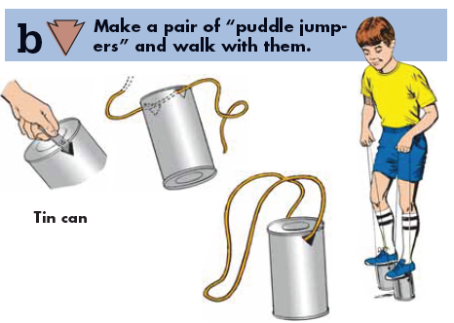

**Other ideas for activities and races from   
“Foot Power” in the old Wolf Book:**

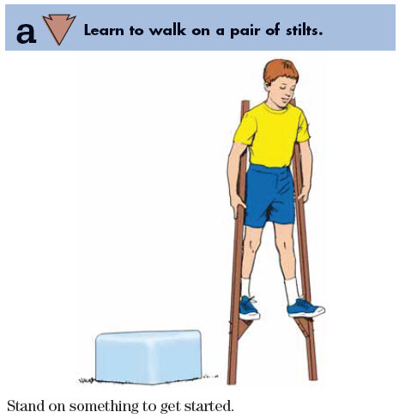

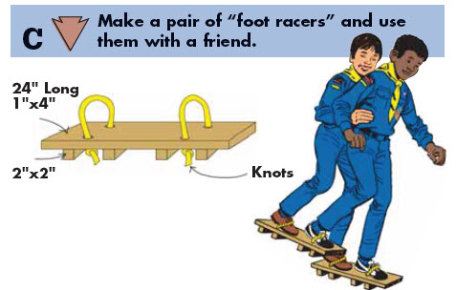

**Collecting Energy**

*Utah National Parks Council*

**Equipment:** Wire coat hangers, pictures of power sources cut from cardboard & labeled with different point values, clothespins

* Stretch a wire coat hanger into a diamond shape.
* Cut out pictures of different power sources from cardboard.
* Hang figures from top of coat hanger diamonds with string.
* Hang coat hangers on stretched cord.
* Boys ‘shoot’ the power sources with thrown clothespins, collecting points for each power source hit.

**Electric Squeeze**

*Baltimore Area Council*

* Cub Scouts hold hands in a circle, with *"it"* in the center.
* One player starts the "shock" by squeezing the hand of one of the Cub Scouts next to him.
* That player passes it on.
* The shock may move in either direction.
* "It" watches the faces and hands of the players, trying to spot the location of the shock.
* When he guesses correctly, the player caught becomes "it".

**Wheelbarrow Races**

* Pair up boys so that they are in groups of two (2).
* One boy places his hands and knees on the floor;
* Second boy picks up first boy's feet and race across the room or to a designated location.

**Electrified Cubs**

*Baltimore Area Council*

**Equipment:** Flashlights and extra batteries

* Darken the room and turn on the lamps with the blue lights in them.
* One person is "it". Give him the flashlight.
* All the other Cubs hide.
* The "it" Cub has to find the others by shining the flashlight at them.
* As soon as a Cub is found he's "electrified" (or caught)!
* The last one to be found wins.
* Also fun to play outdoors.

**Pickin' Cotton**

*Baltimore Area Council*

Each Scout is given two cotton balls, placing them on the floor in front of him. Each Scout kneels on the floor and blows his cotton balls across the room/to the designated location.

**Wind Power Competition**

*Baltimore Area Council*

This game may be played in teams or individual: each team or Scout is given a balloon. To play, set a base such as a book or rock on the ground. Each Scout in turn blows up a balloon and releases it from the base to shoot squealing into the air. The distance each balloon travels is measured to see which went the greatest distance and possibly which one landed the closest to the base.

**Flying Helicopters**

*Baltimore Area Council*

Each Scout is given a piece of paper; additional supplies are provided (staples, paperclips, .tape, straws, . etc. Scouts are to build a flying machine within a limited timeframe (10 - 20 minutes). Have each Scout demonstrate how his flying machine works.

**Flying Feathers I**

*Baltimore Area Council*

Groups should be 5 - 10 Scouts maximum.

* Scouts join hands and try to keep a feather up in the air by blowing.
* One of the group tosses the feather into the air. Scouts must NOT break hands.
* See how long each group can keep the feather in the air.

***VARIATION:*** *See how many groups can keep the feather in the air for a set amount of time.*

**Flying Feathers II**

*Great Salt Lake Council*

**Equipment:** One chair for each boy placed in a circle, straws for each boy and a small craft feather.

**Directions:**

* Boys sit facing in a tight circle on chairs each with a straw.
* A leader will drop the feather in the middle of the boys.
* The boys blow through their straws trying to direct the feather away from themselves and onto another player.
* If the feather touches someone, they are out and must remove their chair from the circle.
* The circle gets moved in and the feather is tossed in again.
* If the feather lands on the floor without touching a player, it is tossed in again and play resumes.
* Players must stay in/on their chairs at all times but can choose if and when they use the straw.
* The game continues in this manner until there is only one player left who is the winner.

**Leg Pinball**

*Great Salt Lake Council*

**Equipment:** a medium soft ball

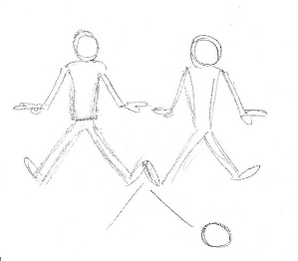

**Directions:**

* Divide boys into two teams.
* Each team sits on the floor in a line about 3-4 feet apart facing the other team.
* Teams are about 20 feet apart.
* Flip a coin to see which team starts first.
* One person on that team rolls the ball towards the opposite team trying to get the ball to roll between players.
* The opposing team will open or close their legs trying to keep the ball from getting between them and thus scoring a point.
* An opposing team member can catch the ball if it goes in between his legs and roll it back trying to get it between players on the other team.
* Play continues in this manner until a predetermined score is reached.

**Musical Race Cars**

*Great Salt Lake Council*

**Equipment:**

Pictures of different race cars (5x7 or larger) – laminated if possible,

Music,

A CD player

**Directions:**

* Spread the pictures out on the floor.
* Have one picture for each boy, subtract one picture.
* The boys will Race around while the music is playing.
* As soon as the leader stops the music the boys will jump on the closest empty picture.
* The boy that does not find an empty picture is out.
* Take one picture away and start the music again.
* Racers can not land on the same picture twice in a row.
* The scout that jumps on the last picture wins the game.

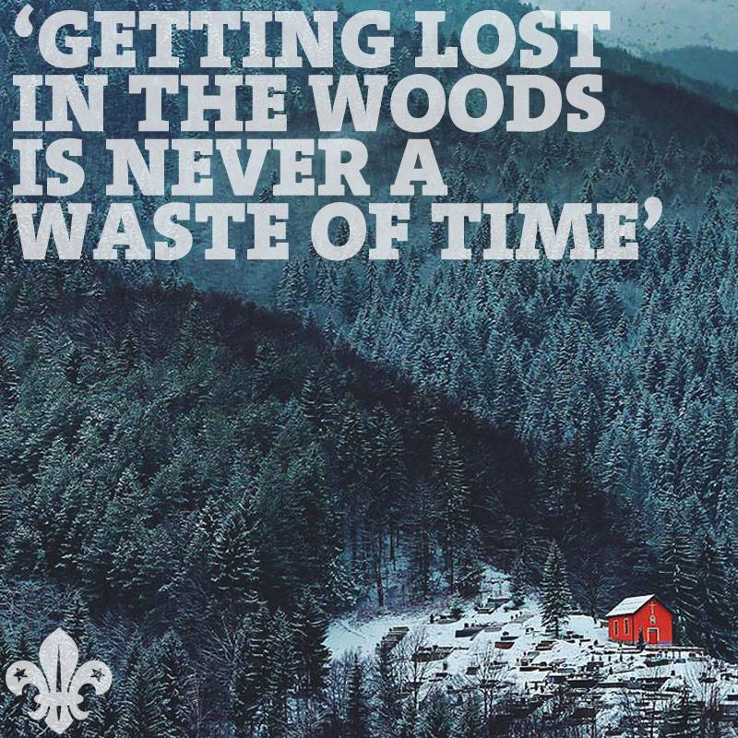

# PACK ACTIVITIES

**Pack Outings**

*Great Salt Lake Council*

Arrange for your pack to visit a recycling plant; the water district; or listen to a weather station through TV or radio. This can be done for the whole pack at once or set up several dates so dens could go. Or spread it out - Wolfs go to Water Plant, Bears to generating station, Tigers to a recycling plant or landfill.

**Or** for personal powering up - tour a health spa or a gym. This could tell your pack the importance of different exercises and why a balanced diet is needed. Be sure to invite parents to help with permission forms and transportation.

**The Ball and Funnel Challenge**

*Las Vegas Area Council*

***The greatest gimmick / trick   
I have seen in a while. CD***

**NEED:** Ping pong ball and large funnel

*Let the boys know that it is time to have a little contest -  
you are going to see who can blow a ping pong ball   
out of a funnel the easiest.*

* Give a ball and funnel to each participating scout,
* Have them place the ball in the funnel and
* Then try to blow the ball out as far as you can.

**The Catch:**

The ball won’t move.

In order to blow the ping pong ball out of the funnel, you must blow across the top of the funnel.

(Leaders - Please **You** Practice First!)

*Brings wipes or buy a lot of funnels at a Dollar Store!*

**Service idea:**

*Utah National Parks Council*

Many older people have a hard time with simple tasks such as changing light bulbs. Encourage your cubs to go ask a neighbor if he can change a light bulb, wash a window or any other simple task.

**Hold Rubber Band Car Races**

*Mrs. Baloo's Files*

Want to build this car??

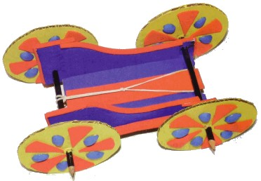

**Materials**

Corrugated cardboard Rubber bands

Sharpened round pencils Craft Glue

D Cell Battery Push Pin

Decorating supplies (markers, …)

Scissors and ruler

**Directions**

1. Copy and print patterns enlarging to sizes given.
2. Trace and cut out patterns. When tracing wheels, mark centers with a push pin.

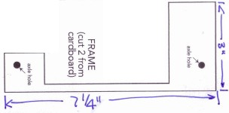

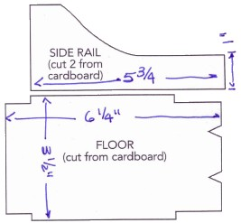

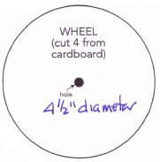

1. To make center axle holes in wheels, remove pushpin and insert pencil through hole. Push pencil through cardboard. (Note: Pencil should fit snugly in cardboard. When you turn pencil, wheel should turn also.)
2. Create axle holes in frame by pushing pencil through frame. **(Note -** Here, pencil needs to turn freely so that when axle turns, frame should not turn.)
3. Adjust holes by moving pencil up and down, making holes larger. Repeat for other three axle holes.
4. Glue floor to frame pieces.
5. Glue side rails to frame. (on inside) along both sides.
6. Insert pencil through wheel hole. Spot glue to secure.
7. Insert wheel and pencil through axle hole on back of frame.
8. Insert other wheel on opposite end of axle. Spot glue to secure.
9. Repeat for two remaining wheels.
10. Let dry.
11. Position one rubber band under back axle, laying flat on floor of car. Wrap rubber band around axle and loop through.
12. Position remaining rubber band on center of floor underneath first rubber band.
13. Pull second rubber band through first, linking both bands.
14. Stretch second rubber band towards front of car, looping band over two front slits on car.
15. To test run, wind rear axle backwards. If rubber band slips, grab band with fingers until it wraps around axle.
16. Turn axle again, winding rubber band.
17. When you release axle, the car will move.
18. Weight car by positioning battery on back end between rubber band and side rail (This will increase frictions)
19. Decorate car using paint, craft foam, markers and other supplies.

**Want to do more???** Then check out this book -

<https://www.amazon.com/gp/reader/1556527365/ref=sib_dp_pt#reader-link>

