# COMMISSIONER'S CORNER

**Never be so busy as not   
to think of others.**– Mother Teresa

**May Theme Prayer***2004-05 Cub Scout Roundtable Leaders’ Guide*Chief Seattle said, “What is man without the beasts? If all the beasts are gone, man would die from great loneliness of spirit. For whatever happens to the beasts soon happens to man. All things are connected. **AMEN**



**FILES/ BOOKS/ LINKS TO MATERIALS FROM UNIVERSITIES AND POW WOWs NEEDED –**

If your council ran a University or a Pow Wow and published a book or posted files on the web or on a cloud somewhere. Let us know. We are always looking for new material. You can write us at –

[davethecommish@gmail.com](mailto:davethecommish@gmail.com) and

[judyjohnsonbsa@yahoo.com](mailto:judyjohnsonbsa@yahoo.com)



Judy and Dave need some help. If you would do one item for Baloo each month, it would help us greatly –

Some ideas for you to consider –

**Biography** – write a one page +/- biography of a person you select that exemplifies that month's emphasized point of the Scout Law.

**Advancement – Choose a rank**. Write a few hints and ideas for the Adventure to be discussed that month at the Roundtable. And, also, any that have a Character Compass pointing to that months point of the Scout Law

**Roundtable Hints** – Prep some hints and ideas for your fellow Roundtable Commissioners each month. This would be easy for someone from a council like Sam Houston where they have an annual RT day where they review all 12 months in advance.

**Crazy Holidays** – Jodi actually retired from that position a few years ago. We can supply you files for each month. You only need to check for updates and additions. Feel free to use more websites if you have a favorite.

**Point of the Scout Law** – Look for items that help get across the meaning of the point of the Scout Law emphasized that month in Roundtable.

**Have another idea?** Let us know how you feel you could help us to make Baloo's Bugle more of what RT Commissioners, Cubmasters, and Den Leaders want.

Write us through the "Send Your Ideas to Baloo" link or directly – [davethecommish@gmail.com](mailto:davethecommish@gmail.com) and [judyjohnsonbsa@yahoo.com](mailto:judyjohnsonbsa@yahoo.com)

# TABLE OF CONTENTS

[COMMISSIONER'S CORNER 1](#_Toc447191025)

[TABLE OF CONTENTS 2](#_Toc447191026)

[CORE VALUES 3](#_Toc447191027)

[KIND(NESS) QUOTES 4](#_Toc447191028)

[RANK ADVANCEMENT CHARTS 6](#_Toc447191029)

[BIOGRAPHY 6](#_Toc447191030)

[**Be Kind to Animals Week®** 6](#_Toc447191031)

[CUB SCOUT LEARNING LIBRARY 9](#_Toc447191032)

[ADVENTURE PLAN TRACKERS 13](#_Toc447191033)

[BE UP TO DATE 13](#_Toc447191034)

[www.scouting.org/programupdates 13](#_Toc447191035)

[CUB SCOUT LEADER TRAINING 13](#_Toc447191036)

[IN-PERSON TRAINING 13](#_Toc447191037)

[ON-LINE TRAINING 13](#_Toc447191038)

[YOU NEED A DEN CHIEF 14](#_Toc447191039)

[What is a Den Chief? (Part 1) 14](#_Toc447191040)

[Where does a Den Chief his cool ideas?? 15](#_Toc447191041)

[What Is A Den Chief? (Part 2) 16](#_Toc447191042)

[Bill Smith on Den Chiefs 16](#_Toc447191043)

[Den Chief Service Award 17](#_Toc447191044)

[Scouting Magazine on Den Chiefs 17](#_Toc447191045)

[ROUNDTABLE HINTS 18](#_Toc447191046)

[SPRING TRAINING 18](#_Toc447191047)

[DEN MEETING TOPICS 21](#_Toc447191048)

[CHARACTER COMPASS 21](#_Toc447191049)

[PACK MEETING THEMES AND PLANS 22](#_Toc447191050)

[PACK MEETING THEMES 23](#_Toc447191051)

[UPCOMING MONTHS 23](#_Toc447191052)

[CUBMASTER THOUGHTS 24](#_Toc447191053)

[**THE CUBMASTER LAW** 24](#_Toc447191054)

[WEBELOS 25](#_Toc447191055)

[Webelos Scout Uniform 25](#_Toc447191056)

[Awesome Interviews 27](#_Toc447191057)

[Boys Life Magazine 27](#_Toc447191058)

[Boy Scouts of America 27](#_Toc447191059)

[Scouting is for Families Like Mine 27](#_Toc447191060)

[Build an Adventure 27](#_Toc447191061)

[Summit Bechtel Reserve 27](#_Toc447191062)

[Cubcast 27](#_Toc447191063)

[Scoutcast 28](#_Toc447191064)

[The Guided Discovery Process 28](#_Toc447191065)

[Bryan’s Blog 28](#_Toc447191066)

[The Cyber Chip is Here 35](#_Toc447191067)

[Leave No Trace (LNT) 36](#_Toc447191068)

[MAY 2016: A MONTH TO CELEBRATE KINDNESS 45](#_Toc447191069)

[**THEME RELATED STUFF** 46](#_Toc447191070)

[MY ANIMAL FRIENDS RELATED ADVENTURES 46](#_Toc447191071)

[**Crazy Holidays** 46](#_Toc447191072)

[TRAINING TOPICS 50](#_Toc447191073)

[Promises 50](#_Toc447191074)

[FUN STUFF 52](#_Toc447191075)

[Fun Facts About Buzzards 52](#_Toc447191076)

[All I Really Need To Know I Learned From My Dog 52](#_Toc447191077)

[THEME PACK AND DEN ACTIVITIES 53](#_Toc447191078)

[KIND PACK AND DEN ACTIVITIES 56](#_Toc447191079)

[THEME & PACK MEETING IDEAS 57](#_Toc447191080)

[GATHERING ACTIVITIES 57](#_Toc447191081)

[OPENING CEREMONIES 59](#_Toc447191082)

[A Matter of Compassion 60](#_Toc447191083)

[AUDIENCE PARTICIPATIONS 61](#_Toc447191084)

[ADVANCEMENT CEREMONIES 62](#_Toc447191085)

[LEADER RECOGNITION 65](#_Toc447191086)

[Scouting is a Candle 65](#_Toc447191087)

[SONGS 65](#_Toc447191088)

[STUNTS AND APPLAUSES 68](#_Toc447191089)

[APPLAUSES & CHEERS 68](#_Toc447191090)

[RUN-ONS 68](#_Toc447191091)

[JOKES & RIDDLES 69](#_Toc447191092)

[SKITS 70](#_Toc447191093)

[CLOSING CEREMONIES 73](#_Toc447191094)

[CUBMASTER’S MINUTES 75](#_Toc447191095)

[CUB GRUB 76](#_Toc447191096)

[GAMES 80](#_Toc447191097)

[SOME LAST THINGS 83](#_Toc447191098)

[Life Lessons Learned from a Dog 83](#_Toc447191099)

[Dogs as Teachers 83](#_Toc447191100)

[I Wish My Daddy Was a Dog 83](#_Toc447191101)

~~program updates banner~~

# CORE VALUES

**The Cub Scout Core Values are the  
12 Points of the Scout Law.**

**The core value highlighted this month is:**

April's point of the Scout Law, **KIND,** will use the theme, **MY ANIMAL FRIENDS.**

**A SCOUT IS KIND**A Scout treats others as he wants to be treated. He never harms or kills any living thing without good reason.

**HOW DOES “MY ANIMAL FRIENDS” RELATE TO THIS POINT OF THE SCOUT LAW?**

A Scout knows there is strength in being gentle. It is important to be kind to all creatures, great and small. This month we will explore ways to be kind to our animal friends.

**Per our Founder, Lord Baden-Powell**

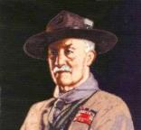

***Note –*** *The original Scout Law published in 1908 had nine points. In 1910, the BSA added Brave, Clean, and Reverent. In 1911 B-P added* ***Clean*** *to his original list.*

**A SCOUT IS KIND***Baden Powell did not use the word Kind, he said -* **A SCOUT IS A FRIEND TO ANIMALS.** He should save them as far as possible from pain, and should not kill any animal unnecessarily, even if it is only a fly---for it is one of God's creatures.   
*(Scouting For Boys, 1908)*

An animal has been made by God,   
just as you have been.   
He is therefore a fellow-creature.  
 *– Lord Robert Baden-Powell*

# KIND(NESS) QUOTES

Quotations contain the wisdom of the ages, and are a great source of inspiration for Cubmaster’s minutes, material for an advancement ceremony or an insightful addition to a Pack Meeting program cover.

No act of kindness, no matter how small,   
is ever wasted. – Aesop

Human kindness has never weakened the stamina or softened the fiber of a free people. A nation does not have to be cruel to be tough. -Franklin D. Roosevelt

Kindness is the language which the deaf can hear and the blind can see. -Mark Twain

You cannot do a kindness too soon, for you never know how soon it will be too late.   
-Ralph Waldo Emerson

Guard well within yourself that treasure, kindness. Know how to give without hesitation, how to lose without regret, how to acquire without meanness.   
-George Sand

A warm smile is the universal language of kindness.   
-William Arthur Ward

Constant kindness can accomplish much. As the sun makes ice melt, kindness causes misunderstanding, mistrust, and hostility to evaporate. -Albert Schweitzer

Carry out a random act of kindness, with no expectation of reward, safe in the knowledge that one day someone might do the same for you.   
-Princess Diana

Love and kindness are never wasted. They always make a difference. They bless the one who receives them, and they bless you, the giver.   
-Barbara de Angelis

Remember there's no such thing as a small act of kindness. Every act creates a ripple with no logical end. -Scott Adams

One who is kind is sympathetic and gentle with others. He is considerate of others' feelings and courteous in his behavior. He has a helpful nature. Kindness pardons others' weaknesses and faults. Kindness is extended to all -- to the aged and the young, to animals, to those low of station as well as the high.   
-Ezra Taft Benson

There is overwhelming evidence that the higher the level of self-esteem, the more likely one will be to treat others with respect, kindness, and generosity.   
-Nathaniel Branden

The level of our success is limited only by our imagination and no act of kindness, however small, is ever wasted. -Aesop

Wherever there is a human being, there is an opportunity for a kindness. -Lucius Annaeus Seneca

Because that's what kindness is. It's not doing something for someone else because they can't, but because you can. -Andrew Iskander

You can accomplish by kindness what you cannot by force. -Publilius Syrus

Always be a little kinder than necessary.   
-James M. Barrie

Transparency, honesty, kindness, good stewardship, even humor, work in businesses at all times.   
-John Gerzema

Kind people are the best kind of people. -Anonymous

Kindness is more important than wisdom, and the recognition of this is the beginning of wisdom.   
-Theodore Isaac Rubin

Three things in human life are important. The first is to be kind. The second is to be kind. And the third is to be kind. -Henry James

A single act of kindness throws out roots in all directions, and the roots spring up and make new trees.   
-Amelia Earhart

How beautiful a day can be when kindness touches it!   
-George Elliston

One who knows how to show and to accept kindness will be a friend better than any possession. -Sophocles

He that has done you a kindness will be more ready to do you another, than he whom you yourself have obliged. -Benjamin Franklin

Never believe that a few caring people can’t change the world. For, indeed, that’s all who ever have.  
 – Margaret Mead

The simple act of caring is heroic. – Edward Albert

When I was young, I admired clever people. Now that I am old, I admire kind people.   
– Abraham Joshua Heschel

Do your little bit of good where you are; it’s those little bits of good put together that overwhelm the world. – Desmond Tutu

When you are kind to others, it not only changes you, it changes the world. – Harold Kushner

I feel the capacity to care is the thing which gives life its deepest significance. – Pablo Casals

Be kind, for everyone you meet is fighting a harder battle. – Plato

Life is mostly froth and bubble. Two things stand like stone. Kindness in another’s trouble, Courage in your own. – Adam Lindsay Gordon

You cannot do a kindness too soon, for you never know how soon it will be too late. – Ralph Waldo Emerson

Be kind whenever possible. It is always possible.  
 – Dalai Lama

If you want to lift yourself up, lift someone else up.  
 – Booker T. Washington

Unless someone like you cares a whole awful lot, nothing is going to get better. It’s not. – Dr. Seuss

Always stop to think whether your fun may be the cause of another’s unhappiness. – Aesop

To belittle, you have to be little. – Kahlil Gibran

Of all virtues and dignities of the mind, goodness is the greatest. – Francis Bacon

Goodness is the only investment that never fails.  
 – Henry David Thoreau

There is no exercise better for the heart than reaching down and lifting people up. – John Holmes

Too often we underestimate the power of a touch, a smile, a kind word, a listening ear, an honest compliment, or the smallest act of caring, all of which have the potential to turn a life around.  
 – Leo Buscaglia

That best portion of a man’s life, his little, nameless, unremembered acts of kindness and love.  
 – William Wordsworth

**Animal Quotes**

*2005 Santa Clara County Council Pow Wow*

A boy can learn a lot from a dog: obedience, loyalty, and the importance of turning around three times before lying down. – Robert Benchley

If a dog jumps in your lap, it is because he is fond of you; but if a cat does the same thing, it is because your lap is warmer. – Alfred North Whitehead

I like pigs. Dogs look up to us. Cats look down on us. Pigs treat us as equals. Sir Winston Churchill

It's funny how dogs and cats know the inside of folks better than other folks do, isn't it**?**– Eleanor H. Porter in her book, Pollyanna, 1912

If you are a dog and your owner suggests that you wear a sweater, suggest that he wear a tail. – Fran Lebowitz

We call them dumb animals, and so they are, for they cannot tell us how they feel, but they do not suffer less because they have no words.   
- Anna Sewell in her book, Black Beauty, 1877

Outside of a dog,   
a book is probably man’s best friend;   
inside of a dog, it’s too dark to read*.*– Groucho Marx

**Quotes About Compassion**

*Alice Retzinger, Golden Empire Council*

If you want others to be happy, practice compassion. If you want to be happy, practice compassion. Dali Lama

Compassion will cure more sins than condemnation.   
Harriett Ward Beecher

It is lack of love for ourselves that inhibits our compassion toward others. If we make friends with ourselves, then there is no obstacle to opening our hearts and minds to others. Anonymous

Compassion is not religious business, it is human business … it is essential for human survival.

Dali Lama

Compassion is based on a keen awareness of the interdependence of all living beings, we are all part of one another, and all involved in one another.   
Thomas Merten

Compassion is the basis of all morality.   
Arthur Schopenhauer

Make no judgements where you have no compassion.   
Anonymous

Compassion is the antitoxin of the soul: where there is compassion even the most poisonous impulses remain relatively harmless. Eric Hoffer

Compassion is not weakness, and concern for the unfortunate is not socialism. Hubert Humphrey

It is much easier to show compassion to animals. They are never wicked. Haile Selassie

By compassion we make others' misery our own, and so, by relieving them, we relieve ourselves also.   
Thomas Browne Sr.

 No man is a true believer unless he desireth for his brother that which he desireth for himself. Muhammad

Man may dismiss compassion from his heart, but God never will William Cowper

Compassion, in which all ethics must take root, can only attain its full breadth and depth if it embraces all living creatures… Albert Einstein

# RANK ADVANCEMENT CHARTS

* Track your Den's completed Adventures and progress to earning their next rank on a wall chart. This worked wonders for us when our son was a Cub Scout. Everyone wanted to have the most completions. And they could see where the goal was.

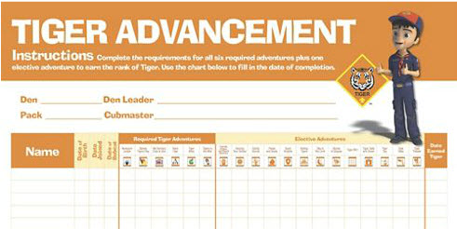

Tiger Advancement Chart, Item: 620578

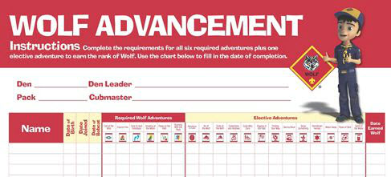

Den Advancement Chart, Item: 620579  
(Scoutstuff.org listing says Den Advancement Chart not Wolf)

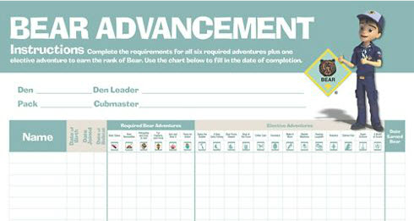

Cub Scout Bear Advancement Chart, Item: 621006  
(Not sure why this one says Cub Scout. None of the others do)

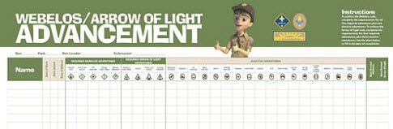

Webelos® Advancement Chart, Item: 620577

# BIOGRAPHY

Be Kind to Animals Week®

**Turned 100 in 2015!**

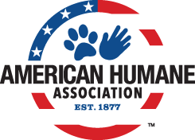

**Be Kind to Animals Week** is the oldest commemorative week in U.S. history – one that taught generations of Americans the value of treating our animal friends with kindness and compassion, is turning **101** this May and is looking to change the world for millions of animals still in need.

**“Be Kind to Animals Week®”** (May 1-7) is the longest-running, most successful humane education campaign in America, and has been supported by U.S. Presidents, movie stars from Shirley Temple to John Wayne, Eleanor Roosevelt to Betty White, and even Dennis the Menace and Porky Pig.  Look [here](http://kindness100.org/pdfs/Kindness100-Timeline.pdf) (<http://kindness100.org/pdfs/Kindness100-Timeline.pdf> ) for stunning facts, amazing photos, and an unparalleled list of VIP supporters who have been part of this iconic and historic part of our national culture and efforts to build a more humane world during the last century.

On the first week of May every year, millions of Americans come together to voice their concern for and improve the wellness, welfare, and well-being of the nation’s animals by celebrating American Humane Association’s “Be Kind to Animals Week®,” the oldest commemorative week in American history.

Generations of schoolchildren have learned the value of treating all creatures of the earth with care, making it the most popular and successful humane education effort ever. Founded in 1877, American Humane Association is the country’s first national humane organization and the only one dedicated to protecting both children and animals.

The outbreak of World War I in July 1914 set the stage for a global conflagration that would eventually lead to the deaths of some 10 million horses used in fighting across Europe. The need for a strong national voice on the importance of treating animals with kindness, compassion, and humanity was never greater.

On October 5-8 of that year American Humane Association held its 38th annual meeting in Atlantic City, New Jersey. Its leaders recognized that then, more than ever, they needed to step up and champion the issue of humane education and animal welfare.

During those four days in Atlantic City, American Humane Association leaders adopted a resolution that local humane societies and individuals across the country would observe a “Humane Sunday which shall be devoted to the consideration of humanity to all living creatures” and “that this Sunday be followed by a week to be devoted to a special plan for kindness to animals, and to be known as ‘Be Kind to Animals’ week.”

Several churches across the country had held annual “Mercy Sunday” events, where members of the clergy delivered sermons on the importance of the humane treatment of animals. Mercy Sunday was the forerunner to “Be Kind to Animals Week,” but the idea did not yet have the backing of a national leader in the humane movement.

Clergy of all denominations were provided sample sermons to use for Humane Sunday, teaching their parishioners the importance of being humane to all creatures great and small. Local humane groups and schools were likewise given toolkits to help them celebrate “Be Kind to Animals Week” in their own communities. This tradition of providing toolkits and campaign materials has continued to this day.

In the century since, associating the first full week of May starting on a Sunday with kindness and compassion for animals has been an indelible rite of passage for nearly every child in America. An annual poster contest has allowed children to imagine creative ways in which we all can be kind to our furry, feathered, and finned friends.

***Highlights of First 100 Years –***For a beautiful booklet, download the Adobe.pdf on this subject at -<http://kindness100.org/pdfs/Kindness100-Timeline.pdf>

***Here are just a few samples of what is in the .pdf.***

**1927:** Popular poet Edgar Guest pens a poem entitled “On Kindness to Animals,” which contains the verse:

They cannot ask for kindness   
Nor for our mercy plead,   
Yet cruel is our blindness   
Which does not see their need

**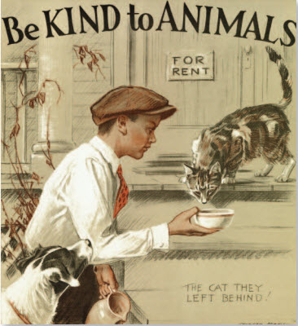**

**1932:** Morgan Dennis, the artist most famously tied to “Be Kind to Animals Week,” unveils the first of many posters for the week. Each year, his poster is a powerful visual representation of a person – usually a child – displaying an act of kindness toward an animal in need. His period specific details – from the fashions worn to even the model years of the cars – create a timeless snapshot of each particular year.

***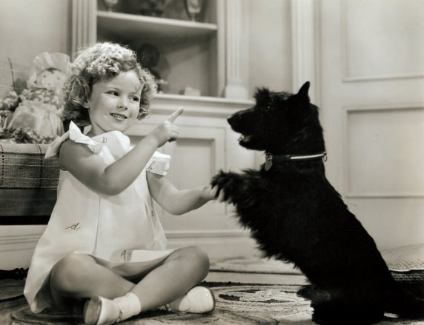***

**1936:** Shirley Temple, the biggest child star of her era, serves as junior chair for “Be Kind to Animals Week.” Though she herself is too young to drive, she urges motorists to be vigilant to avoid animals crossing the roadway. Temple appears twice on the cover of National Humane Review, American Humane Association’s monthly publication, in June 1935 and January 1936, and her participation prompts national coverage.

**1950:** Porky Pig learns an important lesson of compassion on a special “Be Kind to Animals Week”-themed “Looney Tunes” short entitled “Dog Collared,” where he eventually befriends and adopts a dog who follows him everywhere.

**1959:** On Sunday May 3, the nationally syndicated comic strip “Dennis the Menace” features a “Be Kind to Animals Week” theme, reaching out to children and adults alike with the importance of treating all animals with compassion.

 

**1960:** Following the lead of his comic strip character, child actor Jay North, the star of the sitcom “Dennis the Menace,” serves as spokesperson for the year’s celebration; he is joined by fellow CBS child star Jerry Mathers, better known as Beaver Cleaver on “Leave it to Beaver.”

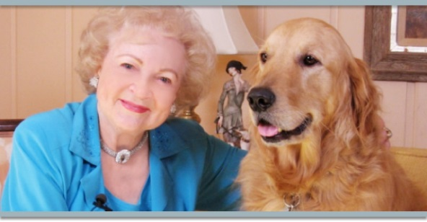

**1971:** Betty White is appointed “National Kindness Chairman,” beginning her decades-long legacy of working with American Humane Association, which endures to this day

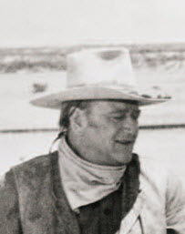 

**1973:** Iconic movie cowboy **John Wayne** lends his voice as chair of the year’s celebration. Popular television show **“Romper Room”** promotes “Be Kind to Animals Week” to its millions of tiny viewers.

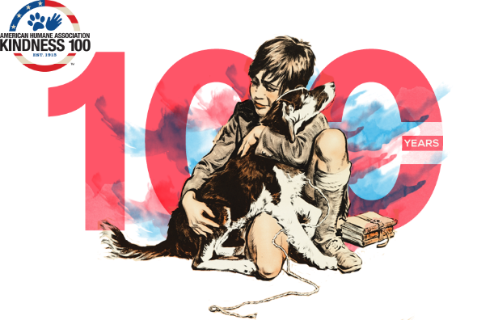

***A New Campaign to Recruit All Americans to the Cause of Animals.*** Unlike most 100-year-olds, this historic, 100-year-old campaign shows no sign of slowing down. In fact, for the Centennial, the American Humane Association is ramping up efforts, launching an ambitious campaign called “**Kindness 100”** to recruit all Americans to become animal advocates and help solve the remaining challenges still facing millions of animals in need. The campaign, which kicked off the with the 100th Anniversary "Be Kind to Animals" Week, seeks to enlist a new generation to do four simple things that can make a world of difference to billions of farm animals, millions of animals abandoned to U.S. shelters each year, animals in entertainment, and disappearing and endangered species.

***Kindness100.org – Where you can find “how to be kind”*** To reach children and adults nationwide, American Humane Association is embarking on a year-long campaign starting with a national media tour, educational roadshow to schools with a traveling museum aboard its fleet of famed Red Star Rescue trucks that save animals in disasters, and a website [www.Kindness100.org](http://www.kindness100.org/) where readers can find a fascinating historical retrospective of “Be Kind to Animals Week,” a series of pre-K-5 curricula to teach children compassion in all areas of life, official downloadable proclamations for local, state and federal officials, and a **Kindness 100 Pledge** with four things people can do to improve the lives of millions – actually, billions – of animals.

***1,000,000 Challenged to Take the Kindness 100 Pledge*** American Humane Association is challenging 1 million people to take the Kindness 100 Pledge online at [www.Kindness100.org](http://www.kindness100.org/) to protect and better the lives of animals in four distinct areas, including 10 billion farm animals by seeking out humanely raised foods, the 6-8 million animals abandoned each year by adopting from a shelter, the more than 100,000 animal actors who entertain, educate and charm us in film and television each year by looking for the “No Animals Were Harmed®” end-credit, and the many endangered and disappearing species of the world by cultivating caring and understanding of magnificent creatures by taking their children to accredited zoos, aquariums, and conservation centers. This year, in honor of the centennial every person who takes the pledge will join the illustrious figures of the past 100 years as an Honorary Chair of Be Kind to Animals Week.

“The need has never been greater and the time has never been better to start a new Compassion Movement,” said Dr. Robin Ganzert, president and CEO of American Humane Association. “To help all of the creatures of the world, big and small, we encourage every American to celebrate ‘Be Kind to Animals Week’ – not only for a week, but all year round. By teaching our children the value of kindness and doing a few simple things that require little or no cost, we may together build a better world for our animals….and ourselves.”

Created against the backdrop of World War I when millions of horses were perishing on the blood-soaked battlefields of Europe, Be Kind to Animals Week has touched hundreds of millions of people, and over the years has featured many iconic spokespeople and advocates including President Warren Harding, Shirley Temple, Eleanor Roosevelt, Milton Berle, Doris Day, Porky Pig, Dennis the Menace, John Wayne, Lorne Greene, Carol Burnett, Clint Eastwood, Betty White and many others.

To join the movement and celebrate the centennial of “Be Kind to Animals Week®,” please visit [www.Kindness100.org](http://www.kindness100.org/). To learn more about how you can support American Humane Association’s Kindness 100 campaign, and to help support America’s first national humane organization and the only one working for the protection of both the nation’s children and animals, please call 1-800-227-4645 or email Anastasia Staten, Vice President, Philanthropic Services at[anastasias@americanhumane.org](mailto:anastasias@americanhumane.org).

**About American Humane Association**American Humane Association is the country’s first national humane organization and the only one dedicated to protecting both children and animals. Since 1877, American Humane Association has been at the forefront of virtually every major advance in protecting our most vulnerable from cruelty, abuse and neglect. Today we’re also leading the way in understanding the human-animal bond and its role in therapy, medicine and society. American Humane Association reaches millions of people every day through groundbreaking research, education, training and services that span a wide network of organizations, agencies and businesses. You can help make a difference, too. Visit American Humane Association at [www.americanhumane.org](http://www.americanhumane.org/) today.

To learn how the American Humane Association became involved with children, too, go to their history pages on their webpage at <http://www.americanhumane.org/about-us/who-we-are/history> and click on the articles about Mary Ellen.

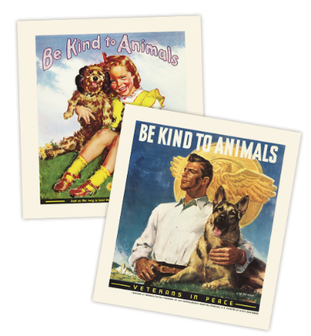

When I was looking for info for this item, I found other similar organizations – the American Society for the Prevent Cruelty to Animals (<https://www.aspca.org/> ) and The Humane Society of the United States (<http://www.humanesociety.org/> ). And I became confused. I my aim was to write about **"Be Kind to Animals Week"** and the American Humane Association owns the copyright to that title, so I chose to write about them and their work and history. No evaluation of other organizations was made.

# CUB SCOUT LEARNING LIBRARY

**The NEW** [**https://cubscouts.org/**](https://cubscouts.org/) **!!!**



**This is the Cub Scout Learning Library –**Everything you could want to know for Cub Scouts is or will be here. And all within a click or 3 of the home page. National heard the message that although things were at [www.scouting.org](http://www.scouting.org) they were often buried too deep to be found.

This site has admin stuff and practical stuff. The new Den Leader Resource Books are here. You can download some of the pages for each Adventure for **FREE**

This website **is** a great resource. There are still parts under construction but what is there is **GREAT!!**



**Yes,** [**https://cubscouts.org**](https://cubscouts.org) **runs on a phone, too!!!**



**There are 4 tabs on top of the home page –**



* Learning Library
* Cub Hub Blog
* Join Scouting
* Pinewood Derby Photo Contest **(NEW LAST MONTH!!)**

1. **Learning Library** takes you where you can learn about your position and pick up hints. Besides specifics for dens of each rank, other clickable links include –

**KEY**

* All or most of material was placed on site this past month
* All or most of material was in place and listed as such in last month's Baloo's Bugle.
* Site / pages under construction
* **Den Leader**

**Den Meeting Basics**

* [Your First Den Meeting](https://cubscouts.org/library/your-first-den-meeting/)
* [Planning Den Outings](https://cubscouts.org/library/den-outings/)
* [The Parts of a Den Meeting](https://cubscouts.org/library/parts-of-a-den-meeting/)
* [**Getting Started**](https://cubscouts.org/library/welcome-to-wolf-cub-scouting/)

Three of the Core Adventures for the selected rank are listed here. Click on them and you will see / can download all the Leader's Guide pages for these three Adventures.

* [**Additional Required Adventures**](https://cubscouts.org/library/call-of-the-wild/)

The remaining Core Adventures for the selected rank are listed here. When you click them you get an intro to the Adventure but do not get the Meeting Plans and Resources. You see this note:

MeetingPlansTo get you started in delivering fun and engaging meetings, complete Den Meeting Plans are available here on the Learning Library for the Backyard Jungle and Games Tigers Play adventures. To obtain Den Meeting Plans for all other adventures, Den Leader Guides are available at your local Scout Shop, online at [**scoutstuff.org**](http://www.scoutstuff.org/), or as an eBook through [**Amazon**](http://www.amazon.com/s/ref=nb_sb_noss_2?url=node%3D154606011&field-keywords=den+leader+guides).

* [**Elective Adventures**](https://cubscouts.org/library/adventures-in-coins/)

All the Elective Adventures for the selected rank are listed here. When you click them you get an intro to the Adventure but do not get the Meeting Plans and Resources. You see the same note (above).

* **Building Strong Dens**

**The Basics of Cub Scouts**

* [Advancement](https://cubscouts.org/library/advancement/)
* [BSA Mission and Vision Statements](https://cubscouts.org/library/bsa-mission-and-vision-statements/)
* [Cub Scout Ages and Ranks](https://cubscouts.org/library/cub-scout-ages-and-ranks/)
* [Cub Scout Uniforming](http://cubscouts.org/library/cub-scout-uniforming/)
* [Den Flags](https://cubscouts.org/library/den-flags/)
* [Den Yells](https://cubscouts.org/library/den-yells/)
* [Leader Survival Kit](https://cubscouts.org/library/leader-survival-kit/)
* [Methods of Cub Scouting](https://cubscouts.org/library/methods-of-cub-scouting/)
* [Purpose of Cub Scouting](https://cubscouts.org/library/purpose-of-cub-scouting/)
* [Roles and Responsibilities](https://cubscouts.org/library/roles-and-responsibilities/)
* [Scout Oath and Law](https://cubscouts.org/library/scout-oath-and-law/)
* [What Is Cub Scouting?](https://cubscouts.org/library/what-is-cub-scouting/)
* **Training**
* [The Role of Training](https://cubscouts.org/?post_type=library&p=3419)
* [Youth Protection](https://cubscouts.org/library/youth-protection/)
* **Den Planning And Administration**
* [Advancement Basics](https://cubscouts.org/library/advancement-basics/)
* [Advancement Requirements](https://cubscouts.org/library/advancement-requirements/)
* [Annual Planning For Your Den](https://cubscouts.org/library/annual-planning-for-your-den/)
* [Coordinating Your Den Plan with Pack](https://cubscouts.org/library/coordinating-your-den-plan-with-the-pack/)
* [Tracking and Recognizing Advancement](https://cubscouts.org/library/tracking-and-recognizing-advancement/)
* [Youth Protection Training](http://www.scouting.org/Training/youthprotection.aspx)
* **Positive Youth Development and Working with Boys**
* [Developmental Differences Boys 7-11](https://cubscouts.org/library/developmental-differences-in-boys-7-11/)
* [Behavior and Discipline](https://cubscouts.org/library/behavior-and-discipline/)
* [Positive Youth Development](https://cubscouts.org/library/positive-youth-development/)
* **Working With Special Needs Cub Scouts** *(Advice is specific to each Special Need. Lots of research was done to prep these pages.)*
* [Parents’ Prejoining Conference](https://cubscouts.org/library/parents-prejoining-conference/)
* [Leadership Techniques](https://cubscouts.org/library/leadership-techniques/)
* [Working With Specific Disabilities and Needs](https://cubscouts.org/library/working-with-specific-disabilities-and-needs/)
* **Cubmaster**
* **Committee Chair/Member**
* **Chartered Org Rep**
* **Parent / Adult Partner**

1. **Cub Hub** takes you to a Cub Scout specific Blog similar to Bryan's Blog. The most recent topics discussed are listed here. There are more at [www.cubscouts.org](http://www.cubscouts.org):

***There were 9 new posts this month. Two about Lion Cubs!! CD***

[](https://cubscouts.org/9-clever-food-ideas-for-cub-scouts-for-blue-and-gold/) [**9 Clever Food Ideas for Cub Scouts for Blue and Gold**](https://cubscouts.org/9-clever-food-ideas-for-cub-scouts-for-blue-and-gold/) Food Ideas for Cub Scouts at Blue and Gold It can be a daunting task to attempt to…

[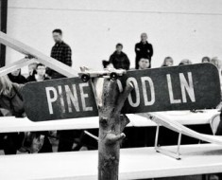](https://cubscouts.org/a-review-of-pinewood-derby-2016/) [**A Review of Pinewood Derby 2016**](https://cubscouts.org/a-review-of-pinewood-derby-2016/) Pinewood Derby 2016 #CubChat Back by popular demand, we hosted a Twitter #CubChat on all things Pinewood…

[](https://cubscouts.org/35-reasons-to-connect-with-the-cub-scouts-on-instagram/) [**35 Reasons to Connect With the Cub Scouts on Instagram**](https://cubscouts.org/35-reasons-to-connect-with-the-cub-scouts-on-instagram/) From Pinewood Derby to Scouting for Food, the Cub Scout leaders and parents on Instagram, Twitter, Pinterest…

[](https://cubscouts.org/q-and-a-for-new-lion-program/) [**5 Questions (and Answers) for the New Lion Program**](https://cubscouts.org/q-and-a-for-new-lion-program/) More Information on the New Lion Program As we mentioned earlier on the Cub Hub, Select councils will…

[](https://cubscouts.org/9-winning-tips-and-ideas-for-blue-and-gold-traditions/) [**9 Winning Tips and Ideas for Blue and Gold Traditions**](https://cubscouts.org/9-winning-tips-and-ideas-for-blue-and-gold-traditions/) Blue and Gold Traditions Blue and Gold banquet traditions are as diverse as they are fun. Since…

[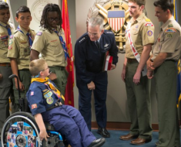](https://cubscouts.org/meet-the-cub-scout-delegate-for-this-years-report-to-the-nation/) [**Meet the Cub Scout Delegate for This Year’s Report to the Nation**](https://cubscouts.org/meet-the-cub-scout-delegate-for-this-years-report-to-the-nation/) Meet Sean Nichols, the Cub Scout Delegate   Sean Nichols is an impressive Wolf Cub Scout who aspires…

[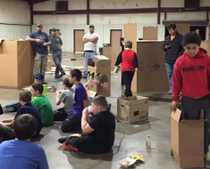](https://cubscouts.org/cub-scouts-make-a-cardboard-city-and-sleep-in-it/) [**Cub Scouts Make a Cardboard City and Sleep in it**](https://cubscouts.org/cub-scouts-make-a-cardboard-city-and-sleep-in-it/) Cub Scouts Make a Cardboard City In an engaging, hands-on activity, Cub Scouts of Pack 328 in…

[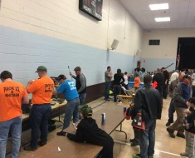](https://cubscouts.org/pinewood-derby-workshop-honors-late-scout-leader/) [**Pinewood Derby Workshop Honors Late Scout Leader**](https://cubscouts.org/pinewood-derby-workshop-honors-late-scout-leader/) A Personal Tragedy Felt By the Whole Community In the days before Christmas, Cub Scout Pack 22 in…

[**Lion Program will bring Scouting to Kindergarten Boys**](https://cubscouts.org/scoutings-lion-program-to-roll-out-in-select-councils/)Something Roaring in the Jungle There is an exciting new Scouting program called “Lion” for Kindergarten-aged boys…

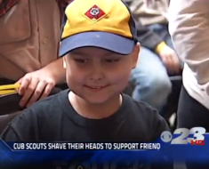 [A Cub Scout With Cancer Finds Solidarity in Shaved Heads](https://cubscouts.org/a-cub-scout-with-cancer-finds-solidarity-in-shaved-heads/)  Scouting is Like a Family Some say a Cub Scout pack is like a family.  Maybe that’s because…

1. **Join Scouting** takes you to [www.beascout.org](http://www.beascout.org)

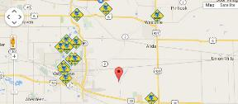

1. **Pinewood Derby Photo Contest** Takes you to an entry form for the Pinewood Derby Photo Contest.

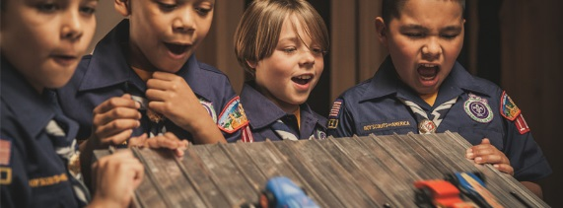

1. **Also, on the home page –**

[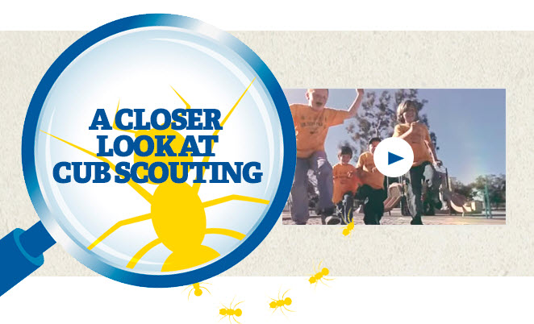](https://www.youtube.com/watch?feature=player_embedded&v=dqKFgk8SJlE)

This link takes you to a YouTube Video   
on Cub Scouting.  
<https://www.youtube.com/watch?feature=player_embedded&v=dqKFgk8SJlE>

**These Six Links take you to:**(From top left across, then down)

**[](http://www.cubscouts.org)**

[**www.scoutstuff.org**](http://www.scoutstuff.org) – The Supply Division site where you can find the location of your nearest National Scout Shop or buy all your Scout supplies

[**http://scoutingwire.org/**](http://scoutingwire.org/) - Where you can get the latest Scouting News from around the country. You can sign up to get notifications when things are posted here...

[**https://cubscouts.org/pinewood-derby-2016-photo-contest**](https://cubscouts.org/pinewood-derby-2016-photo-contest) **-** Takes you to the entry form for the Pinewood Derby photo contest (Same as the link on top of homepage).

[**https://www.scoutbook.com/**](https://www.scoutbook.com/) Where you can get the Scoutbook APP to track your son's Scouting Experience from Tiger to Eagle Scout.

***I just learned that Bob Scott is at it again. Bob led us on the charge to the "CS Adventure Program." Now he is leading the Scoutbook effort. It is sure to be a success!! CD***



[**www.boyslife.org**](http://www.boyslife.org) **–** Go directly to the on-line edition of Boys 'Life

[**http://scoutingwire.org/marketing-membership/**](http://scoutingwire.org/marketing-membership/) Get resources and materials to strengthen your unit at BSA's marketing and membership site. Learn the best practices and tips employed by the most successful units.

# ADVENTURE PLAN TRACKERS

* Tracking Spreadsheets are posted on the USScouts Advancement webpage ([www.usscouts.org](http://www.usscouts.org)). There are be links to them from other places on the site. These spreadsheets are similar in construction and user interface as the existing spreadsheets. The spreadsheets have be tested by the developer of the current spreadsheets and he said they are so good he sees no reason to develop others!!
* Utah National Parks Council has Excel spreadsheets posted for all the new Adventure Plan requirements on their Akela's Council BlogSpot. [www.Akelascouncil.blogspot.com](http://www.Akelascouncil.blogspot.com) .

The Advancement Excel Spreadsheet workbooks are distributed to Scouters for **FREE.**

**PLEASE** **do not download the files from either site to email or send them digitally to others.** They are for your personal / pack use only. If you would like to share these files with others, please copy / send the link to them and send them to the site so they can print off their own. They would love everyone that wants a copy to get their own copy absolutely free. Both USScouts and Utah National Parks receive Ad money based on the number of people visiting the site that helps keep their websites open. Please help us by encouraging others to visit them to obtain the files.

~~~~

# BE UP TO DATE

# [www.scouting.org/programupdates](file:///L:\Cub%20Scouts\Baloo\2015%20-%202016\1601%20-%20Jan%20RT%20for%20Feb%20(Friends)\www.scouting.org\programupdates)

The Program Updates page has been regrouped. Since the CS Adventure is in full swing, the emphasis on getting ready for it has been reduced. The downloads are still all there. And great information about three new Cub Leader courses at [**Philmont Training Center**](http://www.philmontscoutranch.org/ptc.aspx) next summer.

There is a lot of information now on etting ready and implementing the changes to the Boy Scout program.

**Check it all out – stay current!!**

# CUB SCOUT LEADER TRAINING

## IN-PERSON TRAINING

Position-Specific In-Person Training Guides Available Now! The training guides for

* [Den Leader](http://www.scouting.org/filestore/training/pdf/515-215.pdf) (<http://www.scouting.org/filestore/training/pdf/515-215.pdf> ),
* [Cubmaster/Assistant Cubmaster](http://www.scouting.org/filestore/training/pdf/511-503_WB.pdf) (<http://www.scouting.org/filestore/training/pdf/511-503_WB.pdf> ), and
* [Pack Committee](http://www.scouting.org/filestore/training/pdf/511-504_WB.pdf)  (<http://www.scouting.org/filestore/training/pdf/511-504_WB.pdf> )

Are available on Scouting University. You can access them at <http://www.scouting.org/training/adult.aspx> .

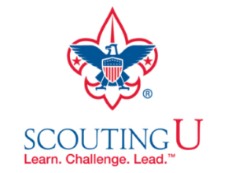

## ON-LINE TRAINING

On-Line Training for all Cub Scout positions has been available since October 25, 2015

The online training for Den Leaders, Cubmasters, Committee Chairs and members, and Chartered Organization Representatives is totally updated with help from volunteers from around the country. The new training is divided into shorter, more targeted modules so leaders can get the training they need, in the order they want, any time they need it. It is organized around the learning needed prior to the first meeting, in the first 30 days, and to be position-specific trained. This training was developed to be implemented in conjunction with the BSA’s new learning management system. Keep an eye on   
my. Scouting Tools (log in at <https://My.Scouting.org>) for more information.

Go to the BSA Volunteer Training Team Facebook page (Link above) andhttp://zamnar.com/data/uploads/17/317782-facebook-like.jpg.   
Then you **automatically** receive the latest news!!

If you are having difficulties with   
the training or system call   
Member Care at 972-580-2489,

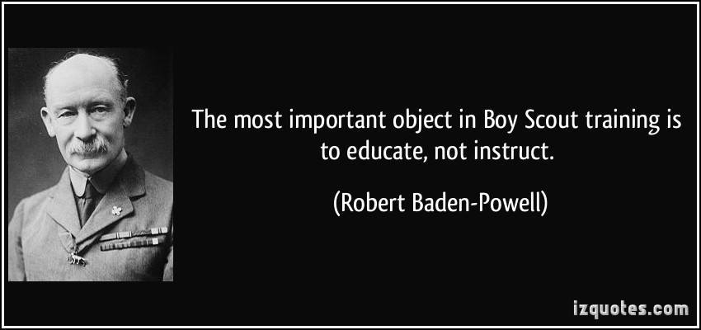

**A Typical Learning Plan has several parts –**

There is no need to complete more than one section at a time. Do what you have time to do.

Here you can see the three parts of the CM Course -



Each of these three parts is broken down into "bite sized" chunks:

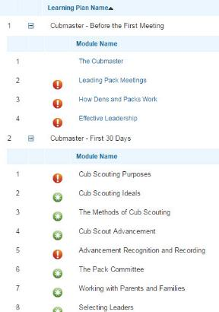

**Go check it out and get your   
people trained!!!**

# YOU NEED A DEN CHIEF



What is a Den Chief? (Part 1)

*Jay Reeves, CS RT Commissioner,   
Hiawatha District, Gamehaven Council, MN*

I don’t know about you, but I think the Den Chief’s position may be one of the toughest things to fill. We have a hard time getting Boy Scouts, you know “older” boys to step out and help. Interestingly enough, in researching this article I found a reference to this problem that could only be expressed in the simpler language of the 1967 Cubmaster’s Packbook.

“To the boy of Den Chief age, Cub Scouting may tend to seem too much ‘kid stuff’ or sissified.”

It goes on to explain that regular contact between Cubmasters and Den Chiefs can help to alleviate this problem. I think it’s much the same in today’s Scouting world.

The position of Den Chief in a Scout troop should be highly sought after. It gives a Boy Scout an opportunity to flex their leadership potential in an environment with ready back up.

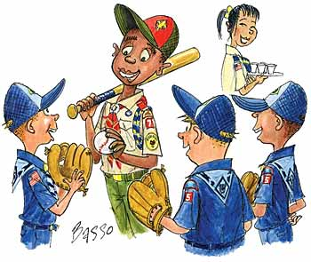

In my own Scouting career, I was Den Chief to a den of Bears when one of the boys was involved in a serious car crash. He was in a full cast from the chest down. It was my privilege to help him continue in the den program to the best of his ability by going to his home on Saturday afternoons and helping him keep up. It was a wonderful opportunity to serve and it was with great pride that I attended his Eagle Court of Honor when I was in college.

A Troop’s Scoutmaster appoints a Den Chief at the request of a Cub Scout Pack. The Den Chief should be an experienced Boy Scout (I’d say at least one year in and have gone to summer camp) and should be at least First Class rank. Varsity Scouts and Venturers are also eligible.

The Den Chief’s responsibilities include:

* Serving as an activity assistant during den meetings
* Setting a good example in attitude and uniforming
* Meet regularly with the den leader and as needed with pack leadership
* Help den leaders as requested
* Attend training for Den Chiefs

When seeking Den Chiefs from a Scout troop, think of it as part of your overall Cub Scout to Boy Scout transition program. Having a boy who graduated from the Pack two years ago return as a Den Chief can be a powerful influence on your Cubs to continue on into Boy Scouts. This can help your “Journey to Excellence” scorecard under Item number 9 – “Webelos-to-Scout transition”!

Den Chiefs should be properly trained. At a minimum, they should complete the online Den Chief Fast Start training available at:

<http://www.scouting.org/Training/Youth/DenChefTraining.aspx> (There is no typo there)

They should also be supplied with their own copy of the Den Chief Handbook (620805), which is filled with tools the Den Chief can use to be successful. It also provides space to track their service and the path to earning the Den Chief Service Award.

From there, the Den Chief should be trained by the Den Leader and attend Den Chief Training provided by the District or Council.

Remember that Den Chiefs are not there to take over responsibility of the den. They aren’t there to do the Den Leader’s job of planning the meeting and maintaining order or discipline. They are there to help the Den Leader in accomplishing the Purposes of Cub Scouting.

Much more information on Den Chiefs is available in the Cub Scout Leader Book (620569).

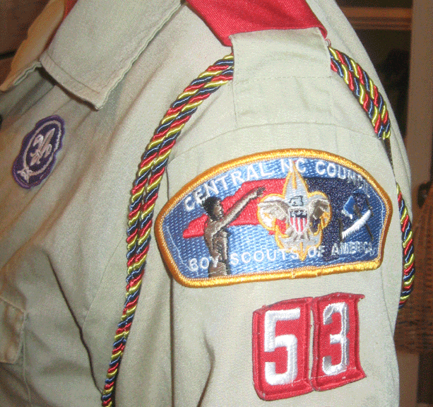

**From National's Website**

**Qualifications:** A Den Chief is an older Boy Scout, Varsity Scout, or Venturer. Selected by the senior patrol leader and Scoutmaster, Varsity Scout Coach, or Venturing Advisor at the request of the Cubmaster. Approved by the Cubmaster and pack committee for recommendation to the den leader. Registered as a youth member of a troop, team, or crew.

**Responsibilities:** The Cub Scout den chief's responsibilities are to:

* Know the purposes of Cub Scouting.
* Help Cub Scouts achieve the purposes of Cub Scouting.
* Serve as the activities assistant at den meetings.
* Set a good example through attitude and uniforming.
* Be a friend to the boys in the den.
* Help lead weekly den meetings.
* Help the den in its part of the monthly pack meeting.
* Know the importance of the monthly theme and pack meeting plans.
* Meet regularly with the den leader to review den and pack meeting plans. Meet as needed with adult members of the den, pack, and troop.
* Receive training from the den leader (and Cubmaster or assistant Cubmaster) and attend Den Chief Training.
* Encourage Cub Scouts to become Webelos Scouts when they are eligible.
* Help the denner and assistant denner to be leaders.

Where does a Den Chief his cool ideas??

**The Den Chief Handbook**, of course!!!

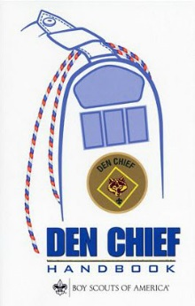

*Item #620805 at ScoutStuff.org*

Or the Den Chief's Guide found here at <http://www.usscouts.org> -

<http://www.macscouter.com/CubScouts/PowWow06/DENCHIEF/LDRGUIDE.PDF>

What Is A Den Chief? (Part 2)

***Editor’s note:*** *In the October 2001 issue of Scouting magazine, Contributing Editor Suzanne Wilson profiled two den chiefs from the Greater St. Louis Area Council in an article on the training, duties, and value of den chiefs. Below are excerpts:*

“…A den chief is a Boy Scout who assists a Cub Scout den leader or Webelos Scout den leader at den meetings, pack meetings, and other events. He’s a ready source of games, songs, skits, and skills, and he encourages the boys in their advancement.

“His presence adds another important asset. He can tell them about Boy Scouting, with its outdoor activities, trips, summer camp, and opportunities for advancement. When it’s time for them to move up to a Webelos Scout den or a Boy Scout troop, his example and encouragement can help them decide to make that transition.

“‘The den chief is one of the keys to the transition to Boy Scouting,’ says Ernest R. (Tommy) Thomas, [former] associate director of the BSA Cub Scout Division. He provides the model that the kids look up to…If you’ve got a good den chief, he will generally take the kids right on into the troop with him.’

“The job also benefits the Scouts. By utilizing skills necessary for working with boys, den leaders, and pack leaders, den chiefs can fulfill their leadership requirements for Star, Life, and Eagle ranks….”

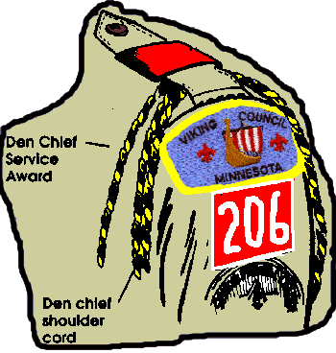

**Den Chief Insignia**

“A den chief wears the den chief insignia on the left uniform sleeve. The Cub Scout pack presents him with the den chief cord, worn on the left shoulder. Cord colors: blue and gold for Cub Scout den chiefs; blue, red, and gold for Webelos den chiefs.

“By completing the requirements for the Den Chief Service Award, a den chief earns an award certificate and may wear the red, white, and blue Den Chief Service Award cord as long as he is a Scout.”

Bill Smith on Den Chiefs

**Den Chiefs are gods.**

Den Chiefs don't make your job much easier, but they do make the Cub Scout experience better. They require coaching and direction to be successful but when they succeed they bring a unique spark to a Cub Scout's life that no one else can. Most children today live in an age-stratified culture where there is little interaction between older and younger kids. Just having an older Boy Scout take an interest in a seven or eight year old is a big deal. When a Webelos Scout visits a troop and one of the older Scouts recognizes him and even knows his name, it's an even bigger deal. These relationships can play an important part in a boy's growth and the effects may be long lasting.

But don't expect a young teen-age lad to be a natural leader. He needs help: coaching, support and acceptance. He must feel that he is a true member of the leadership team. Include him in the planning of your program. Give him explicit responsibilities. As he gains confidence, he will surprise you with his abilities.

**Helping At Den Meetings**

**Gathering Period -** Helps teach boys tricks, puzzles, games, while den leader is busy checking attendance and collecting dues. The activities he uses here could be related to the monthly theme.

**Opening -** Helps den leader organize boys and get them ready for the more serious part of the den meeting. He could hold a uniform inspection during this time.

**Business -** He will have some good ideas for theme activities, service projects, trips, etc. Give him a chance to voice his ideas.

**Activities -** This is when the den chief can be the most help. He is the activities assistant, leading boys in Adventure activities, games, songs, projects, etc.

**Closing -** Helps restore order and quiet for closing ceremony. He can help make announcements.

**After Meeting -** Be sure to include him in your planning for next week and assign him specific responsibilities.

**(Note:** The Webelos Den Chief helps a Webelos den similarly. In addition to the suggestions above, he helps Webelos Scouts learn Boy Scout requirements for the Webelos badge and Arrow of Light Award and helps with demonstrations and teaching of activity badges, as needed.

Den Chief Service Award

*www.usscouts.org*

Detailed Requirements may be found at <http://usscouts.org/advance/boyscout/denchief.asp> and in Den Chief Handbook

***Before beginning work on this award, discuss with your Den Leader and either your Scoutmaster, Varsity Coach, Venturing Adviser, or Cubmaster the role and importance of the Den Chief.***

1. Serve the pack faithfully for 1 full year.
2. Attend a den chief training (if available within year of service) OR be trained by the assistant Cubmaster and den leader.
3. Know and understand the purposes of Cub Scouting.
4. Help Cub Scouts achieve the purposes of Cub Scouting.
5. Be the activities assistant in den meetings. (lead five songs, five stunts or skits, five games, five sports activities)
6. Set a good example by attitude and uniforming.(for a minimum of six months)
7. Be a friend to the boys in the den.
8. Take part in weekly meetings. (for a minimum of six months)
9. Assist the den at the monthly pack program.(at least three times)
10. Meet as needed with the adult members of the den, pack or troop.
11. Complete FOUR of these projects:
    1. Serve as a staff member of a Cub Scout special event, such as a Scouting show, bicycle rodeo, etc.
    2. Serve as a staff member of a Cub Scout Day camp or resident camp.
    3. Advance one rank.
    4. Assist in recruiting three new Cub Scouts.
    5. Assist three Cub Scouts to become Webelos Scouts.
    6. Assist three Webelos Scouts to join a troop.
    7. Help to plan and carry out a joint pack-troop activity.
    8. Recommend to your Scoutmaster, Varsity Scout Coach, or Venturing Adviser another Boy Scout, Varsity Scout, or Venturer to be a den chief.

The information in **GREEN** is not in the requirements as listed in ***Boy Scout Requirements***, but is in the details in the Den Chief Handbook.

**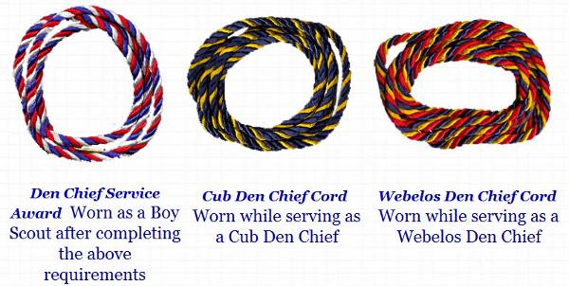**

Scouting Magazine on Den Chiefs

**You Are Boy Scouting!**By Suzanne Wilson  
From the October 2001 issue of *Scouting* magazine at <http://scoutingmagazine.org/2000/10/you-are-boy-scouting/>

**How to make better use of Den Chiefs**By Mark Ray  
Illustrations by Bill Basso  
From the November-December 2006 issue of *Scouting* magazine at <http://scoutingmagazine.org/2006/11/scouters-speak-making-better-use-of-den-chiefs>

**Hail to the Chief**  
Illustrations by Chris Lyons  
From the September-October 2010 issue of Scouting magazine at <http://scoutingmagazine.org/2010/09/hail-to-the-chief/>

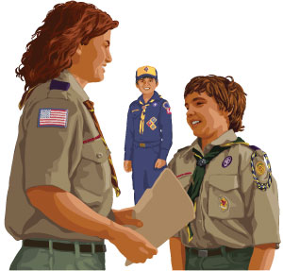

**Learning for Den Chiefs  
From the July 2011 Article,**"Choose Your Own Major"  
*By Cathleen Ann Steg, Photographs by Michael Bowles at* <http://scoutingmagazine.org/issues/0711/a-major.html>

After 18 years as a Scouter and 10 years as a den chief trainer, assistant district commissioner Marcia Lewis of the Capitol District knows what leaders of tomorrow need today.

Prospective den chiefs have fun during the training that ran concurrent to the University of Cub Scouting.

In an intensive all-day program, she put her group of 14 den chiefs in training through their paces, mingling practical advice with some significant ethical training.

“We talked about their attitudes, and how their good attitude will result in a good attitude from their Cub Scouts,” said Lewis. “What we teach here reflects what they have learned at home, school, church. BSA is just finishing up the work.”

**Lewis on leadership:**

“Who are you responsible for? Who are you responsible to? The Cub Scouts! Never forget that!

“Remember: you won’t be demanding things of these Cub Scouts. You’ll be asking them to do things. We’re talking about common courtesy and respect.”

And on the practical side of the job:

Trainee Hughes Nelson cheerfully led the group through the first half of an ever-popular song-without-end, “Found a Peanut.”

Lewis stopped him, saying “Whoa! Put your books down. Will your Cub Scouts have these books with the words? No. So you don’t use the books either.

“Learn the words now so you can teach it to them. This way, you have another song to put in your ‘backpack’ of tricks. It’s all in being prepared.

“You’ll be going to school, going home, doing your homework, going to your own Scout meeting. Not only do you need to be prepared all the time for your own activities, you also need to be ready for your Cubs. It’s a big job!”

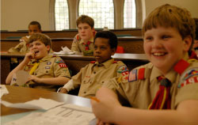

Prospective den chiefs have fun during the training that ran concurrent to the Heart of Virginia's University of Cub Scouting for Adult Scouters and parents.

# ROUNDTABLE HINTS



## SPRING TRAINING

[*Beverly, Capital Area Council*](mailto:frontdesk@bsacac.org)

***Beverly is one of the nice ladies behind the counter at her council service center (No one says Headquarters anymore) that greet people as they arrive.   
(That is her description not mine)***



“Spring Training” – spring is barely here (and isn’t even on the radar for some parts of the country) but it is time to do a little “housekeeping”. With a look ahead to warmer weather and lots of units going camping or on outings, we can take a few minutes at Roundtable to help them have a fun and “legal” experience, not only with program ideas but also a gentle reminder of the BSA requirements for outings.

1. Please remind your participants to check the status of their on-line training, particularly Weather Hazards. That training has been mandatory since 2009 (every unit going on an outing must have at least one person trained in Planning and Preparing for Hazardous Weather). The expiration for this training is 2 years and, as the person who processes Tour Plans for my council, I have had to kick back several because of expired Weather Hazard training. (You might want to pass this along to the Boy Scout Roundtable commissioner so he can remind his participants too)  
     
   If water activities are involved, Leaders with Safe Swim Defense and Safety Afloat will be required, too.
2. Day Camps and Cub and Webelos Resident camps are not far off and **Youth Protection must be taken by staff and parents** alike. Advise your folks to get a jump on the mid-May rush and strain on the My.Scouting website and update their YPT now. And remind them to always print out the card/certificate offered at the end of the training.  
     
   YPT is another course that requires recertification every two years. Instruct the leaders to have the adults with their units check their certification dates.

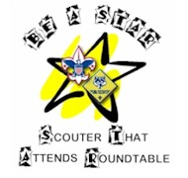

1. Encourage attendance at B.A.L.O.O. – each pack must have at least one B.A.L.O.O. -trained person present on any overnight activity. Ideally, each pack should have more than one person that is B.A.L.O.O. trained and on the camping trip. Otherwise if the trained person gets sick and cannot make it or must go home, the overnight activity will have to be cancelled.
2. Proper preparation of Tour Plans in accordance with your council's rules could be reviewed, too. Tour Plans and other trip paperwork is required to ensure insurance coverage is active in case of injury.

If you take “outing” out of scouting, you are not left with very much. Weather permitting, we need to get the boys outside and away from the television and Play Station as much as we can. There is a wonderful world out there for them to discover. Let us make sure we at Roundtable help the units learn and follow the BSA guidelines for outdoor activities for Cub Scouts.





# DEN MEETING TOPICS

Remember – Boys want to be active!!   
See, too, that they earn their awards   
***(Never say GET. You get sick, you do not get awards – You earn awards. A little CD Philosophy)***.

**Big Rock Ideas** – suggestions for Big Rocks that fit Interest Topics or seasonal activity. If years are next to an item (e.g. 13-14) that suggested Big Rock is in that Roundtable Planning guide and on-line at <http://www.scouting.org/scoutsource/Commissioners/roundtable.aspx>

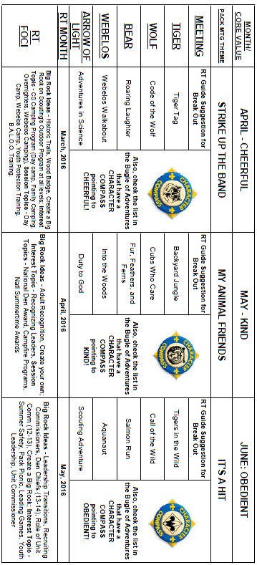

# CHARACTER COMPASS

**MAY -**ADVENTURES with a **CHARACTER COMPASS** pointing to **KIND:**

**TIGER –**

* Backyard Jungle (Core)
* Tiger-iffic (Elec)

**WOLF –**

* Duty to God Footsteps (Core)
* Cubs Who Care (Elec)

**BEAR –**

* Fur, Feathers, and Ferns (Core)
* Critter Care (Elec)

**WEBELOS CORE –**

* Webelos Walkabout (Core)

**ARROW OF LIGHT CORE –**

* Duty to God In Action (Core)

**WEBELOS & AOL ELECTIVES –**

* Into the Wild (Elec)



**JUNE -**ADVENTURES with a **CHARACTER COMPASS** pointing to **OBEDIENT:**

**TIGER –**

* Tigers in the Wild (Core)
* Floats and Boats (Elec)
* Rolling Tigers (Elec)

**WOLF –**

* Call of the Wild (Core)
* Air of the Wolf (Elec)

**BEAR –**

* Bear Claws (Core)
* Salmon Run (Elec)

**WEBELOS CORE –**

* **None** (Core)

**ARROW OF LIGHT CORE –**

* Scouting Adventure (Core)

**WEBELOS & AOL ELECTIVES –**

* Aquanaut (Elec)

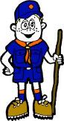

# PACK MEETING THEMES AND PLANS

[*www.scouting.org*](http://www.scouting.org)

**From National's Website for the new plans using the Core Values based on the Scout Law:**

Here are a few thoughts to consider around these new pack meeting plans. First, there is a plan for each month that corresponds with a point of the Scout Law. In addition, each plan has a theme to help make the pack meeting even more fun! The plans do not have to be used in a specific order.

**Tips for Utilizing the Plans**

* Pack meeting plans do not have to be done in any special order, but it is recommended that you include all of the points of the Scout Law each year. The pack planning meeting would be a good time to determine the order.
* There are pack meeting plans for multiple years posted on the website. It is your pack's choice of which one to select from each point of the Scout Law for each year.
* Pack meetings should not last longer than an hour. Adjust the plan to make it fit within the time. Research and experience tells us that Cub Scouts have a hard time sitting still for that long. Keep the meetings fun, active, and engaging.
* If you are comfortable with a costume to fit the theme of the meeting, go for it!
* Importantly, keep it simple and make it fun.
* The following required adventures have a requirement that suggests or requires completion at a pack meeting. Please plan accordingly as part of your annual program planning process. Work with your den leaders to plan when these activities will take place.

**Tiger**

* **Tigers in the Wild,** requirement 5. Participate in an outdoor pack meeting or pack campout campfire. Sing a song and act out a skit with your Tiger den as part of the program.
* **Games Tigers Play,** requirement 3. Make up a new game, and play it with your family or members of your den or pack.

**Wolf**

* **Council Fire,** requirement 6c. Create a den project from recyclables for a pack meeting.

**Bear**

* **Grin and Bear It**, requirement 2. Working with the members of your den, organize a Cub Scout carnival and lead it at a special event.
* **Grin and Bear It**, requirement 3. Help younger Cub Scouts take part in one of the events at the Cub Scout carnival.

**Webelos**

* **Stronger, Faster, Higher**, requirement 5. With adult guidance, lead younger Scouts in a fitness game or games as a gathering activity for a pack or den meeting.

**Arrow of Light**

* **Building a Better World (if chosen**), requirement 10b. Set up an exhibit at a pack meeting to share information about the World Friendship Fund.

**As a personal note:** *I have read some of the plans and they are excellent and just as complete as the new Den Leader Books. The games, and other stuff are right there. Including costuming ideas for that added PIZAZZ!! If you do not use themes and do not add PIZAZZ you are not doing your best for your pack.****GOOD JOB!!!*** *From CD*

Check them out at:   
<http://www.scouting.org/Home/CubScouts/Leaders/CubmasterResources/PackMeetingPlans.aspx>

Kim, the chair of the task force, says **"I do want to stress that the focus is still the Core Value and the theme is just there as an enhancement. Pack meeting theme plans are specifically crafted to bring out the important points of the Core Value in a fun way."**

## PACK MEETING THEMES

|  |  |  |
| --- | --- | --- |
| **2015–2016 Pack Meeting Plans** | | |
| April | Cheerful | ["Strike Up The Band"](http://www.scouting.org/filestore/cubscouts/pdf/YEAR1/310-842(15)_April%20Cheerful_WEB.pdf) |
| May | Kind | ["My Animal Friends"](http://www.scouting.org/filestore/cubscouts/pdf/YEAR1/310-842(15)_May%20Kind_WEB.pdf) |
| June | Obedient | ["It's A Hit"](http://www.scouting.org/filestore/cubscouts/pdf/YEAR1/310-842(15)_June%20Obedient_WEB.pdf) |
| July | Loyal | ["Scout Salute"](http://www.scouting.org/filestore/cubscouts/pdf/YEAR1/310-842(15)_July%20Loyal_WEB.pdf) |
| August | Courteous | ["S'more Cub Scout Fun"](http://www.scouting.org/filestore/cubscouts/pdf/YEAR1/310-842(15)_August%20Courteous_WEB.pdf) |

|  |  |  |
| --- | --- | --- |
| **2016–2017 Pack Meeting Plans** | | |
| September | Helpful | ["To The Rescue"](http://www.scouting.org/filestore/cubscouts/pdf/YEAR2/310-842(15)_September%20Helpful_WEB.pdf) |
| October | Kind | ["Creepy Crawlers"](http://www.scouting.org/filestore/cubscouts/pdf/YEAR2/310-842(15)_October%20Kind_WEB.pdf) |
| November | Courteous | ["Cubs In Shining Armor"](http://www.scouting.org/filestore/cubscouts/pdf/YEAR2/310-842(15)_November%20Courteous_WEB.pdf) |
| December | Cheerful | ["Celebrate"](http://www.scouting.org/filestore/cubscouts/pdf/YEAR2/310-842(15)_December%20Cheerful_WEB.pdf) |
| January | Obedient | ["Cub Scout City Council"](http://www.scouting.org/filestore/cubscouts/pdf/YEAR2/310-842(15)_January%20Obedient_WEB.pdf) |
| February | Reverent | ["Passport To Other Lands"](http://www.scouting.org/filestore/cubscouts/pdf/YEAR2/310-842(15)_February%20Reverent_WEB.pdf) |
| March | Loyal | ["Our National Treasures"](http://www.scouting.org/filestore/cubscouts/pdf/YEAR2/310-842(15)_March%20Loyal_WEB.pdf) |
| April | Thrifty | ["Power Up!"](http://www.scouting.org/filestore/cubscouts/pdf/YEAR2/310-842(15)_April%20Thrifty_WEB.pdf) |
| May | Clean | ["A Picnic With Pizzazz"](http://www.scouting.org/filestore/cubscouts/pdf/YEAR2/310-842(15)_May%20Clean_WEB.pdf) |
| June | Brave | ["Roaming Reptile Alert"](http://www.scouting.org/filestore/cubscouts/pdf/YEAR2/310-842(15)_June%20Brave_WEB.pdf) |
| July | Trustworthy | ["Let The Games Begin"](http://www.scouting.org/filestore/cubscouts/pdf/YEAR2/310-842(15)_July%20Trustworthy_WEB.pdf) |
| August | Friendly | ["#CUBSCOUTS"](http://www.scouting.org/filestore/cubscouts/pdf/YEAR2/310-842(15)_August%20Friendly_WEB.pdf) |

**If you are using a paper copy the link to all the   
Pack Meeting Plans is:**

<http://www.scouting.org/Home/CubScouts/Leaders/CubmasterResources/PackMeetingPlans.aspx>

# **UPCOMING MONTHS**

May's Core Value, **KIND**, will use the theme, **My Animal Friends:**

|  |  |  |
| --- | --- | --- |
| **Month** | **Year** | **Theme** |
| **KIND** (Themes for Compassion) | | |
| December | 1940 | Good Will - Cub Style |
| December | 1941 | Giving Good Will |
| December | 1942 | Good Will |
| December | 1943 | Good Will Month |
| December | 1945 | Follows - Helps - Gives |
| December | 1947 | Helps and Gives |
| December | 1948 | Goodwill |
| December | 1961 | Follows, Helps, and Gives |
| December | 1969 | Cub Scout Gives Good Will |
| December | 1971 | Cub Scout Gives Good Will |
| December | 1972 | Follows, Helps, Gives |
| December | 1975 | Cub Scout Gives Good Will |
| December | 1985 | Follows, Helps, Gives |
| December | 1991 | Follows, Helps, Gives |
| July | 2002 | Inside Out and Backwards |
| December | 2003 | Cub Scout Gives Good Will |
| March | 2004 | Walk In My Shoes |
| November | 2008 | Spreading Seeds Of Kindness |
| March | 2011 | Compassion |
| March | 2012 | Compassion |
| March | 2013 | Planting Seeds of Kindness |
| March | 2015 | Aware and Care |
| **Potential "MY ANIMAL FRIENDS" Months** | | |
| April | 1940 | Pet Show |
| April | 1943 | Animals and Pets |
| August | 1949 | Animals and Pets |
| June | 1962 | Inside Noah's Ark |
| October | 1964 | Animals in Stories |
| June | 1986 | Inside Noah's Ark |
| August | 1992 | Inside Noah's Ark |
| March | 1996 | Inside Noah's Ark |
| March | 2001 | Man's Best Friend |
| May | 2005 | Cub Pet Pals |
| September | 2006 | Zoo Adventures |
| March | 2014 | Pet Pals |

**The core value highlighted next month is:**

June's point of the Scout Law, **OBEDIENT,** will use the theme, **IT'S A HIT.**

**A SCOUT IS OBEDIENT**A Scout follows the rules of his family, school, and pack. He obeys the laws of his community and country.

**HOW DOES “IT'S A HIT” RELATE TO THIS POINT OF THE SCOUT LAW?**

It is easy to forget the importance of being honest when you are playing a game and you really want to win. However, a Cub Scout always tells the truth and is a person worthy of trust. This month, we will reinforce how important it is to be honest—notably when playing ball with friends.

|  |  |  |
| --- | --- | --- |
| **Month** | **Year** | **Theme** |
| **Potential "IT'S A HIT" Months** | | |
| August | 1945 | Sports |
| August | 1953 | Sports Carnival |
| June | 1966 | Sports Carnival |
| August | 1970 | Cub Scout Field Day |
| June | 1975 | Sports Carnival |
| June | 1979 | Learn a Sport |
| August | 2002 | Sports Extravaganza |
| July | 2009 | Cub Scout Sports |
| August | 2015 | Play Ball! |
| June | 2016 | It's a Hit |
| **OBEDIENT** (Themes for Respect) | | |
| May | 1962 | The World Around Us |
| November | 1967 | Around the World |
| December | 1973 | Customs of Countries |
| April | 1978 | The World Around Us |
| December | 1979 | Customs of Other Lands |
| April | 1981 | The World Around Us |
| July | 1988 | The World Around Us |
| December | 1989 | Customs of Countries |
| December | 1994 | Customs of Other Lands |
| February | 2001 | Passports to Other Lands |
| January | 2007 | Poles Apart |
| December | 2010 | Respect |
| December | 2011 | Respect |
| December | 2013 | Passport to Other Lands |

# **CUBMASTER THOUGHTS**

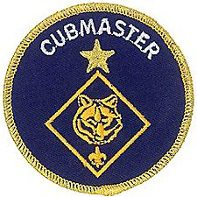

THE CUBMASTER LAW

*Mark Diienno, Cubmaster,   
Garden State Council*

**The Cubmaster is Trustworthy.**   
The Scouts, Leaders, and Families can count on him to get the job done.

**The Cubmaster is Loyal.**   
The Cubmaster will be at almost every event, and is committed to the Success of The Pack.

**The Cubmaster is Helpful.**   
The Cubmaster will help The Leaders of the Pack to continually seek and participate in training opportunities.

**The Cubmaster is Friendly.**   
The Cubmasters has the ability to make the Pack feel like family. The Culture of the unit is a reflection of The Cubmaster’s demeanor.

**The Cubmaster is Courteous.**   
The Cubmaster will always be mindful of those around him. The Cubmaster uses diplomacy and tact, even in the face of anger and complaint.

**The Cubmaster is Kind.**   
The Cubmaster understands the importance of every word spoken, and every deed done, for the eyes of children are sharp, and their ears hear everything.

**The Cubmaster is Obedient.**   
The Cubmaster will not stray from the Program; He follows the Guide to Safe Scouting, The Cubmaster best leads the Pack by following the rules.

**The Cubmaster is Cheerful.**   
The Cubmaster will see the good and positive in every situation. Even though things may not go as planned, The Cubmaster will find a way to get the most out of an opportunity.   
  
The Cubmaster accepts change.

**The Cubmaster is Thrifty.**   
The Cubmaster plans pack meetings and events with one eye on cost, the other on program quality. It is important to save money, it is a crime to waste someone’s time.

**The Cubmaster is Brave.**   
The Cubmaster is the MC at Pack Meetings Campfires and Ceremonies. The Cubmaster knows that if he/she is brave, boys can be moved to be brave.

**The Cubmaster is Clean.**   
The Cubmaster is **THE** Cubmaster 24/7. Cubmasters carry themselves with dignity in public, for the eyes of scouts and FUTURE scouts may be watching. The Cubmaster’s uniform should be perfect to set the goal for the unit

**The Cubmaster is Reverent.**   
The Cubmaster will make time in the unit to recognize God in all things.

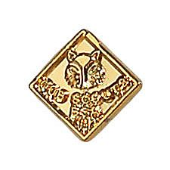

# **WEBELOS**

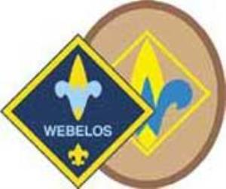

**Always an S**

Webelos always ends with an S whether talking about one Webelos Scout or a den of Webelos. It is an acronym – **WE**’ll **BE** **LO**yal **S**couts. As the CS RT Commissioner who mentored me says – "If you don’t have an S at the end – then there is nothing to which to be loyal." **(She is now a Wood Badge Scoutmaster!!)**

## Webelos Scout Uniform

**From** [**www.scouting.org**](http://www.scouting.org) **-**Webelos Scouts may choose to wear either the blue Webelos uniform based on the Cub Scout uniform or the tan/olive uniform similar to the one that Boy Scouts wear.

For the tan/olive uniform, boys wear the official Boy Scout olive trousers or shorts and official Boy Scout tan long- or short-sleeved shirt with blue shoulder loops. Official blue socks are worn with the blue uniform, and official olive socks are worn with the tan/olive uniform.

With either uniform, all Webelos Scouts should wear the Webelos neckerchief (plaid with the Webelos emblem), Webelos neckerchief slide (handmade slides are also acceptable), Webelos cap, and Webelos belt buckle.

***Note*** *that the Webelos belt buckle will only fit the blue cotton web belt (item number 64046-64048). Also, the Adventure Belt Loops will only fir on Cub Scout belts not on Boy Scout belts.*

**Badges and Insignia**For guidance on the proper placement of all badges and insignia, see the BSA's [*Guide to Awards and Insignia*](http://www.scouting.org/scoutsource/Media/InsigniaGuide.aspx) (No. 33066, available at your local council service center.)

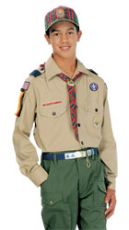http://www.scoutstuff.org/skin/frontend/enterprise/bsaretail/images/s.gifhttp://www.scoutstuff.org/skin/frontend/enterprise/bsaretail/images/s.gifhttp://www.scoutstuff.org/skin/frontend/enterprise/bsaretail/images/s.gif**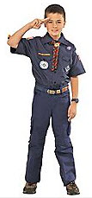**

**From the Official BSA Uniform Inspection Sheet for Webelos –**

**Shirt.** Webelos Scouts have the option of wearing either the long- or short-sleeve navy blue shirt and navy blue shorts or pants OR the long- or short-sleeve tan shirt with the official convertible Boy Scout pants or official shorts or pants. If the shirt has epaulets, blue shoulder loops are worn on them.

**Pants/Shorts.** Webelos Scouts may wear either the official navy blue pants or shorts (with the navy blue shirt), or the official convertible Boy Scout pants (with the tan shirt), or the official Boy Scout pants or shorts (with the tan shirt).

**Belt.** Official navy blue web belt cut to proper length with the Webelos insignia on the buckle. Cub Scout belt loops are worn only on the navy blue belt. Webelos Scouts wearing the optional tan uniform wear the navy blue belt and Webelos buckle.

**Official Boy Scout Uniform Option**

* Webelos Scouts electing this option wear blue shoulder loops on the epaulets, Webelos neckerchief, and Webelos cap.
* The navy blue belt is worn with and will fit only the Webelos buckle. Adventure belt loops and the old Academics and Sports belt loops will fit only on the navy blue belt.
* Badge placement is the same as for the navy blue uniform.

**So, when should a Webelos Scout switch to the Boy Scout uniform?**

**Short answer –   
it is up to the boy and his parents.**

Per the official literature cited in this item, the verbiage confirms that a change is not required –

* On [www.scouting.org](http://www.scouting.org) it says, "Webelos Scouts may choose to wear either …
* On the Inspection sheet it says, "Webelos Scouts have the option of wearing either …

**Things to consider –**

**Cost –** To switch shirts will, probably, involve a cost to the parents unless the unit has a great Experienced Uniform closet. Why thrust an extra cost onto your parents by telling them they must obtain a tan shirt when the Scout moves from Bear to Webelos or at any arbitrary time?

**Size –** After several years as a Cub Scout, most Scouts will be ready for a larger shirt sometime while they are a Webelos Scout. When he outgrows the blue shirt would be a great time to get him a tan shirt!! Why rush it and have to get a second Boy Scout uniform that much sooner as he grows. He might be in Boy Scouts for 7 plus years after Cub Scouts!!

**Timing –** If your unit uses the oval Webelos Badge, when a Webelos Scout is presented the oval badge might be a good time to switch shirts. The Cub Scout diamond could remain intact on his blue shirt and the shirt put away intact into a memory box. And the new oval Webelos Badge sewn on the tan shirt. The tan shirt could have been used as an incentive to encourage him to keep on going to earn the badge. This will save having to remove all the previous rank badges from the blue shirt.

**For a Lesson on Webelos Colors -**

**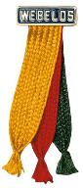**

By Mike Walton, [www.USScouts.org](http://www.USScouts.org)   
Go to the November 2015 Baloo's Bugle issue at   
<http://usscouts.org/usscouts/bbugle2015-2016.asp>

* [Boy Scouts wreath-laying ceremony at Arlington National Cemetery](https://www.youtube.com/watch?v=qb_Qs5ZePTU)

Awesome Interviews

* [Boy Scouts react to meeting President Obama for Report to the Nation](https://www.youtube.com/watch?v=-Eyoygg1H4s)
* [Eagle Scout Iditarod Racer Matthew Filor](https://www.youtube.com/watch?v=Wf0pcE7tEFA)
* [Mike Rowe](https://www.youtube.com/watch?v=85dCjsCgvXQ)

Boys Life Magazine

* [Inside the March 2016 Issue of Boys' Life](https://www.youtube.com/watch?v=YQ3in8MQ_1E)

*Great Videos on different topics*:

* [Where to find the fish in a river or stream](https://www.youtube.com/watch?v=uYQxGd3KrfM)
* [A close-up of volcanic eruptions](https://www.youtube.com/watch?v=zxbtrTmY27k)
* [The Magic Aces Trick](https://www.youtube.com/watch?v=3PI7KeGtA1I)
* [Winter Clothing: Dressing for Cold Weather](https://www.youtube.com/watch?v=_z5vOljDoiA)

*Many more videos are on the Boys Life Magazine You Tube Channel*

Boy Scouts of America

Scouting is for Families Like Mine

* [Michelle C.](https://www.youtube.com/watch?v=7MmVdjSNVO0)
* [Becky](https://www.youtube.com/watch?v=So0aJnQ_o7A)

Build an Adventure

* [Checklist](https://www.youtube.com/watch?v=KgznpL4TiNo)
* [Rocket man](https://www.youtube.com/watch?v=uiWn5Jvj62E)
* [Construction Zone](https://www.youtube.com/watch?v=RVXbAcGig2o)

Summit Bechtel Reserve

* [2017 National Jamboree](https://www.youtube.com/watch?v=VTuX2X6V9cU)
* [It's Never Too Early To Register | 2017 BSA Jamboree](https://www.youtube.com/watch?v=ecfMspU2dd8)



[BSA Facebook](https://www.facebook.com/pages/Boy-Scouts-of-America/113441755297)

Sign up and get all the latest   
as it hits the wires!!!  
Cubs have your parents to Sign Up.

Do you know how to tie all of these?

[[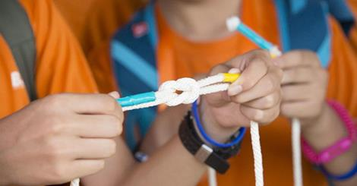](http://scoutingwire.org/four-knots-learn-summer/)](http://scoutingwire.org/four-knots-learn-summer/" \t "_blank)

[4 Knots to Learn Before Summer](http://l.facebook.com/l.php?u=http%3A%2F%2Fscoutingwire.org%2Ffour-knots-learn-summer%2F&h=wAQFkOrA2&enc=AZM8vG4vV35Lu03lkmd5OHVejb1it5PpDIEhevdohzcVlKeuBCKjozo3jAuRVYql4vSl7fNXyRcMStdphODc9pRzV3Qgxxla__dJQ-6o7ofxsn_ddS7OVKIlYtEEzg5JmIpvcwbBFl0MI1nEAKbgryg_5iihTcX63Wf0mXLOhx4ikf-NmzBNgI47EKqnruFQW0oXhd8w9jL4iiUUkKf7mGL1&s=1)

Getting excited for summer yet? So are we! But if the countdown is starting to make you a little impatient, we’ve got just the thing. Pass the time and brush up on your warm-weather adventure skills with these four need-to-know knots for summer:…

SCOUTINGWIRE.ORG

Cubcast

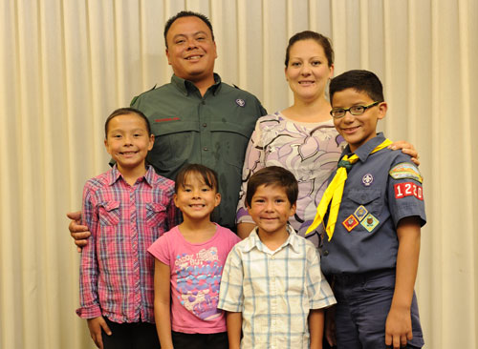

Cub Scouting: The Family Program

There are lots of Cub Scouting events and activities, like pack meetings, where the whole family is encouraged to attend. But what if all the sisters and non-Cub Scout brothers want to race in the Pinewood Derby? How do you preserve the Cub Scout family program and still say “no” to the siblings who cannot participate in Cub Scout-only activities? Steve Hoskins, who works with the BSA National Service Center on claims administration for incidents that occur within packs, troops, teams, and crews, shares with us how to properly and effectively incorporate your family into your Cub Scouting program.

[Listen](http://www.scouting.org/filestore/scoutcast/cubcast/201601_3/CC_Mar_Family.mp3)

Scoutcast

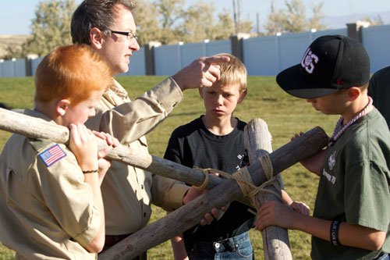

## The Guided Discovery Process

The Scoutmaster is the adult leader of a youth-led troop. The Venturing Advisor is the adult leader of a youth-led crew. How do you assist the youth without lecturing? What is the process of shifting the attention off of yourself, as the adult leader and onto the senior patrol leader or crew president? Join us as Boy Scout Development Task Force member, Larry Green, guides us through this discussion of the guided discovery process

[Listen](http://www.scouting.org/filestore/scoutcast/resources/201601_2/SC_Feb_SMMinute.mp3)

*Be sure to look over the archived Cubcast and Scoutcast recordings. These archives are listed on the left navigation are of the web site.*

Bryan’s Blog

“Bryan on Scouting” is the official blog of Scouting magazine, a Boy Scouts of America publication. Scouting magazine is published five times a year and is received by 1 million registered adult volunteers. Bryan covers many topics every month. He keeps his Blog current and deals with the latest issues.

His articles this past month are listed below (Every title has a hyperlink). The articles in BLUE are of special interest for Cub Scout Leaders.

If the word **SPONSORED** appears, that BSA received compensation for that blog post.

#### **Get Email Updates**

To sign up to receive Bryan’s Blog in your E-mail –

Click the link that appears in every article. Bryan and Gretchen promise never to sell or otherwise exploit your email address. Join 6,852 other subscribers

February 2016

[This Pinewood Derby display case is a functional work of art](http://blog.scoutingmagazine.org/2016/02/23/this-pinewood-derby-display-case-is-a-work-of-art/)

February 23, 2016 // [24 Comments](http://blog.scoutingmagazine.org/2016/02/23/this-pinewood-derby-display-case-is-a-work-of-art/)

[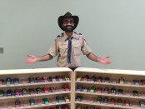](http://blog.scoutingmagazine.org/2016/02/23/this-pinewood-derby-display-case-is-a-work-of-art/)

A Scouter created a beautiful Pinewood Derby display case that's functional, too. It securely stores 150-plus cars to make them ready for race day. 

[When Nepal earthquake hit, this Eagle Scout stayed to help](http://blog.scoutingmagazine.org/2016/02/23/harrison-gibson-nepal/)

February 23, 2016 // [1 Comment](http://blog.scoutingmagazine.org/2016/02/23/harrison-gibson-nepal/)

[](http://blog.scoutingmagazine.org/2016/02/23/harrison-gibson-nepal/)

Eagle Scout Harrison Gibson was three weeks into a trip to Nepal when the earthquake hit. What happened next showcases the best of Scouting values. 

[The secret is out: ROCS, TCT and STEM Treks at Philmont are a hit](http://blog.scoutingmagazine.org/2016/02/22/rocs-tct-stem-at-philmont/)

February 22, 2016 // [1 Comment](http://blog.scoutingmagazine.org/2016/02/22/rocs-tct-stem-at-philmont/)

[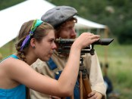](http://blog.scoutingmagazine.org/2016/02/22/rocs-tct-stem-at-philmont/)

There's time for your Scouts to experience Philmont magic this summer, and they don't even need a crew to do so. Philmont's individual programs beckon. 

February 2016

[Meet David Hunt, Eagle Scout and Smithsonian bone specialist](http://blog.scoutingmagazine.org/2016/02/29/david-hunt/)

February 29, 2016 // [0 Comments](http://blog.scoutingmagazine.org/2016/02/29/david-hunt/)

[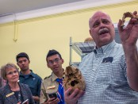](http://blog.scoutingmagazine.org/2016/02/29/david-hunt/)

Eagle Scout David Hunt is collections manager for physical anthropology at the Smithsonian's National Museum of Natural History. 

[At the U.S. Naval Academy, ties to Scouting run deep](http://blog.scoutingmagazine.org/2016/02/29/us-naval-academy/)

February 29, 2016 // [2 Comments](http://blog.scoutingmagazine.org/2016/02/29/us-naval-academy/)

[](http://blog.scoutingmagazine.org/2016/02/29/us-naval-academy/)

Walking around the majestic campus of the U.S. Naval Academy in Annapolis, Md., your chances of running into an Eagle Scout are high: roughly 1 in 10. 

[Cards for Jacob: How your letters can help a Cub Scout recover after surgery](http://blog.scoutingmagazine.org/2016/02/29/mom-aims-to-cheer-up-cub-scout-son-after-surgery-with-cards-for-jacob/)

February 29, 2016 // [3 Comments](http://blog.scoutingmagazine.org/2016/02/29/mom-aims-to-cheer-up-cub-scout-son-after-surgery-with-cards-for-jacob/)

[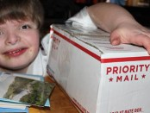](http://blog.scoutingmagazine.org/2016/02/29/mom-aims-to-cheer-up-cub-scout-son-after-surgery-with-cards-for-jacob/)

Sharon Gratton is on a mission to help her Cub Scout son, Jacob, stay positive during a long road to recovery after a major surgery planned for next month. 

[Morgan Freeman honored by Boy Scout council in Mississippi](http://blog.scoutingmagazine.org/2016/02/26/morgan-freeman-honored-by-council-in-mississippi/)

February 26, 2016 // [0 Comments](http://blog.scoutingmagazine.org/2016/02/26/morgan-freeman-honored-by-council-in-mississippi/)

[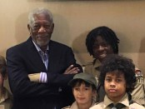](http://blog.scoutingmagazine.org/2016/02/26/morgan-freeman-honored-by-council-in-mississippi/)

On Feb. 12, 2016, Morgan Freeman received the BSA's Distinguished Citizen Award from the Yocona Area Council in northeast Mississippi. 

[These 10 outstanding young people will deliver the 2015 Report to the Nation](http://blog.scoutingmagazine.org/2016/02/26/2015-report-to-the-nation/)

February 26, 2016 // [10 Comments](http://blog.scoutingmagazine.org/2016/02/26/2015-report-to-the-nation/)

[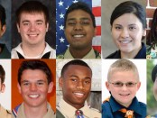](http://blog.scoutingmagazine.org/2016/02/26/2015-report-to-the-nation/)

A group of 10 extraordinary young people representing every Scouting program is heading to Washington, D.C., to present the 2015 Report to the Nation. 

[What was the average age of 2015 Eagle Scouts?](http://blog.scoutingmagazine.org/2016/02/26/what-was-the-average-age-of-2015-eagle-scouts/)

February 26, 2016 // [30 Comments](http://blog.scoutingmagazine.org/2016/02/26/what-was-the-average-age-of-2015-eagle-scouts/)

[](http://blog.scoutingmagazine.org/2016/02/26/what-was-the-average-age-of-2015-eagle-scouts/)

Eagle Scouts are getting older. In 1949, the average age of Eagle Scouts was 14.6 years. In 2015, that number was 17.34 years old.

[Which state had the most Eagle Scouts in 2015?](http://blog.scoutingmagazine.org/2016/02/25/which-state-had-the-most-eagle-scouts-in-2015/)

February 25, 2016 // [26 Comments](http://blog.scoutingmagazine.org/2016/02/25/which-state-had-the-most-eagle-scouts-in-2015/)

[](http://blog.scoutingmagazine.org/2016/02/25/which-state-had-the-most-eagle-scouts-in-2015/)

Once again, Utah takes the crown. No state produced more Eagle Scouts in 2015 than Utah. Here's the full list, 1 to 50. 

[Lions, a new pilot program for kindergarten boys, to begin this fall](http://blog.scoutingmagazine.org/2016/02/24/lions-a-new-scouting-program-for-kindergarten-boys-to-begin-pilot-rollout/)

February 24, 2016 // [107 Comments](http://blog.scoutingmagazine.org/2016/02/24/lions-a-new-scouting-program-for-kindergarten-boys-to-begin-pilot-rollout/)

[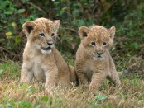](http://blog.scoutingmagazine.org/2016/02/24/lions-a-new-scouting-program-for-kindergarten-boys-to-begin-pilot-rollout/)

Lions, a new Boy Scouts of America program for kindergarten boys, will begin a pilot in participating councils this fall. 

[Eagles: Apply for one of five incredible research expeditions offered by NESA](http://blog.scoutingmagazine.org/2016/02/24/eagles-apply-for-one-of-five-incredible-research-expeditions-offered-by-nesa/)

February 24, 2016 // [8 Comments](http://blog.scoutingmagazine.org/2016/02/24/eagles-apply-for-one-of-five-incredible-research-expeditions-offered-by-nesa/)

[](http://blog.scoutingmagazine.org/2016/02/24/eagles-apply-for-one-of-five-incredible-research-expeditions-offered-by-nesa/)

Eagle Scouts age 18 and older can apply now for a chance to join world-class researchers across the globe in the NESA World Explorers Program. Deadline is March 22. 

[Eagle Scout Class of 2015, by the numbers](http://blog.scoutingmagazine.org/2016/02/24/eagle-scout-statistics-for-2015/)

February 24, 2016 // [57 Comments](http://blog.scoutingmagazine.org/2016/02/24/eagle-scout-statistics-for-2015/)

[](http://blog.scoutingmagazine.org/2016/02/24/eagle-scout-statistics-for-2015/)

Let's look at the Eagle Scout Class of 2015 by the numbers, including average age, a state-by-state breakdown and the number of service hours recorded.

[Scouts present Report to the Nation to Speaker Paul Ryan (and get a selfie)](http://blog.scoutingmagazine.org/2016/03/02/scouts-present-report-to-the-nation-to-speaker-paul-ryan-and-get-a-selfie/)

March 2, 2016 // [0 Comments](http://blog.scoutingmagazine.org/2016/03/02/scouts-present-report-to-the-nation-to-speaker-paul-ryan-and-get-a-selfie/)

[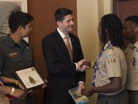](http://blog.scoutingmagazine.org/2016/03/02/scouts-present-report-to-the-nation-to-speaker-paul-ryan-and-get-a-selfie/)

Ten youth delegates on Tuesday presented the Report to the Nation to Speaker Paul Ryan. They even had time for a quick selfie with the representative. 

[Michigan Scouts deliver 2,500 cases of water to residents in Flint](http://blog.scoutingmagazine.org/2016/03/01/michigan-scouts-deliver-2500-cases-of-water-to-residents-in-flint/)

March 1, 2016 // [0 Comments](http://blog.scoutingmagazine.org/2016/03/01/michigan-scouts-deliver-2500-cases-of-water-to-residents-in-flint/)

[](http://blog.scoutingmagazine.org/2016/03/01/michigan-scouts-deliver-2500-cases-of-water-to-residents-in-flint/)

Michigan Scouts collected and hand delivered 2,500 cases of water to 300 residents in Flint, a city crippled by lead-tainted water. 

[Scouts react to meeting President Obama to present Report to the Nation](http://blog.scoutingmagazine.org/2016/03/01/scouts-present-2015-report-to-the-nation-to-president-obama/)

March 1, 2016 // [1 Comment](http://blog.scoutingmagazine.org/2016/03/01/scouts-present-2015-report-to-the-nation-to-president-obama/)

[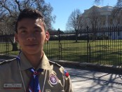](http://blog.scoutingmagazine.org/2016/03/01/scouts-present-2015-report-to-the-nation-to-president-obama/)

The group of 10 youth delegates BSA presented our 2015 Report to the Nation to President Obama, who is also the BSA's honorary president. 

[Two TV-show casting opportunities for Scouters](http://blog.scoutingmagazine.org/2016/03/01/two-tv-show-casting-opportunities-for-scouters/)

March 1, 2016 // [1 Comment](http://blog.scoutingmagazine.org/2016/03/01/two-tv-show-casting-opportunities-for-scouters/)

[](http://blog.scoutingmagazine.org/2016/03/01/two-tv-show-casting-opportunities-for-scouters/)

Now’s your chance to be a television star! Two casting agencies call for outdoors-minded leaders for future TV shows. 

[What officials at the Pentagon said about Scouting](http://blog.scoutingmagazine.org/2016/03/01/scouting-has-some-high-powered-fans-at-the-pentagon/)

March 1, 2016 // [2 Comments](http://blog.scoutingmagazine.org/2016/03/01/scouting-has-some-high-powered-fans-at-the-pentagon/)

[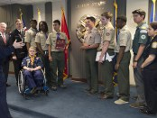](http://blog.scoutingmagazine.org/2016/03/01/scouting-has-some-high-powered-fans-at-the-pentagon/)

Boy Scouts of America representatives visited the Pentagon, where they found a bunch of Scouting fans working for the Department of Defense. 

[Scouts honor fallen heroes in wreath-laying ceremony at Tomb of the Unknowns](http://blog.scoutingmagazine.org/2016/03/01/scouts-honor-fallen-heroes-in-wreath-laying-ceremony-at-tomb-of-the-unknown-soldier/)

March 1, 2016 // [0 Comments](http://blog.scoutingmagazine.org/2016/03/01/scouts-honor-fallen-heroes-in-wreath-laying-ceremony-at-tomb-of-the-unknown-soldier/)

[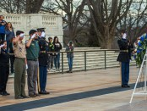](http://blog.scoutingmagazine.org/2016/03/01/scouts-honor-fallen-heroes-in-wreath-laying-ceremony-at-tomb-of-the-unknown-soldier/)

Members of the BSA's Report to the Nation delegation participated in a wreath-laying ceremony at the Tomb of the Unknowns. 

March 2016

[2015 merit badge rankings: The most and least popular](http://blog.scoutingmagazine.org/2016/03/09/2015-merit-badge-rankings/)

March 9, 2016 // [53 Comments](http://blog.scoutingmagazine.org/2016/03/09/2015-merit-badge-rankings/)

[](http://blog.scoutingmagazine.org/2016/03/09/2015-merit-badge-rankings/)

The 2015 merit badge rankings are here, and the winner is clear. More Scouts earned one merit badge than any other, and it wasn't close. 

[How does your troop care for its tents?](http://blog.scoutingmagazine.org/2016/03/08/how-does-your-troop-care-for-its-tents/)

March 8, 2016 // [15 Comments](http://blog.scoutingmagazine.org/2016/03/08/how-does-your-troop-care-for-its-tents/)

[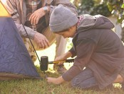](http://blog.scoutingmagazine.org/2016/03/08/how-does-your-troop-care-for-its-tents/)

Who is responsible for tent care in your troop? How do you hold Scouts accountable for damaged or dirty tents or lost tent stakes? 

[Veterans Affairs secretary, whose son is an Eagle Scout, shares why he never earned Eagle](http://blog.scoutingmagazine.org/2016/03/04/veterans-affairs-secretary-discusses-scouting/)

March 4, 2016 // [6 Comments](http://blog.scoutingmagazine.org/2016/03/04/veterans-affairs-secretary-discusses-scouting/)

[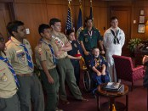](http://blog.scoutingmagazine.org/2016/03/04/veterans-affairs-secretary-discusses-scouting/)

Veterans Affairs Secretary McDonald talked to the BSA's Report to the Nation delegates about his Scouting past. 

[Interior Secretary Jewell talks with Scouts about getting more kids outside](http://blog.scoutingmagazine.org/2016/03/04/interior-secretary-jewell-scouts-want-to-get-more-young-people-outside/)

March 4, 2016 // [9 Comments](http://blog.scoutingmagazine.org/2016/03/04/interior-secretary-jewell-scouts-want-to-get-more-young-people-outside/)

[](http://blog.scoutingmagazine.org/2016/03/04/interior-secretary-jewell-scouts-want-to-get-more-young-people-outside/)

A group of Scouts met with Interior Secretary Sally Jewell to discuss ways to get young people away from screens and out into nature. 

[Photos: Scouts meet President Obama](http://blog.scoutingmagazine.org/2016/03/03/photos-scouts-meet-president-obama-to-deliver-report-to-the-nation/)

March 3, 2016 // [11 Comments](http://blog.scoutingmagazine.org/2016/03/03/photos-scouts-meet-president-obama-to-deliver-report-to-the-nation/)

[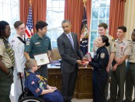](http://blog.scoutingmagazine.org/2016/03/03/photos-scouts-meet-president-obama-to-deliver-report-to-the-nation/)

The delegates, including one Cub Scout, eight Boy Scouts, one Venturer and one Explorer, met President Obama on Tuesday at the White House. 

[Medal of Honor recipient got his start in Scouting](http://blog.scoutingmagazine.org/2016/03/03/medal-of-honor-recipient-got-his-start-in-scouting/)

March 3, 2016 // [2 Comments](http://blog.scoutingmagazine.org/2016/03/03/medal-of-honor-recipient-got-his-start-in-scouting/)

[](http://blog.scoutingmagazine.org/2016/03/03/medal-of-honor-recipient-got-his-start-in-scouting/)

Senior Chief Petty Officer Edward C. Byers Jr. — a former Boy Scout — was awarded the nation’s highest honor for military valor, the Medal of Honor. 

[Read what three Eagle Scout politicians had to say about Scouting](http://blog.scoutingmagazine.org/2016/03/03/read-what-three-high-ranking-eagle-scouts-on-capitol-hill-had-to-say-about-scouting/)

March 3, 2016 // [7 Comments](http://blog.scoutingmagazine.org/2016/03/03/read-what-three-high-ranking-eagle-scouts-on-capitol-hill-had-to-say-about-scouting/)

[](http://blog.scoutingmagazine.org/2016/03/03/read-what-three-high-ranking-eagle-scouts-on-capitol-hill-had-to-say-about-scouting/)

The shared language of what it means to be an Eagle was spoken fluently at the annual Gathering of Eagles on Wednesday in Washington, D.C. 

[Scouts present Report to the Nation to House Minority Leader Nancy Pelosi](http://blog.scoutingmagazine.org/2016/03/03/scouts-present-report-to-the-nation-to-house-minority-leader-nancy-pelosi/)

March 3, 2016 // [0 Comments](http://blog.scoutingmagazine.org/2016/03/03/scouts-present-report-to-the-nation-to-house-minority-leader-nancy-pelosi/)

[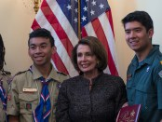](http://blog.scoutingmagazine.org/2016/03/03/scouts-present-report-to-the-nation-to-house-minority-leader-nancy-pelosi/)

The seven Scouts, one Venturer and one Explorer handed their report to House Minority Leader Nancy Pelosi, who spent about 15 minutes with the young people. 

[Scouting gets a good checkup from U.S. Surgeon General](http://blog.scoutingmagazine.org/2016/03/02/scouting-gets-a-good-checkup-from-u-s-surgeon-general/)

March 2, 2016 // [3 Comments](http://blog.scoutingmagazine.org/2016/03/02/scouting-gets-a-good-checkup-from-u-s-surgeon-general/)

[](http://blog.scoutingmagazine.org/2016/03/02/scouting-gets-a-good-checkup-from-u-s-surgeon-general/)

BSA initiatives on the responsible use of medicine, on physical activity and on nutrition align with what the Surgeon General deems most important. 

[Head of Customs and Border Protection also a top Exploring volunteer](http://blog.scoutingmagazine.org/2016/03/02/customs-and-border-protection-commissioner-also-a-full-time-exploring-volunteer/)

March 2, 2016 // [4 Comments](http://blog.scoutingmagazine.org/2016/03/02/customs-and-border-protection-commissioner-also-a-full-time-exploring-volunteer/)

[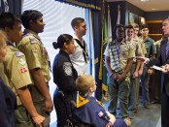](http://blog.scoutingmagazine.org/2016/03/02/customs-and-border-protection-commissioner-also-a-full-time-exploring-volunteer/)

Gil Kerlikowske, commissioner of U.S. Customs and Border Protection, is also chairman of the National Law Enforcement Exploring Committee. 

March 2016

[A hurricane, the Beach Boys and a free Apple Computer bag made 1985 Jamboree legendary](http://blog.scoutingmagazine.org/2016/03/17/the-beach-boys-a-hurricane-and-the-famous-apple-bag-made-1985-jamboree-legendary/)

March 17, 2016 // [37 Comments](http://blog.scoutingmagazine.org/2016/03/17/the-beach-boys-a-hurricane-and-the-famous-apple-bag-made-1985-jamboree-legendary/)

[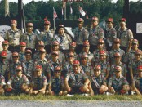](http://blog.scoutingmagazine.org/2016/03/17/the-beach-boys-a-hurricane-and-the-famous-apple-bag-made-1985-jamboree-legendary/)

The 1985 National Scout Jamboree at Fort A.P. Hill, Va., produced stories that have been told and retold for more than 30 years. 

[Scouts Then and Now, Chapter 1: 30 inspiring sets of photos](http://blog.scoutingmagazine.org/2016/03/16/scouts-then-and-now-chapter-1/)

March 16, 2016 // [0 Comments](http://blog.scoutingmagazine.org/2016/03/16/scouts-then-and-now-chapter-1/)

[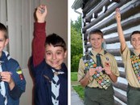](http://blog.scoutingmagazine.org/2016/03/16/scouts-then-and-now-chapter-1/)

In this first chapter of "Scouts Then and Now," check out the same Scout in two phases of his life: his early Scouting years and his later Scouting years. 

[Challenge yourself with the March-April 2016 ‘Where Am I?’ contest](http://blog.scoutingmagazine.org/2016/03/15/challenge-yourself-with-the-march-april-2016-where-am-i-contest/)

March 15, 2016 // [1 Comment](http://blog.scoutingmagazine.org/2016/03/15/challenge-yourself-with-the-march-april-2016-where-am-i-contest/)

[](http://blog.scoutingmagazine.org/2016/03/15/challenge-yourself-with-the-march-april-2016-where-am-i-contest/)

Use the clues and photo to name this secret destination. You could be randomly selected to win $100 to Scoutstuff.org. 

[How the National Baptist Convention of America plans to grow Scouting](http://blog.scoutingmagazine.org/2016/03/15/how-national-baptist-convention-of-america-plans-to-grow-scouting/)

March 15, 2016 // [5 Comments](http://blog.scoutingmagazine.org/2016/03/15/how-national-baptist-convention-of-america-plans-to-grow-scouting/)

[](http://blog.scoutingmagazine.org/2016/03/15/how-national-baptist-convention-of-america-plans-to-grow-scouting/)

A new, two-year initiative launched by the National Baptist Convention of America International is aimed at growing Scouting in five states. 

[Extreme Makeovers, Round 14: Eagle Scout project before-and-after photos](http://blog.scoutingmagazine.org/2016/03/14/extreme-makeovers-round-14-eagle-scout-project-before-and-after-photos/)

March 14, 2016 // [4 Comments](http://blog.scoutingmagazine.org/2016/03/14/extreme-makeovers-round-14-eagle-scout-project-before-and-after-photos/)

[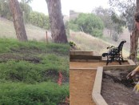](http://blog.scoutingmagazine.org/2016/03/14/extreme-makeovers-round-14-eagle-scout-project-before-and-after-photos/)

This week's batch of 15 projects includes a prayer and meditation center in California, a wheelchair-accessible garden in Illinois, a restoration of Colorado's largest sundial and many more incredible projects. 

[A camp clothes drying rack you can build in minutes](http://blog.scoutingmagazine.org/2016/03/11/a-camp-clothes-drying-rack-you-can-build-in-minutes/)

March 11, 2016 // [5 Comments](http://blog.scoutingmagazine.org/2016/03/11/a-camp-clothes-drying-rack-you-can-build-in-minutes/)

[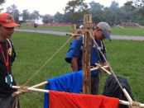](http://blog.scoutingmagazine.org/2016/03/11/a-camp-clothes-drying-rack-you-can-build-in-minutes/)

Clotheslines are so 1960s. Today's most cunning campers build a camp clothes drying rack out of sticks and ropes. 

[Scouts Then and Now: Send in your photos for a new blog series](http://blog.scoutingmagazine.org/2016/03/11/scouts-then-and-now/)

March 11, 2016 // [6 Comments](http://blog.scoutingmagazine.org/2016/03/11/scouts-then-and-now/)

[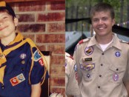](http://blog.scoutingmagazine.org/2016/03/11/scouts-then-and-now/)

Introducing "Scouts Then and Now," a new feature on Bryan on Scouting. Send me two photos of your Scouts: then and now. 

[Nancy Reagan brought her anti-drug message to the 1985 National Scout Jamboree](http://blog.scoutingmagazine.org/2016/03/11/nancy-reagan-1985-jamboree/)

March 11, 2016 // [8 Comments](http://blog.scoutingmagazine.org/2016/03/11/nancy-reagan-1985-jamboree/)

[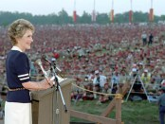](http://blog.scoutingmagazine.org/2016/03/11/nancy-reagan-1985-jamboree/)

Nancy Reagan, the former First Lady of the United States who died Sunday, addressed 30,000 Boy Scouts at the 1985 National Scout Jamboree. 

[New details released about Lions, the pilot program for kindergarten boys](http://blog.scoutingmagazine.org/2016/03/10/new-details-released-about-lions/)

March 10, 2016 // [37 Comments](http://blog.scoutingmagazine.org/2016/03/10/new-details-released-about-lions/)

[](http://blog.scoutingmagazine.org/2016/03/10/new-details-released-about-lions/)

In Lions, the new pilot program for kindergartners, boys wear T-shirts instead of uniforms and earn adventure stickers instead of adventure loops. 

[The real number of Eagle Scout service hours completed is probably much higher than your Scouts report](http://blog.scoutingmagazine.org/2016/03/10/eagle-scout-service-hours-number-probably-hour/)

March 10, 2016 // [20 Comments](http://blog.scoutingmagazine.org/2016/03/10/eagle-scout-service-hours-number-probably-hour/)

[](http://blog.scoutingmagazine.org/2016/03/10/eagle-scout-service-hours-number-probably-hour/)

Many young men may be improperly recording their Eagle Scout service hours completed on projects, one volunteer says. 

[Top 5 merit badges Superman would have no trouble earning](http://blog.scoutingmagazine.org/2016/03/24/top-5-merit-badges-superman-no-trouble-earning/)

March 24, 2016 // [7 Comments](http://blog.scoutingmagazine.org/2016/03/24/top-5-merit-badges-superman-no-trouble-earning/)

[](http://blog.scoutingmagazine.org/2016/03/24/top-5-merit-badges-superman-no-trouble-earning/)

In honor of this week's release of Batman v Superman: Dawn of Justice, I thought I'd share the top five merit badges Superman would have no trouble earning. 

[Top 5 merit badges Batman would have no trouble earning](http://blog.scoutingmagazine.org/2016/03/24/top-5-merit-badges-batman-no-trouble-earning/)

March 24, 2016 // [3 Comments](http://blog.scoutingmagazine.org/2016/03/24/top-5-merit-badges-batman-no-trouble-earning/)

[](http://blog.scoutingmagazine.org/2016/03/24/top-5-merit-badges-batman-no-trouble-earning/)

In honor of this week's release of Batman v Superman: Dawn of Justice, I thought I'd share the top five merit badges Batman would have no trouble earning. 

[13th-edition ‘Boy Scout Handbook’: Inside the guy’s guide to adventure](http://blog.scoutingmagazine.org/2016/03/24/13th-edition-boy-scout-handbook-guys-guide-adventure/)

March 24, 2016 // [26 Comments](http://blog.scoutingmagazine.org/2016/03/24/13th-edition-boy-scout-handbook-guys-guide-adventure/)

[](http://blog.scoutingmagazine.org/2016/03/24/13th-edition-boy-scout-handbook-guys-guide-adventure/)

The new, 13th edition of the Boy Scout Handbook was designed with navigation in mind. It's the most user-friendly Handbook the BSA has ever released. 

[Eagle Scout recovering after he was injured in Brussels attack](http://blog.scoutingmagazine.org/2016/03/23/eagle-scout-brussels/)

March 23, 2016 // [0 Comments](http://blog.scoutingmagazine.org/2016/03/23/eagle-scout-brussels/)

[](http://blog.scoutingmagazine.org/2016/03/23/eagle-scout-brussels/)

Mason Wells, an Eagle Scout from Utah, was injured in Tuesday's deadly bombings in Brussels. 

[Scouts Then and Now, Chapter 2: 36 inspiring sets of photos](http://blog.scoutingmagazine.org/2016/03/23/scouts-then-and-now-chapter-2/)

March 23, 2016 // [3 Comments](http://blog.scoutingmagazine.org/2016/03/23/scouts-then-and-now-chapter-2/)

[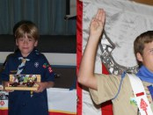](http://blog.scoutingmagazine.org/2016/03/23/scouts-then-and-now-chapter-2/)

In this chapter of Scouts Then and Now, we share 36 sets of photos that show the same young person in two stages of their Scouting lives. 

[Josh Hart, Villanova basketball’s ‘heart and soul,’ is an Eagle Scout](http://blog.scoutingmagazine.org/2016/03/23/josh-hart-villanova-eagle-scout/)

March 23, 2016 // [3 Comments](http://blog.scoutingmagazine.org/2016/03/23/josh-hart-villanova-eagle-scout/)

[](http://blog.scoutingmagazine.org/2016/03/23/josh-hart-villanova-eagle-scout/)

Josh Hart, the Villanova guard who led his team to the Sweet Sixteen, says Scouting instilled in him the work ethic necessary to succeed. 

[Extreme Makeovers, Round 15: Eagle Scout project before-and-after photos](http://blog.scoutingmagazine.org/2016/03/22/extreme-makeovers-round-15-eagle-scout-project-photos/)

March 22, 2016 // [1 Comment](http://blog.scoutingmagazine.org/2016/03/22/extreme-makeovers-round-15-eagle-scout-project-photos/)

[](http://blog.scoutingmagazine.org/2016/03/22/extreme-makeovers-round-15-eagle-scout-project-photos/)

This week's batch of 18 includes a firefighter wall of honor, a dog park, a beautiful new fire pit and more incredible Eagle projects. 

[Unique prep school covered on ’60 Minutes’ draws from Scouting values](http://blog.scoutingmagazine.org/2016/03/21/unique-prep-school-covered-60-minutes-draws-scouting-values/)

March 21, 2016 // [5 Comments](http://blog.scoutingmagazine.org/2016/03/21/unique-prep-school-covered-60-minutes-draws-scouting-values/)

[](http://blog.scoutingmagazine.org/2016/03/21/unique-prep-school-covered-60-minutes-draws-scouting-values/)

St. Benedict's Prep in Newark, N.J., has a lot in common with a Boy Scout troop. According to "60 Minutes," that's by design. 

[This summer, join the conversation about engaging millennials parents in Scouting](http://blog.scoutingmagazine.org/2016/03/21/engaging-millennials-parents-in-scouting/)

March 21, 2016 // [6 Comments](http://blog.scoutingmagazine.org/2016/03/21/engaging-millennials-parents-in-scouting/)

[](http://blog.scoutingmagazine.org/2016/03/21/engaging-millennials-parents-in-scouting/)

This summer, head to Philmont Training Center for "Engaging Millennial Parents in Scouting," a weeklong course. 

[Eagle Scout service project benefits those on four legs](http://blog.scoutingmagazine.org/2016/03/18/eagle-projects-beneficiary-has-four-legs/)

March 18, 2016 // [10 Comments](http://blog.scoutingmagazine.org/2016/03/18/eagle-projects-beneficiary-has-four-legs/)

[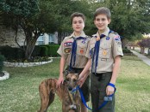](http://blog.scoutingmagazine.org/2016/03/18/eagle-projects-beneficiary-has-four-legs/)

An Eagle candidate from Texas has completed an impressive Eagle Scout service project to benefit the Greyhound Adoption League of Texas. 

Blog Contributors

**Bryan Wendell**, an Eagle Scout, is senior editor of *Boys' Life*, *Scouting* and *Eagles' Call*magazines.   
  
**Gretchen Sparling** is associate editor of *Boys' Life*, *Scouting* and *Eagles' Call* magazines.

# The Cyber Chip is Here

*Robert (Bob) L. Stocker*

*Abraham Lincoln Council, BSA*

[](http://www.scouting.org/filestore/youthprotection/pdf/100-053.pdf)

What is it about a pocket knife and fire that attract boys? That is a discussion that could go one for a long time. The Whittling Chip (Cub Scouts), Totin’ Chip, and Firem’n Chit (Boy Scouts) seem to be items that scouts want to earn right away.

The whittling chip teaches cub scouts how to safely handle and care for pocket knives. The Totin’ Chip teaches Boy Scouts how to safely handle and care for pocket knives, bow saws, and axes. The Firem’n Chit allows Boy Scouts to build and maintain fires for different functions such as cooking and staying warm.

By earning these awards scouts are allowed to carry and use this tools. These tools have been items in a scout’s “toolbox” for quite some time.

With technology, scouts of today have some new digital tools in their scouting “toolbox” and the Boy Scouts of America (BSA) has prepared a training program called the [Cyber Chip](http://www.scouting.org/cyberchip.aspx) to address these new tools. The Cyber Chip, like its counter parts, is here to teach youth, adult leaders, and parents how to use these digital tools in a safe and proper manner.

While the Cyber Chip award is primarily for scouts of all ages, there is lots of information and resources for adult leaders and parents to use in their units and at home.

In designing the Cyber Chip program, the BSA joined with NetSmartz®, which is part of the National Center for Missing and Exploited Children®.

[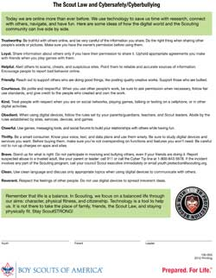](http://www.scouting.org/filestore/youthprotection/pdf/100-055_WB.pdf)

The program is designed for all the different grades of Scouts. They go from 1st thru 12th. Unlike its counter parts, the Whittling Chip, Totin’ Chip, and Firem’n Chit, the Cyber Chip expires each year and has to be “recharged.” Each grade has an activity that that has to be completed in order to “recharge” your Cyber Chip for another year.

In addition to having the links to the Cyber Chip program for each grade, the BSA web site for the Cyber Chip program also has a couple of great PDFs for download, one is at the beginning of this article, and the other (to the right) is showing how the Scout Law and Cyber Safety can live side by side.

Along with the PDFs mentioned, there are some great tips that parents, unit leaders, districts, and councils can use. Below is a copy of that information. To see the full web page click [here](http://www.scouting.org/cyberchip.aspx).

***Integration Ideas***

***Parents***

* *Use the Cyber Chip as a tool to work with your youth to create additional open communications.*
* *Visit www.scouting.org/cyberchip and NetSmartz® for more content ideas and tip sheets.*

***Unit Leaders***

* *Tailor the requirements to your own unit rules. Complete the requirements for the Cyber Chip as a unit at a regular meeting, then hand out the cards and patches on the spot.*
* *Review the resources available on the website, including teaching materials, an implementation guide, and more.*
* *Create a fun challenge for youth to stump the unit leaders.*
* *Play a "Jeopardy!"-style game in a meeting to use what's been learned.*
* *Use the Cyber Chip as a foundational step in preparation for leadership positions such as Webmaster.*

***Councils and Districts***

* *Add Cyber Chip information to council or district websites. Create an area focused on cyber safety. Use resources from NetSmartz®*
* *Spread the word by communicating at events like camporees and Scoutoramas.*
* *Do a tech event for adults or youth—then set teams to compete with each other on their knowledge in a fun fashion*

A personal favorite “Integration Idea” is “Use *the Cyber Chip as a foundational step in preparation for leadership positions such as Webmaster*.” The webmaster or maybe “The Webmaster Patrol” could work on telling your unit’s story thru digital media, but in order to do that the scout needs to have a current/charged Cyber Chip.

Just like a scout has to have a Whittling or Totin’ Chip to carry a pocket knife to a scout event; a scout has to have a current/recharged Cyber Chip to carry a digital device to a scout event.

**Be sure to check out and share the Cyber Chip with your entire unit and check out the great items for the unit leaders**.

# Leave No Trace (LNT)

*Wendy McBride*

*Chief Seattle Council*

Outdoor Code and Leave No Trace principles are in the back of the boy’s handbooks.

Leave No Trace requirements in boy’s handbooks:

Tigers: Tigers in Wild (Outdoor Code, LNT, Plant & Animal identification).

Wolves: Call of Wild #7, Paws on Path #5 (Outdoor Code & LNT); Paws on Path #1 (6 essentials);

Paws on Path #2, #3 (Buddies and Lost)

Bears: Fur, Feathers, & Ferns (Observe Wildlife from Distance; Plants & Magnifying Glass).

Bear Necessities #3 (6 essentials)

Webelos: Outdoor Code & Leave No Trace (Walkabout #1, #2, #3, #5; Camper #2, #3, #7;

Scouting Adventure #1E) Campfire safety (Cast Iron Chef #1; Castaway #1A).

Outdoor Ethics Awareness & Action Awards (replaced LNT award):

<http://outdoorethics-bsa.org/awards/>

Cub Scout World Conservation Award:

<http://www.scouting.org/filestore/cubscouts/pdf/512-036_WB.pdf>

Cub Scout Conservation Good Turn Award: <http://www.scouting.org/scoutsource/BoyScouts/Resources/ConservationGoodTurn.aspx>

Leave No Trace Trainer Training: June 10-11 2016 <http://www.seattlebsa.org/Training-Calendar>

**Leave No Trace Principles** (Front Country/Cub Scouts)

1. Know before you go (plan ahead).
2. Choose the right path (stick to trails).
3. Trash your trash.
4. Leave what you find.
5. Be careful with fire.
6. Respect wildlife.
7. Be kind to other visitors.

**Leave No Trace Principles** (Back Country/Boy Scouts)

1. Plan Ahead and Prepare.
2. Travel and Camp on Durable Surfaces.
3. Dispose of Waste Properly (Pack It In, Pack It Out).
4. Leave What You Find.
5. Minimize Campfire Impacts.
6. Respect Wildlife.
7. Be Considerate of Other Visitors

**Outdoor Code**

As an American, I will do my best to – be clean in my outdoor manners, be careful with fire, be considerate in the outdoors, and be conservation-minded.

**Outdoor Code Opening**

*Sam Houston Area Council, 2009 “Footprints” Baloo’s Bugle.*

**Cub #1** (enters and stands by Cubmaster) As an American, I will do my best to be clean in my outdoor manners.

**CM** I will treat the outdoors as a heritage. I will take care of it for myself and others. I will keep my trash and garbage out of lakes, streams, fields, woods, and roadways.

**Cub #2** I will be careful with fire.

**CM** I will prevent wildfire. I will build my fires only where they are appropriate. When I have finished using a fire, I will make sure it is cold out. I will leave a clean fire ring, or remove all evidence of my fire.

**Cub #3** I will be considerate in the outdoors.

**CM** I will treat public and private property with respect. I will use low-impact methods of hiking and camping.

**Cub #4** I will be conservation-minded

**CM** I will learn how to practice good conservation of soil, waters, forest, minerals, grasslands, wildlife, and energy. I will urge others to do the same.

**Leave No Trace (LNT) Websites**

<http://www.scouting.org/scoutsource/BoyScouts/TeachingLeaveNoTrace.aspx> BSA LNT Course: concepts, activities

<http://lnt.org/teach/concepts-and-plans-teaching-leave-no-trace> activities & discussions

<http://www.leavenotracedude.com/teach/general-teaching.shtml> preparing to teach LNT; activities & discussions

Note: activities are at the bottom of the principles pages, which are on the side menu.

<http://nevadaoutdoorschool.org/OutdoorEthics/OE_LessonPlans/LNT_Quick.pdf> games & activities: <http://tourismpurewalking.com/leave-no-trace-resources-for-kids/> games & activities:

<http://www.nps.gov/gaar/forkids/upload/leave%20no%20trace%20worksheet.pdf> board game (gathering activity)

<http://familyfocusblog.com/teaching-your-children-to-leave-no-trace/> reasons for LNT rules

<http://www.outdoors.org/publications/outdoors/web/kids/leave-no-trace-for-kids.cfm> tips to help kids follow rules

<http://backpackingkids.wordpress.com/2012/11/18/leave-no-trace/> tips to help kids follow LNT rules

**Council Camping:** <http://www.seattlebsa.org/Camping/Cub-Scout-Camping/>

Winter Camp, Resident Camp, Day Camp, Family Camp, Parent & Pal

**Journey to Excellence:**

<http://www.scouting.org/scoutsource/Awards/JourneyToExcellence.aspx>

From the 2016 Pack Scorecard:

**#6**: Conduct outdoor activities & field trips. (3-5 outdoor den activities per year.)

**#7:** Cub Scouts attend day camp, family camp, and/or resident camp. (33%-75%)

**#8:** Service Projects (conservation project for gold level)

Reminder: save day camp, resident camp, and family camp rosters for Summertime Pack Award (JTE #9), National Den Award.

**Tour Plans:** <http://www.seattlebsa.org/index.php?option=com_docman&Itemid=204> Tour plan rules and forms are at the bottom of the page. Units only need to file tours plans for water activities, over-nighters, and trips outside council boundaries.

**Humor**

Silly comments & questions at National Parks: <http://www.everyday-wisdom.com/park-rangers.html>

Murphy’s Laws of Camping:

<http://www.camptrip.com/camping-jokes/funny-camping-lessons/>

<http://www.camptrip.com/camping-jokes/murphys-laws-camping/>

**Leave No Trace Activities & Tips**

**Guide Kids to Discover Principles**: Rather than talking to your group, have them spend as much time as possible experiencing situations and making decisions. Encourage them to be involved in the activity and think for themselves rather than passively sitting and listening to you ramble on. Groups should learn together as they participate and discover the impacts their actions make. Some may catch on more quickly and some may be resistant to change. By presenting situations where they can choose, rather than list the rules of LNT, they discover their own current land ethics and decide how they need to modify it.

*From* [*http://www.leavenotracedude.com/teach/general-teaching.shtml*](http://www.leavenotracedude.com/teach/general-teaching.shtml)

**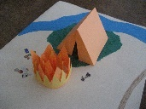 Camp Ohno!**

Set up a full-size, or miniature model camp. Challenge kids to spot all the ways the campsite doesn’t follow Leave No Trace principles.

*From* [*http://nevadaoutdoorschool.org/OutdoorEthics/OE\_LessonPlans/LNT\_Quick.pdf* p. 1](http://nevadaoutdoorschool.org/OutdoorEthics/OE_LessonPlans/LNT_Quick.pdf%20p.%201).

Includes more violations for full-size camp.

*and* [*http://www.leavenotracedude.com/minimize-campfire-impact.shtml*](http://www.leavenotracedude.com/minimize-campfire-impact.shtml)

MINIATURE CAMP OHNO BACK COUNTRY LNT VIOLATIONS:

Travel & Camp on Durable Surfaces

The tent is not set up in an established campsite, or on a durable surface (fragile plant life).

Trash your Trash

There is litter around the campfire. (Put trash in a trash bag and take with you.)

Leave What You Find

Picked flowers can’t pollinate and make more flowers, or provide food for bees and hummingbirds.

Minimize Campfire Impacts

The huge campfire uses more wood, produces more smoke and sparks, and leaves a bigger dead spot on the ground. (Build a smaller fire; use a fire pan or make a mound fire. Or even better, skip the fire altogether and use a camp stove.)

The fire is too close to the tent, creating a fire hazard. The tent could catch on fire.

Trash is too close to the fire. It could catch fire, and the fire could spread.

Respect Wildlife

There are food scraps on the ground. Don’t feed the wildlife -- it damages their health, alters their natural behaviors, and exposes them to predators and other dangers. (Put food scraps in a trash bag.)

The tent is set up too close to water. (It should be 200 feet away from the water.) If campers are close to the lake or stream, or close to the access path to it, then wildlife won’t come to the water to drink. Wash dishes and bodies far from the water source so it is not contaminated.

Don’t pick the wildflowers.

Be Considerate of Others

The brightly colored tent really stands out. A more natural color is better, minimizing the visual impact you have on others. Instead of bright yellow tents, use grey, green, or blue tents. Use a tan backpack cover and save the hunter orange one for hunting season. Consider the colors of your clothing and plan to wear earth-tones. This will help your group seem smaller and less noticeable, especially in open areas where there is little forest cover.

The tent is too close to trail.Tucking your tent away off the trail and in a secluded area allows other hikers on the trail to enjoy the unspoiled views and scenery. Try to find a place screened by trees or rocks and far from any other groups.

Don’t pick the wildflowers. Leave them for others to see and enjoy.

MINIATURE CAMP OHNO FRONT COUNTRY LNT & SAFETY VIOLATION:

Trash your Trash

There is litter around the campfire. (Put trash in a trash bag and take with you.)

Leave What You Find

Picked flowers can’t pollinate and make more flowers, or provide food for bees and hummingbirds.

Be Careful with Fire

There is no campfire ring.

The fire is too close to the tent, creating a fire hazard. The tent could catch on fire.

Trash is too close to the fire. It could catch fire, and the fire could spread.

The huge campfire creates more sparks than a small campfire would. A bigger campfire is a bigger

fire hazard.

Respect Wildlife

There are food scraps on the ground. Don’t feed the wildlife -- it damages their health, alters their natural behaviors, and exposes them to predators and other dangers. (Put food scraps in a trash bag.)

The tent is set up too close to water. (It should be 200 feet away from the water.) If campers are close to the lake or stream, or close to the access path to it, then wildlife won’t come to the water to drink. Wash dishes and bodies far from the water source so it is not contaminated.

Don’t pick the wildflowers.

Be Kind to other Visitors

The brightly colored tent really stands out. A more natural color is better, minimizing the visual impact you have on others. Use grey, green, or blue tents.

The tent is too close to trail.Pitching your tent away from the trail allows others to enjoy the views and scenery better.

Don’t pick the wildflowers. Leave them for others to see and enjoy.

The huge campfire uses more wood, and creates more smoke & pollution. Build a smaller fire.

**Know Before You Go** (Plan Ahead)

GAMES & ACTIVITIES:

**Going on a Camping Trip**

Take photos of various items, from a woolly hat to a pair of shorts. Print the photos off, maybe three per page and then laminate the pages. Cut the laminated page into the three parts, each part with a photo. You might make a total of some 30 photos.

The photos should be a mix of sensible and less sensible items for being active outdoors. Examples: matches, lighter, novel, map, sandals, hiking boots, banana, water melon, etc.

Spread the photos on the ground, or the floor if you are indoors. Ask the children to choose, say, 10 items only from the 30, that they would bring with them when on a camping trip or scouts outing. Discuss what should be brought and what not.

*From:* [*http://tourismpurewalking.com/leave-no-trace-resources-for-kids/*](http://tourismpurewalking.com/leave-no-trace-resources-for-kids/)

**6 Essentials Kim’s Game**

(Tigers in Wild #1; Wolf Paws on Path #1; Bear Necessities #3; Webelos Walkabout #2)

Lay out the 6 essentials (water bottle, trail food, flashlight, first aid kit, whistle, sun protection). A boy leaves the room. The others remove one of the 6 essentials. The boy comes back, and guesses what’s missing. Each boy should have a turn to guess.

**6 Essentials Identification Activity**

(Tigers in Wild #1; Wolf Paws on Path #1; Bear Necessities #3; Webelos Walkabout #2)

Put a bunch of stuff out on the table, including the 6 essentials. Challenge boys to identify which are the 6 essentials (water bottle, trail food, flashlight, first aid kit, whistle, sun protection).

**Nifty Neckerchiefs**

Participants pass a neckerchief around the circle. Each participant names a use for the neckerchief when it is passed to him. See how many times the neckerchief can go around the circle. Point out that items with many uses are better to take backpacking, and it’s good to be creative with the resources you have so you don’t need to take as much.

Neckerchief uses: bandage; sling; neck cooler (when wet); water filter (grey water); tie something; carry something.

*From* [*http://nevadaoutdoorschool.org/OutdoorEthics/OE\_LessonPlans/LNT\_Quick.pdf*](http://nevadaoutdoorschool.org/OutdoorEthics/OE_LessonPlans/LNT_Quick.pdf)

**Skit:** A Cub Scout with too much stuff, and inappropriate stuff in his backpack arrives at the meeting spot before a hike/camping trip. The Scout shows the Den Leader what’s in the backpack, and the Leader responds. The Boy Scout should really ham it up. (Skit demonstrates what to bring, and what not to bring (teddy bear, computer, etc.)

**Will You Make It?**

**Directions:** Distribute event and solution cards amongst participants, one for each participant, with the goal of having people find their corresponding event or solution card to form a pair. Once all participants are matched have each pair share their event and solution, open discussion to other solutions or personal experiences.

*From:* [*http://nevadaoutdoorschool.org/OutdoorEthics/OE\_LessonPlans/LNT\_Quick.pdf*](http://nevadaoutdoorschool.org/OutdoorEthics/OE_LessonPlans/LNT_Quick.pdf) p. 3.15.

**Choose the Right Path** (Stick to Trails)

TIPS:

When you can’t see the ground as easily, you are more prone to slipping or falling, contracting poison oak or more seriously, contracting Lyme disease. According to Health Canada, “You are most likely to come into contact with ticks by brushing against plants.” In addition, you could also get lost in the woods. Yikes! So do yourself and your family a favor by staying on trails.

*From* [*http://familyfocusblog.com/teaching-your-children-to-leave-no-trace/*](http://familyfocusblog.com/teaching-your-children-to-leave-no-trace/)

GAMES & ACTIVITIES:

**Durable Surface Hopscotch**

**Materials:**

Durable surface cards: snow, grass, rock, sand, established trail, playa, gravel.

Nondurable: cryptobiotic soil, wetlands, steep slope, moss, wildflowers.

**Directions:** Ask participants if anyone can define durable. Look around you - point out a durable surface and a nondurable surface, or ask them to! Then have them form a circle and in the middle spread out the surface cards face down (5x5). Make sure there is a possible way to complete the hopscotch! One at a time have participants try to get from start to finish. Participants step on a blank card, flip it over, show the group and judge whether it’s a durable surface or not. If it is they can move on to an adjacent card (vertical, horizontal) until they make it to the finish. If it’s not, they go back to the circle and the next person tries. Encourage them to work as a group - hence once one person makes it across they all have won. As a conclusion discuss what durable surfaces are and review examples.

Miniature version: make index card surfaces and paper Cub Scout figure (below). Boys must get the Scout Figure from start to finish (like above), moving him across the index card surfaces.

*From* [*http://nevadaoutdoorschool.org/OutdoorEthics/OE\_LessonPlans/LNT\_Quick.pdf*](http://nevadaoutdoorschool.org/OutdoorEthics/OE_LessonPlans/LNT_Quick.pdf) 3, 11-14. Surface pictures.

Cub Scout Paper Figures: <http://www.makingfriends.com/friends/f_scouts.htm>

Durable surface Information: <http://www.leavenotracedude.com/teach/general-teaching.shtml>

Established Trail: Once a trail is created, you should take the responsibility to stay on that trail. If it goes through some mud, then go right through the mud with it. Don't go around the mud to keep your boots nice and clean because that just tramples more plants and widens the trail or creates a web of trails over time.

Rock: Keep an eye out for lichens and mosses living on the rock. These small plants are fragile and easily crushed between boot and solid rock.

Sand: very durable, but also softer than rock. Footprints are left behind, but since these surfaces are fairly sterile vegetation is not destroyed.

Snow or ice: a really cool way to travel with no lasting trace. Tracks left in snow will melt quickly during summer or be covered by more snow if traveling in winter. Take care that the snow cover is sufficiently deep to protect vegetation, or the possibly soft ground underneath, especially in spring and fall and along edges of snowfields.

Grass: dry grasses are quick to recover from some traffic. If the grass is dead, then your impact will remain for the season, but the next growth will erase it. Green grass is more easily damaged, but is still more resilient than other vegetation.

Soft-leaf Plants: the least durable ground cover. When you walk through ferns, flowers, herbs, and other fragile vegetation, just a few steps destroy those plants.

**Trash Your Trash**

TIPS:

Ants and mice have become pests in high-use areas because of visitors' careless actions (leaving trash, food around).

*From:* [*http://www.outdoors.org/publications/outdoors/web/kids/leave-no-trace-for-kids.cfm*](http://www.outdoors.org/publications/outdoors/web/kids/leave-no-trace-for-kids.cfm)

GAMES & ACTIVITIES:

**How Long will it Last?**

*From* [*http://www.leavenotracedude.com/teach/dispose-waste-trash.shtml*](http://www.leavenotracedude.com/teach/dispose-waste-trash.shtml)

**Materials** for each group: Plastic zip-loc bag, paper napkin, unused cigarette butt, patch of cotton cloth, patch of leather, wool glove or patch of wool material, top of tin can, such as tomato paste can, crushed aluminum soda can, section of plastic 6-pack soda can ring, glass marble.

**Directions:** Hand out the zip-loc bag full of items to each group. Ask them to arrange all the items by how long they think the item will take to 'degrade' in the wild. Degrade means to break down and disintegrate into the dirt.

**Answer:**

* 2 months - banana peel or other organic matter
* 6 months - paper napkin
* 8 months - patch of cotton cloth
* 1 year - wool glove or patch of wool material
* 4 years - cigarette butt
* 20 years - Plastic zip-loc bag
* 40 years - leather (glove, belt, or cord)
* 100 years - top of tin can, such as tomato paste can
* 300 years - crushed aluminum soda can
* 500 years - section of plastic 6-pack soda can ring
* forever - glass marble, at least 1,000,000 years

*Sam Houston Council, ’08 “Litter to Glitter” Baloo’s Bugle*

How Long will it Last?

* Orange and banana peels – up to 2 years
* Wool socks – 1-5 years
* Cigarette butts – 1-5 years
* Plastic-coated paper – 1-5 years
* Plastic bags – 10-20 years
* Plastic film container – 20-30 years
* Nylon fabric – 30-40 years
* Tin cans – 50 years
* Leather – up to 50 years
* Plastic bottles – 100 years or more
* Plastic six-pack holders – 100 years
* Aluminum cans – 500 years
* Glass bottles – 1,000 years or more
* Styrofoam – 10,000 years or more

**Leave What You Find**

TIPS:

Take a picture or video of the child with their find (antlers, bird nests, special rocks, etc.)

Remind kids that other people will walk down the trail and they will want to see the special item too. You can call this “sharing” the find with others.

If kids start to break off tree branches or otherwise damage the environment, ask them how they would feel if someone broke into their home and started wrecking it with a sledgehammer. Remind them that the forest is the animals’ home.

*From* [*http://backpackingkids.wordpress.com/2012/11/18/leave-no-trace/*](http://backpackingkids.wordpress.com/2012/11/18/leave-no-trace/)

GAMES & ACTIVITIES:

**Puzzle activity**

Use three simple picture puzzles. Break the puzzles into their pieces. In a yard, sandlot, or playground, scatter all the pieces of one puzzle in a small area. In another location scatter just two or three pieces, and in another location leave just one piece. Split your group into three teams and have one group at each location recover the pieces. Ask each group to try and reconstruct the puzzle or describe the picture based on the pieces they found.

Discussion: Ask each group how easy it was to reconstruct the puzzle. Discuss the importance to scientists of finding fossils or artifacts where they were originally deposited. Discuss the impacts of intentional vandalism or theft of fossils or artifacts. Discuss the effects of unintentional impacts, i.e.; driving off-road, hobby collecting, campsite construction. Ask the group if they can think of other ways in which fossils and artifacts can be lost or damaged. Discuss ways in which these resources can be viewed and enjoyed on-site without damage. Remind the group that it is against the law to remove or destroy these resources!

Note: Although this Quick Concept deals with fossils and artifacts, the principle of leaving what you find applies to all things that should remain undisturbed in the backcountry. Wildlife, petrified rock, and nests are examples of other discoveries to leave for people to enjoy.

*From* [*https://lnt.org/teach/leave-what-you-find*](https://lnt.org/teach/leave-what-you-find)

**Candy Activity**

Take a re-usable hard plastic container that can hold enough niceties (chocolate bars, Actimels, sweets in wrappers, etc.) for around 80% of the children you have. All items should not be the same – try to have at least three different types of goodies – and all should have some kind of wrapper or packaging.

Place the container outside the view of the children (behind a tree, for example) and split them into groups of, say, 5. One group at a time is sent to pick one item each out of the container and keep it and move to a second location. By the time the last 20% of children get to the container, it will be empty. They will get nothing.

Discuss this idea of taking things from nature (e.g. flowers) and how it would mean there would be nothing left for future visitors. Always have a nice thing in reserve for the children who got nothing during the exercise. Allow the children to eat or drink whatever they got from the container.

*From* [*http://tourismpurewalking.com/leave-no-trace-resources-for-kids/*](http://tourismpurewalking.com/leave-no-trace-resources-for-kids/)

**Be Careful with Fire**

TIPS:

Add a warm glow to a night under the stars, instead, by lighting candles, putting headlamps behind or inside (empty) colored water bottles, or simply looking at the stars or moonlight.

*From:* [*http://www.outdoors.org/publications/outdoors/web/kids/leave-no-trace-for-kids.cfm*](http://www.outdoors.org/publications/outdoors/web/kids/leave-no-trace-for-kids.cfm)

GAMES & ACTIVITIES:

**Campfire Quiz:**

<http://nevadaoutdoorschool.org/OutdoorEthics/OE_LessonPlans/LNT_Quick.pdf> p. 5, 22.

**Respect Wildlife**

TIPS:

Feeding Animals: When we feed wild animals, the animals are conditioned to associate humans with food, and if it’s a bear for example, we don’t want bears around our families at all! This is a safety hazard for us and the animals since if we’re not around, how will the animals survive?

*From* [*http://familyfocusblog.com/teaching-your-children-to-leave-no-trace/*](http://familyfocusblog.com/teaching-your-children-to-leave-no-trace/)

A student found a very interesting little lizard and brought it back to show his group. After petting its cool bumps and taking a couple pictures, it was carefully set down along the trail.  
The sweat and oil from his hands and being displaced from its regular habitat killed the lizard in a few days.  *From* [*http://www.leavenotracedude.com/respect-wildlife.shtml*](http://www.leavenotracedude.com/respect-wildlife.shtml)

Before swimming fill a pan or water bottle, move 200 feet away from the water (lake, river), and rinse off bare skin. It's the same principle as showering before entering a swimming pool. The quick rinse keeps sunscreen, insect repellent, and other chemicals on the skin from entering and potentially damaging natural water sources.

*From:* [*http://www.outdoors.org/publications/outdoors/web/kids/leave-no-trace-for-kids.cfm*](http://www.outdoors.org/publications/outdoors/web/kids/leave-no-trace-for-kids.cfm)

Manage Your Pet: Animals don't have a grocery store back home to buy all the food they want. If they expend energy running away from humans or dogs, that is energy they need to work very hard to replenish. *From* [*http://www.leavenotracedude.com/respect-wildlife.shtml*](http://www.leavenotracedude.com/respect-wildlife.shtml)

GAMES & ACTIVITIES:

**Animal Thoughts Activity**

*From* [*http://www.leavenotracedude.com/respect-wildlife.shtml*](http://www.leavenotracedude.com/respect-wildlife.shtml)

**Materials**

* a bag of scenarios cut into individual slips of paper:
  + You come upon a bush of huckleberries and pick them all for a special treat at camp.
  + You pull two really nice walking sticks with cool beaver-chewed ends out of a dam across a meandering creek bed and the water rushes out the opening.
  + You cut down a dead snag tree and use it for firewood.
  + You yell across the meadow to your buddy that It’s time for dinner.
  + It's too dark to do dishes after dinner so you wait to clean in the morning.
  + You run out of rinse water so you rinse the soapy dishes off in the creek.
  + You decide to have a campfire.

**Presentation**

* Ask for volunteers to play the roles of: Bear, Beaver, Bird, and Raccoon.
* Position the four animals around the area. Give them pictures of their animals, or animal name signs to hold. The animals will respond with their thoughts for each scenario that is chosen.
* Everyone else gets to be campers. One at a time, they pull a scenario out of the bag and read it. If it would be more fun, they can act out the scenario too.
* Each animal in turn tells what he thinks about the actions taken and how it affects him.
* After all animals talk, everyone can discuss or add ideas before the next scenario.

For example, cutting down a dead snag could affect animals by:

* destroying the bird's nest that was in it. Or, killing the bugs the bird eats.
* killing the ant colony or bee hive that the bear was going to use to survive the winter.
* destroying the hollow cavity in which the raccoon sleeps.
* removing a lot of bio-mass that could have decayed and provided nutrients for new bushes, berries, and trees.

**Motivator**  
Think about how you'd feel if someone walked in your front door uninvited and made himself at home. He watched TV for a few hours, ate all your snacks and soda, and then left without cleaning up after himself. How would you feel? Well, we do that whenever we hit the trail.

  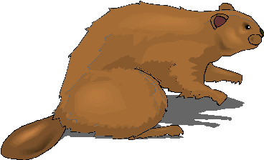   

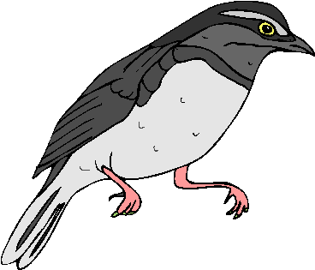

**Be Kind to Other Visitors**

# MAY 2016: A MONTH TO CELEBRATE KINDNESS

*Alice Retzinger, Golden Empire Council*

Check out these dates to celebrate May how they can relate to the Point of the Scout Law for the month – Kind!

**First Week: Nurses Appreciation Week**

It brings awareness to the importance of nurses in the care, comfort, and well-being of all of us, and especially our children and the aging, and those in poor health. In 1953, when Dorothy Sutherland of the U.S. Department President Eisenhower to proclaim a "Nurse Day" and commitment to quality health – it took years before the recognition.

**Second Week: Crochet Week**

There is a Humanitarian Aid project that delivers scarves or caps to help people keep warm

And it’s not just for girls! Did you know that the Master Weavers in the British Isles were originally restricted to men and boys?

Boys can learn to do hand crochet, which can be used for several simple projects. Or invite a “guest expert” family member from the pack to come and talk about their experience in making scarves, caps and mittens – or baby clothes or even larger items as a service to those in need.

**May 3rd**

This day honors those hard working, patient and understanding people to whom we entrust our children. Teachers mold our kids in a positive direction, affecting who they are and who they become. From Kindergarten through college, teachers are an important part of our children's lives. They teach and encourage kindness by their example. Do something KIND for a teacher today!

**May 5th – Cinco de Mayo**

On May 5, 1862, the Mexican army defeated the French army at the Battle of Puebla. This single military battle signified defeat of a European colonial power, and a victory for the Mexican people. This single battle was the roots of Cinco de Mayo.

Cinco de Mayo is not the celebration of Mexican Independence which is celebrated September 16th.

**May 8th**

**World Red Cross Day -** Visit a local office or invite a representative to come and talk about how they help people in need, and how even Cub Scouts can help do that job. You might be able to do a service project!

**Mother’s Day –** While Sunday is for families, you might try having a special Mother/Grandmother/Scout Brunch the day before. Have the boys make simple food such as a casserole and veggies with dip. Make sure every boy has someone to invite, even if it’s a Grandmother or Mother for a Day. Have boys and their guests work together to put a flowering plant in a pot the boys have decorated beforehand.

**May 10th – National Clean Your Room Day –**

And what could be KINDER to your parents than to clean your room?

**May 12: International Nurses Day** -

Celebrated on May 12, because this it's the birthday of Florence Nightingale.

**May 13 - Buzzard Day**

You may think a buzzard is a gross bird that it not at all KIND – but check out the "Fun Facts About Buzzards." You will be surprised! It’s often the same with people or other animals you think you don’t like – if you find out about them, or get to know them you may find a new friend.

**Frog Jumping Day – is a great day to jump like a frog.** Or, is today intended to jump "over" a frog? Either way, today is a fun day. In 1865, Mark Twain published a story eventually called “The Celebrated Jumping Frog of Calaveras County.” Today, that is still an exciting holiday in the California gold rush town!

Celebrate with your own contest or read Mark Twain’s story "Jim Smiley and His Jumping Frog" Also, we don't think Mark Twain would mind if you jumped like a frog or jumped a frog today. If you don’t have the real thing, make origami frogs to jump and have some fun! Go to: [www.origami-instructions.com/easy-origami-jumping-frog.html](http://www.origami-instructions.com/easy-origami-jumping-frog.html) for easy instructions.

**May 15th**

**National Chocolate Chip Day –** so make up a batch of cookies, and then to show you can be KIND, share some with a friend or neighbor!

**National Sea Monkey Day –** celebrate an amazing pet that comes alive when placed in water. Watch them swim and play. Give them an extra treat. If you don’t have any, today is the day to go out and get a kit!

**May 23rd**

**National Lucky Penny Day –** Even though some people think we should just stop making pennies, they can add up quickly to bring good luck to animals or even scouts. Check out the idea for saving pennies to help an animal service group, provide for pets of the homeless, or even help support scouting packs who need lots of pennies!



**THEME RELATED STUFF**

## MY ANIMAL FRIENDS RELATED ADVENTURES

The following Adventures involve "My Animal Friends" –

**TIGER –**

* Backyard Jungle - #3 – Be helpful …

**WOLF –**

* None

**BEAR –**

* Critter Care – The entire Adventure involves being kind to animals.

**WEBELOS & ARROW OF LIGHT CORE** and  **WEBELOS & ARROW OF LIGHT ELECTIVES –**

* None

**Crazy Holidays**

*Jodi, SNJC Webelos Resident Camp Director Emeritus, 2006-2011. Adapted from* <http://holidayinsights.com/moreholidays/index.htm>  
<http://www.brownielocks.com/may.htm>l

**May is:**

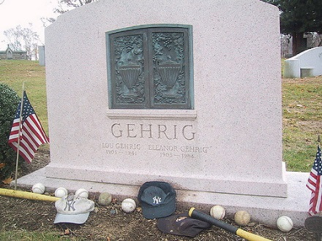

* [ALS Awareness Month (Amyotrophic Lateral Sclerosis or Lou Gehrig's Disease)](http://web.alsa.org/site/MessageViewer?em_id=155203.0)
* [American Wetlands Month](https://www.epa.gov/wetlands/may-american-wetlands-month-learn-explore-take-action)
* Arthritis Awareness Month
* Asian American & Pacific Islander Heritage Month
* Better Hearing & Speech Month
* Brain Tumor Awareness Month
* [Celiac Awareness Month](http://www.beyondceliac.org/community/Get-Social/Celiac-Awareness-Month/1422/)

[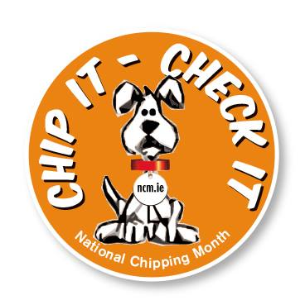](http://www.humanesociety.org/animals/resources/tips/microchips.html?referrer=http://www.brownielocks.com/may.html)

* [Chip Your Pet Month](http://www.humanesociety.org/animals/resources/tips/microchips.html?referrer=http://www.brownielocks.com/may.html)
* Clean Air Month
* Creative Beginnings Month

  
1960's Boy Scout Troop 227 Member with Commissioner Dave –   
Bo Fox of Papa-Doo-Run-Run ([www.papadoo.com](http://www.papadoo.com))

* [Drum Month](http://www.playdrums.com/programs/international-drum-month/)
* Family Wellness Month
* [Gardening for Wildlife Month](http://www.nwf.org/How-to-Help/Garden-for-Wildlife/Garden-Month.aspx)



* [Get Caught Reading Month](http://www.readwritethink.org/classroom-resources/calendar-activities/caught-reading-month-20650.html)
* Gifts From The Garden Month
* Global Health and Fitness Month

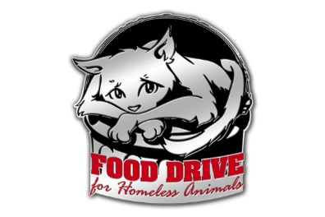

* [Go Fetch! Food Drive for Homeless Animals Month](http://www.tailsinc.com/2012/05/go-fetch-for-homeless-animals/)
* [Golf Month](https://www.fibodo.com/national-golf-month)
* Heal the Children Month
* Healthy Vision Month
* Home Schooling Awareness Month
* International Civility Awareness Month



* [Jewish-American Heritage Month](http://www.jewishamericanheritagemonth.us/index.aspx)
* Lupus Awareness Month

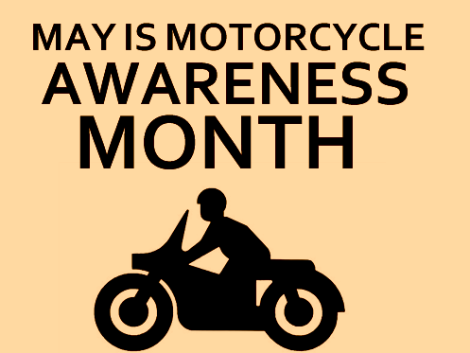

* Motorcycle Safety Month
* National Allergy/Asthma Awareness Month
* National Barbeque Month
* National Better Hearing Month

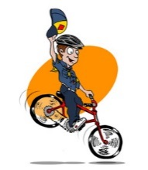

* [National Bike Month](http://bikeleague.org/bikemonth)
* National Blood Pressure Month
* National Egg Month
* National Foster Care Month
* National Good Car Keeping Month
* National Hamburger Month
* National Hepatitis Awareness Month
* [National Inventors Month](http://www.uiausa.org/)

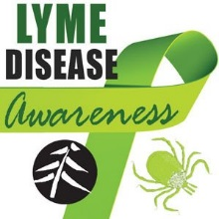

* [(World) Lyme Disease Awareness Month](https://www.lymedisease.org/get-involved/take-action/lyme-awareness-month/)



* [National Mediterranean Diet Month](http://oldwayspt.org/newsroom-media/press-releases/may-national-mediterranean-diet-month)   
  (and International)
* National Mental Health Month
* [National Military Appreciation Month](http://www.nmam.org/)
* National Moving Month
* National Osteoporosis Prevention Month
* National Photo Month
* National Physical Fitness & Sports Month
* National Physiotherapy Month
* National Preservation Month



* National Salad Month
* National Salsa Month (the sauce)
* [National Smile Month](http://www.nationalsmilemonth.org/)
* National Stroke Awareness Month



* [National Sweet Vidalia Onions Month](http://www.vidaliaonion.org/)
* National Vinegar Month
* National Youth Traffic Safety Month
* Neurofibromatosis Awareness Month
* Older Americans Month
* Personal History Month
* Prepare Tomorrow's Parents Month
* Skin Cancer Awareness Month
* Strike Out Strokes Month
* Tourette Syndrome Awareness Month
* Ultra-violet Awareness Month
* Women's Health Care Month
* Young Achievers of Tomorrow Month
* National Family Month (5/12 to 6/16)

**Weekly Celebrations:**

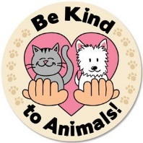

* Be Kind To Animals Week: 1-7
* Children's Mental Health Week: 1-7



* Drinking Water Week: 1-7
* Goodwill Industries Week: 1-7
* Kids Win Week: 1-7
* National Family Week: 1-7
* National Pet Week: 1-7
* National Wildflower Week: 1-7
* Teacher Appreciation Week: 1-7

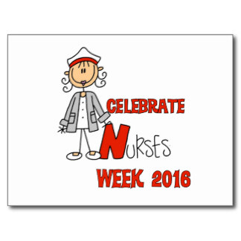

* National Nurses Day and Week: 6-12
* National Hospital Week: 8-14
* National Hug Holiday Week: 8-14
* Universal Family Week: 10-16
* EMS (Emer Medical Services) Week: 15-21
* Food Allergy Awareness Week: 8-14
* National Dog Bite Prevention Week: 15-21
* National Nursing Home Week: 8-14 (Starts Mother's Day to Saturday)



* National Police Week: 8-14
* Reading is Fun Week: 8-14
* Salute to Moms 35+ Week: 8-14
* Children's Book Week: 2-8
* National Etiquette Week: 9-13
* National New Friends, Old Friends: 15-21
* National Safe Boating Week: 21-27
* National Medical Transcription Week: 15-21
* National Stationery Week: 15-18
* National Backyard Games Week: 23-30

**May, 2013 Daily Holidays,   
Special and Wacky Days:**

1 [May Day](http://holidayinsights.com/other/mayday.htm)

1 [Loyalty Day](http://holidayinsights.com/moreholidays/May/loyaltyday.htm)

1 [Mother Goose Day](http://holidayinsights.com/moreholidays/May/mothergooseday.htm)



1 [Save the Rhino Day](http://holidayinsights.com/moreholidays/May/saverhinoday.htm)

2 [Baby Day](http://holidayinsights.com/moreholidays/May/babyday.htm)

2 [Brothers and Sisters Day](http://holidayinsights.com/moreholidays/May/brothersisterday.htm)

3 [National Teachers Day](http://holidayinsights.com/other/teacher.htm)

3 [Lumpy Rug Day](http://holidayinsights.com/moreholidays/May/lumpyrugday.htm)

3 [World Press Freedom Day](http://holidayinsights.com/moreholidays/May/worldpressfreedomday.htm)

4 [Bird Day](http://holidayinsights.com/other/birdday.htm)

4 [National Candied Orange Peel Day](http://holidayinsights.com/moreholidays/May/candiedorangepeelday.htm)

4 [Renewal Day](http://holidayinsights.com/moreholidays/May/renewalday.htm)

4 [Star Wars Day](http://holidayinsights.com/moreholidays/May/starwarsday.htm)

5 [Cinco de Mayo](http://holidayinsights.com/other/cinco.htm)



5 [National Hoagie Day](http://holidayinsights.com/moreholidays/May/hoagieday.htm)

5 [Oyster Day](http://holidayinsights.com/moreholidays/May/oysterday.htm)

6 [Military Spouses Day](http://holidayinsights.com/moreholidays/January/spousesday.htm)

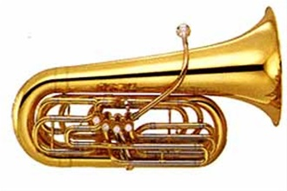

6 [International Tuba Day](http://holidayinsights.com/moreholidays/May/tubaday.htm)

6 [Space Day](http://holidayinsights.com/moreholidays/May/spaceday.htm)

6 [Beverage Day](http://holidayinsights.com/moreholidays/May/beverageday.htm)

6 [National Tourist Appreciation Day](http://holidayinsights.com/moreholidays/May/touristappreciationday.htm)

6 [National Nurses Day](http://holidayinsights.com/other/nursesday.htm)

6 [No Diet Day](http://holidayinsights.com/moreholidays/May/nodietday.htm)

7 [Birth Mother's Day](http://holidayinsights.com/moreholidays/May/birthmothersday.htm) – Sat. before Mother's Day

7 [National Tourism Day](http://holidayinsights.com/moreholidays/May/tourismday.htm)



8 [Mother's Day](http://holidayinsights.com/other/mother.htm) - second Sunday

8 [Iris Day](http://holidayinsights.com/moreholidays/May/irisday.htm)

8 [No Socks Day](http://holidayinsights.com/moreholidays/May/nosocksday.htm)

8 [V-E Day](http://holidayinsights.com/other/veday.htm)

8 [World Red Cross Day / World Red Crescent Day](http://holidayinsights.com/moreholidays/May/redcrossday.htm)

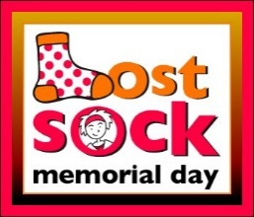

9 [Lost Sock Memorial Day](http://holidayinsights.com/other/lostsockday.htm)

10 [Clean up Your Room Day](http://holidayinsights.com/moreholidays/May/cleanuproomday.htm)

11 [National Receptionist Day](http://holidayinsights.com/other/receptionistday.htm) the 2nd Wed in May



6 [School Nurses Day](http://holidayinsights.com/other/nursesday.htm)

11 [Eat What You Want Day](http://holidayinsights.com/moreholidays/May/eatwhatyouwantday.htm)

11 [Twilight Zone Day](http://holidayinsights.com/moreholidays/May/twilightzoneday.htm)

12 [Fatigue Syndrome Day](http://holidayinsights.com/moreholidays/May/fatiguesyndromeday.htm)

12 [International Nurses Day](http://holidayinsights.com/other/nursesday.htm)

12 [Limerick Day](http://holidayinsights.com/stpat/limerickday.htm)

13 [Blame Someone Else Day](http://holidayinsights.com/other/blamesomeoneday.htm) - first **(and only)** Friday the 13th of 2016.

13 [Frog Jumping Day](http://holidayinsights.com/moreholidays/May/frogjumpingday.htm)

13 [Leprechaun Day](http://holidayinsights.com/stpat/leprechaunday.htm)



14 [National Train Day](http://holidayinsights.com/moreholidays/May/trainday.htm)- date varies

14 [International Migratory Bird Day](http://holidayinsights.com/other/birdday.htm)

14 [Dance Like a Chicken Day](http://holidayinsights.com/moreholidays/May/dancelikeachicken.htm)

15 [National Chocolate Chip Day](http://holidayinsights.com/moreholidays/May/chocolatechipday.htm)



15 [Police Officer's Memorial Day](http://holidayinsights.com/moreholidays/May/policememorialday.htm)

16 [Armed Forces Day](http://holidayinsights.com/other/afd.htm) - third Saturday of month

16 [Love a Tree Day](http://holidayinsights.com/moreholidays/May/loveatreeday.htm)

16 [National Sea Monkey Day](http://holidayinsights.com/moreholidays/May/seamonkeyday.htm)

16 [Wear Purple for Peace Day](http://holidayinsights.com/moreholidays/May/wearpurpleforpeace.htm)

17 [Pack Rat Day](http://holidayinsights.com/moreholidays/May/packratday.htm)

18 [International Museum Day](http://holidayinsights.com/moreholidays/May/internationalmuseumday.htm)

18 [No Dirty Dishes Day](http://holidayinsights.com/moreholidays/May/nodirtydishesday.htm)

18 [Visit Your Relatives Day](http://holidayinsights.com/moreholidays/May/visitrelativesday.htm)

19 [Boy's Club Day](http://holidayinsights.com/moreholidays/May/boysclubday.htm)

20 [Be a Millionaire Day](http://holidayinsights.com/moreholidays/May/beamillionaireday.htm) - now we all can go for that

20 [National Bike to Work Day](http://holidayinsights.com/moreholidays/May/biketoworkday.htm) – 3rd Fri of May

20 [Pick Strawberries Day](http://holidayinsights.com/moreholidays/May/pickstrawberriesday.htm)

21 [National Memo Day](http://holidayinsights.com/moreholidays/May/memoday.htm)

21 [National Waiters and Waitresses Day](http://holidayinsights.com/moreholidays/May/waitersday.htm)

22 [Buy a Musical Instrument Day](http://holidayinsights.com/moreholidays/May/musicalinstrumentday.htm)



23 [Lucky Penny Day](http://holidayinsights.com/moreholidays/May/pennyday.htm)

24 [National Escargot Day](http://holidayinsights.com/moreholidays/May/escargotday.htm)

25 [National Missing Children's Day](http://holidayinsights.com/moreholidays/May/missingchildrenday.htm)

25 [Tap Dance Day](http://holidayinsights.com/moreholidays/May/tapdanceday.htm)

26 [Sally Ride Day](http://holidayinsights.com/moreholidays/May/sallyrideday.htm)

27 [Sun Screen Day](http://holidayinsights.com/other/sunscreenday.htm)

28 [International Jazz Day](http://holidayinsights.com/moreholidays/May/jazzday.htm)

28 [Amnesty International Day](http://holidayinsights.com/moreholidays/May/amnestyintlday.htm)

29 [Learn About Composting Day](http://holidayinsights.com/moreholidays/May/compostingday.htm)

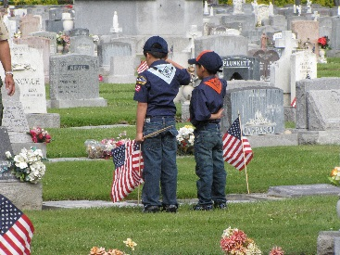

30 [Memorial Day](http://holidayinsights.com/other/memorial.htm)

30 [Water a Flower Day](http://holidayinsights.com/moreholidays/May/waterflowerday.htm)

31 [National Macaroon Day](http://holidayinsights.com/moreholidays/May/macaroonday.htm)

31 [Save Your Hearing Day](http://holidayinsights.com/moreholidays/May/saveyourhearingday.htm)

31 [World No Tobacco Day](http://holidayinsights.com/other/notobaccoday.htm)

# TRAINING TOPICS

## Promises

***Bill Smith,*** *the Roundtable Guy*

**Promises**

Much of the ideals of Cub Scouting are about promises. We are all familiar with the Scout Oath (Promise) a boy makes to win his Bobcat Badge. It’s a serious moment for all when he makes that promise and becomes a Cub Scout.

Making a promise is awfully important for a six or seven year old. He has been aware of promises for some years now. Making and keeping promises are basic parts of family life. They are often the glue that binds family members together.

That old line from Robert Service’s poem about "The cremation of Sam McGee":

***A promise made is a debt unpaid*.**

May be a bit beyond our younger Cub Scouts but the sentiment is right on target.

If you promise something, you must keep that promise. You really must do it! You can’t back out of it, you can’t pretend you didn’t make that promise; you must come through and do it. No excuses.

The promise is an essential tool that Scouting uses to build character in boys. Keeping promises is being responsible. Keeping your word is what we expect from our best leaders and our best and closest friends. Someone who is **trustworthy** is one who keeps promises. Our communities, our governments, our culture depends on this kind of trust.

**We expect that level of trust from the boys.  
How about the leaders?**

[WWW.Scouting.org](http://WWW.Scouting.org) makes these promises to prospective cub Scouts:

In Cub Scouting you'll have lots of fun, adventure, and activities with your den and pack……

Some of the best things about Cub Scouting are the activities you get to do: camping, hiking, racing model cars, going on field trips, or doing projects that help your hometown and the people who live there. Cub Scouting means "doing." ([*http://www.scouting.org/Home/CubScouts/CubScouts/ThingsToDo.aspx*](http://www.scouting.org/Home/CubScouts/CubScouts/ThingsToDo.aspx) )

Or this from the "What Is Cub Scouting" Fact Sheet (<http://www.scouting.org/FILESTORE/pdf/02-502.pdf> )

Cub Scouting means "doing." Everything in Cub Scouting is designed to have boys doing things.

The videos on [www.BeAScout.org](http://www.BeAScout.org) and [www.CubScouts.org](http://www.CubScouts.org) show Cub Scouting as 85% outside fun. Are they making a promise there? Some cynical adults may say, "That’s just advertising." A six year old may differ. He might think that it what is promised.

It’s pretty easy to make these sorts of promises, especially if you are never called upon to pay up. A little too often we do just that. We promise boys an adventure full of fun activities: camping, BB-guns, games and sports with friends and family and then, what if it doesn’t happen.

How does a six-year-old react to broken promises? Does he develop better character, or does he copy his role models and learn that it is OK to make big promises and never keep them? Like, for instance, the Cub Scout Promise.

**Keeping a Promise.**

Many years ago, when I was a novice Council Membership Chairman, I was paired up with Rick, a new Field Director as my advisor. One of Rick’s first pieces of advice was that we should do something about keeping promises. He was concerned that when we went into schools and communities in September, we told boys that they could go to camp and have all sorts of fun. They could shoot bows and arrows and bb-guns and do lots of other neat stuff. They couldn’t, of course, until they went to camp in July and that that was ten long months away – an eternity for a six-year-old. Rick considered that a promise – debt unpaid.

A District Exec in our council had experimented with what he had called Tiger Days: a sort of gathering of Tigers and partners at various community events. We thought that we might do something like that at one of our camps. We enlisted the help of our Program Director, Dave who enthusiastically opened out biggest Cub Camp every Saturday in October and developed a program to introduce all our new members into the fun of outdoor Cub Scouting. Over the next several years, there were the three of us every October Saturday at 6:30 AM putting up signs, setting up targets, building a campfire and getting ready for another gang of eager adventurers. This idea spread to, or erupted spontaneously in, other councils across the country and became a regular feature of our outdoor program.

By the way, Dave went on to National where he was instrumental in developing the [Cub Scout Outdoor Program Guidelines](http://www.scouting.org/scoutsource/CubScouts/resources/CubScoutOutdoorProgramGuidelines.aspx), and is now [Pastor of Operations and Communication](http://coolchurchtech.typepad.com/about.html) - Abundant Life Church in Oregon ([www.coolchurch.com](http://www.coolchurch.com) ) and Rick became [the Scout Executive of The Great Salt Lake Council in 2009](http://www.deseretnews.com/article/705285690/Great-Salt-Lake-Council-names-Barnes-its-new-Scout-executive.html?pg=all) [and retired from that post on February 29, 2016.](https://www.facebook.com/saltlakescouts/photos/a.313390452144.151392.119988957144/10153862422482145/?type=3&theater) Both made keeping promises a priority in their occupations.

How about the rest of us, do we make promises to prospective Cub Scouts? Do we keep them? If you expect the boys in your pack or den to keep the Promises they make when they recite the Scout Oath, then you had better pay attentions to what you told them the night they joined.

And whose job is it to keep the promises made by other people: those in the District, or in the Council, or at National? Is a den leader responsible for those “debts” incurred when a boy and his family logged into [www.BeAScout.org](http://www.BeAScout.org) or [www.CubScouts.org](http://www.CubScouts.org) ?? If not, who is? And when should it be settled? Are we going to let it wait until next summer, if and when they go to camp before they get to do all those neat things they saw on the flyers we handed out last month?

Take a good look at your pack’s plans for the year. Think of it as sort of a balance sheet full of assets and debits of fun and good will. It’s up to each one of us to do our best to make sure that every Cub Scout gets the full measure of fun and adventure that was promised. Whether we are den leaders, Cubmasters or just the common folk who support and help them, we all have important roles in keeping those promises. It may not matter who made the promise; if the boy believed it, it is a promise made, and we must keep it.

**What are YOU going to do now?**

***The best gift for a Cub Scout.......  
 ......get his parents involved!***

***The greatest gift you can give your child   
 ..... good self-respect!***



# FUN STUFF

Fun Facts About Buzzards  
*Alice, Golden Empire Council*

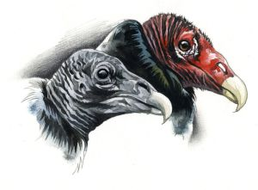

* Buzzards are actually gentle birds – they can’t kill their prey. And if they disappeared, we’d be overrun with dead animals!
* Buzzards are actually vultures – and they can only hiss or grunt, since they don’t have voice box!
* They are the most graceful fliers in the world, even though they look ugly and awkward up close!
* Vultures are bald for a good reason – so the carrion (dead meat) they eat doesn’t stick to them.
* The naked red heads of the adult turkey vultures look like (surprise) turkeys!
* They can smell carrion from over a mile away. They also have good eyesight!
* During the hot summer months turkey vultures will “poop” on their feet to cool them off.
* Turkey vultures don’t build a nest, and they pick really hard to find places to use!
* Vultures mate for life.
* The California and Andean Condors are actually in the vulture family.
* As groups of vultures catch thermal updrafts they look like water boiling in a pot – so they are called kettles. Turkey vultures have been reported by aircraft pilots to rise to as high as 20,000 feet and soar for hours without flapping their wings.
* Turkey vultures can travel up to 200 miles a day, and they don’t eat while they are traveling!
* They are very large, but only weight 2-3 pounds, so they can “float” in columns of rising air for hours – and they don’t flap their wings, but just rock from side to side and ride the currents!
* Hawks look for “kettles” – groups of flying vultures – because they know the vultures always find the best thermals!
* Turkey vultures can swoop up to 60 mph in order to avoid being "mobbed" by ravens or jays.
* Turkey vultures can live up to 24 years.

## All I Really Need To Know I Learned From My Dog

*Baltimore Area Council*

***Actually, this could be an opening, closing or a series of run-ons. CD***

**Personnel:** Narrator and any number of Cubs.

**Setting:** Have lines on back of cards with pictures of dogs on the front. Follow readings with the Pledge of Allegiance. (Combine lines to accommodate the number Cubs.)

**Narrator:** All I really need to know I learned from my dog. Here are some examples.

Select the lines you wish to use. Use as many Cubs as you wish

* Allow the experience of fresh air and the wind in your face to be pure ecstasy.
* When loved ones come home, always run to greet them.
* Take naps and stretch before rising.
* Run, romp, and play daily.
* Be loyal.
* Never pretend to be something you’re not.
* Eat with gusto and enthusiasm.
* If what you want lies buried, dig until you find it.
* When you leave your yard, make it an adventure.
* Bond with your Pack.
* On cold nights, curl up in front of a crackling fire.
* When you’re excited, speak up.
* When you’re happy, dance around and wag your entire body.
* Delight in the simple joy of a long walk.
* On hot days, drink lots of water and lay under a shady tree.
* Playtime is important.
* Every day can be an adventure.
* Sometimes a bark is worse than a bite.
* Too much of anything will make you sick.
* It’s hard to stay mad at something cute.
* Looking adorable or pitiful can work in your favor.
* It’s nice to be taken care of.
* Accidents happen.
* Play nicely with others and they’ll play nicely with you.
* Stop and smell the roses, the dirt, the grass...

# THEME PACK AND DEN ACTIVITIES

**Pet Photo Frame**

*Santa Clara County Council*

**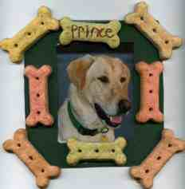Supplies:**

* Dog biscuits, kitty treats or other favors to represent the animal you will feature in the photo (for a bird, how about small seed bells, or other bird toys)
* 1 picture of your favorite animal
* Acrylic paint- any color
* Fine tipped marker
* Craft glue
* Paint brush- a small foam one will not leave brush marks
* 5x5 inch piece of cardboard or photo matting- cereal boxes work great
* Craft knife
* Sealer- design master super surface sealer, clear sealer and satin finish 383 works great
* Ribbon or magnet

**Directions:**

1. Center your picture on top of cardboard and trace around it.
2. Use craft knife to cut out hole for picture.
3. Paint the front of the frame in the color of your choice.
4. Glue treats on to the frame.
5. On one of the treats or an open space on the frame write the animal's name, plus the dates of birth and death if they are now little angels.
6. Seal with sealer.
7. On the backside of the frame glue or tape the picture in place.
8. Add ribbon or magnet to the back to hang.

***Here is another way to make frames CD -***

**Fridge Frames**

*Baltimore Area Council*

Make a frame for your favorite pet photo and hang it on your fridge. Glue craft sticks together to form the frame. Let dry. Paint decoupage solution on dog biscuits, goldfish crackers, or animal crackers. Let dry. Glue to frame. You can make a birdseed frame by spreading the edge of the frame with glue and sprinkling on seeds. Let dry. Paint with decoupage solution. Stick 2 magnetic strips on the top and bottom of the back of the frame. Center the photo and use masking tape to attach it to the frame.

**VIRTUAL PET SHOW**

*Piedmont Council*

Instead of having a real pet show, boys bring drawings or photos of their pet ***(see Critter Care, a Bear Elective Adventure)***. Set up an area in the room where the boys can display their “pets.” People can go around the area looking at the virtual pets. Each boy stands next to his pet’s photo and talks about his pet. They can also bring one or two of their pet’s favorite toys, food, or maybe a taping of the pet’s voice. Those boys who do not have pets may create imaginary ones (pet dinosaur? Pet gorilla?). Have a showing with drawings and other paraphernalia.

**FIELD TRIP IDEAS**

*Piedmont Council*

* Zoos
* Veterinarians: Ask a vet if your den could visit
* Feed Shop
* Aquarium
* Pet supply shops: Find out if your den could visit

**GUEST SPEAKER**

*Piedmont Council*

* A veterinarian to come to your pack meeting and talk about the importance of caring for your pets properly.
* A Feed Shop owner to come and talk about animal nutrition
* A pet shop owner or manager
* A volunteer at the local SPCA or other animal shelter
* A county or city animal control officer
* Someone who raises show animals
* A person who judges dog or cat or other animal shows
* One who cares for horses

**Bird Cookies**

*Santa Clara County Council*

Make tasty cookie treats for your feathered friends.

**Supplies:**

* + 1 cup softened unsalted butter
  + 3 beaten eggs
  + 3 1/2 cups flour
  + 1 tsp. baking soda
  + Pinch of salt
  + Mixed birdseed

**Directions:**

1. Stir flour, baking soda, and salt together in a large bowl.
2. Add butter and eggs. Mix until well blended.
3. Roll dough out on floured surface and cut different shapes with cookie cutters.
4. Make a hole in the top of each cookie with a drinking straw.
5. Press birdseed into each side of the cookies.
6. Bake in oven at 350 degrees for 10-12 minutes.
7. After Bird Cookies have cooled, tie a ribbon or string through the hole and hang on a tree branch.

**Balloon Dog**

*Baltimore Area Council*

**Materials:** Long thin balloons (available in craft & hobby stores)

**Optional:** Hand or Foot Pump

* The first trick to making a balloon animal is to blow up the balloon. This is hard. You can buy a hand pump or use a football pump to help blow up the balloons. Do not blow the balloon up all the way. Leave the last half of the balloon unfilled. Experiment to find the proper amount.
* Carefully tie the balloon. When twisting a balloon, always start at the end with the knot. Do not worry, it will not break if you twist it, but you must hold on to both ends of the balloon. Otherwise, the balloon will untwist. The balloon will not stay twisted by itself. You have to twist the balloon together.

****

**Directions -**

* 1. Blow up the balloon half way.
  2. Start at the beginning with the knot and twist a 3 to 4” bubble (or 3 or 4 fingers wide). Make sure you hang on to both ends of balloon, otherwise it will untwist. Twist it around 2 or 3 times. Do not worry it will not break. Why didn’t it break? There is space at the end of the balloon for the extra air. That is why we only blow the balloon up half way.
  3. While holding on to the twisted balloon, make another bubble the same size. This will be the one ear. Do not let go.
  4. Make another balloon bubble the same size. This is the other ear. Look at the picture.
  5. Twist balloon joints A & B together twist 2 or 4 time all the way around. The balloon will not break, and they will stay together. If yours looks like this, very good; if not, try it again -practice makes perfect!!
  6. Now for the neck. Twist a 2 to 3” bubble or 3 or 4 fingers wide. This is the neck. Make sure you hang on to the balloon, both parts.
  7. To make the legs, start by twisting a 2 to 3” bubble. Hang on to the neck as you twist the balloon, and do not let go of the leg.
  8. Second leg, same as the first. Twist a 2 to 3” bubble. Twist those two parts together just like you did with the ears. Remember twist around each other 4 or 5 times. Twist the parts together to look like the drawing.
  9. Have a lot of balloon left over? Hotdog! We make the body 1 hands long. Then twisting; make sure you hang on to the balloon. Make the back legs like you did in step 7

**Dog Biscuit Neckerchief Slides**

*Piedmont Council*

**Materials:** Small dog biscuit; Pompoms; Felt; Wiggle eyes; Seed beads; 1” long - 1/2” diameter PVC pipe

**Slide 1**

1. Cut two ears out of felt and glue on the biscuit.
2. Glue on wiggle eyes.
3. Place two 1/4” or 1/2” pompoms side by side just below the eyes.
4. Glue on a seed bead for the nose.
5. 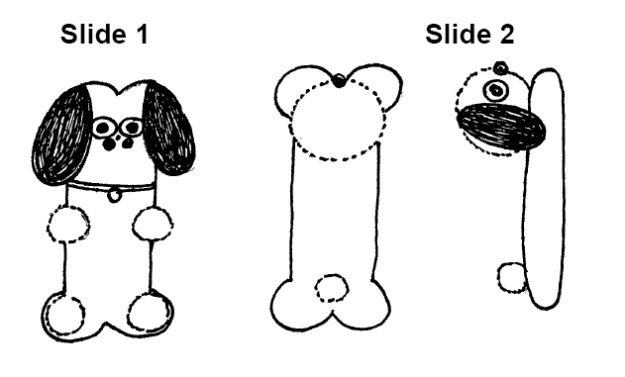Glue on 4 small pompoms for the dog’s feet.
6. If desired, fashion a collar and tag using scrap felt.

**Slide 2**

1. Fashion dog’s head with wiggle eyes and felt ears.
2. Glue the head on the biscuit.
3. Glue on a pompom for a tail.

**Cat Grass**

*Baltimore Area Council*

Indoor cats will adore this munchable treat. Dip a pencil eraser in black paint. Stamp a paw print on a terra cotta pot. Let dry. Fill the pot with soil. Sprinkle with l-tablespoon oat grass seed (find it at large retailers). Cover with more soil and moisten. Place the pot in a warm location and add water daily to keep soil moist. The grass will sprout in just a few days. When grass is about 4 inches tall, it’s ready. Set pot by kitty’s food for grazing.

**INVISIBLE DOG LEASH**



**Materials:**

* + Wide mouth canning jar ring;
  + Ribbon (1/4” or wider);
  + Sturdy wire (16 gauge is stiff but is hard to work with. 19 gauge makes a less stiff leash, but is easier to use);
  + Material to decorate the collar;
  + Low temp glue gun

**Directions:**

1. Cover the canning jar ring with ribbon to make a collar. Use hot glue to hold the ends of the ribbon to the ring.
2. Decorate the collar with rhinestones, glitter paints, etc.
3. Cut wire so it will extend from your hand to about 5” from the floor. Add 3” for twisting the ends under.
4. Fasten the wire to the collar by twisting it around the top and tucking the cut ends under so it can’t be seen.
5. Twist the other end of the wire into a loop (for your hand) and tuck the sharp edge inside. Gently shape the wire so it curves down a bit.
6. If desired, wrap ribbon around the wire.
7. When you walk your invisible dog, hold the wire in front of you as you walk, so the dog appears to be wearing the collar.

**Pencil Pup**

*Santa Clara County Council*

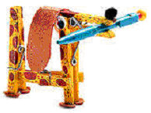

**Supplies:**

* + (4) pinch-style wooden clothespins,
  + Wood Glue,
  + Felt,
  + Googly Eyes,
  + Pom-pom,
  + Markers,
  + Pencil

**Directions:**

* To form the front end of the dog pinch open a clothespin and apply glue to the inner surface of the opened end. Then clamp the glued end onto a second clothespin, just behind the metal spring.
* For the dog's tail end, glue and clamp together the last two clothespins so that one holds the other wide open. When the glue is dry, fit the opened end of the back half onto the lower end of the front half. Apply glue to bond the two sections.
* From the felt, cut out floppy ears and circular paws. Then glue ears and paws, the googly eyes, and the pom-pom nose onto the dog.
* Add spots or other distinguishing details with colored markers. Finally, pinch open the dog's mouth and insert a pencil, balancing its weight equally on both sides.

**Cup of Fish**

*Santa Clara County Council*



**Supplies:**

* + Package of blue Jell-O,
  + Gummy fish (or fruit-flavored sharks),
  + Clear plastic cups

**Directions:**

1. Make blue Jell-O according to the directions on the box.
2. Pour into the clear plastic cups.
3. Let the cups cool about an hour in the refrigerator until partially set.
4. When the Jell-O is partially set, place a few gummy fish in each cup.  
   ***I would make some more Jell-O and pour it on top after putting the fish in the cups. CD***
5. Place cup back in the refrigerator until the Jell-O is completely set.
6. Eat and enjoy.

**Variations:**

* + Frozen fish-popsicles (just freeze the Jell-O in Popsicle molds - add the gummy fish when they are partially set - unmold very gently when entirely frozen). These are really messy to eat and are best eaten outside.
  + An entire punch bowl of fish Jell-O (made this way)!

# KIND PACK AND DEN ACTIVITIES

*Alice, Golden Empire Council*

**Collect blankets, towels and pet food for pet rescue groups in your area.** Also, Food Banks now stock pet supplies, recognizing that people in need also have pets they love.

**Visit a veterinarian or invite one to your meeting.**

**You could combine this with a visit to a local zoo or a Nature Center or perhaps a group that rescues animals.** Before your visit, find out what your group could bring to help support their work – often simple items like old blankets, dish soap, and pet food are really needed.

**Ask den or pack families to share their experiences of service to others –** this could be the start of a group service project. Ask them to bring in pictures and other items and tell why they chose the project and if it changed their thinking in any way.

**Invite a guest who trains dogs for service or as rescue or blind service dogs to come to a den meeting.** Recently, two people who train service dogs brought their dogs and spent a great den meeting teaching the boys about their program. Check with a local service club or your Reference Librarian to make a connection.

**Challenge den or pack families to save their change every day for a month and then donate the funds to a community group, such as a shelter for homeless families or a pet rescue group.** Look for a group that boys have something in common with, and discuss how they would feel it they were in that situation. For example, what would it be like if you had to put all your stuff in just one small bag? (If you were homeless) What would you choose? What if you couldn’t come back to your own room? What if you had to go to a new school?

**Check out children’s books and poems about KINDNESS –** They range from “Horton Hears a Who” to Native American poetry about feelings of betrayal and abandonment. Check with your local Children’s Librarian for some great ideas

**In Sacramento, we depend on Bats to keep us from drowning** **in bugs!** Challenge Pack Families or Dens to choose some “undesirable” animal and research what is good about them. How do they have a positive impact on your lives!

**Pennies for Packs –** an idea from a Herms District scouter to help support packs in areas without enough resources. This could be an ongoing project, with funds going to help provide uniforms, books, program materials, attendance at camp or field trips.

**Contact your area Volunteer Center or Bureau –** almost every town or region has one – they can suggest activities that would fit your group.

**Challenge every family to do a Spring Cleaning, and donate gently used items to a shelter –** Books, toys, clothing are great, but check with your local charity to see what they prefer and need. (One group I know picks up the oversupply of books at a thrift store, cleans them up, then shares them with a Children’s Home or Shelter for Families)

**Investigate Bullying –** BSA has some new Scout focused literature (They look like comic books) that could help get the subject out in the open. According to a poll of kids, about one in three kids has been bullied and almost half of those also said they had sometimes been the bully. And usually, there is a need for compassion for both the bully and the person he picks on. So it’s a topic that could be helpful for both adults and kids to look at. Check out: [**www.stopbullyingnow.com/**](http://www.stopbullyingnow.com/)or [**www.kidshealth.org**](http://www.kidshealth.org)

**Make sure parents know of the Kind, compassionate and/or positive choices their son makes –** they may not see their son in that role, and it’s always great to applaud someone in front of parents or peers! Try sending home a note or an email.

# THEME & PACK MEETING IDEAS

# GATHERING ACTIVITIES

***Note on Word Searches, Word Games, Mazes and such –*** *In order to make these items fit in the two column format of Baloo’s Bugle they are shrunk to a width of about 3 inches. Your Cubs probably need bigger pictures. You can get these by copying and pasting the picture from the Word version or clipping the picture in the Adobe (.pdf) version and then enlarging to page width.* ***CD***

**Pets in Spanish***Santa Clara County Council*

Label the pets below with their Spanish names:

1) el perro 2) el carpa dorada 3) el gato

4) el periquito 5) el potro 6) la tortuga

7) el loro 8) la marmota

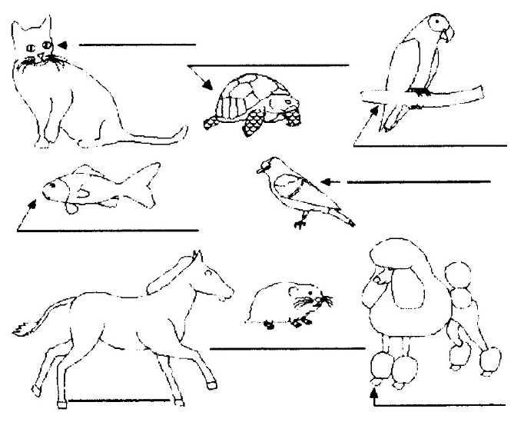

**Answers:**

Cat: el gato Turtle: la tortuga Parrot: el loro  
Goldfish: el carpa dorada Parakeet: el periquito  
Pony: el potro Hamster: la marmota Dog: el perro

**A Dog's Life Word Search***Santa Clara County Council*

Can you find the dogs hidden in the puzzle below?

They may be horizontal, vertical or diagonal, forwards or backwards.

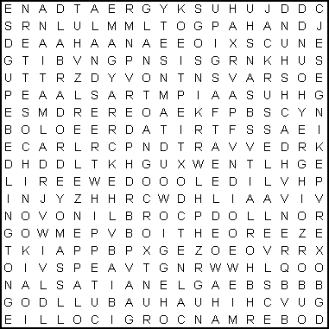

AIREDALE ALSATIAN APPENZELLER

BASSET BEAGLE BEDLINGTON

BLOODHOUND BORZOI BOXER

BULLDOG CHIHUAHUA CHINOOK

CHOW CHOW COLLIE CORGI

DACHSHUND DALMATIAN DOBERMAN

GREAT DANE GREYHOUND HUSKY

JACK RUSSELL LABRADOR LANDSEER

MAGYAR MASTIFF PEKINGESE

POINTER POMERANIAN POODLE

PUG ROTTWEILER SAMOYED

SANSHU SETTER SHEEPDOG

SPANIEL TERRIER WHIPPET

**Animals and Their Babies***Piedmont Council*

Equipment: Copies of the game

Directions: Match the animal with its baby. (Answers are in parentheses)

|  |  |
| --- | --- |
| 1. Hen | A - Calf |
| 2. Seal | B - Chick |
| 3. Frog | C - Cub |
| 4. Cat | D - Cygnet |
| 5. Dog | E - Duckling |
| 6. Deer | F - Fawn |
| 7. Mare | G - Gosling |
| 8. Sheep | H - Kitten |
| 9. Lion | I - Lamb |
| 10. Swan | J- Philly/foal |
| 11. Whale | K - Puppy |
| 12. Bear | L - Tadpole |
| 13. Goose |
| 14. Duck |

1. Hen (B-Chick), 2. Seal (A-Calf), 3. Frog (L-Tadpole), 4. Cat (H-Kitten), 5. Dog (K-Puppy), 6. Deer (F-Fawn), 7. Mare (J-Philly/foal), 8. Sheep (I-Lamb), 9. Lion (C-Cub), 10. Swan (D-Cygnet), 11. Whale (A-Calf), 12. Bear (C-Cub), 13. Goose (G-Gosling), 14. Duck (E-Duckling)

**Gathering Ideas***Alice, Golden Empire Council*

**Collect blankets, towels and pet food for local pet rescue services.** In our area, the Food Bank also provides pet food for those in need.

**No Matter How Small.** Read “Horton Hears the Who” to celebrate the KIND way Horton behaved - A fun story about compassion – that teaches “A person’s a person, no matter how small.”

**Disability Awareness Round Robin.** Have several Disability Awareness games set up around the room. As people arrive, divide them up so some people start at each station, then go around clockwise to the other stations. The Braille Cell below would work. See other suggested activities under GAMES section.

**Smiles for Everyone.** Challenge each boy, den or family to bring all kinds of smiles cut out of magazines and newspapers. Have a large piece of paper for each den, furnish paper glue sticks. Each group can create a collage of “Smiles” – talk about how a smile makes everyone feel welcome, and challenge everyone to practice smiling all week long.

**Animal Crossword**

*Baltimore Area Council*

**Across**

1. My stripes are usually black and white.

3. I am a bear from China.

5. The \_\_\_ is a mammal that lives in the ocean.

7. I have the longest neck.

8. It looks like I wear a mask.

9. Some people think I am a bear, but I am not. I am a “marsupial” animal. That means I carry my baby in my pouch.

10. The Siberian \_\_\_ is the largest member of the cat family.

13. I say “meow”

14. The male \_\_\_ carries the babies, not the female.

16. I am also known as the American Bison.

17. I can be stubborn at times.

18. In Florida, you will see signs that read, “Do not feed the \_\_\_\_\_\_\_\_\_\_\_\_.”

**Down**

2. This is short for rhinoceroses.

3. A flightless marine bird.

4. The African \_\_\_ is the largest land mammal.

5. We lived millions of years ago.

6. I am a reptile.

11. I am a primate. Did you know that you are a primate too?

12. Short for hippopotamus.

13. People drink my milk.

15. This is Billy Bear’s favorite animal.

17. I am man’s best friend.



**Johnny Appleseed Hidden Picture***Alice, Golden Empire Council*

Johnny Appleseed, who was really named John Chapman, walked all over the country, planting apple seeds as he went, so that there would be trees for birds to nest in, people and animals would have fruit to eat and shade to enjoy on a hot day. He looked to future generations as he shared generously with people who would never know he had been responsible.See how many of the hidden items you can find.

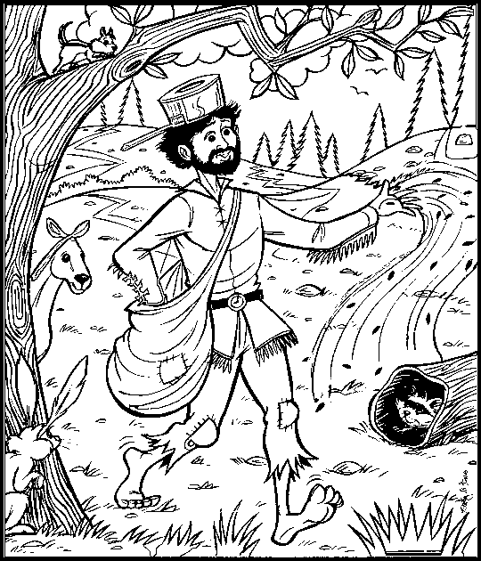

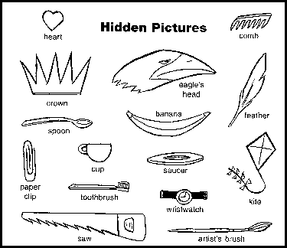

# OPENING CEREMONIES

**MAN’S BEST FRIEND OPENING***Piedmont Council*

**Arrangement:** Each Cub Scout holds a picture of the animal he is talking about. If desired, other animals can be added or substituted to make the ceremony more personal.

**Leader:** When you hear the term “man’s best friend,” you think of dogs. Tonight we’d like to tell you about some other of man’s best friends.

1. A cat can be a friend. My cat likes to curl up on my lap and purr. He likes to swat at his toy mouse and chase after a piece of string that I pull.
2. A fish can be a friend. You might think that all a fish can do is swim around in his tank, but my fish makes me smile when he makes funny faces.
3. A rabbit can be a friend. I like to watch my rabbit wrinkle up his nose, munch on carrots and hop around.
4. Some of our animal friends are out of the ordinary. You could have a pet that is a slithery snake, or a little white mouse, or a high-hopping frog.
5. Of course, we can’t forget our friends the dogs. My dog is my friend because he loves to run and play with me. We both love to dig in the dirt and snooze in the shade. I always know he is happy to see me when he wags his tail.

**Leader:** Tonight, we will celebrate all kinds of pets. Let the festivities begin!

**All I Really Need To Know I Learned From My Dog***Baltimore Area Council*

***Actually, this could be an opening,   
closing or a series of run-ons. CD***

**Personnel:** Narrator and any number of Cubs.

**Setting:** Have lines on back of cards with pictures of dogs on the front. Follow readings with the Pledge of Allegiance. (Combine lines to accommodate the number Cubs.)

**Narrator:** All I really need to know I learned from my dog. Here are some examples.

Select the lines from "**All I Really Need To Know I Learned From My Dog**," found under **"Fun Stuff"** in this issue you wish to use. Use as many Cubs as you wish

**Always Do Your Best***Baltimore Area Council*

Prepare four cue cards, one for each Scout, with the following text on the back and the key word in large letters on the front. After reading each card, the Scout should hold his card up for everyone to see the key word.

1. Key Word - “Always”   
   When training a pet, a good Scout remembers to feed him and take care of him - Always (holds up his card).
2. Key Word - ‘Do”   
   Pets need company and someone with whom to play. Left alone, a pet becomes lonely and can become mean. Playing and spending time with a pet is the right thing to - Do (holds up second card).
3. Key Word - ‘Your”   
   When you have trained a pet, he learns to behave and to follow your instructions. When a pet does what you want him to do, you know that he is - Yours (holds up third card).
4. Key Word - “Best”   
   Pets often learn to greet you when you get home from school. Knowing that a pet likes to be with you is the - Best (holds up last card).

**Opening and Closing - Noah’s Ark***Santa Clara County Council*

**Props:** Make an ark out of a large sheet of cardboard set up so that the animals can enter and leave. Boys can also have pictures or stuffed animals of the animal they represent. Cubmaster or Den Leader playing Noah can be in a robe or other costume. He could also be holding a list to check off the animals as they arrive.

**Opening**

***Cubs enter two by two***

**1st Cubs:** We are the Tigers.

**Noah:** (checking list) Please enter. Take the last stall on the right. (Tigers enter)

**2nd Cubs:** We are the Bobcats.

**Noah:** Good to see you. You have the third stall on the left (Bobcats enter)

**3rd Cubs:** We are the Wolves.

**Noah:** Welcome. Second level, fifth stall on the left. (Wolves enter)

**4th Cubs:** We are the Bears.

**Noah:** Good. Come on in. Sixth stall on the left. (Bears enter). Now all the animals are aboard and we are ready to start. Let the Pack Meeting begin!

**During the Pack Meeting at spaced intervals Noah comes out to send the birds to find dry land. The last bird does not return which leads right into the closing**

**1stInterval,**

**Noah:** Fly away bird, find me dry land. (Pretends to send bird then waits a few moments) Oh, the bird returns. No dry land yet.

**2nd Interval**

**Noah:** Fly away bird, find me dry land. (Pretends to send bird. After a moment it returns) Oh, you have brought me a twig from a tree. Still too soon to land.

**Closing**

**Noah:** Flay away bird, find me dry land. (Sends bird, waits, bird does not return) Hooray, there is dry land. The ark is aground. Come animals, come out of the ark. It is time to start living on the ground again. (Animals come out of ark, stretching and scratching)

**Animals & Noah:** Aah, look at the rainbow!

**Noah:** Thank you for joining us on our journey.

# A Matter of Compassion

Before the meeting, prepare large letters that spell out COMPASSION, so that each boy in turn can hold up or post his letter on the wall.

**Narrator:** This month, we’ve been learning all about being **KIND.** Having Compassion is being KIND.

**Cub #1:** *(letter C or holds it up)* Caring for others is what Cub Scouts do – a Good Deed every day!

**Cub #2:** *(Posts letter O or holds it up)* Only when you “Walk a Mile” in someone else’s shoes can you really understand.

**Cub #3:** *(Posts letter M or holds it up)* Make sure you treat others as you would like to be treated!

**Cub #4:** *(Posts letter P or holds it up)* Pets sometimes need compassion – we could collect blankets, towels or pet food to help pet rescue services.

**Cub #5:** *(Posts letter A or holds it up)* Always use kind words and tone of voice.

**Cub #6:** *(Posts letter S or holds it up)* Some people have special challenges that make it hard to walk or move.

**Cub #7:** *(Posts letter S or holds it up)* Some people have special challenges that make it hard to read or talk like everyone else.

**Cub #8:** *(Posts letter I or holds it up)* I learned how they feel with some of the games we played this month.

**Cub #9:** *(Posts letter O or holds it up)* Overcoming challenges takes a lot of courage.

**Cub #10:** *(Posts letter N or holds it up)* So NEVER forget to Do Your Best, no matter how you show Compassion to others!

**Narrator:** Let’s now celebrate this great country, with the tradition of accepting people of all races and creeds, and the freedom to accept and help anyone with challenges!

*(Go to Opening Flag)*

# AUDIENCE PARTICIPATIONS

**Little Rabbit***Baltimore Area Council*

Divide the audience into 4 groups. Each group says the indicated words whenever they hear “their” word in the story. Practice as you make assignments.

**Little Rabbit:** “Hoppity Hop”

**Mother Rabbit:** “Oh Dear”   
**Feather:** “Flutter, Flutter”

**Forest:** “Rustle, Rustle”

There was once a LITTLE RABBIT who didn’t mind MOTHER RABBIT very well; and never, never told her where he was going when he went out to play. This one particular day, LITTLE RABBIT was playing just outside his house when a pretty FEATHER came floating by. Now this LITTLE RABBIT found that when he threw the FEATHER in to the air, the wind would carry it tumbling along. The poor LITTLE RABBIT completely forgot MOTHER RABBIT’S orders about not straying and kept throwing and following the FEATHER until he was deep, deep into the FOREST.

All of a sudden, LITTLE RABBIT discovered that he was lost. This part of the FOREST was strange to him. LITTLE RABBIT forgot all about his FEATHER and started running and running, trying to find his way home, Everywhere LITTLE RABBIT ran, the FOREST grew stranger and stranger. He missed MOTHER RABBIT very much. LITTLE RABBIT knew MOTHER RABBIT would be worried about him and he felt so foolish for following the FEATHER without watching how far he was going. Then LITTLE RABBIT saw a deer and asked the deer if he could tell him how to get back to his home at the edge of the FOREST. The deer could not tell him and this made LITTLE RABBIT even sadder. He wished so much that he had minded MOTHER RABBIT and not wandered into the FOREST chasing the FEATHER.

About now, though, MOTHER RABBIT was starting to search for LITTLE RABBIT. The animals along the way told MOTHER RABBIT about LITTLE RABBIT chasing a FEATHER into the FOREST. All the animals thought he was so foolish. LITTLE RABBIT was thinking about how the sun came rising over the FOREST each morning, and disappeared over the meadow at night. So LITTLE RABBIT decided that if he followed the sun as it crossed the sky, it would lead him through the FOREST to home. As LITTLE RABBIT was running and following the sun, he thought of how foolish it was not to listen to MOTHER RABBIT. Ahead of him, LITTLE RABBIT saw MOTHER RABBIT and his heart leaped with joy; and he vowed to never disobey her again.

**THE LOST LIZARD***Piedmont Council*

Divide Audience into four groups. Assign each group an action that goes with one of the key words. Practice the actions & noises as you are assigning groups.

* CUB SCOUT: Make sign & say, “I’ll do my best.”
* LIZARD: Slide feet on floor & say, “Scurry, scurry.”
* CAP: Pantomime putting on cap and say “thoomp” as the cap hits your head
* COAT: Pantomime putting on coat then say, “Ziiiiiip” as you zip up your coat

*Also, have the audience follow the narrator in pantomime as he tells the story*

Once there was a CUB SCOUT who had a pet LIZARD that he kept in a box. One day the CUB SCOUT looked in the box and the LIZARD was gone. “I guess I’ll have to put on my CAP and COAT and look for my LIZARD,” he said. So the CUB SCOUT put on his CAP and his COAT and he put the box in his COAT pocket and went outside to look for the missing LIZARD.

First, the CUB SCOUT looked under the porch *(pantomime looking under porch)*. No LIZARD. Next, the CUB SCOUT looked behind a tree *(pantomime).* No LIZARD. Then the CUB SCOUT looked in the bushes *(pantomime)*. No LIZARD.

Just as the CUB SCOUT was losing hope of finding his lost LIZARD, the March wind came around the corner of the house and blew the CUB SCOUT’S CAP off. Holding his COAT tightly around him, with the box in his COAT pocket, the CUB SCOUT ran down the street after his CAP *(pantomime).*

The CUB SCOUT chased his CAP past the fire hydrant to the street corner. After looking carefully both ways *(pantomime),* the CUB SCOUT ran across the street after his CAP. The wind was blowing strong, so the CUB SCOUT held his COAT tightly around him as he chased the CAP into the park.

Finally the March wind put the CAP down on a rock, and the CUB SCOUT caught up with it. And when the CUB SCOUT picked up his CAP, what do you think he saw? There on the rock, under the CAP, was his lost LIZARD!

He picked up the LIZARD, put it in the box, put the box in his COAT pocket, put his CAP on his head and went straight home.

When he got inside the house, the CUB SCOUT took off his COAT and his CAP and took the LIZARD out of the box. To his surprise, he discovered that this wasn’t his missing LIZARD after all. Sitting quietly on his desk, the CUB

SCOUT found his own LIZARD.

“Oh well,” said the CUB SCOUT. “I’ll take the new LIZARD to the den meeting this afternoon. Mrs. Smith will put him in our den zoo. Won’t she be proud of me?” And with that, the CUB SCOUT put both LIZARDS in the box and went outside to play...after putting on his CAP and COAT, of course.

**Wouldn't and Shouldn't – A Different Perspective***Alice, Golden Empire Council*

Divide the group into two groups and assign each group one of the words listed below. Practice as you assign parts. Read the story. After each of the words is read, pause for the group to make the appropriate response.

WOULDN'T: No, No, No  
SHOULDN'T: Never, Never, Never

Once there was a trash pick-up company who had two people that worked for them that were always causing trouble. One of them was named WOULDN'T and the other was named SHOULDN'T.

WOULDN'T would never drive his garbage route the same way twice and so he missed picking up some of the people's trash. SHOULDN'T would drive around his route so early that half the people had not even put out the garbage when he came around. No matter what the supervisor told them it made no difference. WOULDN'T would start on a different street, and SHOULDN'T would start before light. Complaints were being phoned into the trash pick-up company all the time. Finally a lady told SHOULDN'T how much she appreciated him and the trash pick-up company.

She told him how horrible her property would be if it were not for the garbage disposal. A man thanked WOULDN'T for getting out of his truck and picking up some of the garbage that had fallen onto the road.

That had been the trouble all along. SHOULDN'T was embarrassed to be driving a trash pick-up truck. When he realized how necessary his job was, he stopped going so early so that no one would see him and all the people on his route were happy.

WOULDN'T didn't feel that what he did was important. From that day on, he still started on a different street every week but he never missed a house.

So now the trash pick-up company is happy and so are WOULDN'T and SHOULDN'T.

**Narrator:** And that just goes to show that sometimes all it takes is for someone to look at the situation and understand another person’s feelings!

# ADVANCEMENT CEREMONIES

**Kindness Through the Ages Advancement**

*Alice, Golden Empire Council*

Before the Ceremony, each award is covered by a quote about being KIND or showing KINDness. When the boy is called up, he reads the quote before receiving his award. ***There is a large selection of appropriate Quotes from which to choose in this issue of Baloo's Bugle.***

**Cubmaster:** There’s a lot to think about if you want to practice being KIND or showing KINDness to other people. Tonight, each boy is going to read a quote that will give us all some help in being KIND.

*Call up boys and parents as usual, and ask each boy to read his quote before he is given the parent pin to put on his parent or guardian.*

*Be sure to lead cheers for all the boys earning awards.*

*When all awards have been given….*

**Cubmaster:** As you can see, KINDness can be shown in many ways – thank you Cub Scouts, for sharing some wise ideas about being KIND. And thank you for working hard to earn those awards!

**Rover the Rescuer**

*Baltimore Area Council*

**Equipment:** St. Bernard dog or any dog with small barrel around his neck, Cubmaster dressed in ski attire. Cubmaster hands out awards in “brandy barrels” made from paper tubes with plugs in ends.

*(Awards chairman runs in from side of room with dog.)*

**Cubmaster:** Rover the Rescuer has some awards for our mountain hike. (Calls out names of boys receiving Tiger badge and has them come to the front.) I understand you have finished the Tiger run and for this I have something for you. (Hands out awards. Leads Cheer)

I have been told that (calls boys’ names receiving Wolf badge and has them come forward) have mastered the Wolf Ridge. We have fine awards for this great accomplishment. (Hands out awards. Leads Cheer)

I have been told that (calls boys’ names receiving Bear badge and has them come forward) have mastered the Bear Canyon. We have fine awards for this great accomplishment. (Hands out awards. Leads Cheer)

Many people have been talking about the expert slope of Webelos Mountain and I would like to meet and greet these boys for their fine work. (Calls out names and has them come forward. Hands out awards. Leads Cheer)

It takes many hours or work and practice to be good at anything worthwhile and the survival of the world may someday rest with the accomplishments of these boys.

**BEST FRIENDS ADVANCEMENT***Piedmont Council*

**Cubmaster:** You know, I think that old saying about a dog being man’s best friend is true. My best friend is my dog.

**Asst. CM:** Goldfish are nice!

**Tiger Ldr:** Not me. My best friends have been Bobcats. But now they all want to be Tigers.

**Cubmaster**: Tigers!

**Asst. CM:** I said, goldfish are nice.

**Wolf DL:** I have a list of my friends here now. They worked so hard that now their wish can come true and they will be Tigers.

**Cubmaster:** Let me see that list. Will the following Cub Scouts and their parents please step forward? (Calls out list of names)

**Cubmaster:** Having completed all the requirements and doing your best, I hereby present to you this patch and card to show that you have now become Tigers. (Presents awards and shakes hands)

**Cubmaster:** Now Tigers, please present these pins to your parents as a token of your appreciation for their support in helping you fulfill your wish. (Hands pins to the boys, who present pins to the parents)

**Wolf Ldr:** My best friends all want to become Wolfs.

**Cubmaster:** Wolfs!

**Asst. CM:** Goldfish are nice.

***(Cubmaster repeats process for   
Wolf and Bear Scouts)***

**Webelos DL:** My best friends all want to become Webelos.

**Cubmaster:** Webelos? What kind of pet animal is a Webelos?

**Webelos DL:** A wild one.

**Asst. CM:** I still think goldfish are nice.

**Cubmaster:** (Takes list of Webelos Scouts from den leader and repeats process)

**Cubmaster:** In conclusion, this special award goes to our Assistant Cubmaster, the Friends of the Goldfish award! (Hands him a bag of Goldfish crackers)

**Asst. CM:** My favorite!

**MAN’S BEST FRIEND ADVANCEMENT IDEAS***Piedmont Council*

1. Attach awards to stuffed or plastic animals. If you have enough animals for the boys receiving the awards, use one toy per boy; otherwise, use one toy per group (Bobcat, Tigers, Wolves, and Bears). Mention the good qualities of each of the animals. Mention how these qualities are valued among friends, both humans and animals. Example: Dogs are loyal and will be there for you; Birds can sing and make you happy; Goldfish are quiet so they are good listeners!
2. If all the boys in the pack are receiving awards, prepare part of the award at the den meeting. Gather old calendars and magazines that have pictures of dogs. Ask boys to find and cutout a picture of a dog that looks like his dog, or that would be his dog if he had one. Have them glue or tape the pictures to cards. Ask them to write a few words to explain why they consider that dog their friend. Make sure to include their names. Attach their awards to the cards. At the ceremony, comment on the dog and the boy’s description. Talk about the ways people make friends with dogs, other animals, and humans.

**Noah’s Ark Advancement***Santa Clara County Council*

**Props:** Robe and walking stick for Noah (Cubmaster (CM)) and similar costume for his assistant (Assistant CM(CA) or Awards Chair). Also needed is a 1’ x 6’ plank to cross over into the Ark.

**CM:** Well, we finally have completed building the Ark. I’m sure glad we didn’t have to build two of these. The weather shows it will only be a few hours before the rains start, so we better get busy rounding up all the animals for the trip. I must remember, though not to let the termites go with us!

**CA:** Noah, what animals do you want me to round up and bring aboard first?

**CM:** The first one will be the Bobcats. Will you please call them to the Ark?

**CA:** Will (*read names*) and their parents please come forward and cross over onto the Ark? (*Cubmaster presents awards.*)

**CM:** It’s time to bring aboard the Tigers. Will you please call them to the Ark? (Repeat for Wolf, Bear, and Webelos) We have certainly called aboard the most important animals to the Ark. Of course, most of you recognize them as Cub Scouts. And just like the two of each species of animals that were on Noah’s Ark, Cub Scouts are famous for doing things in twos:

**CM** To do their best,

**&** To do their duty to God and their country,

**CA** To obey the Scout Law  
To help other people at all times,  
To keep myself physically strong, mentally awake, and morally straight.

**CA:** Congratulations to each Cub Scout who has earned and been presented an award tonight. We know that you have learned through your accomplishments more knowledge and character that will carry you through Boy Scouts and on to successful young men.

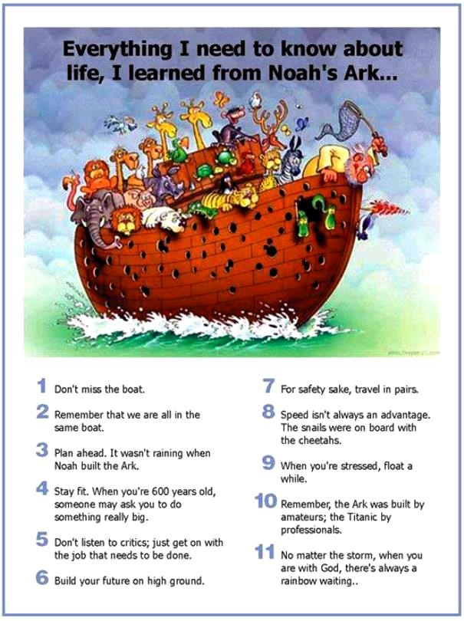

**Pet Show**

*Baltimore Area Council*

**Props:** Boys can be outfitted in Dog or Cat faces. Den Leaders should be dressed as Pet Trainers and the Cubmaster as the Pet Show Announcer.

**Cubmaster:** “Ladies and Gentlemen, you are about to see a parade of advancements in our Pet Show, the likes of which you have never seen before! For our 1st act, our pets with their trainers (parents) have trained and have the cunning skills like Bobcats. They have performed during their training for us showing what feats they have mastered.” (Bobcats and parents come forward and go through Bobcat requirements with Cubmaster. Present badges.)

“Notice how well these skilled pets have been trained by their trainers. Let’s have a fine round of applause for this fine act we have just seen performed before our very eyes.”

“And now we have for our second colossal act of advancement this evening, another fine trained act. The skills of Tigers have been instilled in these pets and they are: (read names of boys receiving Tiger badges). Here come those Tiger skilled pets and their trainers: (Go through similar talk to cover some of Tiger requirements. Handle Wolf, Bear, and Webelos badges in same manner.)

“And now ladies and gentlemen, we have a stupendous act which takes much skill and requires work and patience as these young men climb to great heights ...in fact, to the very top in the Cub Scout parade of advancement. Let’s all watch breathlessly as we give special honors in a ceremony which will demonstrate to you what heights these boys have climbed with the help of their trainers along the way. It is a privilege to introduce to you the participants in this outstanding feat.” (Call the boys and parents forward and present activity badges with flowery language pertaining to that particular activity badge.)

“And now for the stars of our show ... the young men who have completed the requirements for the Arrow of Light ...the highest award in Cub Scouting. In order to qualify for this award these young men have shown knowledge about Scouting, citizenship and first aid. As these stars step into our center ring, let’s give them a roaring round of applause.” (Read names …) “We have presented for you one of the most exciting, most stupendous Pet show in the history of Cub Scouting. The young men you have seen before you have attained the heights of advancement...an amazing array of ability and stupendous skill ...an extravaganza extraordinary!”

# LEADER RECOGNITION

## Scouting is a Candle

*Sam Houston Area Council*

Scouting is a candle that will light you on your way.  
It’s trying on your honor, and helping every day.  
Exploring worlds around you and looking wider still.  
Pitching tents out in the woods and hiking up a hill.  
Music and voices blended under God’s majestic sky,   
Helping those around you, kindness in great supply.  
The meaning in a moment, in a smile, or in a tear,   
Makes you a little taller with each new Scouting year.  
A promise to your God and to your country, too,   
Makes you a part of your world, and your world a part of you.  
It’s something that you carry wherever you may go,   
A secret deep inside you that only Scouts would know.  
But it’s the kind of secret that you want the world to know,   
You can’t hide all the happiness; you can’t hide all the glow.  
A candle glows together, it shines externally.  
Make it shine on everyone, that’s the way the world should be.

**Materials –** candles (longer tapers, OR take a small birthday cake candle and mount it on a piece of wood/plywood – write in black marker – thank you for shining your light in our pack.)

**Cubmaster –** Tonight we would like to say thank you to some leaders and parents who have lit up our pack meeting with their helping hands. (Call adults forward and give them thanks and the memento.)



# SONGS

**Be Kind to Your Scouting Friends***Piedmont Area Council*Tune: The Stars and Stripes Forever

Be kind to your Scouting friends,  
That's a pledge from one Scout to another.  
Be kind to your leaders today,  
'Cause for helping they don't get any pay.  
Be kind to your neighbors and friends,  
'Cause by caring you follow Scouting's letter.  
Scouting and friendship are grand,  
And as we grow, the world will know,  
We've made things better.

**The Wrong End**

*Santa Clara County Council*

(Tune: My Bonnie Lies Over the Ocean)

Oh, rabbits have bright, shiny noses,

I’m telling you this as a friend.

The reason their noses are shiny:

The powder puff’s on the wrong end.

Wrong end – wrong end –

The powder puff’s on the wrong end –

Wrong end –

Wrong end – wrong end –

The powder puff’s on the wrong end!

**Bingo**

*Baltimore Area Council*

There was a farmer, had a dog,   
And Bingo was his name-O   
B-I-N-G-O, B-I-N-G-O, B-I-N-G-O,   
And Bingo was his name-O.

There was a farmer, had a dog,   
And Bingo was his name-o.   
(Clap)-I-N-G-O, (Clap)-I-N-G-O, (Clap)-I-N-G-O.   
And Bingo was his name-O.

(Repeat. Each time replace one more letter of Bingo’s name with a clap.)

**I Know a Cat**

*Baltimore Area Council*

Sung to Bingo

I know a cat with perky ears,  
And kitty is her name-o.  
K-I-T-T-Y, K-I-T-T-Y, K-I-T-T-Y  
And kitty is her name-O

She makes a sound and it’s “meow”  
And Kitty is her name-o  
K-I-T-T-Y, K-I-T-T-Y, K-I-T-T-Y  
And kitty is her name-o

**Tom the Toad**

*Baltimore Area Council*

Tune - Oh Tannenbaum

Oh Tom the Toad, Oh Tom the Toad,   
Why are you lying in the road?   
Oh Tom the Toad, Oh Tom the Toad,   
Why are you lying in the road?   
You did not see the car ahead,   
And on your head are tire treads.   
Oh Tom the Toad, Oh Tom the Toad,   
Why are you lying in the road?

Oh Matt the Rat, Oh Matt the Rat,   
Why did you tease my pussycat?   
Oh matt the Rat, Oh Matt the Rat,   
Why did you tease my pussycat?   
You used to be so brown and thin,   
And now you are inside of him.   
Oh Malt the Rat, Oh Matt the Rat,   
Why did you tease my pussycat?

Oh Jake the Snake, Oh Jake the Snake,   
How did you find my garden rake?   
Oh Jake the Snake, Oh Jake the Snake,   
How did you find my garden rake?   
You used to be so long and slick,   
And now you are so short and sick.   
Oh Jake the Snake, Oh Jack the Snake,   
How did you find my garden rake?

Oh Doug the Bug, Oh Doug the Bug,   
Why did you fall into my rug?   
Oh Doug the Bug, Oh Doug the Bug,   
Why did you fall into my rug?   
I really like to play with you,   
And now you’re stuck upon my shoe.   
Oh Doug the Bug, Oh Doug the Bug,   
Why did you fall into my rug?

Oh Sid the Slug, Oh Sid the Slug,   
why are you sitting in my mug?   
Oh Sid the Slug, Oh Sid the Slug,   
Why are you sitting in my mug?   
You’re sitting there, you look sublime,   
But now my mug is till of slime.   
Oh Sid the Slug, Oh Sid the Slug,   
Why are you sitting in my mug?

**How Much Is That Doggie in the Window?**

*Baltimore Area Council*

(<http://www.niehs.nih.gov/kids/lyrics/howmuch.htm> )

**Chorus:**How much is that doggie in the window? (arf! arf!)  
The one with the waggley tail  
How much is that doggie in the window? (arf! arf!)  
I do hope that doggie’s for sale

I must take a trip to California  
And leave my poor Cub Scout alone  
If he has a dog, he won’t be lonesome  
And the doggie will have a good home

**Chorus**

I read in the paper there are robbers (roof! roof!)  
With flashlights that shine in the dark  
My son needs a doggie to protect him  
And scare them away with one bark (Chorus)

I don’t want a bunny or a kitty  
I don’t want a parrot that talks  
I don’t want a bowl of little fishies  
He can’t take a fish for a walk (Chorus)

**Chorus**

*Note: Arf! Arf! Sounds like a small dog.  
Roof! Roof! Sounds like a bigger dog.*

**I Have a Dog**

*Santa Clara County Council*

(Tune: “Reuben, Reuben, I’ve Been Thinking”)

I have a dog his name is Fido.

I have raised him from a pup.

He can stand upon his hind legs,

If you hold his front legs up!

***There is a second verse to this in the Cub Scout Roundtable Planning Guide CD***

**Inchworm**

*Santa Clara County Council*

***There was no reference for a tune for this song in the SCCC Pow Wow Book. CD***

Inch worm, inch worm  
Measuring the marigolds  
You and your arithmetic  
You'll probably go far  
Inch worm, Inch worm  
Measuring the marigolds  
Seems to me you'd stop and see  
How beautiful they are  
Two and two are four  
Four and four are eight  
Eight and eight are sixteen  
sixteen and sixteen are thirty-two

**The Cat Came Back**

*Santa Clara County Council*

Old farmer Johnson had troubles of his own  
He had a yellow cat that wouldn't leave him alone  
He tried and he tried to give that cat away  
Gave him to a man going very far away

**Chorus**

But the cat came back, the very next day  
Oh the cat came back, they thought he was a goner  
But the cat came back, he just couldn't stay away, away, away

Gave it to a man going way out west  
Told him to give it to the one he loved the best  
First the train jumped the track, then it slipped the rail  
No one is alive today to tell the sad detail

**Chorus**

Gave it to someone going up in a balloon  
Told him to give it to the man in the moon  
Balloon came down about 90 miles away  
But where the pilot is today I cannot say

**Be Kind to Your Web Footed Friends**

*Santa Clara County Council*

***This is sung to the tune of Sousa’s “The Stars and Stripes Forever.” How many of you sang this each week at the end of “Sing Along with Mitch?” CD***

Be kind to your web-footed friends  
For a duck may be somebody's mother  
Who lives all alone in a swamp  
Where it's very cold and damp  
You might think that this is the end  
Well it's not caus' I know another stanza

Be kind to your web-footed friends  
For that cop may be Dick Tracy's brother  
Who lives all alone on the beat  
On a dark and dingy street  
You might think that this is the end  
Well, Why not!

**Be Kind to Your Cub Scouting Friends**

*Tune: Stars and Stripes Forever*

Be kind to your Cub Scouting friends,  
That's a pledge from one Scout to another.  
Be kind to your leaders today,  
'Cause for helping they don't deserve trouble,  
Be kind to your neighbors and friends,  
'Cause by caring you follow Scouting's letter.  
Scouting and friendship are grand,  
And as we grow, the world will know,  
We've made things better.

**Boa-Constrictor**

*Santa Clara County Council*

I'm being swallowed by a boa-constrictor  
I'm being swallowed by a boa-constrictor  
And I don't like it one little bit  
Oh, no, he's got my toe

*Follow up with the following verses -*

O gee, O gee, he's up to my knee  
Oh, my, Oh, my, he's reached my thigh  
O fiddle, O fiddle, he's at my middle  
Oh heck, Oh heck, he's up to my neck  
O dread, O dread, He's got my GULP!!!

**JOHNNY HAD A LITTLE DOG**

*Piedmont Council*

(Tune: Mary Had a Little Lamb)

Johnny had a little dog,

Little dog, little dog.

Johnny had a little dog,

Who’s fur was bright as gold.

And everywhere that Johnny went,

Johnny went, Johnny went,

And everywhere that Johnny went,

The dog was sure to go.

It followed him to pack one day,

Pack one day, pack one day,

It followed him to pack one day,

Which was against the rules.

It made the Cub Scouts laugh and play,

Laugh and play, laugh and play.

It made the Cub Scouts laugh and play

To see a dog at pack.

And so the leader turned it out,

Turned it out, turned it out.

And so the leader turned it out

But still it lingered near.

Why does the dog love Johnny so,

Johnny so, Johnny so,

Why does the dog love Johnny so,

Because he is a Cub.

**WHEN THE DOGS COME RUNNIN’ IN**

*Piedmont Council*

(Tune: When the Saints Go Marchin’ In)

Oh when the dogs come runnin’ in,

Covered with mud from toe to shin,

My mother gives me a mop and a bucket,

When the dogs come runnin’ in.

‘Cause they trample mud on floors and sheets.

And it would be an awesome feat,

If I could get them to use the door mat,

When the dogs come runnin’ in.

# STUNTS AND APPLAUSES

## APPLAUSES & CHEERS

*Baltimore Area Council*

**Alligator Applause:** Alligator opens his mouth very slowly, then snaps shut very fast. Both hands together start opening from fingers and palm, keeping wrists together, then snap hands together very fast. Repeat 3 times.

**Beehive**: Leader instructs everyone to start humming, when he raises his hands, the humming gets louder. When he lowers his hands, the humming gets more quiet.

**Coo-Coo Bird:** Coo-coo, coo-coo, coo-coo.

**Elephant:** Hold arms down in front of you like a trunk, putting hands flat together, lean over slightly and swing arms slowly back and forth while bringing fingers of both bands up and down saying “peanuts, peanuts.”

**Mosquito:** With hand, slap yourself on the neck, arms, legs, etc.

**Seal Applause:** Extend arms, cross bands at wrist and clap several times, and make barking sounds.

**The Lost Sheep:** The leader makes an elaborate announcement introducing a soloist, who is to sing a ballad entitled “The Lost Sheep.” The singer takes his position, glances to the leader who nods his head as a signal to begin. The singer then gives a plaintive “Baa-aa-aa,” bows and exits the stage.

**Owls:** Cub comes on stage carrying a picture of an owl. He says, “‘Owl be seein’ ya!”

**Quacking Up**: Have several Scouts walk across the stage staring at the ceiling and saying “Quack, quack.” Leader then asks what they are doing and they reply, “Quacking Up!”

*Alice, Golden Empire Council*

**Show You Care Applause:** Demonstrate, then have audience do it three times – Say “Show You Care” as you put one hand over heart, second hand over first hand and bouncing up and down (like a heart beating). Repeat three times.

**Let’s Walk Together Applause:** Audience teams up in twos, with arms linked and walk around in a circle, in place, while saying “Let’s Walk Together!”

**Johnny Appleseed Applause:** Make a motion of taking a big bite out of an apple. Then make a motion of picking out a seed, making a hole with a stick, dropping the seed and “covering” the seed with dirt with your foot. Now say, “There’s another Apple Tree!”

**Horton Hears a Who Applause:** Divide audience into two groups. One group is the “Who” and on signal they say very quietly, “The Who!” as they put their hands on either side of their mouths.

The second group says loudly “Who’s There?” on signal as they cup a hand to their ear.

Point to each group several times in random order, but on the last turn, “The Who” shouts as loud as they can.

*Santa Clara County Council*

**Big Bear:** Stand up. Pretend to be a bear standing on his hind legs and give a great big “GROWL”.

**Snake:** Put hands together above your head. While standing, slither with your body in place and say, “SSSSSSSSSSSSS”.

*Piedmont Council*

**CAT’S MEOW APPLAUSE:** Groups yells, “You’re the cat’s MeeeeOOOOOOW!!!” to a person receiving the applause.

**CAT STRETCH APPLAUSE:** Have the group start in their chairs, move hands and arms slowly upward until they are as far above their heads as possible, then stretch out their legs as far as possible, then stand and arch their backs and say “Purrrrrfect!”

**RABBIT APPLAUSE:** Place hands on head to resemble rabbit ears. Wiggle your nose and your tail. Hop three times.

**SAINT BERNARD CHEER:** Point up the mountain and yell, “To the rescue!”

**PARROT APPLAUSE:** Make wings with your arms, flap and say, “Polly wants to say, You’re GREAT!”

## RUN-ONS

*Piedmont Council*

***End each run on at your Pack meeting with***

***“‘Hot Diggity Dog!”***

Cub: Mr. Pet Store owner, I want to buy a dog. How much are these puppies?

Owner: They are $5.00 apiece.

Boy: OK, but I wanted a whole one.

Cub #1: What invention are you working on?

Cub #2: It may sound silly, but I believe it’s a winner.

Cub #1: Really, what is it?

Cub #2: I’ve invented a dog food that tastes just like a mailman’s ankle.

Emcee: We interrupt this program for a spot announcement.

Dog: (offstage):Arf, Arf, Arf!

Emcee: Thank you, Spot.

*Santa Clara County Council*

Two dogs meet each other in the park…

Dog 1: Hi, I’m Rover. What’s your name?

Dog 2: I don’t know, but I think it’s “Down Boy.”

Boy 1: Why do fire fighters use Dalmatians?

Boy 2: They use them to keep the crowds back.

Boy 3: No, they’re just for good luck.

Boy 1: They use the dogs to find the fire hydrant.

Boy: Doctor, can you treat my dog?

Doctor: I would, but I’m all out of dog treats!

*Baltimore Area Council*

My dog is really smart.   
How smart is he?   
Every time I do something cute, he gives me a treat.

I’ve got a slow dog.   
How can you tell?  
This morning he brought me yesterday’s newspaper.

I finally trained my dog not to beg at the table.  
How did you do that?   
I let him taste my cooking.

*From the Baloo Archives*

One day a man wakes up to find his family dog lying on the ground, not moving. He calls the vet who promptly comes over carrying a black bag and a black box. As the family watches the vet sets down the box and the bag and does a quick examination of the dog. He then opens up the black box and out jumps a cat. The cat looks up at the vet who nods his head. The cat walks slowly around the dog and then stops and walks around the other way. The cat looks at the vet who nods again, and then proceeds to jump back into the box. The family eagerly awaits the vet's diagnosis. The vet says, "Well I'm sorry but you're dog is dead." The father says "how much do we owe you?" "Well," says the vet, "It is $40 for the examination and $50 for the cat scan!"

**Dog breeds that didn't make it***From the Baloo Archives*

* Collie + Lhasa Apso = Collapso, a dog that folds up for easy transport
* Bloodhound + Borzoi = Bloody Bore, a dog that's not much fun
* Pointer + Setter = Poinsetter, a traditional Christmas pet
* Kerry Blue Terrier + Skye Terrier = Blue Skye, a dog for visionaries
* Great Pyrenees + Dachshund = Pyradachs, a puzzling breed
* Pekingnese + Lhasa Apso = Peekasso, an abstract dog
* Irish Water Spaniel + English Springer Spaniel = Irish Springer, a dog fresh and clean as a whistle
* Labrador Retriever + Curly Coated Retriever = Lab Coat Retriever, the choice of research scientists
* Newfoundland + Basset Hound = Newfound Asset Hound, a dog for financial advisors
* Terrier + Bulldog = Terribull, a dog that makes awful mistakes
* Bloodhound + Labrador= Blabador, a dog that barks incessantly
* Malamute + Pointer = Moot Point, owned by, oh, well, it doesn't matter anyway
* Collie + Malamute = Commute, a dog that travels to work
* Deerhound + Terrier = Derriere, a dog that's true to the end

## JOKES & RIDDLES

*Santa Clara County Council*

When is the vet busiest?   
 *When it’s raining cats and dogs.*

What happened when the dog ate his owner’s watch?  
 *He got a lot of ticks.*

What is a baseball dog? *One that catches flies,   
chases fowls, and dashes for home when he sees the catcher.*

Why did the dog take a wishbone to bed?  
 *Because he wanted to make his dreams come true.*

*Baltimore Area Council*

What do you call a happy Lassie? A jolly collie!

What looks like half a cat? The other half!

What game do cows play at parties ? Moosical chairs!

How for can a dog go into the woods? Only half way, when   
 he gets halfway in, he starts coming out again.

What kind of dog washes clothes? A laundermutt

What kind of market does a dog hate? A flea market.

Who brings dogs their presents at Christmas? Santa Paws

How are dogcatchers paid? By the pound

How does a flea get from place to place? By itch-hiking.

What is a little dog’s favorite drink? Pupsi-cola.

What goes tick, tick, woof, woof? A watch dog

*Santa Clara County Council*

**Be Kind to Animals (by John Ciardi)**

There once was an ape in a zoo

Who looked out through the bars and saw – You!

Do you think it’s fair

To give poor apes a scare?

I think it’s a mean thing to do!

**Elephant Jokes in Honor of Horton***Alice, Golden Empire Council*

Q: What cheers you up when you are sick?  
A: A Get Wellephant card!

Q: What should you do to a blue elephant?  
A: Cheer it up!

Q: How can you tell when an elephant has been in   
 your refrigerator?  
A: Look for elephant tracks in the butter.

Q: [What has 6 legs, 3 ears, 4 tusks, and 2 trunks?](javascript:void(0))  
A: An elephant with spare parts.

Q: What is large and gray and goes around and   
 around in circles?  
A: An elephant stuck in a revolving door!

Q: How can you tell when an elephant is under   
 your bed?  
A: Your nose is squashed against the ceiling.

***And my personal favorite Elephant joke. I won a Silver Dollar on this from the Editor of the Westwood (NJ) Local (An old time weekly shopper that carried all the Scouting news, Little League and other news. Thank you Mr. Barblinado) when Elephant Jokes first came out. The joke is probably not completely politically correct any more. CD***

Q: Why do ducks have web feet?  
A: To stamp out forest fires.  
Q: Why do elephants have flat feet?  
A: To stomp out burning ducks!!

Q: [What seven letters did Old Mother Hubbard say   
 when she opened her cupboard?](javascript:void(0))  
A: O I C U R M T

Q: What do you call an oyster that won't share?  
A: A Selfish Shellfish! (Try saying it fast three times!)

Knock-Knock Knock, Knock

Who's there? Who's there?

Cash Pecan

Cash who? Pecan, who?

No, thanks. Pecan someone

I prefer peanuts. your own size!

# SKITS

**BADEN-POWELL & GOOD DEEDS**

*Alice, Golden Empire Council*

**Setting:** An adult dressed as Baden Powell, and standing off to the side of the stage (or a large picture of BP, with a voice coming from off-stage.) A group of Cub Scouts and their Den Chief (DC) are sitting in the middle, looking like they are talking. (moving their mouths and hands, but not saying anything) If possible, it would be great to have stars on the wall behind the boys, with small white Christmas lights, not turned on, but able to be turned on at the end.

**Baden-Powell:** When I founded scouting, I wanted boys to learn how to take care of themselves. But I also taught them to be kind to others – to do a good deed every day. I often think (that) when the sun goes down, the world is hidden by a big blanket from the light of heaven – but the stars are little holes pierced in that blanket by those who have done good deeds in this world. The stars are not the same size; some are big, some are little, and some men have done small deeds – but they have made their hole in the blanket by doing good deeds before they went to heaven.

**DC:** (Looking at a Cub #1) Wow, you’re doing great – you almost have the Scout Oath memorized! But remember to put in “..to help other people” – Baden-Powell wanted scouts to do a good deed each day.

1. What kind of good deed?
2. Well, Saturday my family helped plant trees along the river – it was hard work, but fun, too. And boy, did I get dirty!
3. I helped my den leader clean up after we finished our project – that's a good deed, too.
4. So, we need to do a good deed every day? Sounds kind of hard.
5. Well, sometimes you have to work hard to do a good deed –my dad and I helped paint a neighbor's fence – and that was hard work.
6. But sometimes, a good deed is pretty easy. There’s a new boy in my class, and he was kind of lost – so I helped him find the cafeteria and meet some of my friends – I guess that was my good deed for the day.

**Cub #1:** Hey, I helped Mom bring in all the groceries from the car – was that a good deed?

**DC:** Sure, that was a good deed. Just remember to be kind and helpful, and you won’t have any trouble doing a good deed each day…

(pauses, then looks like he has a great idea) Hey, even helping you learn the Scout Oath is a good deed!

**The Doggy Story**

*Baltimore Area Council*

This delightful bit of nonsense has been around for quite a while and can use as many as eight Cub Scouts or be cut down to the number in your Den. Very few props are used. Cub Scouts should speak slowly and clearly.

1. Say (name) what kind of dog have you?
2. I have a setter. (walks on stage carrying chair, sits on chair, quickly rises and exits.)

***(As each succeeding player comes in, ONE repeats, “Say what kind of dog have you? Each makes his response as follows and exits)***

1. (pointing a stick at audience) I have a pointer
2. (carrying a large spring) I have a springer
3. (with bucket) I have a water spaniel
4. (with clock or watch) I have a watch dog
5. (with box or boxing gloves) I have a boxer
6. (enters with a mop)

**Cub # 1:** Say, what kind of dog have you?

**Cub #8:** I have a puppy!

***Alternate ending:***

**Cub #8:** (enters with a paper bag)

**Cub #1:** Say, what kind of dog have you?

**Cub #8:** I have my favorite kind of dog! (Pulls a hot dog in a bun out of the bag and takes a bite.)

**INVISIBLE PET**

*Piedmont Council*

Cub #1: (Dragging a leash behind him) Come on boy, let’s go.

Cub #2: What are you doing?

Cub #1: I’m taking my dog for a walk.

Cub #3: I don’t see any dog, just a leash that you are dragging along.

Cub #1: That’s because it is an invisible dog.

Cub #2: Invisible dog?!

Cub #1: My mom says I can have a real dog if I learn to be responsible and take care of it. I have to feed him, and walk him and just be his friend. If I do that, then my folks will take him to the vet and get all his shots.

Cub #3: So you are just practicing on a pretend dog at first?

Cub #1: I am now. The pretend elephant was just WAY too much work!

***See instructions on making a leash for an invisible dog in “Pack and Den Activities” CD***

**BONE**

*Piedmont Council*

**Scene:** All the Cubs except one are on the stage. The last Cub will enter at the end of the skit. Adjust to the size of your den.

**Cub #1:** Hey, did you hear?

**Cub #2:** No, what?

**Cub #1:** (Name of the last Cub) found a dinosaur bone in his backyard.

**Cub #3:** How do you know it was from a dinosaur?

**Cub #1:** He said it was from Rex, you know, like in Tyrannosaurus Rex.

**Cub #4:** How did he find it?

**Cub #1:** He was digging around in the yard.

**Cub #5:** Did he call the TV news people?

**Cub #2:** How big of a bone was it?

**Cub #3:** We better ask him what happened.

***(The last Cub enters)***

**Last Cub:** Hi guys, what’s up?

**Cub #4:** Tell us about your bone.

**Cub #5:** Yeah. Is it from a Tyrannosaurus Rex dinosaur?

**Last Cub**: Oh, that bone. No, it wasn’t from a Tyrannosaurus Rex. It was from Rex.

**Cub #1:** What other dinosaur is a Rex?

**Last Cub:** Not a dinosaur. It was my dog Rex! He sure was upset I dug up his bone!

**Three Rivers**

*From the Baloo Archives*

**Cast:** Camp Cook, 3 strangers, Three Rivers (a boy on all fours acting like a dog)

**Props:** Big Kettle or Dutch Oven

**Setting**: The camp cook is stirring the contents of the big kettle when along comes a stranger.

**1st Cub:** What’s cooking? Sure does smell good.

**Cook**: Homemade stew. Want a plate?

**1st Cub:** Yeah, if it’s not any trouble. Got an extra plate?

**Cook:** Sure do. Three Rivers just finished cleaning some. (The 1st Stranger picks up a plate from the pile the cook is pointing to.)

**1st Cub:** Are you sure these plates are clean?

**Cook:** Sure are, stranger. Three Rivers just cleaned ‘em.

***(This is the crux of the skit. Make sure the audience understands that Three Rivers cleaned the plates.)***

*(Two more strangers come in and get served.)*

**3rd Cub:** "Cookie, that stew was great! To show my appreciation, I’d like to clean up the dishes.

**Cook:** Never mind about that. Three Rivers will take care of them. Three Rivers!!! Three Rivers!!! Here boy, come on Three Rivers!!!"

**Three Rivers:** (Enters, barking.)

**Cubs:** (Pretend to get sick.)

**It’s A ???**

*Baltimore Area Council*

**Personnel:** 4 Cubs and as many others as you wish to include in the dialog.

**Setting:** A tent is set up in the woods. It is a very dark night. Boys are inside tent. This skit could be done at a Pack outdoor activity or on stage indoors. It is easy for Cubs because most of the speaking is done inside a tent, out of sight, so lines could be read instead of memorized.

**Pete:** Hey, Ben. You all right?

**Ben:** (sleepily) Yes.

**Jim:** Why don’t you guys be quiet. I’m trying to sleep.

***(A short pause - silence prevails)***

**Tom:** Hey. Pete. You all right?

**Pete:** Sure

**Ben:** Wish I had Skippy here.

**Jim:** A dog in a tent? What for?

**Ben:** To keep me warm.

**Pete:** Yeah, Keep you warm. You’re scared.

**Tom:** You guys go to sleep.

***(A short pause - silence)***

**Ben:** listen! What’s that noise?

**Pete:** Just the wind blowing.

**Tom:** Might be something prowling around.

**Ben:** What?

**Tom:** Oh, I don’t know. A bear, maybe.

**Jim:** Or a panther.

**Ben:** A panther?

**Tom:** Yeah, or it could be a coyote!

**Pete:** A coyote?

**Jim:** Maybe it’s a mountain lion.

**Ben:** Oh, no!

**Tom:** Hey, it’s coming closer!

**Pete:** Where’s my flashlight?

**Jim:** Look out! It’s coming in the tent.

***(All yell and run out of tent. Flashlights on Ben, who is holding a toy stuffed dog or real dog)***

**All:** It’s Skippy !

**Skunk In The Tent**

*Baltimore Area Council*

Cub #1: Mr. \_\_\_\_\_, Mr. \_\_\_\_\_, there’s a skunk in our tent.

Cub #2: It’s a real skunk!

Cub #3: What should we do?

CM: Quietly sneak up on your tent. Don’t frighten the skunk. Then lay a trail of breadcrumbs from your tent leading into the forest. That should lead the skunk back into the wild. (The Cubs go do it, and return shouting. . . )

All Cubs: Help! Help!

CM: What’s wrong? Did you go up to your tent quietly like I told you?

All Cubs: Yes.

CM: Did you frighten the skunk?

All Cubs: No.

CM: Did you boys lay the trail of breadcrumbs leading into the forest like I told you?

All Cubs: Yes.

CM: Then what’s wrong?

Cub #1: Well, Mr. \_\_\_\_\_, now we have TWO skunks in our tent!

**Puppy in the Box**

*Santa Clara County Council*

**Props:** A cardboard box with holes, cup of water inside, and a stuffed dog (or rabbit, etc.)

**Announcer:** This scene takes place on the street outside a grocery store.

***Several participants are gathered around outside the store, chatting.***

**Roger:** (Enters holding the box) Hi guys, would you please hold this box for me while I go into the store? (Exits)

**Martin:** I wonder what's in the box?

**Gerry:** I don't know, but something is leaking out!

**Bob:** (Rubs finger against the bottom of box, then licks finger) Hmmm, it tastes like lemon soda.

**Martin:** (Also rubs box and tastes finger) No. I think it's more like chicken soup.

***Feel free to add in a line for everyone in your den***

**Roger:** (Returns, looks in box) Oh, you naughty puppy!

**Puppy in the Box (Version 2)**

*Santa Clara County Council*

**Cast:** Owner, 1st Pedestrian, 2 Friends, box

**Setting:** Street Corner

**Owner:** (Walking up to #1) Would you hold my box? I have to go into a store for a moment.

**Cub #1:** Sure! Be glad to.

**Cub #2:** (Walks up.) Hey! What's in the box?

**Cub #1:** I don't know. This guy comes up to me and hands it to me. Hey! It's leaking! Maybe it's ice cream and it's melting. Let's taste it. (Taste drip) Tastes like vanilla ice cream to me!

**Cub #2:** (Tastes it.) Chocolate it is, my friend. Hey Joe! Try this -- what does it taste like?

**Joe:** (Tastes it.) Definitely pistachio.

**Cub #1:** Naw! It's vanilla!

**Cub #2:** I told you, it's chocolate!

***(Owner comes back. )***

**Cub #1:** Mister -- what's in the box? Vanilla ice cream?

**Cub #2:** Or chocolate?

**Joe:** It tastes like pistachio to me!

**Owner:** How foolish of you guys. That's my pet dog!

***I usually see these next two done as a Run Ins. CD***

**Lost Dog**

*Santa Clara County Council*

**Setting:** Dave is crying

**Dave:** Boo hoo hoo!

**Bob:** Hey Dave, why are you crying?

**Dave:** (still sniffling) I lost my dog

**Bob:** Maybe he’ll come home.

**Dave:** No, he won’t come home. He’s lost.

**Bob:** Why don’t you put an ad in the lost and found column of the newspaper?

**Dave:** No. It wouldn’t do any good.

**Bob:** Well, why not?

**Dave:** Because my dog can’t read!

**Smart Dog**

*Santa Clara County Council*

**Tom:** That’s a nice dog you have.

**John:** Thank you. He’s nice and he’s smart.

**DOG:** Arf!

**Tom:** A smart dog, huh? What’s his name?

**John:** Snoop.

**DOG:** Arf!

**Tom:** What kind of dog is he anyway?

**John:** A police dog.

**DOG:** Arf

**Tom:** A police dog? He doesn’t look anything like a police dog.

**John:** Of course he doesn’t. He’s a police detective in disguise!

**DOG:** Arf!

**Doggie Doctor**

*Santa Clara County Council*

A person comes to the psychologist and says that he needs help; he thinks that he is a dog, holding up his hands like a dog begging.

Throughout the skit, the person acting like a dog, does dog-like things, like scratching behind his ears, whining, etc. Doctor asks how long he has had this problem.

Ever since he was a puppy is the reply.

The doctor asks if he will lie on the couch but the person says that he can’t since he can’t get on the furniture.

The doctor’s advice is to make sure that he gets all his shots and doesn’t go chasing any cars.

# CLOSING CEREMONIES

***Be sure to check out the Noah’s Ark closing that is in Openings to show the way to use Noah’s Ark throughout the Pack Meeting. CD***

**A Scout is KIND**

*Alice, Golden Empire Council*

***Gather props, or enlarge the images shown below.***

**Narrator:**  – The point of the Scout Law (KIND) that was our focus this past month. So let’s review:

**Cub #1:** *(holding up clock or enlarged image)* KINDness is the right choice no matter what time of day or night it is.

**Cub #2:** *(holding up calendar or enlarged image)* And it doesn’t matter what month it is – always be KIND!

**Cub #3:** *(holding up globe, map or enlarged image)* It also doesn’t matter where you are – KINDness can be practiced across the world!

**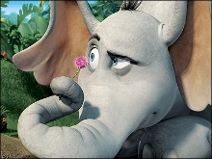 Cub #4:** *(holding up Elephant or enlarged image)* Dr. Seuss’ story about Horton Hears a Who shows that it doesn’t matter what size you are - You can be KIND and compassionate!

**Cub #5:** *(holding up a picture of Scouts of all ranks or enlarged image)* No matter what rank you are in Scouts, always remember that a Scout is KIND!

**Narrator:** So when you leave here tonight, please remember:

**All: A Scout is KIND**!

At the end of this closing, have other Cub Scouts come forward, join these Cub Scouts, and proceed right into the Closing Flag Ceremony.

**Seeds of Kindness Closing**

*Sam Houston Area Council*

**Set Up:**A group of Cub Scouts is talking with the Cubmaster.   
The conversation is ending and the Cubmaster says:

**Cubmaster:** Remember, guys, it’s important to be kind to everyone you meet but, it is most important to be kind to the people in your family.

*The Cubmaster walks off stage.  
The Cub Scouts start to gather closer together   
and the conversation continues.*

**Cub Scout #1** Wow, I never thought about that.

**Cub Scout #2** Yeah, I guess it really is important to be kind to my family.

**Cub Scout #3** My mom is kind when she cooks our favorite foods. I love it when she makes lasagna.

**Cub Scout #4** Mmmmm. Yum! Maybe we can think up a special recipe for our families.

**Cub Scout #5** OK. Let’s write down the ingredients. (Looks for a card and pencil and starts writing.)

**Cub Scout #6** Well, we should probably start with a cup of eagerness. Maybe even three cups. It’s important to be eager to help at home.

**Cub Scout #1** Sure, and how about some cheerfulness. Maybe two cups. Cheerfulness and Laughter help everyone feel good at my house.

**Cub Scout #5** This is beginning to look enticing. What next?

**Cub Scout #2** How about some courtesy. Two hands full. You can never have enough of that at our house!

**Cub Scout #3** What about helpfulness? At least a cup and a half of that!

**Cub Scout #4** And obedience with the ability to follow instructions. That’s really important to my parents.

**Cub Scout #6** Oh, and a gallon of patience…especially with my sisters! Write that one in big letters!

**Cub Scout #5** Hey guys, this is looking really great. Is there anything we’ve left out?

**Cub Scout #1** I’d say we need at least four cups of love for each other. In fact, we should add a little more for good measure.

**Cub Scout #2** Yeah. Don’t forget to put down the instructions, too.

**Cub Scout #3** Stir it all up. Mix it well.

**Cub Scout #4** What will we call it?

**Cub Scout #5** How about “A Recipe for a Happy Family.”

**Cub Scout #6** And make sure to serve generous portions daily!

**FRIENDS--CLOSING**

*Piedmont Council*

**Set Up:** Five Cub Scouts and a Cubmaster (CM) or other Leader. Have each Scout make a card with a picture of his pet or selected animal. Have his part in LARGE letters on the back side of the card. Feel free to use whatever animals you want. Do not be limited by these ideas.

1. My best friend is my pet dog. I walk him, feed him, water him, and brush his fur to keep him clean. My folks take him to the vet to get his shots. He thanks me by being my friend by saying “Bow-wow-wow-wow” (Continues to bark)
2. I learn responsibility by taking care of my cat. I care for her. I like to hear her purr when I pet her. She thanks me by saying, “Meow-meow-meow” (Continues to meow)
3. I care for my friend, the snake. I keep him in his cage and watch him slither around. He doesn’t make much noise but when he does it sounds like “Hiss-sssss-sssss” (Continues to hiss)
4. I care for my bird, and my bird is my friend. I clean his cage everyday and hear him say, “Tweet-tweet-tweet-tweet” (Continues to tweet)
5. I care for my hamster. I feed him and watch him running in his wheel, squeaking like this all night long “Squeak, squeak, squeak” (Continues to squeak)

**CM:** These Cub Scouts learn to be friends by being a friend to a pet. There are many different kinds of pets out there, just like there are many different types of friends. By being kind and responsible for our pets, we learn to be kind and responsible to our friends, too.

**The Dog’s Cold Nose Closing**

*Baltimore Area Council*

**Set Up:** Four Cub Scouts and a Cubmaster (CM) or other Leader. Have each Scout make a card with a picture of his pet or selected animal. Have his part in LARGE letters on the back side of the card.

**CM:** Did you ever wonder why the dog has a cold nose? A man named Arthur Guiterman gives us this theory.

1. When Noah, perceiving ‘twas time to embark,   
   Persuaded the creatures to enter the ark.   
   And Noah’s old dog, though long past his prime,  
   Assisted in herding them. Two at a time.
2. He drove in the elephants, zebras and gnus,   
   Until they were packed like a box full of screws.   
   The cat in the cupboard, the mouse on the shelf,   
   The bug in the crack; then he backed in himself.
3. But such was the lack of available space   
   He couldn’t tuck all of him into the place;   
   So after the waters had flooded the plain   
   And down from the heavens fell blankets of rain.
4. He stood with his muzzle thrust out through the door   
   The whole forty days of that terrible pour!   
   Because of which drenching, zoologists hold,   
   The nose of a healthy dog always is cold!

**Mothers Day Closing Ceremony**

*Santa Clara County Council*

*You could assign each verse to a different Cub Scout. You could have a den read this in unison. You could have he Cubmaster use this as a Cubmaster's Minute.*

I Love You, Mother

by Joy Allison

“I love you, mother” said little John;

Then forgetting his work, his cap went on,

And he was off to the backyard swing,

Leaving his mother his room to clean.

“I love you, mother” said little Phil,

“I love you more than tongue can tell.”

Then he teased and pouted half the day

Till his mother rejoiced when he went to play.

“I love you, mother” said little Dan.

“Today I’ll help you all I can.”

To the cradle then he did softly creep

And rocked the baby till it fell asleep.

Then stepping softly he took the broom

And swept the floor and dusted the room.

Busy and happy all day was he,

Helpful and cheerful as a boy should be.

“I love you, mother,” again they said,

Three little boys going to bed.

How do you think the mother guessed,

Which of them really loved her best?

program updates banner

# CUBMASTER’S MINUTES

**If It’s Harder, It’s Even More Important**

*Alice, Golden Empire Council*

Most of us find it pretty easy to understand and relate to someone who is a lot like ourselves – and it’s pretty easy to be kind and not be critical. But the true test of being a “Good Scout” is when we can look at someone who is different, who worships a different God, who honors a different flag, who dresses in a different way, and we can put ourselves in that person’s place, walk a mile in his shoes, and treat him as we would treat our friends. It’s when we see someone who walks or talks or writes in a way that makes us uncomfortable – and instead of pity we feel a kinship – Now that is being KIND!

**If a Dog can -**

*Voyageur Council*

With all the wonderful skills dogs can learn, there is one thing they cannot do. Dogs cannot see colors. As a matter of fact, monkeys and apes are the only animals that can see colors.

Do you ever feel like you cannot do something because you are too small, too clumsy or too young? Well next time you do, remember the dog and how he can retrieve objects, guide the blind, track lost people all without being able to distinguish colors.

**Freedom**

*Baltimore Area Council*

Boys, I want to tell you a story that has a meaning. When I was a boy I had three turtles. They had a beautiful terrarium with rather low sides. They had everything they needed, except one thing… FREEDOM. Every chance they had, they would climb out.

People in many countries in this world lack the same thing - FREEDOM. But not in America. In America we have Freedom of Speech, Freedom of the Press, Freedom to go wherever we chose, the Freedom to Worship God as we wish and the Freedom to choose people to govern us.

A boy like you can grow up to be wherever he dreams of being. This is why I love America. Don’t you? Good Night!

**Horizons**

*Voyageur Council*

We often speak of horizons, .not one, but plural, horizons. Did it ever occur to you that there is more than one? When you have worked and planned to reach your horizon, you stop to rest and look up to see before you still another horizon just as far away as the last. When that horizon is within your grasp, wonder of wonders, still another is waiting. Few men ever reach all horizons, some never even reach the first, and still others never start. Look at what they miss. All they ever see is the small area around them. This is NOT the Cubbing way. Cub Scouts must reach a series of horizons on their climb to the Arrow of Light. Small horizons, but they lead to the farther horizons of Scouting and manhood.

**Some Dogs Are So Dog-Gone Cheerful**

*Baloo's Archives*

Have you ever stopped to wonder why some dogs are so dog-gone cheerful. It's kind of pleasant, isn't it, to be around a happy dog? On the other hand, we usually try to steer clear of dogs who appear to be kind of grumpy. That's the way it is with people, too. It's much nicer to be around people who have a cheerful attitude than someone who's always looking on the dark side of things. You know, if you look for them, there are lots of reasons to be happy.

**Little Things**

*Baltimore Area Council*

The other day in Colorado a great stalwart tree fell. It was nearly 800 years old, a mere sapling when Columbus landed. It had been struck by lightning 14 times; it had braved the storms of almost five centuries. It had defied earthquakes and hurricanes; it had laughed in scorn at the winter’s blast and blizzards. But in the end, tiny beetles killed it. They bored under the bark, dug into its heart, and one day down come this mighty king of the forest. It is the little things that make or break us – in our business – our profession – our homes – our lives and in Scouting. Don’t let the little things get you down – Keep your eye on the goal!

# CUB GRUB

**Cub Grub Cookbook**

This is a really great cookbook for Cubs -

<http://balboaoaks.bsa-la.org/download/blog/Cub%20Grub%20Cookbook.pdf> -

You can save a copy on your PC by selecting   
**File, Save As...** in your web browser's menu bar.

**Johnny Appleseed Smiles**

*Alice, Golden Empire Council*

**Ingredients:**

* Red medium apple, cored & sliced
* Peanut butter or cream cheese,
* Tiny marshmallows

**Directions**

* Spread one side of each apple slice with peanut butter.
* Place 3 or 4 tiny marshmallows on top of the peanut butter on one apple slice.
* Top with another apple slice, peanut butter side down.
* Squeeze gently.
* Eat right away.
* Finish by singing **The Smile Song** –

I've got something in my pocket,  
it belongs across my face.

I keep it very close at hand,  
in a most convenient place.

I'm sure you couldn't guess it  
if you guessed a long, long while.

So I'll take it out and put it on,  
it's a Great Big Cheerful Smile!

**People Biscuits***Baltimore Area Council*

**Ingredients:**

* 1½ cup all-purpose flour
* 2 teaspoon baking powder
* 1 cup milk
* 1 teaspoon sugar
* 2 tablespoon margarine
* 1 egg
* 1 teaspoon salt
* Raisins
* ½ cup shredded cheddar cheese

**Directions**

* Soften the margarine to room temperature.
* Mix all the ingredients except the egg with a fork to form soft dough.
* Turn the dough onto a lightly floured surface.
* Knead 10 times.
* Roll dough ½ inch thick.
* With a gingerbread man cookie cutter, cut out the dough and place on a greased cookie sheet.
* Brush the biscuits with a beaten egg.
* Add raisin eyes.
* Bake in a 400 degree oven for 20-25 minutes until golden brown.
* Enjoy your People Biscuits.

**People Chow***Baltimore Area Council*

**Ingredients:**

* 1 stick butter.
* 1 box Crispix cereal
* 1 cup semisweet chocolate chips
* 2 cups powdered sugar
* 1 cup peanut butter *(check for allergies!!!)*

**Directions**

* Melt together butter, semisweet chocolate chips and peanut butter.
* Pour over 1 box of Crispix cereal in medium bowl.
* Put sugar in a large bowl and add the ingredients to coat.
* Serve in a plastic bag.

**Bird Poop***Santa Clara County Council*

**Ingredients:**

* 5 cups of your favorite crunchy cereal
* 2 cups of skinny pretzels (if long, break them in half)
* 3 cups of rice crisp cereal
* 1 bag of white chocolate chips
* 2½ cups of mini marshmallows

**Directions:**

1. Mix all the dry ingredients in a large bowl.
2. Melt the white chocolate in the microwave for about 1 minute.
3. Pour the melted chocolate over the dry ingredients and spread on wax paper to cool.
4. When your masterpiece is cool, break into chunks that look like icky bird poop.

**Homemade Doggie Treats**

***Please note: The recipes in this box are for real dog biscuits and animal treats. There is nothing in it that would harm a child, but they ares meant for animals!***

**Dog Biscuits***Baltimore Area Council*

**Ingredients:**

3/4 cup hot water

1/2 cup margarine

1 cup powdered milk

1 pinch salt

1 egg, beaten

3 cups whole wheat flour

*Variation: increase margarine to ½ cup and add 2 teaspoons sugar*

**Directions:**

In large bowl pour hot water over the margarine. Stir in powdered milk, salt, and egg. Add flour, ½ cup at a time. Knead for a few minutes to form stiff dough. Pat or roll to ½ inch thickness. Cut into bone shapes. Bake at 325 degrees for 50 minutes. Cool. They will dry out quite hard. Makes about 1¼ pounds of biscuits. Costs around 30 cents per pound.

**Four-Legged Family Member Treats***Baltimore Area Council*

**Ingredients:**

Nonstick cooking spray

1/2 cup shredded cheddar cheese

1/2 cup shredded Parmesan cheese

3 Tbsp. Vegetable oil

1 1/2 cups flour (use part whole wheat if desired)

1/4 cup nonfat dry milk powder

2 tsp. Salt or garlic salt

1/2 cup water

**Directions:**

Preheat the oven to 350 degrees. Spray a baking sheet with nonstick cooking spray; set aside. In a large bowl, combine the cheeses with the oil. Stir in the flour, milk powder and salt until well blended. Add the water and knead until stiff yet pliable dough forms.

On a lightly floured surface, roll the dough to a ¼ inch thickness. Cut out dog bones or other desired shapes, using a cookie cutter if you’d like. Re-roll scraps until all the dough is used.

Place on the prepared baking sheet and bake about 25 minutes. (Smaller cookies may take less time to bake, and larger cookies may take more.) Turn once during baking, Treats should be golden brown when done. Remove from oven and cool on a wire rack. Makes about 3 dozen treats for dogs or cats.

**Nice Spice Dog Biscuits***Santa Clara County Council*

*These biscuits are really for your dog,   
not your Scouts!!.*

**Ingredients:**

1 1/2 cup unbleached all-purpose flour

1 1/2 cup whole wheat flour

1/2 cup cornmeal

2 Tbsp nonfat dry milk

1 tsp cinnamon

1 tsp nutmeg

1 1/2 tsp allspice

1 egg

1 to 1 1/4 cup water

**Directions:**

1. Preheat oven to 350 F.
2. Stir all dry ingredients together in mixing bowl.
3. Add the egg and slowly stir in the water with a wooden spoon.
4. Keep stirring until dough becomes stiff.
5. Knead the dough until a smooth texture.
6. Roll out ¼ inch thick (flour the top and bottom of the dough)
7. Cut out with a bone shaped cookie cutter
8. Lightly grease a cookie sheet.
9. Bake for 45 min to 1 hour.
10. Remove from oven and leave them overnight to let harden.
11. Store in plastic Ziploc bags.

***Now back to recipes for humans – If you want more recipes for Doggie Treats try -***

**Cookies For Canines:  
9 Homemade Dog Treat Recipes**

Go to - <http://www.thekitchn.com/cookies-for-canines-homemade-d-135078> for some more fun ideas for treats you can make for your favorite dog!

**Homemade Animal Cookies**

**Supplies:**

Blender, large bowl, wooden spoon, table knife, pastry blender or 2 table knives, rolling pin, animal cookie cutters, cookie sheet, spatula, oven mitts, cooling rack

**Ingredients:**

* 1 cup rolled oats
* ¼ cup honey
* 1 tsp. salt
* 1½ cups all-purpose flour
* ½ tsp. baking soda
* ½ tsp. cinnamon
* ½ cup (1 stick) cold butter
* ½ cup buttermilk
* 2 Tbsp. extra all-purpose flour

**Directions:**

1. Pre-heat the oven to 400°F.
2. Put the rolled oats in the blender container. Cover and blend at high speed to grind the rolled oats into oat flour. (The oat flour will look powdery)
3. Place the oat flour in the bowl. Add the honey, salt, all-purpose flour, baking soda, and cinnamon to the bowl and stir well with the wooden spoon.
4. Cut the butter into 8 equal slices. Place the butter in the flour mixture.
5. With the pastry blender, cut the butter into the dry ingredients by using a back-and-forth motion until the bits of butter-flour mixture are the size of small peas.
6. Add the buttermilk to the bowl and mix thoroughly with your hands until the mixture forms a dough. Continue to mix together until smooth.
7. Allow the dough to sit for 5 minutes.
8. Sprinkle the extra 2 tsp. flour over a clean surface. With the rolling pin, roll the dough until it is ¼-inch thick.
9. Cut the dough with animal cookie cutters.
10. Use the spatula to place the crackers 2 inches apart on the ungreased cookie sheet.
11. Bake the crackers for 10 to 12 minutes or until they are lightly golden brown.
12. Remove the cookie sheets from the oven using oven mitts. Let the crackers cool for 5 minutes, and then use the spatula to move them from the cookie sheets to the cooling rack.

**Brown Sugar Turtle Pralines***Santa Clara County Council*

A praline is a rich, pastry-shaped candy made with sugar, cream, butter, and pecans. Make some turtle pralines that look like your pet turtle.

**Ingredients:**

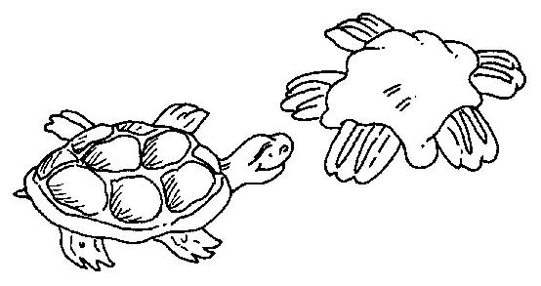

* 2 cups pecan halves
* 2 cups light brown sugar
* 1 cup light cream
* 2 Tbsp. butter

**Directions:**

***Adults need to be watching this process closely!!***

1. With a paring knife, cut ½ cup pecan halves into quarters by cutting each pecan horizontally into two pieces. Set aside.
2. Use the wooden spoon to combine the light brown sugar and the cream in the saucepan.
3. Bring the sugar and cream mixture to boil over a medium heat, stirring constantly.
4. Clip a candy thermometer to the side of the saucepan. Continue to cook mixture until the thermometer reads 238°F.
5. Remove the pan from the heat. Stir in the butter. Stir in the remaining 1½ cups of pecan halves.
6. Beat the candy for 2 minutes or until it loses its shine.
7. Drop the candy by tablespoon onto waxed paper. Use the back of the spoon to shape the patties into a round shape.
8. Use the pecan quarters to decorate the candies to look like turtles. Put 2 pecan quarters at the front and 2 at the back for legs. Put 1 pecan quarter in between the front legs as a head.
9. Refrigerate the candy until cool, for at least 30 minutes, before serving. Makes about 24 candies.

**BANANA DOGS***Piedmont Council*

**Ingredients:**

* 3/4 cup peanut butter, any style
* 2 tablespoons honey
* 4 hot dog buns, split
* 2 small bananas
* 1 tablespoon lemon juice

**Directions:**

1. Put peanut butter and honey in a small bowl. Stir.
2. Spread 3 tablespoons of peanut butter-honey mixture on one hot dog bun.
3. Prepare 3 other hot dog buns the same way.
4. Peel and halve the bananas length-wise.
5. With a pastry brush, coat the 4 banana halves with lemon juice. This will help keep the banana from turning brown. Place one banana half in each hot dog bun.
6. Wrap each sandwich in clear plastic wrap.

**Cat Cookies***Santa Clara County Council*

**Ingredients:**

* 1 package refrigerated sugar cookie dough
* 1 Tbsp. flour
* Red cinnamon candies

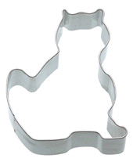

**Directions:**

1. Sprinkle flour on a clean, flat surface and roll out cookie dough.
2. Cut out cookies in the shape of a cat head or body using a cookie cutter.
3. Carefully transfer cookies to cookie sheet.
4. Bake according to package directions.
5. Allow the cookies to cool on the cookie sheet for about 3 minutes then press cinnamon candies in place for the eyes and nose.
6. Transfer to wire rack to continue cooling.

**Lizard Skins***Santa Clara County Council*

**Ingredients:**

* ½ cup Peanut butter
* 12 ounces Marshmallows
* 4 drops Green food coloring
* 16 Raisins
* 4 cups Rice Krispies; Cheerios or Corn Flakes
* Pam non-stick cooking spray

**Directions:**

1. Heat peanut butter with marshmallows in a large saucepan over low heat until melted.
2. Add green food coloring and mix in.
3. Pour in cereal and stir quickly.
4. Spray 8" pan with cooking spray then pour contents into pan.
5. Allow to cool in fridge, then cut into long thin strips, about 1" x 4".
6. Cut each raisin in half and stick on one end of each strip to make the lizard's eyes.

 program updates banner

# GAMES

**ANIMAL RELAY**

*Piedmont Council*

Divide the group into teams. Prepare slips of paper with different pets on them.

Fold them and place them in a container *(like a Cub Scout hat)*. Make one set for each team. First player runs to the container, picks a slip of paper, and reads it aloud. He then runs back acting like the pet written on the paper.

**PET MIX-UP**

*Piedmont Council*

This is played with all the players blindfolded. Divide players into different teams of pet animals. *(Baltimore Area Council suggests three to a team)*  No one is to tell what his animal is. Players are then scattered around the room at random. On signal, the players begin to make their animal calls trying to find their teammates.

Players may not make any other noise except the noise that the animal makes.

When they find all their team members, they link elbows. The first team to find all their members is the winner.

**CAT AND DOG RELAY**

*Piedmont Council*

Divide the group into teams. Prepare one stick, about 4 feet long, for each team.

Within teams, pair off boys and line them up relay style behind a starting line. A turning line should be drawn approximately 30 feet away. Give the first pair a stick. They stand back to back and straddle the stick holding it with both hands in front. On signal, the first pairs move towards the turning line with one person going forward and the other backwards. At the turning line, they stop and go back without turning around. They run back to the starting line to give the stick to the next pair.

**What Fish Is This?**

*Voyageur Council*

**Equipment:** Copy of the game

**Directions**: A fishy quiz. Tell me what kind of fish I am. Can either be done on paper or orally by having Cubmaster call out the joke lines and audience guessing. Answers are at end of line.

A prolonged crier? whale

A choir singer? bass

The mariners dread? rock

As slippery as ice? eel

Useful to birds? perch

A persistent serenade? Cat

What we do in deep water? flounder

A weapon of warfare? sword

A mother's pride? sun

Sometimes known to shoot? star

A household pet? dog

A swindler? shark

What all men want? gold

Nervous and unstable? jelly

Delightful to children? sucker

**Hare Hop**

*Santa Clara County Council*

**Equipment:** Per team: 1 pair of rabbit ears (made from cardboard, cotton and wire attached to a hat); 1 small balloon and 1 large balloon for each member; lots of string; 1 chair for each team.

**Formation:** Relay. Divide the group into teams of six. Line up each team in straight lines at one end of the playing area. Place the chairs, one for each team, at the opposite end of the playing area.

On 'Go', the first player of each team dons the rabbit ears, while his teammates blow up one small and one large balloon. One long piece of string is tied to the small balloon. The first player then ties the string around his waist, with the balloon hanging from behind, to represent his tail. He hugs the large balloon to his tummy, to represent the fluffy underside of a bunny. Then, with his ears and his two balloons, he hops down to the chair, hugs the large balloon until it breaks, and sits on his 'tail' until the small balloon breaks. When both balloons have burst, he hops back to the team where he gives the ears to the second player. The fun is helping each rabbit get 'dressed' and in cheering each bunny on. The relay ends when all bunnies have lost their tummies and tails.

**Poor Kitty**

*Santa Clara County Council*

**Equipment:** 1 blindfold

Arrange the group in a circle with a blindfolded player in the center. Then have the players move around the circle very quietly. The blindfolded player should approach the circle in any direction and secure a victim who, in a disguised voice, says 'poor kitty' and then imitates the 'meow' of a cat. If the blindfolded player fails to identify his prisoner, he releases him and the game continues. If he succeeds, the two change places.

**The Frog Hop**

*Santa Clara County Council*

Draw a finish line about 25' from the start and line the players up about 3' apart. At "Go" they race by jumping first to the right, then to the left, then straight ahead. This procedure is followed until someone crosses the finish line.

**Dog Chases Its Tail**

*Santa Clara County Council*

This game mimics the silliness and futility of a dog chasing its tail. You need a bandanna. Have the players line up, holding each other around the waist. (Do not allow kids to hook fingers through belts or belt loops--this results in ripped clothing and hurt fingers.) Have the last player tuck a bandanna in his pocket, or under his belt or waistband, so that it hangs down like a tail. Next, the front of the line begins to chase the end of the line, attempting to grab the bandanna. Players in the middle can help or hinder the head or the tail, depending on their whims. If the line breaks, the player who let go must step out, shortening the line.

**Poodle**

*Santa Clara County Council*

In this guessing game, the word "poodle" is substituted for a verb. To play, one boy picks a secret verb, then the other boys ask questions using poodle in place of the verb: "Can you poodle in a pool?" "Does poodling make you tired?" The child who correctly guesses the secret verb gets to choose the next one. Who knew verbs could be this much fun? *Or use the name of a breed of dog owned by the Den Leader or Den Chief or any member of the den.*

**Doggie Where’s Your Bone**

*Santa Clara County Council*

It is an inside game. A boy plays the part of the dog. He sits in a chair with his back to the den. An eraser or another object is put under the chair. That is the bone. While the dog is turned around with his eyes closed someone sneaks up and steals the bone and hides it somewhere on his person. Then everyone sings: Doggy, Doggy, where's your bone? Somebody's stole it from your home. Guess who! It might be you! Then the dog has three chances to guess who took it. Sometimes it is left under his chair. If the dog guesses right then he gets to do it again. If he guesses wrong then the boy who has the bone gets a turn as the dog.

**Cats Get Your Corner**

*Santa Clara County Council*

You pick someone to be it.  The person that is "it" gets a ball (like a standard red kickball or maybe something softer like a nerf ball). All the cats pick a corner to stand in.  The den leader acts as an umpire.  When everyone has a corner then the ump yells "cats get a corner". Then everyone takes off running for the corner that is next. Everyone is supposed to run in the same direction so no one should run into each other.  While the cats are running, "it" tries to hit them with the ball.  If you get hit you stand in the middle. The cat that never gets hit wins and becomes the next “it”.

**Sheepdog**

*Baltimore Area Council*

This is a different form of the game “Tag.” The aim of the game is for the “dogs” to round .up and catch the “sheep.”

It starts off with one Scout trying to catch the rest. When a boy is caught he will hold hands with the other and give chase to the rest. When a third boy is caught, he will join the chain. When the fourth is caught, the four will split up into groups of two, etc. The person who is last caught is the winner.

As an alternative, the “chain” can remain unbroken to form one really long line, sweeping up the “sheep”.

**Rattlesnake**

*Baltimore Area Council*

Arrange Cubs in a circle. Blindfold one in the center; give him a rolled newspaper. The Cubs in the circle pass and shake a tin can with pebbles in it. “It” tries to swat the Cub caught being the snake; when caught the Cub becomes “It” in the center of the circle.

**Dog Team Relay**

*Baltimore Area Council*

This requires a smooth tile or wood floor. One boy is to sit on a paper sack. 4-6 boys make up the dog team. The boys must first tie square knots joining several small pieces of rope to form one large one. The combined pieces should be long enough to go around the Cub dog team. Once the loop is finished, the boy on the sack holds the loop and the other boys drag him on his sack to the finish line. The first team to finish by crossing the line wins.

**I’ve Lost My Dog**

*Baltimore Area Council*

Players stand in a ring facing inwards. The leader stands in the center. He addresses one of the players, saying, “I’ve lost my dog.” The player asks, “What is it like?” The leader describes any other person in the ring--trying also to make the description fit a dog. When the questioner guesses the identity of the person described, the one described leaves his place and is followed round the circle by the questioner. Both race in the same direction, each returning to his place. The last to get back becomes the one to whom the leader will speak when the game begins again.

**Dog And Bone**

*Baltimore Area Council*

One Cub is the dog and is located in the middle of the circle. The other Cubs are in a circle around the dog. An object to be the bone should be of some quiet material. As the dog hides his eyes, a Cub creeps up and quietly takes the bone back to his spot in the circle, hiding it behind his back. The dog is then told to find the bone by calling the name of the person he thinks has the bone. He gets three tries. If he doesn’t guess the right person, he is still the dog. If he guesses correctly the person caught is then the dog.

**Obedience School**

*Baltimore Area Council*

Based on Simon Says, preface the commands with “The Trainer Says” Use appropriate dog tricks or behaviors such as lie down, beg for a treat, roll over, speak (woof), scratch your ear, wag your tail, show your tongue and pant.

***The following games from Alice focus on being KIND and Compassionate to those with disabilities. They are from the "Ethics in Action" plans that BSA published in years past. CD***

**Protect the Speck Relay Race**

*Alice, Golden Empire Council*

Divide the players into teams. Provide each team with a spoon and a pink pom-pom ball to represent “Whoville.”

Designate a start and finish line. In turn, each person races to the finish line and back to their team holding the pom-pom in the spoon.

If you use small plastic spoons and larger pom-poms it will make the game more challenging!

**Who-ville Safety**

*Alice, Golden Empire Council*

**Materials:** An equal number of balloons of two colors – more than the number of people on each team.

Divide group into two teams. Each team is assigned one color of balloons. Release the balloons for each team at the same rate, gradually putting all balloons into play.

The object is to keep all the balloons off the ground as long as possible.

For more fun, play the Horton Hears a Who soundtrack!

**Disability Awareness Games**

*Alice, Golden Empire Council*

To make Cub Scouts aware of the needs of others, here are some special games. These “disability awareness games” are fun in themselves, but they also serve to show able-bodied boys the problems of boys who have physical disabilities – and awareness is the first step in being compassionate!

Without making a big deal of it, you might introduce these games with the thought that disabled boys must deal with the limitations imposed for the games in their everyday lives. The idea is to make scouts aware of the needs of others.

**Fumble Fingers**

*Alice, Golden Empire Council*

* Divide the den into two teams.
* Tell players to untie their shoe laces.
* Then tell them to put one hand behind their back (or tie one hand to belt.)
* On signal, each team tries to the tie their shoe laces, with each player only using one hand.
* First team finished wins.

**Ships In The Fog**

*Alice, Golden Empire Council*

* Divide the den into two teams and line them up relay fashion at one end of the room.
* For each team set up a series of obstacles—a chair, tables, stools, etc.—between them and the other end of the room.
* Blindfold the first player on each team.
* On signal, he starts for the other end of the room, trying to avoid the obstacles.
* His teammates may call out directions (“Go right”, “Turn left”, etc.)
* When he reaches the other end of the room, he takes off the blindfold and runs back to touch the next player, who is already blindfolded.
* Continue until all team members have raced.
* First team finished wins.

**Muffled Sounds**

*Alice, Golden Empire Council*

* Divide the den into two teams and give each player two cotton balls to stuff in his ears.
* When all ears are covered, one leader steps outside the room where he or she cannot be seen and produces a series of sounds—tinkling bell, sentence spoken in normal conversational tones, pan being scraped, barking dog, hammer on a board, etc.
* When the leader returns, each team huddles and writes a list of the sounds it heard.
* Winning team is the one with the longest list of correct sounds. You could pre-record the sounds.

**Walk In My Shoes Relay**

*Alice, Golden Empire Council*

Identify a starting and ending point. Divide into two teams. Have each team, one person at a time, race to the target and back again, till everyone has a chance. Now, “handicap” boys, one team member at a time, in the following ways (But DO NOT tell the boys what the changes represent):

* Rub Vaseline on a pair of dollar glasses to represent poor vision
* Give each boy a big box that he must “wear” on one foot to represent difficulty in walking
* Each boy must wear an oven mitt on one hand and pick up six tissues on the ground to represent having trouble with bending fingers, like a person with arthritis.
* Hand each boy a paper with a paragraph that has jumbled letters, representing a person with dyslexia or some other learning disability – he must try to read the words before he can head back to the finish. (Don’t insist on being able to make out the meaning – just let each boy try for a minute)
* Tell each boy he has to listen for instructions from his teammates – (“Hop on one foot, Turn around and walk backwards, etc.”) and if he doesn’t do what they say, he must start over – then have the team open their mouths without saying the instructions – they just move their mouths.

Talk about which way was fastest and why? What difficulties did they have on the second race? Who might have the same kind of problem doing the race? How do they think they would feel if they had to do everything with the “handicap?” Talk about how people who have some handicap might feel, and how we should interact with them.   
***Be sensitive to any boys with reading difficulties if you are doing the last idea. - Alice***

# SOME LAST THINGS

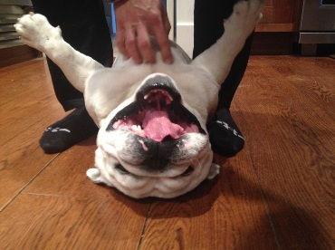

## Life Lessons Learned from a Dog

*Santa Clara County Council*

* If you stare at someone long enough, eventually you'll get what you want.
* Don't go out without ID.
* Be aware of when to hold your tongue,   
  and when to use it.
* Leave room in your schedule for a good nap.
* Always give people a friendly greeting.
* When you do something wrong, always take responsibility (as soon as you're dragged shamefully out from under the bed).
* If it's not wet and sloppy, it's not a real kiss.

***SCCC suggests this as a CM’s Closing Minute CD***

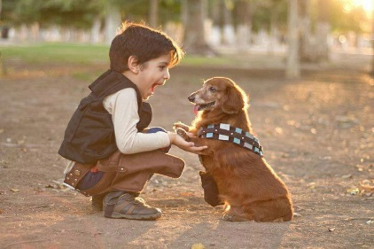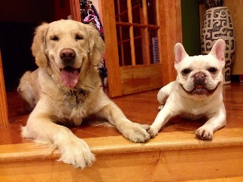

## Dogs as Teachers

*Santa Clara County Council*

If a dog were your teacher you'd learn stuff like:

* When loved ones come home, always run to greet them.
* Never pass up the opportunity to go for a joyride.
* Allow the experience of fresh air and the wind in your face to be pure ecstasy.
* When it's in your best interest--practice obedience.
* Let others know when they've invaded your territory.
* Take naps and stretch before rising.
* Run, romp, and play daily.
* Avoid biting when a simple growl will do.
* On warm days, stop to lie on your back on the grass.
* On hot days, drink lots of water and flop under a shady tree.
* When you're happy, dance around and wag your entire body.
* Delight in the simple joy of a long walk.
* Eat with gusto and enthusiasm. Stop when you have had enough.
* Be loyal.
* Never pretend to be something you're not.
* If what you want lies buried, dig until you find it.
* When someone is having a bad day, be silent, sit close by and nuzzle them gently.

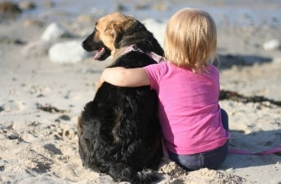 

## I Wish My Daddy Was a Dog

*Baltimore Area Council*

One day when my son was just a lad starting out in school   
He came into my workshop and climbed upon a stool   
I saw him as he entered but I hadn’t time to play.   
So I merely nodded to him and said “Don’t get in the way”.

He sat a while just thinking--as quiet as could be.   
Then carefully he got down and came and stood by me.   
He said “Old Shep, he never works and he has lots of fun.   
He runs around the meadows and barks up at the sun.”

“He chases after rabbits and always scares the cats.   
He likes to chew on old shoes, and mother doesn’t like that.   
But when we’re tired of running we sit down on a log,  
 I sometimes get to thinking I wish my Daddy was a dog.

Cause then when I came home from school he’d run & lick my hand  
And we would jump and holler and tumble in the sand.   
And then I’d be as happy, as happy as could be.   
Cause we would play the whole day through just my Dad and me.

“Now I know you work real hard to buy us food and clothes.   
And you need to get the girls those fancy ribbons and bows.   
But sometimes when I’m lonesome I think it would be lots of fun  
If My Daddy Was a Dog and all his work was done.”

Now when he’d finished speaking he looked so lonely there,   
I reached my hand out to him and ruffled up his hair.   
And as I turned my head aside to brush away a tear,   
I thought how nice it was to have my son so near.

I know the Lord didn’t mean for man to toil his whole life through,   
“Come on my son, I’m sure I have some time for you.”   
You should have seen the joy and sunlight in his eye.   
As we went outside to play -- Just my son and I.

Now, as the years have flown and youth has slipped away,   
I’ve tried always to remember to allow some time to play.   
When I pause to reminisce and think of joys and strife,   
I carefully turn the pages of this wondrous book of life

I find the richest entry recorded in this daily log   
Is the day that small boy whispered, I wish my Daddy was a dog

