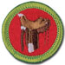 Horsemanship
Merit Badge Workbook
This workbook can help you but you still need to read the merit badge pamphlet (book). No one can add or subtract from the Boy Scout Requirements #33216. Merit Badge Workbooks and much more are below: Online Resources.
Workbook developer: craig@craiglincoln.com. Requirements revised: 2004, Workbook updated: February 2009.
Scout’s Name: Unit:
Counselor’s Name: Counselor’s Ph #:
1. Do the following:
a. Describe the safety precautions you should take when handling and caring for a horse.

b. Explain and demonstrate how to approach

and lead a horse safely from a stall, corral, or field

and how to tie the horse securely.

c. Demonstrate how to safely mount

and ride a horse

and how to safely dismount the horse after your ride.

2. Name 15 main parts of a horse.
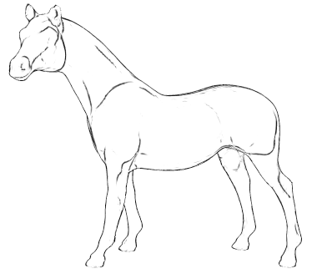

3. Name four leading breeds of horses. Explain the special features for which each breed is known.

4. Show how to care for a Western and English saddle and bridle.
Name 10 parts of the saddle and bridle that you will use.

5. Show how to groom, pick out hooves, prepare a horse for a ride, and care for a horse after a ride.

6. Describe the symptoms of colic.

Describe four other horse diseases.

7. Name three main conformation faults of the feet and legs, and explain how to detect them.

Explain the difference between lameness

and unsoundness.

8. Explain how to trim and shoe a horse's foot and how to make adjustments according to its conformation, the season of the year, and the riding conditions.

9. Demonstrate the correct way to feed a horse. Explain how you determined what and how much to feed the horse

and why the amount and kind of feed will be changed according to activity level and the kind of horse it is.

10. Show how to properly saddle and bridle a horse.
11. On level ground, continuously do the following movements. Do them correctly, at ease, and in harmony with the horse.

a. Mount the horse.
b. Walk the horse in a straight line for 60 feet.
c. Make a half-circle of not more than 16 feet in radius.
d. Trot or jog in a straight line for at least 60 feet.
e. Make a half-circle of not more than 30 feet in radius at a jog or trot.
f. Halt straight.
g. Back up straight four paces.
h. Halt and dismount.

Online Resources (Use any Internet resource with caution and only with your parent’s or guardian’s permission.)
Boy Scouts of America: ►scouting.org ►Guide to Safe Scouting ►Age-Appropriate Guidelines ►Safe Swim Defense
►Scout ►Tenderfoot ►Second Class ►First Class • Rank Videos ►Safety Afloat
Merit Badge Books: www.scoutstuff.org Please don't post workbooks on your site. Please instead post links to these: MeritBadge.org: http://meritbadge.org/wiki/index.php/MBW -or- usscouts.org: http://www.usscouts.org/mb/worksheets/list.asp

Requirement Resources
These resources and much more are at: http://meritbadge.org/wiki/index.php/Horsemanship
1, 8, 9, 10, 11. ExpertVillage Horsemanship Lesson Videos & How to Ride: Lead - Lead & Tie - Mount - Mount & Discmount
Rider Position - Canter - Lope - Back up - Jog - Trot - Gallop - Exercise - Lateral Work
2. A diagram of a horse is in the Horsemanship Worksheet - Parts of a horse.
3. Popular Horse Breeds -all Horse Breeds
4. Saddle parts and care - Saddle - Bridle
5. Bathing & Grooming a horse - Hooves
6. Horse Diseases

General Resources
Horse Illustrated: http://www.animalnetwork.com/horse Horse & Rider: http://www.horseandrider.com
http://www.horsenews.com The United States Pony Clubs: http://www.ponyclub.org
National Reining Horse Association: http://www.nrha.com United States Dressage Federation: http://www.usdf.org
United States Equestrian Team: http://www.uset.com USA Equestrian: http://www.equestrian.org

