 Aviation
Merit Badge Workbook
This workbook is not required but is designed to help you with this merit badge. No one can add or subtract from the Boy Scout Requirements #33215. Use page backs & add pages as needed. Please send comments to: craig@craiglincoln.com. Requirements revised: 2000, Workbook updated: January 2004.

Scout’s Name: Unit:
Counselor’s Name: Counselor’s Ph #:
1) Do the following: a) Define "aircraft."

Describe some kinds and uses of aircraft today.
Kind: Uses:

Explain the operation of piston,

turboprop,

and jet engines.

b) Point out on a model airplane the forces that act on an airplane in flight. (Hint: To make a model airplane out of paper…)
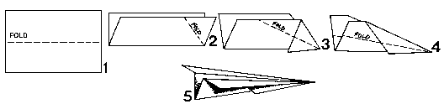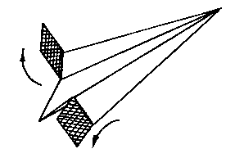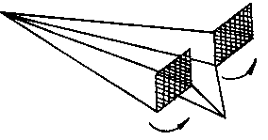
c) Explain how an airfoil generates lift,
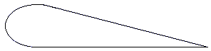

how the primary control surfaces (ailerons, elevators, and rudder) affect the airplane’s attitude,
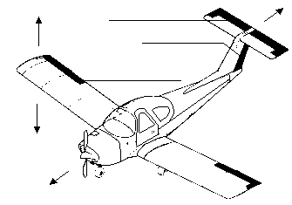
Ailerons:

Elevators:

Rudder:

and how a propeller produces thrust.

d) Demonstrate how the control surfaces of an airplane are used for

Ailerons Elevators Rudder Flaps
takeoff,
straight climb,
level turn,
climbing turn,
descending turn,
straight descent,
and landing.
e) Explain the following: the recreational pilot and the private pilot certificates;

the instrument rating.

f) Find out what job opportunities there are in aviation.

Describe the qualifications and working conditions of one job in which you are interested.

Tell what it offers for reaching your goal in life.

2) Do TWO of the following:
 a) Take a flight in an aircraft.
Record the date, place,
type of aircraft, and duration of flight,
and report on your impressions of the flight.

 b) Visit an airport. After the visit, report on how the facilities are used,

how runways are numbered,

and how runways are determined to be "active."

 c) Visit a Federal Aviation Administration facility—  a control tower,  terminal radar control facility,  air route traffic control center,  flight service station, or  Flight Standards District Office. (Phone directory listings are under U.S. Government Offices, Transportation Department, Federal Aviation Administration. Call in advance.)
Report on the operation

and your impressions of the facility.

 d) Visit an aviation museum or attend an air show:
Report on your impressions of the museum or show.

 e) Explain the purposes and functions of the various instruments found in a typical single-engine aircraft:
attitude indicator,
heading indicator,
altimeter,
airspeed indicator,
turn and bank indicator,
vertical speed indicator,
compass, navigation (GPS and VOR)
and communication radios,
tachometer,
oil pressure gauge,
and oil temperature gauge.
 f) Visit an aircraft maintenance shop:
Interview a technician:
and report on his/her ideas about aircraft maintenance.

g) Create an original poster of an aircraft instrument panel. Include and identify the instruments and radios discussed in requirement 2e.
3) Do TWO of the following:
 a) Interview a professional or military pilot:
Report on what you learned.

 b) Interview a flight attendant.:
Report on what you learned.

 c) Interview a certified flight instructor:
Report on what you learned.

 d) Under supervision, perform a preflight inspection of a light airplane.
 e) Obtain and learn how to read an aeronautical chart.
 Measure a true course on the chart.
 Correct it for magnetic variation,
 compass deviation,
 and wind drift.
 Arrive at a compass heading.
 f) Using one of many flight simulator software packages available for computers, "fly" the course and heading you established in requirement 3e or another course you have plotted.
 g) On a map, mark a route for an imaginary airline trip to at least three foreign countries. (Hint: Here is a map…)
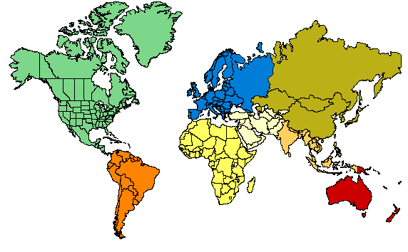
Start from the commercial airport nearest your home. From timetables (obtained from agents or online from a computer), decide when you will get to and leave from all connecting points. (Hint: Consider using the table below…)

Depart Flight Time Arrive Time Depart Flight Time Arrive Time

1 7

2 8

3 9

4 10

5 11

6 12
 h) Build and fly a fuel-driven model airplane.
Describe safety rules for building and flying model airplanes.

Tell safety rules for use of glue, paint, dope, plastics, and fuel.

 i) Assemble a poster (or album) of original photographs taken while accomplishing the requirements.

