http://www.USScouts.Org • http://www.MeritBadge.Org
Please submit errors, omissions, comments or suggestions about this workbook to: Workbooks@USScouts.Org
Comments or suggestions for changes to the requirements for the merit badge should be sent to: Merit.Badge@Scouting.Org
______________________________________________________________________________________________________________________________________________
1. Do the following:
a. Explain why BB and pellet air guns must always be treated with the same respect as firearms.
b. Describe how you would react if a friend visiting your home asked to see your or your family's firearm(s).
c. Explain the need for and use and types of eye and hearing protection.
d. Give the main points of the laws for owning and using guns in your community and state.
e. Explain how hunting is related to the wise use of renewable wildlife resources.
f. Successfully complete a state hunter education course, or obtain a copy of the hunting laws for your state,
then do the following:
1. Explain the main points of hunting laws in your state and give any special laws on the use of guns or ammunition, and
2. List the kinds of wildlife that can be legally hunted in your state.

g. Explain to your counselor the proper hygiene guidelines used in shooting.
h. Identify and explain three shotgun sports.
1.
2.
3.
Identify places in your community where you could shoot these sports and explain how you can join or be a part of shooting sports activities.
i. Give your counselor a list of sources that you could contact for information on firearms and their use.

2. Do ONE of the following options
A. Shotgun Shooting (Modern Shotshell Type) - OPTION A
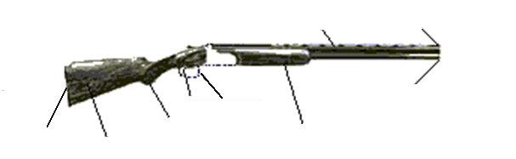
a. Identify the principal parts of a shotgun, action types, and how they function.

Part Name | Function
b. Identify and demonstrate the rules for safely handling a shotgun.
Demonstrate how to handle shotguns in a safe manner.
c. Identify the parts of a shotgun shell and their functions.

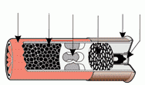
Part name | Function
d. Identify the various gauges of shotguns.
Explain which one you would pick for use and why.
Gauge:
Use
Why?

Gauge:
Use
Why?

Gauge:
Use
Why?

Gauge:
Use
Why?
e. Identify and explain the fundamentals of safely shooting a shotgun.
Explain what a misfire, hangfire, and squib fire are, and explain the procedures to follow in response to each.
 | What is it? | Procedure to follow in response
Misfire
Hangfire
Squib fire
f. Identify and explain each rule for safely shooting a shotgun.
g. Demonstrate the knowledge, skills, and attitude necessary to safely shoot moving targets, using the fundamentals of shotgun shooting.
h. Identify the materials needed to clean a shotgun.
i. Demonstrate how to clean a shotgun safely.
j. Discuss what points you would consider in selecting a shotgun.
k. Shooting score required - Hit at least 12 out of 25 targets (48%) in two 25-target groups. The two groups need not be shot in consecutive order. A minimum of 50 shots must be fired.
1st Group Score: 2nd Group Score:
Shooting skill rules:
- Targets may be thrown by a hand trap, manual mechanical trap, or on any trap or skeet field. Note: If using a hand trap or manual mechanical trap, the trap operator should be at least 5 feet to the right and 3 feet to the rear of the shooter. If throwing left-handed with a hand trap, the trap operator should be at least 5 feet to the left and 3 feet to the rear of the shooter.
- All targets should be thrown at a reasonable speed and in the same direction.
- Targets should be generally thrown so as to climb in the air after leaving trap.
- Scores may be fired at any time, either in formal competition or in practice.
- Any gauge shotgun not exceeding 12 gauge may be used.
- Only commercially manufactured ammunition may be used. Reloads may not be used in BSA shooting sports programs.
- Shooters must shoot in rounds of 25. Rounds need not be shot continuously on the same day (the term “round” refers to a single series of 25 shots).
- If using a trap field, shoot station 3 with traps set to throw straightaway targets.
- If using a skeet field, shoot station 7 low house.

B. Muzzleloading Shotgun Shooting - OPTION B
a. Discuss a brief history of the development of the muzzleloading shotgun.
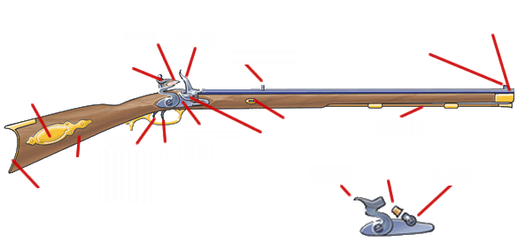
b. Identify principal parts of percussion and flintlock shotguns and discuss how they function.
Part Name | Function
Part Name | Function
c. Demonstrate and explain the rules of safely handling a muzzleloading shotgun.
d. Identify the various grades of black powder and their proper and safe use.
e. Discuss proper safety procedures pertaining to black powder use and storage.
f. Discuss proper components of a load.
g. Identify proper procedures and accessories used for safely loading a muzzleloading shotgun.
h. Demonstrate the knowledge, skills, and attitude necessary to safely shoot a muzzleloading shotgun on a range, including range procedures.
Explain what a misfire, hangfire, and squib fire are, and explain the procedures to follow in response to each.
 | What is it? | Procedure to follow in response
Misfire
Hangfire
Squib fire
i. Shoot a moving target with a muzzleloading shotgun using the five fundamentals of firing the shot.
j. Identify the materials needed to clean to clear a muzzleloading shotgun’s failure to fire and explain or demonstrate proper correction procedures..
k. Demonstrate how to clean a muzzleloading shotgun safely.
l. Identify the causes of a muzzleloading shotgun's failure to fire and explain or demonstrate proper preventive procedures.
m. Discuss what points you would consider if selecting a muzzleloading shotgun.
n. Shooting skill required -- Hit at least 5 out of 15 targets in each of two 15-target groups. The two groups need not be shot in consecutive order. A minimum of 30 shots must be fired.
1st Group Score: 2nd Group Score:
Shooting skill rules:
- Targets may be thrown by a hand trap, manual mechanical trap, or on any trap or skeet field. Note: if using a hand trap or manual mechanical trap, the trap operator should be at least 5 feet to the right and 3 feet to the rear of the shooter. If throwing left-handed with a hand trap, the trap operator should be at least 5 feet to the left and 3 feet to the rear of the shooter.
- All targets should be thrown at a reasonable speed and in the same direction.
- Targets should be generally thrown so as to climb in the air after leaving trap.
- Scores may be fired at any time, either in formal competition or in practice.
- Any gauge shotgun not exceeding 10 gauge may be used.
- Standard clay targets customarily used for trap and skeet are to be used.
- On a standard trap field, the shooter should be positioned 8 yards behind the trap house. The trap should be set to throw only straightaway targets
- On a skeet field, use station 7 low house.

When working on merit badges, Scouts and Scouters should be aware of some vital information in the current edition of the Guide to Advancement (BSA publication 33088).Important excerpts from that publication can be downloaded from http://usscouts.org/advance/docs/GTA-Excerpts-meritbadges.pdf.
You can download a complete copy of the Guide to Advancement from http://www.scouting.org/filestore/pdf/33088.pdf.

